Columnar Joints in Lava and Starch:
Solving a 300 year old geology problem
using kitchen materials

March Meeting of the APS
Press release backgrounder, March 5, 2007.

Feel free to use this material. Contact Prof. Stephen W. Morris
smorris@physics.utoronto.ca . All images, movies and papers available at:
http://www.physics.utoronto.ca/~smorris/APS/APSpress.html

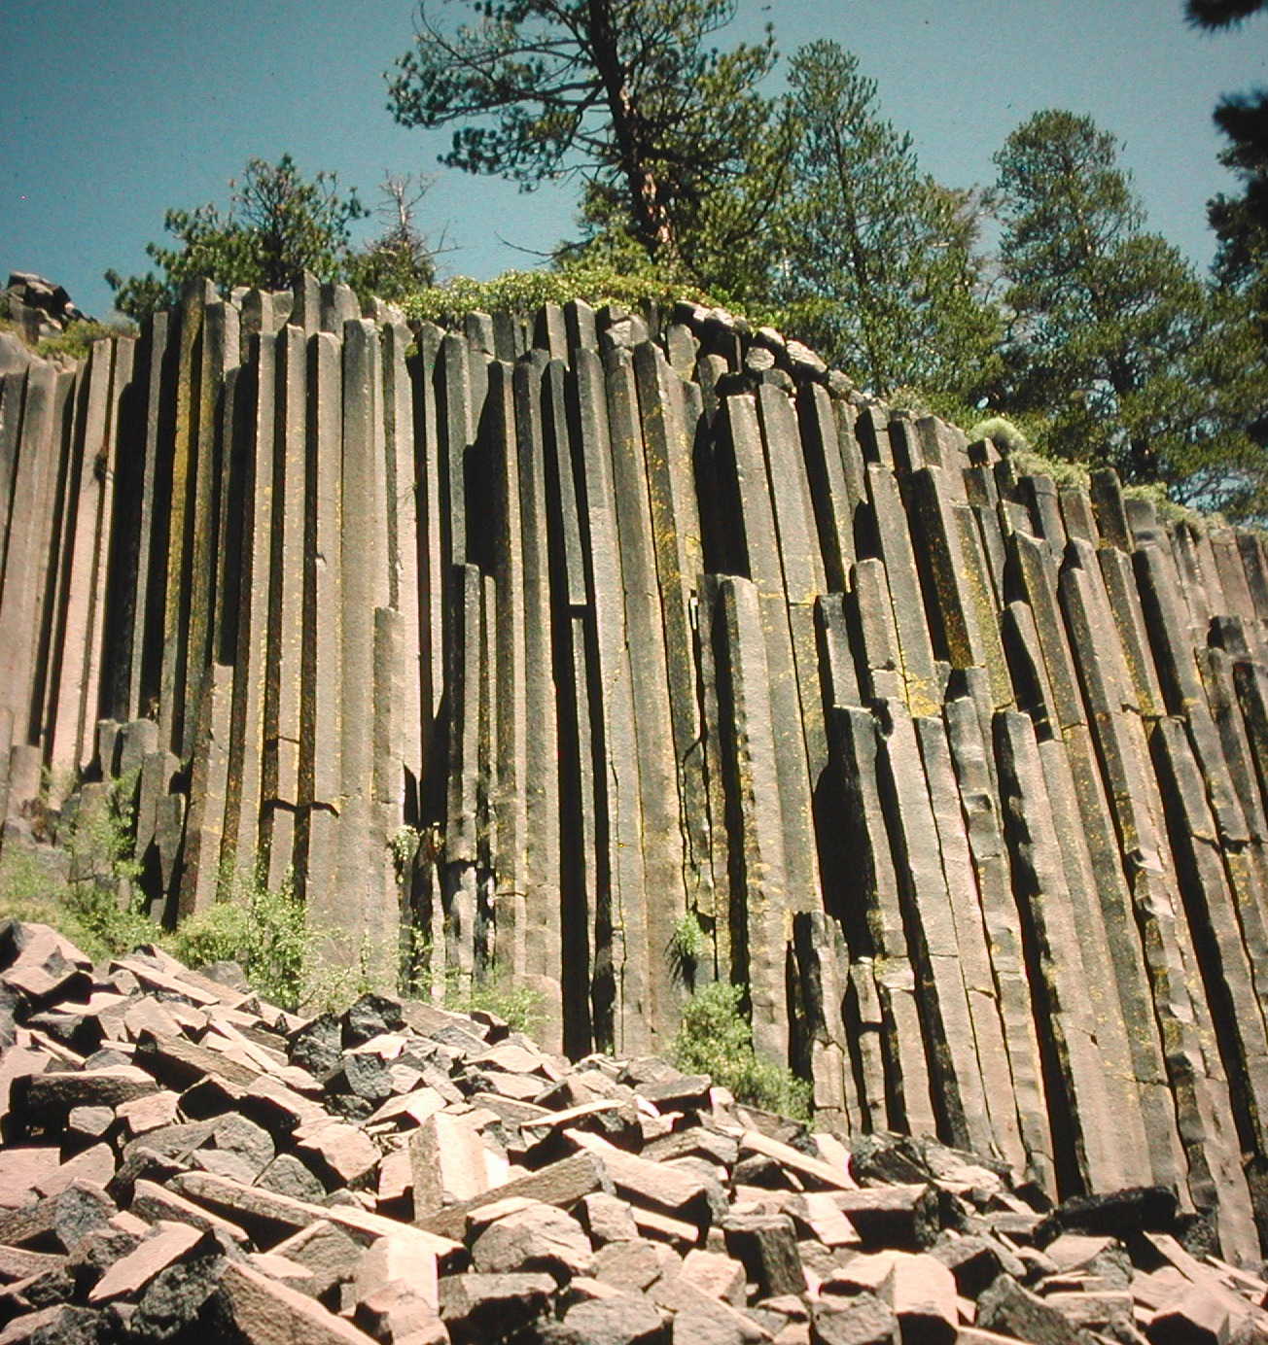
Columnar joints are strange, uncanny formations in which outcroppings of rock are mysteriously broken into nearly perfect hexagonal pillars, all the same size and packed tightly together. The most famous examples have accumulated legends since ancient times: The Giant’s Causeway in Northern Ireland, Fingal’s Cave in Scotland, The Devil’s Postpile in California (picture) and The Devil’s Tower in Wyoming. The names conjure the apparently supernatural degree of organization of these columns, which appear to be the work of giants or the devil. What causes these “joints” (to use the geologist’s word for cracks)?

Since they were first discussed in the scientific literature in the 17th century, these formations have attracted the interest of geologists and tourists. Found all over the world, they are now known to be the result of cooling lava flows, in which shrinkage causes stresses that fracture the rock. The columns are formed as a sharp front of cooling moves into the lava flow, assisted by the boiling off of groundwater. As the front advances, it leaves behind a crack network which evolves into an almost hexagonal arrangement. This network carves out the columns. Many mysteries remain: what causes the ordering of the network into hexagons? What sets the size of the columns, which varies in different outcrops between a few inches and a few yards?

Amazingly enough, you can make columnar joints in your kitchen! Just mix 50:50 corn starch and water and put it into a coffee cup. Dry the mixture with a bright light above it --- this might take up to a week. When the mixture is dry, carefully break it apart and you will see that the interior is broken up into small “starch columns” a few mm wide. In this experiment, water replaces the heat in the lava, and the columns are 1000X smaller. Why?

We have learned how to control this “kitchen experiment” very precisely so that we can study the process in detail. We have also studied real lava columns in Washington state, Scotland and Ireland. We can measure how the columns evolve by using X rays to see the cracks inside the starch. We can also understand why the size of the columns in lava is 1000X that of starch.

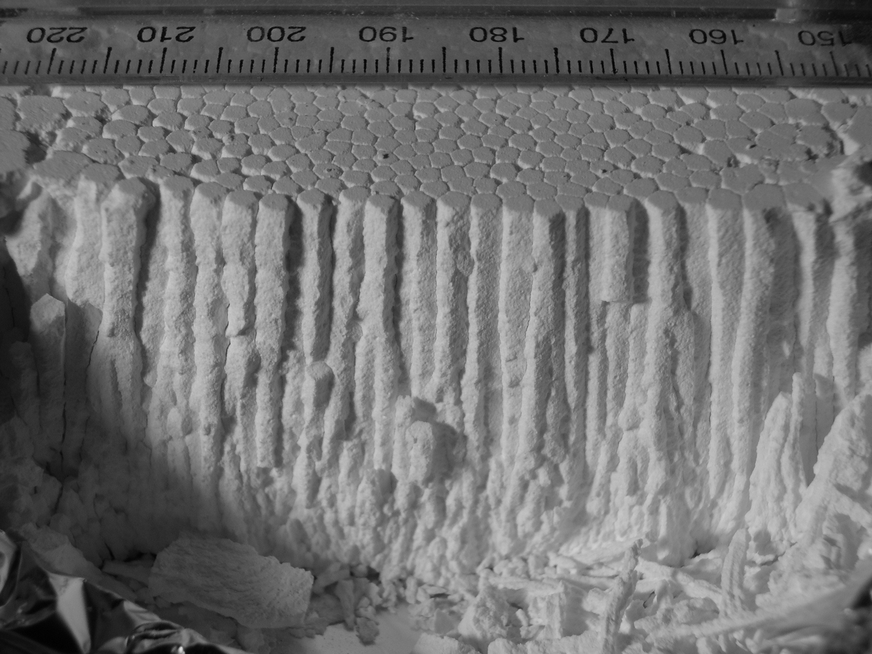
Controlled experiments make very regular looking columns, just like those found in real lava (picture).

The scale in the picture is in mm: the size of the columns depends on the speed that the cracks advance, and the rate at which the water can move through the starch. The analogous properties of lava are known from measurements to be much slower. The ratio of these explains the 1000X magnification of the columns in lava.

References and links

The Experimental Nonlinear Group, University of Toronto: http://www.physics.utoronto.ca/nonlinear
Contacts; Prof. Stephen Morris smorris@physics.utoronto.ca
Lucas Goehring goehring@physics.utoronto.ca

Papers:
Lucas Goehring and Stephen W. Morris, Europhysics Letters, 69, 739 (2005).
Lucas Goehring, Zhenquan Lin and Stephen W. Morris, Physical Review E 74, 036115 (2006).
Lucas Goehring and Stephen W. Morris, Submitted to Journal of Geophysical Research.

