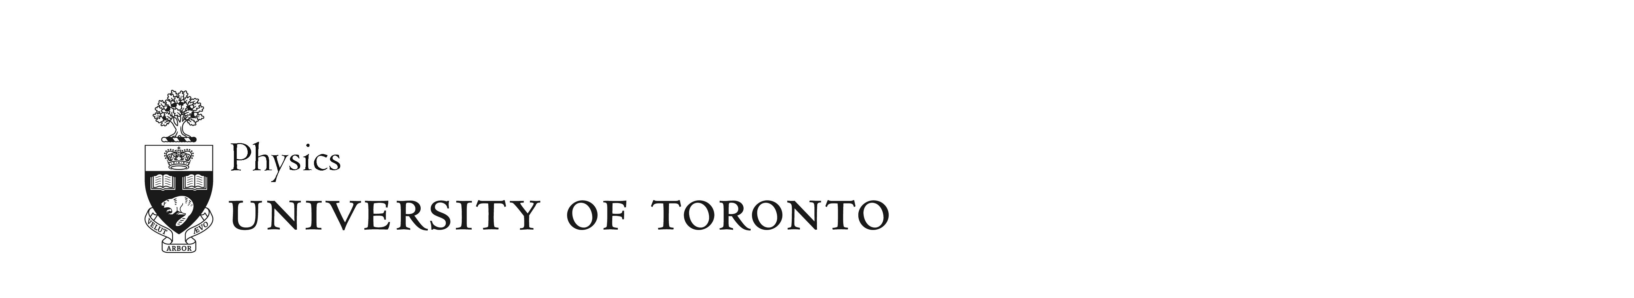

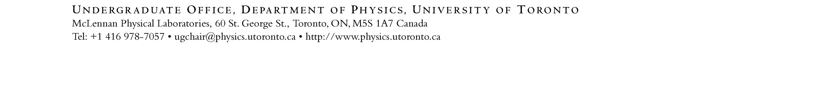

**3rd and 4th Year Supervised Courses in Physics: Guidelines and Enrolment**

* **Read** the Supervised Course Guidelines on this page.
* Your supervisor will determine in consultation with you the course outline/syllabus and grading scheme, which is filled in on page 2.
* A pdf version of this document along with your **unofficial transcript** is then uploaded on the application form on the [Supervised Courses webpage](https://www.physics.utoronto.ca/undergraduate/research-mentorship-and-career-opportunities/3rd-and-4th-year-supervised-courses-physics-phy37xphy47x/). Prepare these before filling in the form.
* **Read** the expectations for the Supervised Course Oral Examination on page 3.

**Supervised Course Guidelines**

|  |  |
| --- | --- |
| **Approval:** | Enrolment in Supervised Courses requires the approval of the Course Coordinator. |
| **Qualification:** | * Enrolled in a Physics Specialist, Physics Joint Specialist, or Physics Major POSt. Exceptions can be made for students enrolled in a Physics Minor POSt. * Minimum Cumulative GPA of 2.7 (B-). Exceptions can be made for students whose recent academic performance (e.g., Sessional GPA recently meeting this criterion) indicates that they will be successful in a supervised study course. Students with lower grades are encouraged to try the Independent Study course before attempting the Research Project course. |
| **Finding a supervisor:** | Students are required to find their own supervisor for a Supervised Course. The supervisor can be from Physics or other Science/Applied Science Departments at the University of Toronto. The Course Coordinator can provide assistance. Registration should be completed a week before the sessional deadline for adding courses. Contact the Course Coordinator if you are unable to meet this deadline. |
| **Grading Scheme and Syllabus:** | * A course syllabus and grading scheme must be prepared by the supervisor in consultation with the student. These must satisfy the following criteria: * Meetings between student and supervisor, at least bi-weekly. * A written report summarizing the study or research. * An oral examination worth at least 30% of the grade. The exam consists of a 15-minute presentation and follow-on questions and discussion. The Course Coordinator or other designate will be an examiner along with the supervisor. See Page 3 for expectations for the oral examination. * Courses require a minimum of physics content either in their focus or in their methodology. For Physics students in Supervised Courses on topics related to our joint programs (e.g., in Biological Physics), exceptions can be made. Topics related to undergraduate laboratory development and Physics Education Research qualify. * Work worth at least 10% of the grade must be completed by the course drop-date of the session in which the course is taking place. * All final grades are submitted to the Course Coordinator two weeks before the grade submission deadline for the Faculty. * Outline includes title and brief content description. |
| **Workload:** | The workload should be comparable to other courses at the third and fourth year level. |
| **Limit on Supervised Courses:** | A student may count up to 1.5 FCE of Supervised Study/Research Project courses towards their POSt program requirements. *You may only be enrolled in one Supervised Course in Physics at a time*. |

|  |
| --- |
| **Project Title:**  **Syllabus and Grading Scheme (at least 30% for oral exam):** |

**3rd and 4th Year Supervised Courses in Physics:**

**Expectations for Oral Presentation and Oral Exam**

The oral exam consists of a 15-minute presentation followed by questions and discussion for typically 20 to 30 minutes. The examiners will be the student’s supervisor and the Course Coordinator. The latter convenes and chairs the exam. After the discussion, the student will be asked to step out of the room while the examiners discuss a grade for the exam. The student will then be asked to return, where the exam will be discussed and the student given a grade and additional feedback.

The oral exam, though preferably performed in person, can be conducted remotely at the discretion of the Course Coordinator and consistent with University Policies.

The Course Coordinator will only be involved in grading the oral exam. The supervisor is responsible for the other parts of the course evaluation and assigning a final grade.

For the oral exam, the students are expected

* To have corresponded with the Course Coordinator on scheduling of the exam. The Course Coordinator will initiate the scheduling process normally about two months prior to the end of term.
* To have slides that are well prepared, which include an introduction and conclusion/summary as well as main results of the research project or the main topics and ideas covered in the supervised readings.
* To have practiced the presentation with the supervisor and/or with their research group.
* To be prepared to answer questions specific to their project as well as relevant background questions.

When asking questions, examiners shall bear in mind the student’s experience and program of study.

*This document was last updated September 12, 2025*