ADVANCED UNDERGRADUATE LABORATORY

BRI

BRILLOUIN SCATTERING

Revisions:
July 2013: Henry M. van Driel
February 2005: Jason Harlow
November 1987: John Pitre

Copyright © 2011 University of Toronto
This work is licensed under the Creative Commons
Attribution-NonCommercial-ShareAlike 3.0 Unported License.
(http://creativecommons.org/licenses/by-nc-sa/3.0/ )
Overview:
The purpose of this experiment is to introduce Brillouin scattering, a type of light scattering that allows one to determine acoustic properties of a medium. It is used here to measure the velocity of sound in two liquids, methyl acetate and carbon tetrachloride. The experiment makes use of a Fabry-Perot interferometer, one of the highest resolution spectroscopic instruments ever invented.

Introduction
Light scattering allows one to learn about certain properties of matter. Elastic light scattering involves no change in wavelength (or photon energy) from the incident beam while inelastic scattering involves a change. An example of elastic light scattering is Rayleigh scattering, which occurs from particles much smaller than an optical wavelength such as atoms or molecules; it is responsible for, e.g., the blue sky. In inelastic light scattering Stokes scattering occurs if the wavelength shift is to a longer wavelength (lower photon energy) scattering while anti-Stokes scattering, involves a shift to a shorter wavelength. Anti-Stokes scattered light is generally weaker in intensity than the Stokes light. Inelastic light scattering is a sensitive probe of time-dependent material phenomena, including material excitations such as molecular rotations or vibrations. Common forms of inelastic light scattering are Brillouin and Raman scattering. Raman scattering is often associated with light scattering from individual molecules in which there is change in electronic or nuclear configuration (e.g. through a vibrational or rotational mode). If the molecule gains energy in the scattering process, the incident light photon loses energy and one has Stokes scattering. If the molecule is initially in an excited sate and loses energy in the scattering process, the scattered light is anti-Stokes scattered.

Brillouin scattering is inelastic light scattering from collective excitations of a condensed matter system such as magnons (magnetic spin waves) or acoustic phonons (sound waves) that produce time-dependent density changes. One of the main applications of Brillouin scattering is the determination of the elastic properties of materials such as the velocity of sound. Whereas the fractional shift of wavelength occurring in Raman scattering can approach unity, the fractional shift in Brillouin scattering is typically in the range of 10⁻⁶. Precision, high-resolution instruments such as Fabry-Perot interferometers are therefore needed to detect such small shifts. However with precision comes the need for experimental patience!

To understand the basic idea behind Brillouin scattering, consider a plane wave with angular frequency ω₀ and propagation constant ${\vec{k}}_{0}$ (the magnitude of which is 2π/λ₀, where λ₀ is the wavelength) propagating inside an isotropic medium with (scalar) electric susceptibility χ. The electric field is given by
$\vec{E}(\vec{r},t)={\vec{E}}_{0}\text{cos}({\vec{k}}_{0}⋅\vec{r}−ω_{0}t)$. (1)

The field induces an electric polarization density in the medium given by

$\vec{P}\text{ = }ε_{0}c\vec{E}(\vec{r}\text{,t})$. (2)

This time-dependent polarization density serves as a source for all re-radiated light including the reflected, transmitted and scattered light. The susceptibility χ consists of a time-independent piece, which leads to the reflected and transmitted light along particular directions and Rayleigh scattered light that propagates in all directions. However, since the susceptibility depends on the atomic or molecular density, which, in turn, depends on the time dependent oscillations associated with the modes of the medium, the susceptibility has a time dependent part. Hence the susceptibility can be written as

$c=c_{0}+\sum_{i}{\frac{∂χ}{∂Q_{i}}}Q_{i}^{0}\text{cos}({\vec{q}}_{i}⋅\vec{r}\text{ - }Ω_{i}t)$ (3)

where the first term on the right hand side is time independent; q_{i} and Ω_{i} and the spatial and temporal frequencies of mode i with generalized co-ordinate Q_{i}. Hence the polarization density can be written in the form:
$\begin{aligned}\vec{P}{\text{=P}}_{0}\text{cos}({\vec{k}}_{0}⋅\vec{r}\text{ - }ω_{0}t)\text{+cos}({\vec{k}}_{0}⋅\vec{r}\text{ - }ω_{0}t)\sum_{i}{P_{i}}\text{cos}({\vec{q}}_{i}⋅\vec{r}\text{ - }Ω_{i}t) \\ {\text{=P}}_{0}\text{cos}({\vec{k}}_{0}⋅\vec{r}\text{ - }ω_{0}t)+\frac{1}{2}\sum_{i}{P_{i}}\left[\text{cos}\left([k_{0}+{\vec{q}}_{i}]⋅\vec{r}\text{ - }[ω_{0}+Ω_{i}]t\right)\text{+cos}\left([k_{0}\text{ - \{}\vec{q} | | i]⋅\vec{r}\text{ - }[ω_{0}−Ω]t\right)\right]\text{.}\end{aligned}$ (4)
The first term, which has the same temporal frequency as the incident light beam, is responsible for all the elastically scattered light (reflected, transmitted, Rayleigh, etc.). The last two terms are responsible for Stokes and anti-Stokes inelastically scattered light. In essence, the time-dependence or modulation of the electric susceptibility produces “side-bands” of the incident light. For liquids, which do not possess shear strain and hence transverse acoustic waves, only the longitudinal acoustic modes contribute to the density modulation.

It is the geometry that determines the particular acoustic mode or sound wave-vector that is probed by the scattering process. For a particular scattering direction Brillouin Stokes scattering occurs from a mode with ${\vec{q}}_{i}= {\vec{q}}_{0}$ and corresponding $Ω_{i}=Ω_{0}$. For example, for a right angle scattering geometry (scattered light is collected at 90° from the direction of the incident beam), the wavevectors of the incident light, the sound wave and Stokes scattered light are related as follows:

${\vec{k}}_{0}$

${\vec{k}}_{0}−{\vec{q}}_{0}$
$$−{\vec{q}}_{0}$$

Figure 1. Relation of wavevectors in Brillouin scattering.

The anti-Stokes light scattered along the same direction probes the mode with ${\vec{q}}_{i}= −{\vec{q}}_{0}$, which, by symmetry, also has $Ω_{i}=Ω_{0}$. Hence the Stokes and Anti-Stokes waves probe modes propagating in opposite directions. In summary, for the right angle scattering geometry the Rayleigh and Brillouin scattered light beams have the following wavevectors and temporal frequencies:

Rayleigh | $\left|\vec{k}\right|=k_{0}$ | ω₀
Stokes | ${{\vec{k}}_{0}\text{ - \{}\vec{q}}_{0}$ | ω₀ - Ω₀
Anti-Stokes | $\vec{k}\text{ + }(−{\vec{q}}_{0})$ | ω₀ + Ω₀

The dispersion relation for light propagating inside a medium of refractive index n is given by

$ω_{0}=\frac{c}{n}k_{0}=\frac{c}{n}\frac{2πn}{λ_{0}}=c\frac{2π}{λ_{0}}$ (5)
where λ₀ is the vacuum wavelength of light. Similarly, for the longitudinal sound wave the dispersion relation is

$Ω=v_{s}{\text{q = v}}_{s}\frac{2π}{Λ}$ (6)
where v_{s} is the velocity of sound and Λ is the sound wavelength. Typically, $v_{s}\text{<<}c$ and so k and $\left|\vec{k}\text{ - \{}\vec{q} | \right|$ have the same magnitude to a good approximation. In the right angle scattering geometry therefore $\text{q = }\sqrt{2}k_{0}$ and so the frequency of the acoustic mode that is accessed is

$Ω=\sqrt{2}v_{s}k_{0}$. (7)

For visible incident light, a sound velocity of ~km/s, the acoustic mode frequency and therefore the Brillouin shift is ~ 10¹⁰ s⁻¹. This is much less than the incident light frequency, which is of the order of 10¹⁶ s⁻¹. The scattered light spectrum is summarized in Figure 4.

Rayleigh peak

Intensity

Anti-Stokes
Stokes

ω₀ +Ω
ω₀ -Ω ω₀
Frequency

Figure 2. The Brillouin scattering spectrum.

From the shift in frequency and Eq.7 one can obtain the speed of sound in the liquid, at least for small wavevectors. The width of the measured Rayleigh and Brillouin peaks depend on thermal fluctuations in the material as well as the resolution of the interferometer. No interferometer has perfect resolution! The weak Brillouin peaks typically sit on the shoulders of the Rayleigh peak as hinted at here.
To determine the Brillouin spectrum one employs a Fabry-Perot interferometer (see Appendix 1). As the separation between Fabry-Perot plates is scanned using a piezoelectric element the output spectrum repeats itself when complete constructive interference occurs. The separation between identical spectral peaks is known as the free spectral range (FSR), the unique range of low (compared to the light) frequencies. One has to therefore first determine the FSR. Once this is known, the Brillouin shift can be determined by measuring the fraction of the FSR that corresponds to the Brillouin shift.

Experiment

The optical setup for this experiment is shown in Figure 3.

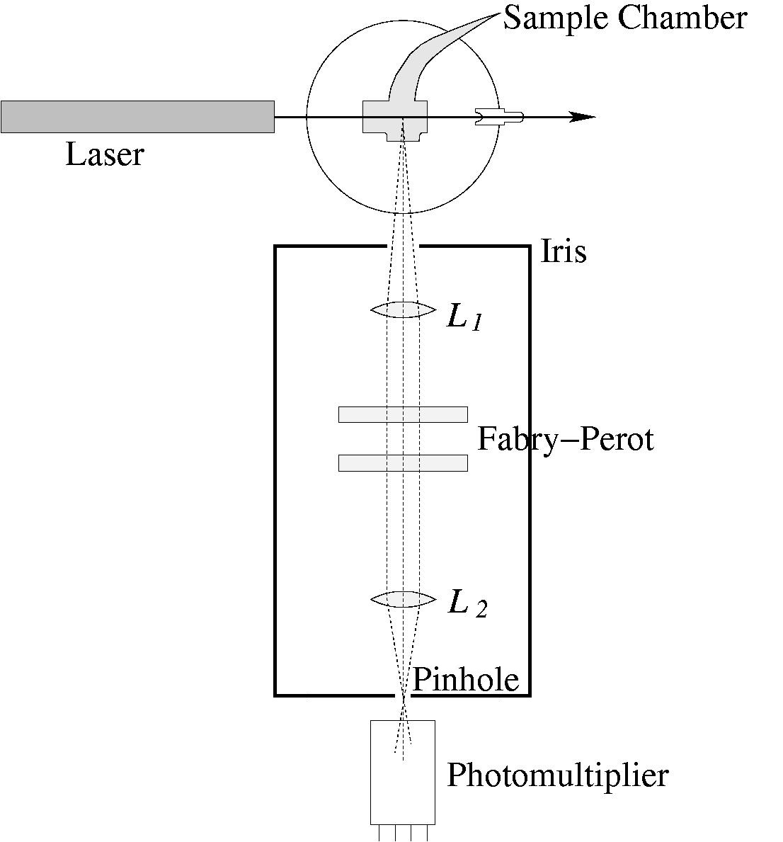

Figure 3. Optical setup for Brillouin scattering.

The major challenge in this experiment is proper alignment of the interferometer and the other optical components. Because the scattered light is very weak the detector is a very light sensitive photomultiplier tube and is easily damaged by strong light. NEVER open the shutter in front of the photomultiplier if the room lights are on, or if the mirror-reflected He-Ne alignment beam is on the pinhole.
Incident light is produced by a Helium-Neon laser. This laser light is monochromatic with a wavelength of λ₀ = 633.0 nm in vacuum (slightly smaller in air). The beam passes through the sample, and a small amount of light is Rayleigh scattered (which can be observed at different angles). The Brillouin scattered light typically cannot be distinguished from the Rayleigh scattered light by eye.
[Safety note: A He Ne laser presents a possible eye hazard. DO NOT LOOK ALONG THE LINE OF PROPAGATION OF THE BEAM. IF YOU MUST OBSERVE THE BEAM DO SO ONLY THROUGH IT’S SCATTERED LIGHT.]
The light scattered from the liquid at right angles to the incident beam passes through a small iris opening. This iris should be closed down to 1.5 cm or less while measurements are being taken. Lens L₁ is positioned so that the scattering point in the liquid is at its focal point. If this is so, scattered light rays passing through L₁ will become collimated. This light now passes through the Fabry-Perot interferometer. The light beam must be normally incident on the interferometer plates. For more information on the Fabry-Perot Interferometer see the separate manual. Light transmitted by the Fabry-Perot passes through lens L₂ and must be focused onto a pinhole in front of the photomultiplier tube. Only light scattered from the illuminated region of the sample is able to pass through the pinhole.

Alignment of the Fabry-Perot Interferometer

Alignment of the Fabry-Perot is critical to achieving high resolution. The two plates for the Fabry-Perot must be parallel to resolve the Brillouin spectrum. One simple suggested setup for aligning the optics is shown in Figure 4. It makes use of a frosted mirror instead of the sample to increase the amount of light in the alignment procedure.
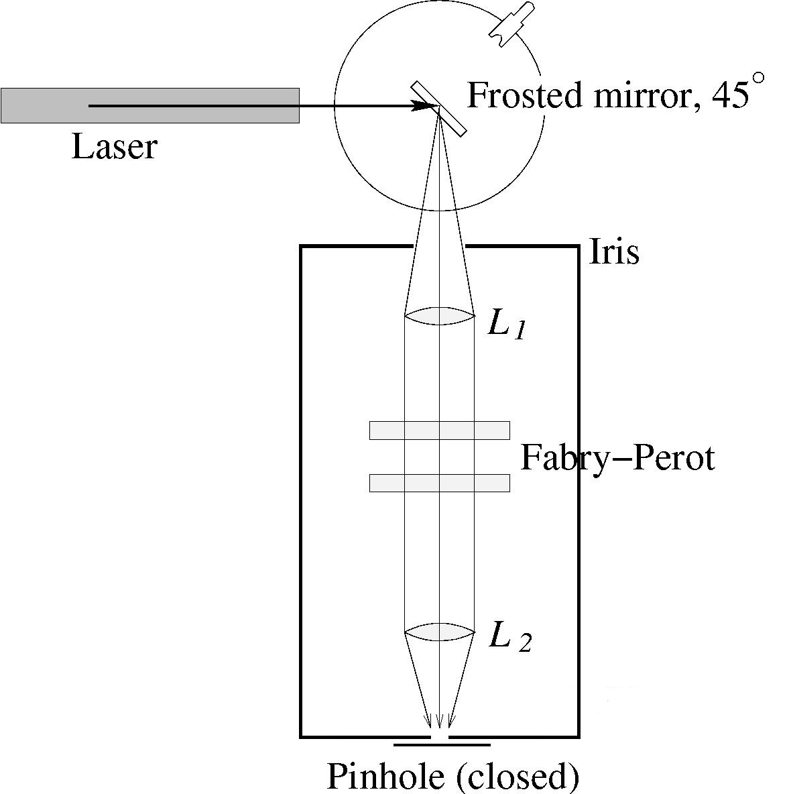

Figure 4. A simple setup for aligning the optics.

Here are some suggested steps to align the Fabry-Perot.

- Align the laser and mirror. Let the laser beam reflect from the silver side of the mirror, turned to approximately 45° so that the reflected light is incident on the pinhole.
- Align the track. Take everything from the track and put up the bar pointer (one that has a sharp tip on the top). The laser beam needs to be centered vertically on the pointer and pinhole everywhere along the track. If necessary adjust the mirror but not adjust the laser during this part of the alignment process.
- Tilt the mirror holder until the beam passes through the same spot above the alignment bar everywhere along the track. Note that the entire beam does NOT have to pass through the pinhole.
- To finalize the pre-alignment, raise or lower the laser so the reflected beam strikes the pinhole. The bubble gauge on the laser must indicate that the laser is level. Also, reduce the iris opening down to a diameter of ≈ 5 mm and ensure that the reflected laser beam passes through its centre.
- Make sure everything is cleared from the track.
- Adjust the collimator lens L₁. Place the lens onto the track at about 15 cm (focal length of lens) from the mirror, and move the lens laterally so the laser beam still hits the pinhole as before. Adjust the lens so it is perpendicular to the incident beam. If L₁ is positioned properly, the emerging beam will be collimated so that it has a constant width on a piece of paper held anywhere between L₁ and the pinhole.
- Adjust the Fabry-Perot. Put the FP and its base plate on the rail; adjust its mirrors (which need to be parallel) to be perpendicular to the laser beam. Check for the following (listed in order):
- Back reflection from FP mirror.
This part of the alignment ensures the FP plates to be perpendicular to incoming light beam. You will need a small piece of paper with a small hole. Put the paper lightly against the far side (FP side) of L₁, allowing the beam to pass through the hole. If the Fabry-Perot is aligned approximately correctly, the reflected light will coincide with the incident light; otherwise it will appear on the piece of paper.
Now turn the mirror so the laser light is incident on the frosted side, mimicking a scattering source; the resulting scattered light will be dim but should still be observed as a set of concentric rings or fringes centred on the pinhole. Widen the iris to 1.5 cm in diameter and turn off the room lights to observe this light.
- Fringe pattern
If you do not see the concentric rings centred on the pinhole, adjust the FP using the knobs that control one of the mirrors. When the spacing between the FP mirrors is ramped, the fringes should appear and disappear around the pinhole.
- Adjust the focusing lens L₂. Put L₂ back on the track so that all the fringes are focused on the pinhole.
- Turn on the heat sink¹ for noise reduction; it is found on top of the rack along with the other electronics.
- Carefully remove the mirror along with its cylindrical base.
- Locate the methyl acetate sample and place it as in Figure 3. Note that you will not be able to see the scattered light feeding through the system because it is quite faint, but it will be detected by the photomultiplier. If necessary increase the iris diameter to 1.5 cm to permit more light to pass to the photomultiplier.
¹This equipment should be on for at least an hour before it is able to reduce noise.

- To conduct the experiment, close the setup box. When you are sure that no excessive light (from inside and outside the lab room) is present, open the shutter of the photomultiplier tube; it’s found behind the pinhole. Turn on the electronic components. Lastly, initiate the data recorder of your choice, chart recorder or LabVIEW. To open LabVIEW, look under Local Disk(C:)→Brillouin Scattering (folder)→Brillouin Scattering (software). For more details, read “Tech Memo on Fabry-Perot Interferometry”.
- To obtain more precise results, use the STACK knobs on the ramp generator that control the reflective mirror on the FP at high precision, and slightly move L₁ and L₂ to obtain fringes that provide better resolution. Note that moving L₁ slightly will provide more widely spaced fringes at L₂; this helps to observe them.
Light Detection and Electronics

The light detection system is shown schematically in Figure 5. The detection system employs a photomultiplier tube (PM). When the high voltage is on, the PM may “burn-out” when overexposed to light. Even after the high voltage is off, the PM will “remember” being exposed to a great deal of light by giving high dark noise for several days. Thus, it is extremely important that the shutter in front of the PM is not opened unless all the room lights are switched off, the room door is closed, and the 45° alignment mirror has been removed.

Photo-multiplier

Preamplifier

Amplifier

Analyser

Rate meter

Chart Recorder/LabVIEW
Figure 5. Schematic of the light detection system.

When biased to 1500 V, the PM produces a small current when weak light is incident on its photocathode. This current (pulse) is first amplified by a preamplifier and then by a main amplifier. The gain on the main amplifier is adjustable using the GAIN controls on the front. The use of the heat sink improves the signal to noise for the PM; it reduces the temperature on the device and therefore decreases the noise.
The amplified current pulse passes to an analyser that accepts or rejects it depending on the amplitude. The threshold level of the analyser can be adjusted. If the incoming pulse is larger than the selected threshold value, the analyser will produce a digital output pulse. If it is lower than the threshold, the analyser will not respond. The analyzer is useful because it can filter out pulses due to electronic noise and PM dark counts (current pulses produced spontaneously by the photomultiplier in the absence of light).
Since the peak PM amplitudes obtained are of the order of hundreds of counts per second when everything is well aligned, it is best to begin by setting the analyzer to give a dark count of approximately 40 counts per second to prevent it from discriminating against most of the scattering signal.
The output of the analyzer is sent to a rate meter. The count rate is registered on a meter and an analog output is provided to drive a chart recorder, or sent as input to recording software. In order to improve the signal to noise ratio there is a TIME CONSTANT setting that allows one to average the signal over different lengths of time. If long time constants are used the signal will be “smooth” but the response time of the detection system to intensity changes will be long. A spectrum is taken by scanning the Fabry-Perot while recording the rate meter output on a chart recorder/LabVIEW.
The ramped voltage for the Fabry-Perot shown in Figure 6 is provided by the RAMP GENERATOR.
Ramp Amplitude
Ramp Length
Figure 6. Ramp Generator Output

The RAMP GENERATOR produces a series of voltage versus time ramps that can be varied in length from a few milliseconds to 16 minutes and in amplitude from 0 to 1000 Volts. The larger the ramp amplitude, the larger the distance the plate moves during one sweep. For larger distances, the FP passes through it free spectral range several times and the spectrum repeats accordingly.
For this experiment, it is best to cover about three free spectral ranges in one sweep. This corresponds to a voltage of ~ 500 V. For good results, a ramp length from 200 to 1000 seconds is best. At shorter ramp lengths the detection system will not respond fast enough to intensity changes when the TIME CONSTANT of the rate meter is long enough to give a good signal to noise ratio. Note, the frequency scale is established by the free spectral range of the interferometer, i.e. by the “distance” between successive repetitions of the spectrum. This is c/2d, where d is the separation of the interferometer plates. You will need to measure d.

Sample Electronics Settings

Power supply: 1500V, Course Gain: 1/16, Fine Gain: 0.8
E: 4.0, ∆E: 0.5, Range CPS: 10³ to x2, Time Constant: 5
Positive signal, Amplitude: 7.5, Sweep rate of 200s.

Goal: Use your working experiment to determine the velocity of sound in both the methyl acetate and carbon tetrachloride samples. Compare with values given in the literature. Conduct an appropriate error analysis.
Appendix I. A Brief Introduction to the Fabry-Perot Interferometer

This appendix gives a brief overview of the theory behind the Plano Fabry-Perot interferometer (FP) used in this lab. It is taken from Section 4 of the technical manual for the Fabry-Perot Interferometer, authored anonymously and not dated, which refers to the Burleigh RC-10, RC-40 and RC-50 interferometers. This helpful manual is available and should be kept near the Brillouin Scattering setup for reference. There are several optics textbooks (such as Optics by Eugene Hecht) that provide a detailed theoretical treatment.
The FP is constructed with two partially transmitting flat mirrors that are parallel to each other. If the FP is illuminated with a beam of coherent, monochromatic light at normal incidence, it will transmit the beam only when the optical path length between the surfaces is an integral number of half wavelengths of the incident light. FPs are capable of extremely high spectral resolution, are extremely efficient, and are spectrally tunable. The actual mirrors used in this FP are two glass disks with partially transmitting coatings on their inner “first” surfaces, which face each other across a gap of air, and antireflection coatings on their “second” surfaces. In each case the second surface is slightly wedged by 0.2 to 0.5 degrees with respect to the first surface to avoid forming additional reflections (see Figure A1). When in use, the parallelism and position of the first surfaces of the two mirrors must be maintained to within λ/200.
α
α=0.2° to 0.5°
d
Figure A1. Plano Fabry-Perot configuration.

Theory

The condition for constructive interference (reinforcement) for a transmitted wave front is
(A1)
where n is the refractive index of the medium between the two reflecting surfaces, d is the mirror spacing, θ is the inclination of the normal of the mirrors to the wave front direction, m is the order of the interference, and λ is the wavelength. In our case, air separates the mirrors, so n=1.0003, or, to a precision of 0.03% we may assume that n=1, which we do for the remainder of this appendix.

The spectral display obtained with a FP is repetitive. Consecutive fringes obtained with quasimonochromatic light correspond to consecutive integer values of the order of interference. The range of wavelengths that can be displayed in the same spectral order without falling into adjacent orders is termed the FREE SPECTRAL RANGE (FSR).
Using plane mirrors separated by a distance d, we have
FSR= λ²/2d (wavelength units) (A2)
or
FSR= πc/d (angular frequency units) (A3)
where c is the speed of light. Figure A2 illustrates the concept of Free Spectral Range by giving the input and output spectra of a Fabry-Perot for fixed etalon separation, d.
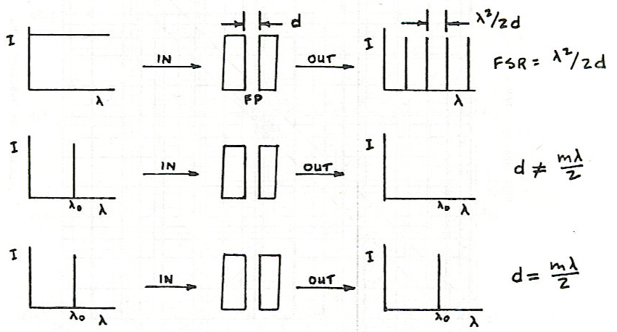
Figure A2. FP outputs for broadband and monochromatic inputs.

