ADVANCED UNDERGRADUATE LABORATORY

C3D

Conductivity In Less Than
Three Dimensions

Revisions:
July 2016: David Bailey
January 2008: David Bailey
2004-05: Jason Harlow
2003: Tetyana Antimirova
Original: David Bailey 2002

Copyright © 2016 University of Toronto
This work is licensed under the Creative Commons
Attribution-NonCommercial-ShareAlike 4.0 Unported License.
(http://creativecommons.org/licenses/by-nc-sa/4.0/) 

Introduction
Any field is constrained by the geometry of the space in which it exists. Measuring such fields allows one to determine a wide range of physical properties: everything from the depth of the local water table to setting limits on the size and existence of extra space-time dimensions.
If a current I is introduced from an external source into the interior of a medium of constant resistivity, the current will flow radially away from the source point. The potential due to this source (relative to the potential at infinite distance) will vary as
()
where R is the distance from the source to the point where the potential is measured. This is the familiar 1/R potential of any non-self-interacting field (e.g. electric, gravitational, acoustic, …) that can fill all space and is generated from a point source. In many systems, such as wires, thin films, or quantum chromodynamic gluon strings, the field is effectively constrained to less than 3 dimensions and the potential no longer follows a 1/R potential. In modern superstring (and related) theories, there are fields that extend in more than 3 space dimensions and they similarly have different radial potential dependences.
Resistivity Surveying is a popular and successful geophysical prospecting method. Electric current is passed into the ground, and the resulting electric potential patterns on the ground are measured, revealing subsurface resistivity variations caused by geological, hydro-geological and manmade variations. Resistivity surveys are used today for groundwater investigations, depth to bedrock measurements, contamination investigations, mineral exploration and archaeology.
In this experiment students investigate electric potential patterns caused by current flow in simple objects. Two suggested objects are a sheet of aluminum foil and a slab of graphite of unknown thickness. By using a power supply capable of delivering 1 Ampere of current, and a DC voltmeter which can sample various points on a surface, various properties of these objects can be measured.

Theory
When direct current flows through a real conducting object, it is generally introduced by a positive and a negative electrode, which are connected to a battery or power supply. While current is steadily flowing through the object, there is a non-zero electric field within the conductor. Note that this is not possible in electrostatics. The electric field at any point within the conductor is related to the current density by:
()
where is the electric field in V∙m⁻¹, is the current density in A∙m⁻² and σ is the conductivity of the object in Ω⁻¹m⁻¹. Or, in terms of the resistivity,
()
where ρ is the resistivity, defined as ρ=1/σ, with units of Ω∙m. The electric field is related to the gradient of the electric potential by:
()
Figure 1 shows the typical dipole potential pattern. Equipotentials are lines or surfaces upon which the electric potential is constant. -fields follow current flow lines, which are everywhere perpendicular to the equipotentials.

Figure 1: A typical equipotential pattern set up by DC current flowing from C₁ (positive) to C₂ (negative). Current flow lines (dashed) follow the Electric Field vectors, which are perpendicular to the equipotentials (solid lines).

Edge Effects
Current flow lines at the boundary between a conductor and an insulator must run parallel to the boundary, since current cannot flow into the insulator. The equipotentials just inside the edges of the conductor must therefore be perpendicular to the edge. This will have effects on the overall patterns of equipotentials within the conductor.

Four-Wire Method
Typically resistivity measurements are done using some configuration of four wires. Two deliver current: C₁ and C₂. Two are used to measure potential difference between various points: P₁ and P₂. There are many ways to arrange these four wires, each with various advantages and disadvantages in resistivity surveys. Two of the most common linear arrangements are the Wenner and Schlumberger arrays. Each sets P₁ and P₂ between C₁ and C₂ along a line connecting C₁ and C₂, as shown in Figure 2.

Figure 2: Electrode configurations used in resistivity surveys: A Wenner array has a=b; a Schlumberger array has b<a/4.

Let the total current flowing from C₁ to C₂ be I, the voltage measured between P₁ and P₂ be V. How can we use these measurements in the above configurations to make resistivity measurements of real or imagined objects?

1-D: Infinite Long, Narrow Strip (wire)

Figure 3. Schlumberger array on a long, narrow rectangular cylinder of cross-sectional area A, e.g. a narrow strip of Al foil.

Consider the theoretical situation depicted in Figure 3. Since the cylinder is narrow, like a long thin wire, we can assume the current flows in a homogeneous manner through it, with current flow lines all parallel to the length of the cylinder. The constant current density between C₁ and C₂ is simply J=I/A. The Electric field can be estimated between P₁ and P₂. From Equation we know that the magnitude of the electric field is equal to the gradient in electric potential. Along the short line of length b between P₁ and P₂ the gradient in electric potential is approximately E=V/b, where V is the measured potential difference. We now may insert these expressions for E and J into Equation to yield:
()
So our estimate for resistivity of the material in the cylinder is:
()

2-D: Infinite Thin Conducting Sheet (foil)
Figure 4. Schlumberger array set up on an infinite sheet of thickness d.

Consider the theoretical situation depicted in Figure 4 for an infinite sheet. The current, I, spreads out away from the positive electrode at C₁ and flows out to infinity. Assuming the sheet has uniform resistivity, the current should spread out evenly, creating concentric circular equipotentials around C₁. The area that this current passes through at each circle is the circumference of the circle times the thickness of the sheet, d, so the current density is J=I/2πrd. Near the points P₁ and P₂, where the voltage is being measured, the current density due to C₁ will be approximately J₁=I₁/2πad (assuming that d <<b<<a). Similarly, a negative electrode at C₂ will contribute an approximate current density J₂=I₂/2πad, so the total current density will be J=J₁+J₂=(I₁+I₂)/2πad. If the same current I flows in at C₁ and out at C₂, then I₁=I₂=I and J= I/πad. Near the points P₁ and P₂, where the voltage is being measured, the current density would be approximately J=I/πad (assuming that b<<a). The magnitude of the electric field in this region is found from the gradient in potential, E=V/b. We now may insert these expressions for E and J into Equation to yield:
()
So our estimate for resistivity of the material in the infinite sheet is:
()
QUESTION: Does this result hold for a very large but finite sheet? One might think it should if the sheet dimensions are much larger than a, b, & d and the probes are far from the edges. But think about this: For an infinite sheet the current flowing in at C₁ can flow out at C₂ or out at infinity, but for a finite sheet the current can only flow out at C₂ unless the edges of the sheet are grounded. The symmetry arguments are unaffected by whether the edges are grounded, but if the current can’t leave at the edges, then at the edges the current flowing out from C₁ must be the same as the current flowing into C₂, so only half as much current will flow for a given voltage. So for a large but finite sheet with ungrounded edges we expect
()
(Note: This is a good point to remind you that you should never assume that the person writing these manuals are always correct, so you will want to convince yourself by your measurements whether equation or , or something in between if the finite sheet is not large enough to ignore edge effects.)

3-D: Infinite Half-Universe Filled with Conductor
Figure 5. Schlumberger array set up on the surface of an infinite half-universe of homogeneous conductor.

Consider the theoretical situation depicted in Figure 5. The current, I, spreads downward away from the positive electrode at C₁. Assuming the current spreads out evenly, there will be concentric hemispherical equipotentials centered on C₁, descending into the conductor. The area that this current passes through at a distance r from C₁ is the area of the hemisphere, so the current density is J=I/2πr². Following the same arguments as for the infinite sheet, our estimate for resistivity of the material in a very large but finite half-universe conductor will be
$ρ=\frac{2{πa}^{2}V}{\text{bI}}$ ()
Once again, you may want to think about how this result may differ between “infinite” and “very large” conductors, and the possible boundary conditions for the latter.

Two-Layer Models
Figure 6. Wenner array set up on a two-layer conductor. The top layer has resistivity ρ₁ and depth, d. The bottom layer has resistivity ρ₂ and infinite depth.

Where rocks and soils occur in more or less horizontal layers and the layers have differing electrical resistivities, resistivity surveying may be used to find the depths and resistivities of the various layers. One simple model is the “two-layer Earth”, in which the top layer has resistivity ρ₁ and depth d, and the layer just below it has resistivity ρ₂ and infinite depth. Numerical methods can be used to compare observations with such a model.
Theoretical master curves have been computed for the situation shown in Figure 6. Current and potential electrodes are arranged in a Wenner Array. Equation , derived for an infinite half-universe, can be used with b=a to yield an equation for “apparent resistivity”, ρ_{a}:
$ρ_{a}=\frac{2π\text{aV}}{I}$ ()
If the lower layer is more resistive than the upper layer, more current flows in the upper layer than for a uniform earth, thereby increasing the measured voltage. The apparent resistivity will be greater than ρ₁. If the lower layer is less resistive than the upper layer, more current flows in the lower layer, reducing the measured voltage at the surface. The apparent resistivity will be less than ρ₁.
For best results, the array spacing must be varied over a wide range. If a is much smaller than the depth d, then the bottom layer will have very little effect on the measured resistivity. Thus ρ_{a}≈ ρ₁ when a<<d. As a is increased, one can plot ρ_{a} versus a, and more is learned about the depth, d, and the resistivity of the lower layer. See Appendix 1 for a description of the curve-matching method often used in exploring the two-layer model; Orellana 1966 or Mooney 1956 may also be useful references.

Safety Reminders
- Treat the 1 A constant current supply with respect: a 100 mA current can kill you and 10 mA can cause a painful shock. The reason this supply it is not lethal is because you are protected by your skin, but you can still be shocked if you are careless or silly, so keep reading.
- The internal resistance of the human body is typically a few hundred ohms – depending on the path – so applying 20 V internally can generate lethal several hundred mA currents.
- The resistance of human skin is typically 10⁵ Ω, so for the maximum voltage of the power supply of 20 V, the maximum current through your body should typically be less than ~0.1 mA, unless the skin resistance is reduced or bypassed.
- Do not touch the experiment if your hands are wet! The resistance of wet skin can be as low as ~1000 Ω, which could allow the constant current supply to generate painful shocks.
- Never touch more than one probe at a time. Electricians sometimes work on electrical equipment with only one hand and put the other hand in their pocket to prevent any unexpected currents flowing from one hand to the other across their chests and stopping their heart.
- Touching the current probes to your tongue will produce a very painful shock that could cause permanent damage, a grade of zero for the experiment, and possible expulsion from the course.
- Do not stab the current probes through your skin. This could kill you and the resulting posthumous Darwin Award (http://www.darwinawards.com/darwin/darwin1999-50.html) would embarrass your family, friends, and teachers.
- Don’t do any other silly things with the apparatus.
NOTE: This is not a complete list of all hazards; we cannot warn against every possible dangerous stupidity, e.g. opening plugged-in electrical equipment, juggling cryostats, …. Experimenters must constantly use common sense to assess and avoid risks, e.g. if you spill liquid on the floor it will become slippery, sharp edges may cut you, …. If you are unsure whether something is safe, ask the supervising professor, the lab technologist, or the lab coordinator. If an accident or incident happens, you must let us know. More safety information is available at http://www.ehs.utoronto.ca/resources.htm.

Experiment
Two current and two voltage electrodes are provided. The power supply for the current electrodes provides a constant current with a maximum voltage of 20V. First make a thin (i.e. one-dimensional) strip of aluminum foil and measure its resistivity to confirm that everything is working well.
The two suggested objects you may then measure are a sheet of aluminum foil and a large graphite table. The graphite table consists of a slab of unknown thickness with air underneath. Here are some questions you may address.
- Calculate the resistivity of the aluminum foil from your sheet measurements. Does this value agree with the value from the thin strip, and does it agree with the literature value, e.g. see NDT 2002.
- What are the patterns of equipotentials? Are they what you would expect for a dipole current source?
- How are the patterns affected near the edges of the conductor? Are equipotentials indeed perpendicular to the edges as expected from the theoretical boundary conditions?
- Measure the resistivity and depth of the graphite slab, using the curve-matching method. Compare with literature values for graphite conductivity, e.g. Deprez 1988.
- How does the electric potential vary along a radial line near one of the current-carrying electrodes? Is the functional dependence of V versus r what you would expect?
- When the current electrodes are set up near the edge of the conductor, does this change the functional dependence of V versus r near the electrodes? Would you expect it to? How do the edges affect the curve-matching method, which assumes you have two layers of infinite size?
- Can you figure a way to make measurements with the edges of the sheet or slab “grounded”. Consult with the supervising professor before doing anything with the graphite slab, to be sure you won’t damage it.
- Can you understand the properties of conducting objects with other shapes or composition?

Bibliography
N. Deprez and D.S. McLachlan, The analysis of the electrical conductivity of graphite powders during compaction, Journal of Physics D: Applied Physics 21 (1988) 101-107; http://iopscience.iop.org/article/10.1088/0022-3727/21/1/015.
H.M. Mooney and W.W. Wetzel, The Potentials About a Point Electrode and Apparent Resistivity Curves for a 2, 3 and 4-layered Earth, University of Minnesota Press, 1956
NDT Education Collaboration, Conductivity and Resistivity Values for Aluminum & Alloys, March 2002;
https://www.nde-ed.org/GeneralResources/MaterialProperties/ET/Conductivity_Al.pdf.
E. Orellana and H.M. Mooney, Master Tables and Curves for Vertical Electrical Sounding (VES) Over Layered Structures, Madrid Interciecia 1966, QC809 .E15 O7 (Physics Library Reference).

Appendix 1: The curve matching method
The interpretation of a Wenner sounding using a curve matching method requires logarithmic plotting for both apparent resistivity ρ_{a} and spacing a. When both the observed and theoretical curves are plotted on the same type of logarithmic paper, the effect of scale is eliminated while curve shape is maintained. Once a satisfactory match between the observed and theoretical curves is obtained, parameters like the resistivities ρ₁ and ρ₂ and the thickness d, of the best fitting model can be determined. We plot the apparent resistivity (vertical axis) calculated from the observations as 2πaV/I against the spacing a (horizontal axis). The set of theoretical master curves for the Wenner array is shown at Figure 7. The individual curves are described in terms of a reflection coefficient κ given by
()
which has maximum and minimum values of +1 and -1.
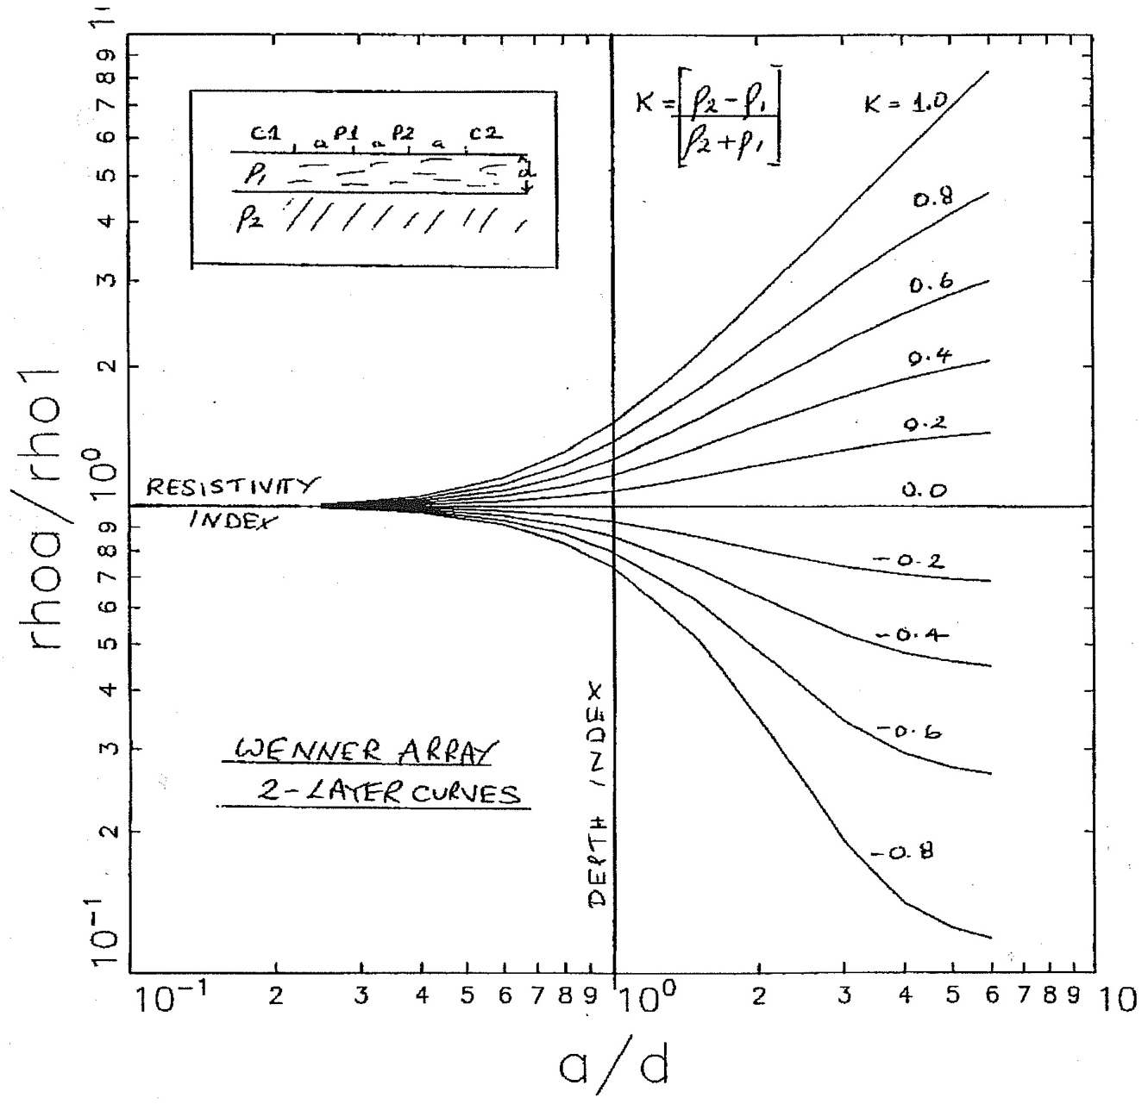
Figure 7. Set of theoretical master curves for the Wenner array.

We ignore higher-order or strong-field self-interaction effects that are usually unimportant in everyday measurements..

