DEVELOPMENT OF THE LARMOR CONDITION

Let S′ be a frame of reference rotating with respect to the laboratory frame S with an angular velocity represented by the vector$\vec{ω}$.
According to the general law of relative motion, the time derivative $\frac{\text{d \{}\vec{A}}{\text{d t}}$of any time

dependent vector$\vec{A}(t)$ computed in the laboratory frame S, and its derivative$\frac{δ\vec{A}}{δ\text{ t}}$ computed in the

moving frame S′ are related through
$\frac{\text{d \{}\vec{A}}{\text{d t}}\text{ = }\frac{δ\vec{A}}{δt}\text{ + \{}\vec{ω}\text{ x \{}\vec{A}$ (I1)
In particular if we consider the vector angular momentum$\vec{I}$, then by replacing $\vec{A}\text{ by \{}\vec{I}$
in equation (I1) we have
$\frac{\text{d \{}\vec{I}}{\text{dt}}\text{ = }\frac{δ\vec{I}}{δt}\text{ + \{}\vec{ω}\text{ x \{}\vec{I}$ (I2)
which rearranges to
$\frac{δ\vec{I}}{δt}\text{ = }\frac{\text{d \{}\vec{I}}{\text{d t}}\text{ + \{}\vec{I}\text{ x \{}\vec{ω}$ (I3)
An expression for$\frac{\text{d \{}\vec{I}}{\text{d t}}$ is now determined. From elementary electromagnetic theory the torque $\vec{τ}$
on a magnetic moment in a magnetic field${\vec{B}}_{o}$ is given by
$τ\text{ = \{}\vec{μ}\text{ x }{\vec{B}}_{o}$ (I4)
Since
$\vec{τ}\text{ = }\frac{\text{d \{}\vec{I}}{\text{d t}}$ (I5)
then
$\frac{\text{d \{}\vec{I}}{\text{d t}}\text{ = \{}\vec{μ}\text{ x }{\vec{B}}_{o}$ (I6)
and substituting for$\vec{μ}$ using equation (1) this gives
$\frac{\text{d \{}\vec{I}}{\text{d t}}\text{ = }γ\vec{I}\text{ x }{\vec{B}}_{o}$ (I7)
Substituting equation (I7) into equation (I3) gives
$\frac{δ\vec{I}}{δt}\text{ = }γ\vec{I}\text{ x }{\vec{B}}_{o}\text{ + \{}\vec{I}\text{ x \{}\vec{ω}$ (I8)
or
$\frac{δ\vec{I}}{δt}\text{ = }γ\vec{I}\text{ x }\left({\vec{B}}_{o}\text{ + }\frac{\vec{ω}}{γ}\right)$ (I9)
By comparing (I9) to (I7) it follows that in the rotating frame, the effective field which is seen is
${\vec{B}}_{e}\text{ = }{\vec{B}}_{o}\text{ + }\frac{\vec{ω}}{γ}$ (I10)
If the rotating frame has an angular velocity such that
${\vec{B}}_{o}\text{ = -}\frac{\vec{ω}}{γ}$ (I11)
then the effective field in the rotating frame is zero. Also$\frac{δ\vec{I}}{δt}\text{ = 0}$ and so$\vec{I}$ is a fixed vector in the
rotating system. This means that in the laboratory frame,$\vec{I}$ precesses about ${\vec{B}}_{o}$ with a frequency
${\vec{ω}}_{L}\text{ = - }γ{\vec{B}}_{o}$ (I12)
where ⏐ω_{L}⏐ is called the LARMOR FREQUENCY.
In summary, in a magnetic field, the angular momentum$\vec{I}$ and the magnetic moment$\vec{μ}$ precess at the Larmor frequency given by equation (I12), and when a frame of reference is rotating at the Larmor frequency the magnetic field (which gave rise to the precession at the Larmor frequency) is zero in the rotating reference frame.

EFFECT OF ROTATING FIELDS ON TRANSITIONS

We will continue to use the notation of Appendix I so that${\vec{B}}_{o}$ is the static field in S. The linearly polarized field${\vec{B}}_{1}$ in S gives rise to a constant field${\vec{B}}_{1}$ along the x axis in S′ and it rotates with S′ about$\hat{k}(\text{or }{\vec{B}}_{o})$ in S at a rate ω.
The total field ${\vec{B}}_{e}$, which is shown in figure II1, is static in S′ and is given by
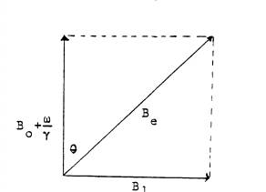
${\vec{B}}_{e}\text{ = }\left(B_{o}\text{ + }\frac{ω}{γ}\right)\hat{k}\text{ + }B_{1}\hat{i}\text{.}$ (II1)
The unit vectors î and $\hat{k}$ are in S, and the$\hat{k}$ component is zero for the Larmor frequency as was shown in Appendix I.

Figure II1: Effective Field in the Rotating Frame of Reference.

The angle θ between${\vec{B}}_{e}\text{ and }{\vec{B}}_{o}$ is given by
$\text{tan}θ\text{ = }\frac{B_{1}}{B_{o}\text{ + }\frac{ω}{γ}}\text{ = }\frac{−γB_{1}}{−γB_{o}\text{ - }ω}$ (II2)
where ω is the rate of precession of ${\vec{B}}_{1}$ about ${\vec{B}}_{o}$. Using equation (I12) and the analog for ω₁
ω₁ = -γB₁ (II3)
equation (II2) becomes
$\text{tan}θ\text{ = }\frac{ω_{1}}{ω_{L}\text{ - }ω}$ (II4)
From this equaiton θ is never large or the effect of B₁ is negligible unless ω ≈ ω_{L} or ω_{L} - ω ≈ ω₁. The width of the resonance, that is, the value of the difference ⏐ω - ω_{L}⏐ below which the effect is appreciable is of the order of ω₁. You should be able to show that${\vec{B}}_{1}$ is of the order of 15 gauss and hence you can calculate the magnitude of ω₁ as a fraction of ω_{L} for this experiment.
If a linearly polarized field is composed of two components, one rotating with angular frequency of ω, then the other has an angular frequency of -ω. At resonance, for one component ω = ω_{L} and for the second ω = -ω_{L}. For the second component
$\text{tan}θ\text{ = }\frac{ω_{1}}{2ω_{L}}$ (II 5)
and hence θ ≈ 0 because ω₁ << ω_{L}. Thus absorption of power is due only to the component where ω = ω_{L}.

GaAs GUNN DIODES

The discovery that microwaves could be generated by applying a steady voltage across a crystal of gallium arsenide was made in 1963 by J.B. Gunn. The Gunn diode is not a diode in the sense that it is junction since it is bulk property device but only in the sense that it is a two port device. The brief description of Gunn diodes given here can be supplemented with material from books like Bulman, Hobson, Shurmer or Streetman.

The Gunn Effect Mechanism
The band structure for GaAs is given in figure III-1.

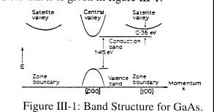

The mechanism responsible for the Gunn effect, sometimes called the "transferred electron mechanism", is that of transfer of electrons from the lowest valley in the conduction band to valleys of higher energy where the mobility is less, leading to negative differential resistivity and travelling domains of high electric field within the semiconductor.
The first effect of applying an increasing electric field across a specimen of gallium arsenide is to increase the energy and momentum of electrons in the central valley. When the field is high enough for electrons to gain an energy of 0.36 eV they may remain in the central valley, but most of them will transfer to a satellite valley in which the density of states is high and the effective mass of the electron is very large. The associated momentum change is produced by longitudinal optical phonons. As a result, the electron mobility falls by a factor of 50 times, and this accounts for the region of negative differential conductivity indicated in figure III-2.

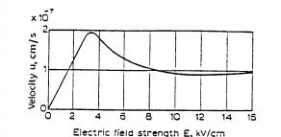

Figure III-2: Average Electron Velocity vs Field Strength for GaAs.

The threshold for negative differential conductivity varies with material and is typically 3000 V/cm for GaAs. If the GaAs is biased so that the field falls in the negative conductivity region, then if there is an increase in electric field due to a random fluctuation of charge as the current is drifting, the mobility of the electrons will decrease in the region of the increased field. Electrons ahead will move away and electrons behind will pile up. This space charge fluctuation which usually forms near the cathode and builds up exponentially is called a Gunn domain. The drifting domain reaches the anode where it gives up its energy as a pulse of current.

Modes of Operation of Gunn Diodes
The Gunn diode can be operated in a number of different modes. The simple drift of stable domains or transit time mode results in a current waveform composed of a series of spikes which appear with a frequency equal to the inverse transit time, v_{s}/L. This mode, although easy to understand and usually the first to be discussed in texts is not appropriate for efficient conversion of D.C. to microwave power because of the narrowness of the current pulses. It is also not useful for applications requiring frequency control of the Gunn oscillator since the frequency is determined by the transit time of the domains.
There are several modes of operation in which the transit time of space charge and domains through the device is not the frequency control. Frequency control is obtained by placing the Gunn diode in an external high Q resonant cavity such as that shown in figure III-3 so that the circuit reacts on the Gunn effect device and impresses a sinusoidal voltage waveform on the D.C. bias as is shown in figure III-4. We shall discuss the most important modes, the delayed domain mode, the quenched domain mode, the limited space charge accumulation (LSA) mode and the hybrid mode.
For the delayed domain mode, the Q factor of the resonant circuit and the impedance Z_{L} of the load must be large enough so that the sinusoidal

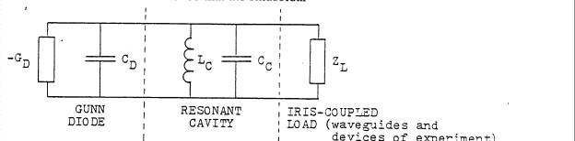

-G_{D} = negative conductance of the Gunn diode
C_{D} = parasitic capicitance of the Gunn diode
L_{C} = inductance of the resonant cavity
C_{C} = capacitance of the resonant cavity
Z_{L} = load impedance

Figure III-3: Equivalent Circuit of a Gunn Oscillator.
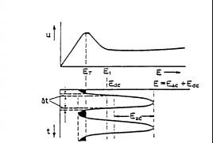

Figure III-4: A.C. Voltage Impressed on the D.C. Bias of a Gunn Diode.

voltage waveform amplitude at the device terminals is large enough to cause the voltage to fall below threshold E_{T} over a portion of each cycle. The domain transit time must be less than the resonant period of the circuit so that the domain may disappear into the anode while the voltage is below threshold. The next domain is not nucleated until the voltage once more rises above threshold. The formation of domains is thus controlled by the resonant period of the circuit and this is the big advantage of this mode over the transit time mode.
In the quenched domain mode, the impedance Z_{L} is still larger and the alternating field created within the specimen by the external circuit will be large enough to drive the net field below a minimum sustaining value while the domain is in transit and thus cause the domain to be extinguished. The next domain will be nucleated when the terminal voltage again rises through threshold. The difference between this mode and the delayed domain mode is that in the quenched domain mode, frequencies higher than the transit time frequency can be generated.
In any mode where domains are formed there will be very high electric fields in the region of the domain. This can cause impact ionization and breakdown and result in destruction of the device. To prevent this, only small voltages may be applied across the device and this will result in low power output. Also, in modes where the transit time is important for frequency control, the physical size of the device must be kept small and this too will limit output power of the device.
In the limited space charge accumulation (LSA) mode one does not allow domains to form and so higher terminal voltages (giving higher rf power output) may be applied to the device without causing impact ionization. Also, the device length is not related to the frequency and may be many times the distance electrons would drift during one period at the operating frequency. In these devices which are sometimes called overlength devices, the output power depends directly on the material volume.
Domains do not form instantaneously but in a time called the dielectric relaxation time which depends on the differential mobility of the electrons. In order that domains do not form, the time δt which is spent during one oscillation in the region between E_{T} and E₁ in figure III-4 must be small compared with the average negative dielectric relaxation time between E_{T} and E₁. As the electric field rises above threshold and into the region between E_{T} and E₁, space charge inhomogeneities begin to form. Before they have grown to a significant size, the electric field must become large enough for the instantaneous negative differential mobility to fall to a very low value. Thus, space charge perturbation can be limited to a very small value if the dielectric relaxation time, averaged over the time that electric field exceeds threshold, is greater than the rf period. Also, the time spent below threshold during each cycle (shaded areas) must be long enough for dissipation of the space charge growth which occurs when the voltage swings above threshold. Another way of saying this is to say that in order to avoid successive build up of small amounts of space charge over many cycles, it is necessary for the positive differential mobility damping to exceed the negative differential mobility growth.
Although LSA devices have high output power they are difficult to fabricate. The doping of the sample and the design of the frequency controlling cavity are critical if the conditions mentioned in the paragraph above are to be met. In addition, the internal homogeneity of the low field conductivity must be better than about 10 per cent to avoid internal injection of significant dipolar space charge.

Hybrid mode devices, which are similar to LSA mode devices have less strigent conditions to fulfill and are easier to fabricate. When doping is not uniform enough for LSA operation the space charge growth during one cycle, when terminal voltage exceeds threshold, is sufficient for dipolar domains to form incipiently. The growth does not proceed to the quasi-static domain equilibrium inherent in the quenched domain mode, and operation has partly an LSA and partly a quenched domain character. As the terminal voltage falls below threshold, dipolar space charge begins to dissipate but it is not completely quenched before the voltage again rises through threshold. Accordingly, it again grows into an incipient domain during the next cycle of operation. If the device is sufficiently long, it will contain multiple domains, each of the same size but separated spatially by the transit distance per cycle. The dipolar space charge is eventually quenched as it enters the anode. The presence of the domains causes the current to be less than it would be in the LSA operation and thus the efficiency of hybrid operation is less than that of LSA operation but greater than that of quenched mode devices. The presence of multiple domains in the hybrid device means that the peak electric field is less than in a quenched domain device where there is a single domain. Thus the likelihood of avalance breakdown is less, or alternatively the device can be operated at higher bias voltages to generate more power.

Fabrication and Device Construction
The active region of the Gunn diode where there is negative resistance and in which domains may form is composed of n-active GaAs in which the dopant is commonly Sn, Se or Te. Diodes can be made from slices of a bulk single crystal from a melt but all useful devices are made from epitaxial GaAs. Epitaxy or epitaxial growth is the technique of growing an oriented single crystal layer on a single crystal substrate. Liquid phase epitaxy, vapour phase epitaxy and molecular beam epitaxy are various techniques of epitaxial growth.
A typical epitaxial Gunn diode structure is shown in figure III-5. The starting point is a heavily doped substrate of bulk grown single crystal GaAs to define the single crystal growth and to give mechanical strength to the thin active region of the device. When designating relative doping
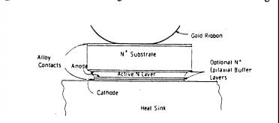

Figure III-5: Typical Epitaxial Gunn Diode Structure.

concentrations on diagrams of devices such as in figure III-5, it is common to use + and - symbols. Thus a heavily doped (low resistivity) n-type layer would be referred to as n⁺ material. It has become common practice to grow an epitaxial "buffer" layer of highly doped n⁺ material on the highly doped substrate in order to reduce propagation of crystal defects and diffusion of impurities from the substrate into the active region of the device. Metallic contacts are often made onto low resistivity n⁺ epitaxial "buffer" layers.
The active region is epitaxially grown with the doping a couple of orders of magnitude less than in the substrate. Doping concentrations vary depending on the application but are typically 2 × 10¹⁵ cm⁻³ for X band microwave devices. The length of the active region is typically 10μm and one can see that the critcial field is reached for an applied voltage of 3 volts. The product of doping concentration, times the device length for this typical device is 2 × 10¹² cm⁻² and that value is typical of practical continuous wave devices. The mode of operation for these typical parameters is a mixture of several of the previous mentioned modes. The relative proportion of each mode depends quite sensitively on the bias voltage, the conductivity uniformity and the circuit loading.

The physical construction of the Gunn diode is shown in figure III-6. The overall geometry is roughly 200 μm square with a length of 10μm. It is in a package of less than 1 mm³ which is mounted on a 3-48 screw. The whole package is a couple of mm in diameter and less than a half a centimeter long. The mounting of the Gunn diode at the end of a post in the centre of the resonant cavity allows electric field oscillations within the Gunn diode to excite a particular TE resonant mode in the cavity. The most likely resonant mode can be deduced by the physical location of the post and Gunn diode. The diode waveguide circuit shown in figure III-6 does not show the varactor diode which is used for frequency tuning.

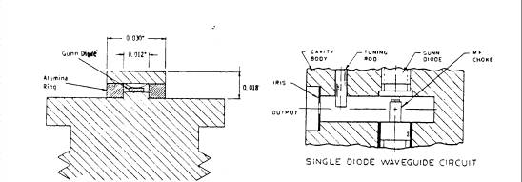

Figure III-6: Physical Construction of a Typical Gunn Diode.

Frequency Control With a Varactor Diode
The resonant cavity capacitance, C_{C}, may be varied with a variable capacitance (varactor) diode to give frequency control over the microwave oscillations. The term varactor is a shortened from of variable reactor, referring to the voltage variable capacitance of a reverse biased p-n junction. The varactor diode is also made of properly doped GaAs and is fabricated from liquid phase, expitaxially grown p-n junctions much in the same way that the Gunn diode is made. The mechanical mounting and electrical connections are similar to that of the Gunn diode as well. As is shown in figure III-7,
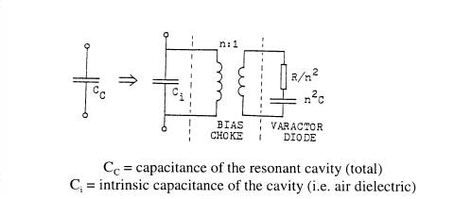

Figure III-7: Coupling of the Varactor Diode to the Cavity Capacitance.

the varactor diode is on the end of a bias choke (which isolates the rf and provides the D.C. bias) and it is inserted into the resonant cavity much as the quartz tube is inserted into the sample cavity in this experiment. The capacitance of the junction is of the order of 1 pF and it varies roughly as V^{-1/2} where V is the D.C. bias. This means that the resonant frequency of the Gunn oscillations may be varied by varying the D.C. bias to the varactor diode.

The Varian VSX-9011-ND Gunn Effect Oscillator
A test performance sheet for the VSX-9011-ND is given in figure III-8. For a fixed operating voltage (bias voltage) the oscillator may be electrically tuned by varying the varactor voltage. The frequency increases by about 0.005 GHz per volt. A suitable operating bias voltage is 9.5 V. The frequency also depends on the bias voltage and will decrease if the bias voltage is lowered. All voltages should be applied slowly from zero. In the VSX-9011-ND there is a mechanical tuning rod but it should never be adjusted.
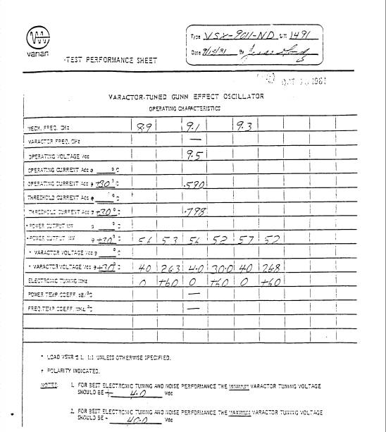

Figure III-8: Test Performance Sheet for the VSX-9011-ND Oscillator.

SPECIFICATIONS FOR THE MODEL X532B WAVEMETER

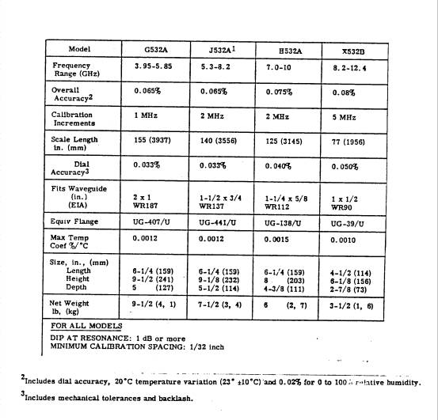

OPERATION OF THE BELL 620 GAUSSMETER

FRONT PANEL CONTROLS

Full Scale Range
Instrument covers the range from 0.1 gauss to 39K gauss.

Probe Zero (Fine and Coarse)
Zeroing controls to provide zero output in the absence of a magnetic field. See Zeroing Procedure.

a. NOR - normal position

b. REV - for measuring fields with reverse polarity

c. A.C. - for measuring A.C. fields

d. CAL - position for checking internal calibration. See Calibration Procedure.

e. BATT - battery test position if internal battery is used.

CAL TO 1.0
Potentiometer for calibration. See Calibration Procedure.

Output Jacks
- accepts standard banana plugs
- back jack is grounded to case
- red jack gives positive output voltage proportional to the full scale field for upscale readings (negative for below zero readings)
- output voltage 1.0 V D.C. full scale
- source impedance 1 KΩ
- main A.C. field frequency 400 Hz

Normal Operating Procedure
Turn the FULL SCALE RANGE switch to 30 K. Turn the function switch to NOR and turn on the power. Place the probe in the field to be measured and reduce the range until there is a meter indication. If the meter reads less than zero, turn the probe head through 180° or turn the function switch to REV

Zeroing Procedure
Insert the probe into the zero gauss chamber accessory (mu metal can). Rotate the RANGE switch counter clockwise until a reading is obtained on the meter. Adjust the ten turn COARSE control to bring the reading near zero while reducing the RANGE setting. Below the 1 gauss range, the FINE control may be used for better resolution of zero adjustment.

NOTE: Before removing the probe from the zero gauss chamber, turn the RANGE switch up to at least 1 to avoid off scale readings due to the earth's magnetic field.

Zeroing controls may also be used to suppress small residual fields up to approximately 30 gauss.

Calibration Procedure
Although the instrument is well calibrated, this adjustment should be made when very accurate readings are required.

After the instrument and probe have warmed up (5 min.), set the RANGE switch to the 30K range and the FUNCTION switch to CAL. Adjust the CAL screwdriver adjustment to obtain a full scale (1.0) meter reading, or, if a voltmeter is connected to the output jacks, a 1.0 V reading.

The internal calibration procedure is referenced to a standard NMR magnet traceable to the National Bureau of Standards.

Meter Tracking Error
For a D.C. field meter readout: ±1% of full scale.
For an A.C. field meter readout 10 to 400 Hz: ±2% of full scale.

Accuracy
The accuracy is limited by the sum of the internal calibration error, the linearity of the probe and meter scale errors for meter readout.

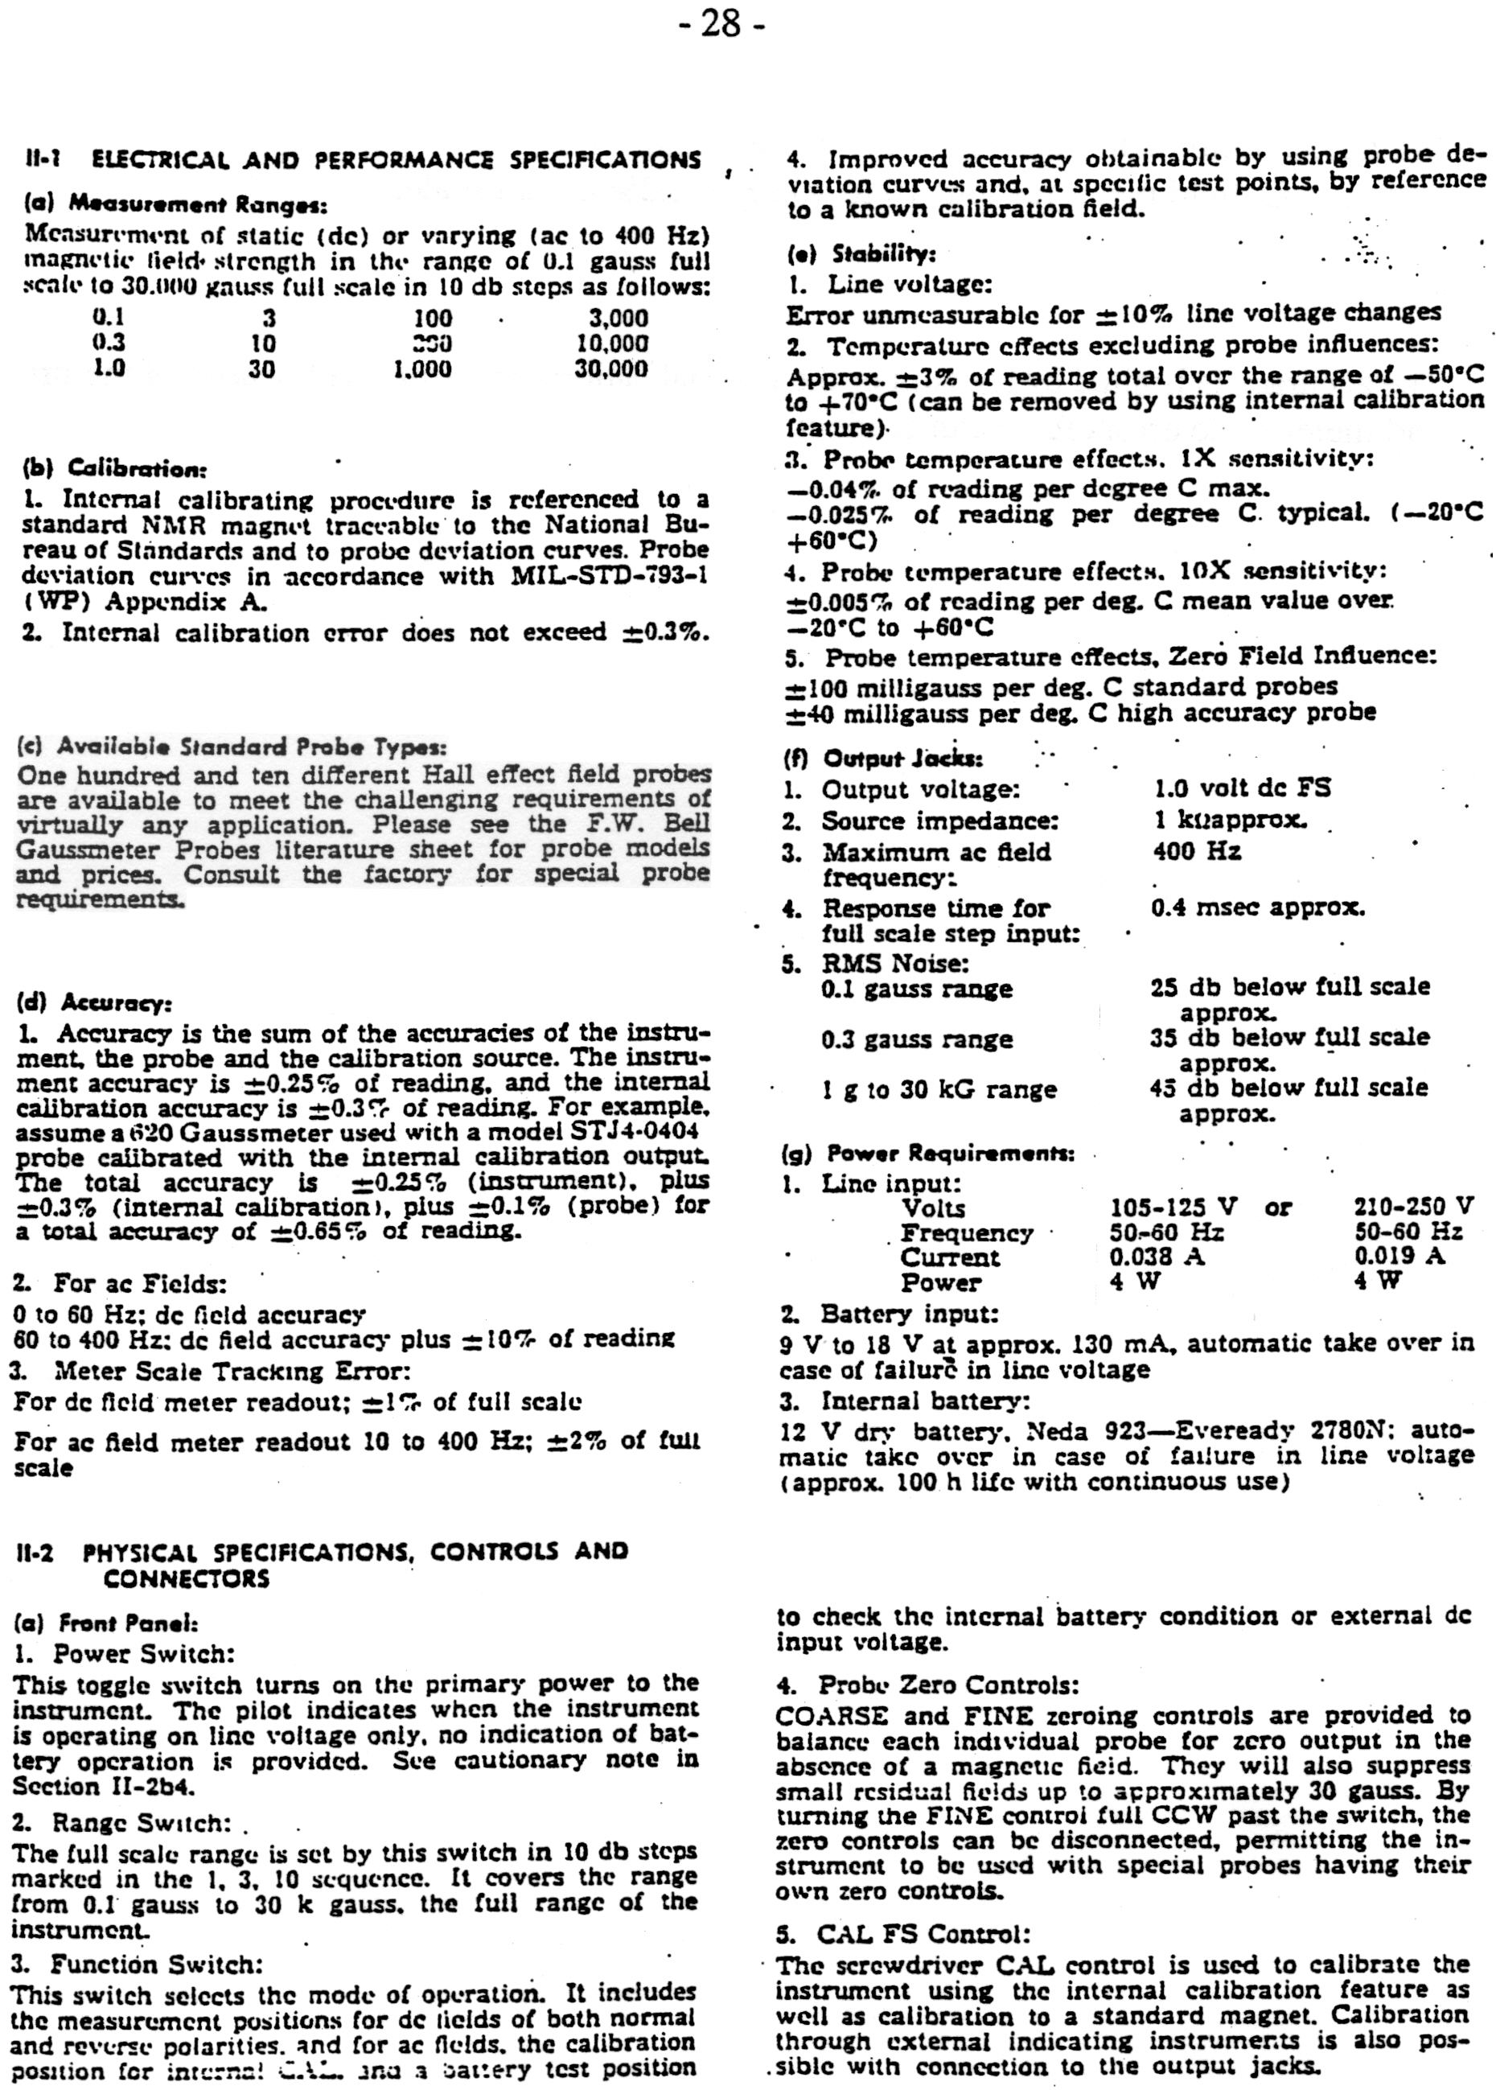

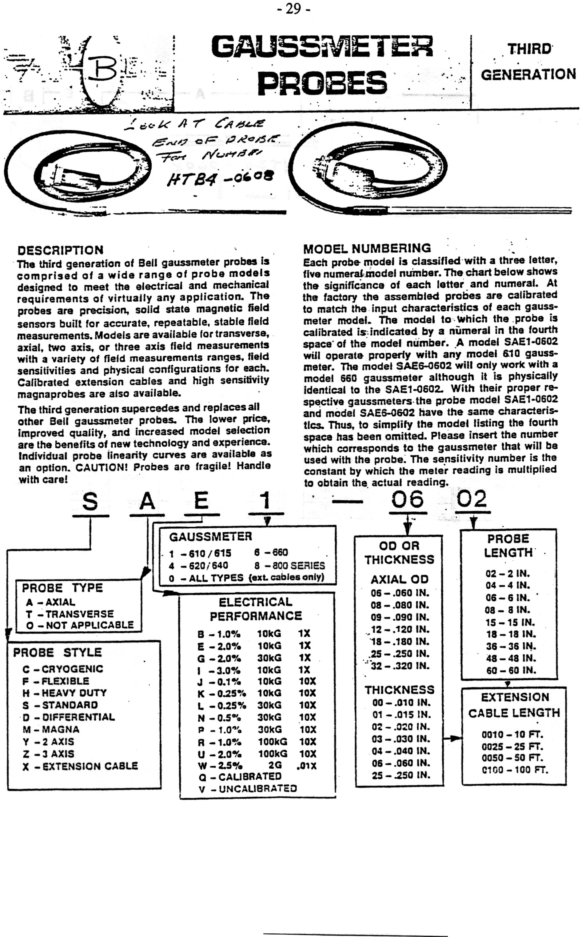

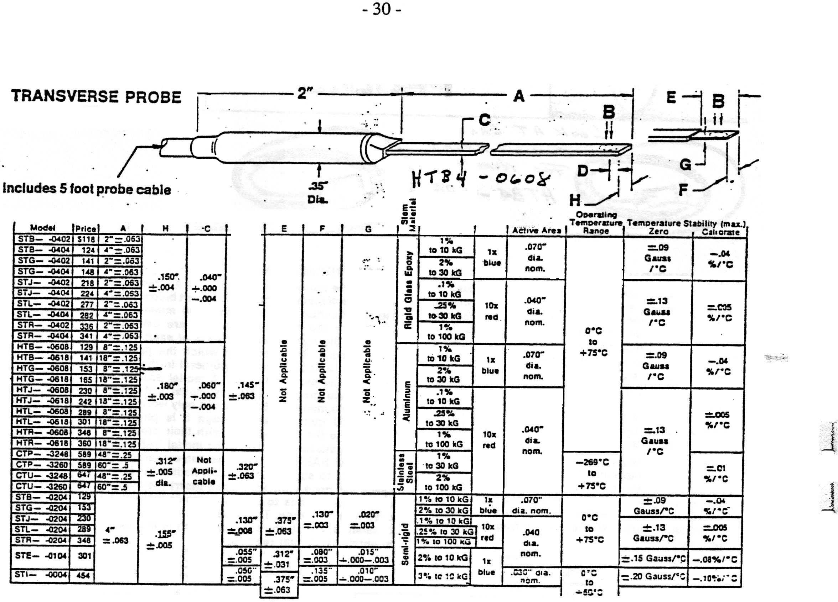

APPENDIX VI

THE RESONANCE ISOLATOR

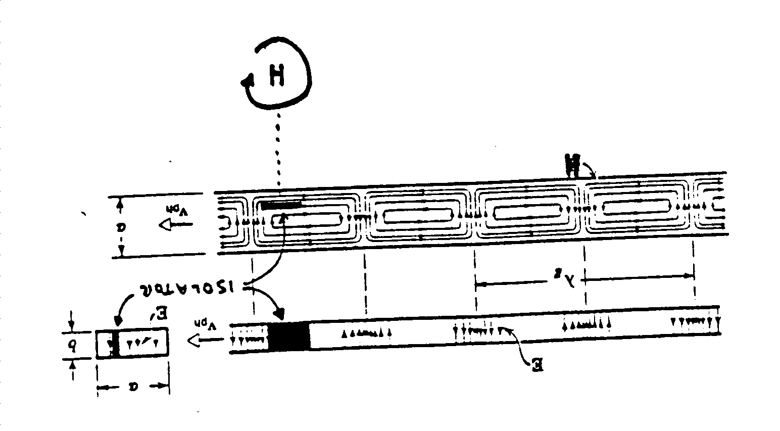

Figure VI-1: Wave Guide Cross Sections Showing the Position of the Ferrite Slab.

The explanation of absorption in the resonance isolator is quite similar to the explanation for absorption in the cavity.

The isolator consists of a ferrite slab with step shaped pieces of dielectric at the ends for matching purposes. The ferrite slab sits in a field of 0.2 to 0.3 tesla produced by a permanent magnet and the electrons in the ferrite precess at microwave frequencies.

It can be seen from figure VI-1, that at the position of the ferrite slab, the magnetic field due to the microwaves rotates with uniform amplitude. If the sense and frequency of rotation of the magnetic field is the same as the precession of the electrons in the field of the permanent magnet, then absorption of the microwaves will result. For microwaves travelling in the opposite direction, the rotation of the microwave magnetic field at the position of the ferrite slab is in the opposite sense and no absorption will take place.

The magnetic field due to the permanent magnet is normal to the paper and it is left to the student to determine the exact direction so that microwaves travelling to the right will be transmitted while those travelling to the left will be absorbed. Conclusions should be checked empirically since one knows from the apparatus the direction of the permanent magnetic field and the direction of travel for the transmitted waves.

We follow here the development of Abragam p19.
For a proof of equation (I1) see for example Symon p 271.

