ADVANCED UNDERGRADUATE LABORATORY

EXPERIMENT 32, FILM

Thin Film Interference

References updated by Barbara Chu, August 2006
Revision: March 2006 by Yi Chai
Original By: Jason Harlow, 2006

1. Introduction
The interference of reflected waves of light from transparent layers of material is responsible for many beautiful phenomena in nature, such as butterfly wings, peacock feathers and soap bubbles. Multiple layers of thin transparent films with various indices of refraction can be deposited on glass or metal substrates in a variety of ways to control light. This has many applications in science and industry, including anti-reflection coatings, mirrors and optical filters.
Since the discovery of the phenomenon of interference colors associated with thin solid films, immense studies of the science and technology of thin film have been conducted for nearly two centuries. Majority interest in this field has been dominated by the unforeseen behaviors of solid films and the usefulness of consequential optical properties with potential applications in mirrors and interferometers. In particular, exploitation of the optical interference phenomenon has led to development of instruments with tunable reflectance and transmittance.
When thin film based mirrors are used for the purposes of reflection and transmission, the most ideal system bears a minimized absorption of incident light. Such systems are made possible by formation of non-metallic, or dielectric, coated thin films, sometimes referred to as dielectric mirrors. The process involves deposition of multilayer dielectric material onto glass substrate. The choices of the type and thickness of the dielectric layers allow for adjustable reflectance targeting at specific range of wavelengths. This experiment carries out the fabrication of multilayer high reflectance narrowband thin films by the photometric method.

2. Theory
To investigate the optics of thin film interference, we will follow the derivation of Fowles Chapter 4, and Hecht Chapter 9. The general solution encompassing oblique incident light can be deduced following the derivation of Chopra [2] page 722.

Single Layer Dielectric Thin Film
First consider the case of a single layer of dielectric material, with thickness d and index of refraction n, deposited onto a substrate with index of refraction n_{S}. This sample is exposed to a medium with index of refraction n₀, typically air. As shown in Figure 1, when light of vacuum wavelength λ₀ is normally incident on the sample, transmission and reflection from both interfaces occur.
Figure 1. Electric and Magnetic fields across a single dielectric layer

The boundary conditions require that the electric and magnetic fields be continuous at both interfaces. They yield the following equations:
First interface
$E_{0}+E_{0}^{'}=E_{1}+E_{1}^{'}$ (1)
$n_{0}E_{0}−n_{0}E_{0}^{'}={\text{nE}}_{1}−{\text{nE}}_{1}^{'}$ (2)
Second interface
$E_{1}e^{\text{ikd}}+E_{1}^{'}e^{−\text{ikd}}=E_{T}$ (3)
${\text{nE}}_{1}e^{\text{ikd}}−{\text{nE}}_{1}^{'}e^{−\text{ikd}}=n_{S}E_{T}$ (4)
To get equations (2) and (4) the relation $\text{cB}=\text{nE}$ was used. The phase factors e^{ikd} and e^{-ikd} in equations (3) and (4) result from the fact that the wave has traveled a distance of d inside the dielectric layer; thus it is advanced or delayed by a phase of kd, where k is the wave number.
By eliminating the amplitudes within the layer, E₁ and E’₁, equations (1) through (4) can be combined to yield:
$1+\frac{E_{0}^{'}}{E_{0}}=\left(\text{cos}\text{kd}−\frac{{\text{in}}_{S}}{n}\text{sin}\text{kd}\right)\frac{E_{T}}{E_{0}}$ (5)
$n_{0}−n_{0}\frac{E_{0}^{'}}{E_{0}}=\left(−\text{in}\text{sin}\text{kd}+n_{S}\text{cos}\text{kd})\frac{E_{T}}{E_{0}}\right)$ (6)
Equations (5) and (6) can be represented by a matrix equation of the form:
$\left[\begin{matrix}1 \\ n_{0}\end{matrix}\right]+\left[\begin{matrix}1 \\ −n_{0}\end{matrix}\right]r=M\left[\begin{matrix}1 \\ n_{S}\end{matrix}\right]t$ (7)
In equations (7), r is called the reflection coefficient with
$$r=\frac{E_{0}^{'}}{E_{0}}$$
and t is called the transmission coefficient with
$$t=\frac{E_{T}}{E_{0}}$$
finally, M is the transfer matrix and
$M=\left[\begin{matrix}m_{\text{11}} & m_{\text{12}} \\ m_{\text{21}} & m_{\text{22}}\end{matrix}\right]=\left[\begin{matrix}\text{cos}\text{kd} & −\frac{i}{n}\text{sin}\text{kd} \\ −\text{in}\text{sin}\text{kd} & \text{cos}\text{kd}\end{matrix}\right]$ (8)
Solving for r and t gives
$r=\frac{m_{\text{11}}n_{0}+m_{\text{12}}n_{S}n_{0}−m_{\text{21}}−m_{\text{22}}n_{S}}{m_{\text{11}}n_{0}+m_{\text{12}}n_{S}n_{0}+m_{\text{21}}+m_{\text{22}}n_{S}}$ (9)
$t=\frac{2n_{0}}{m_{\text{11}}n_{0}+m_{\text{12}}n_{S}n_{0}+m_{\text{21}}+m_{\text{22}}n_{S}}$ (10)
As the result, the measurement of the reflectance R and the transmittance T are given by R=|r|² and T=|t|², respectively. Physically, R and T indicate the proportion of light intensity reflected by and transmitted through the dielectric system.
Question 2.1. With $\text{kd}=\frac{π}{2}$, evaluate R and T for single layer dielectric films of ZnS (n = 2.3) and MgF₂ (n = 1.35). How do these values compare with those of a bare glass substrate (for glass, n = 1.5)?
Question 2.2. In general, for $\text{kd}=\frac{π}{2}$, what happens to R and T if a single layer of thin film on glass substrate exposed to air for:
- n of dielectric greater than n_{S}?
- n of dielectric larger than n_{S}?
Substitute some values of different dielectric materials and verify. Consult Chopra page 750 Table III for refractive indices of some common materials used in thin film.
Question 2.3. Repeat question 2.2 for $\text{kd}=π$ and $\text{kd}=\frac{3π}{2}$
Multilayer All-dielectric Thin Film
Now consider the situation where there are N dielectric layers coated above the substrate. The layers are labeled {1, 2, 3 … N}. They have indices of refraction {n₁, n₂, n₃ … n_{N}} and thicknesses {d₁, d₂, d₃ … d_{N}}, respectively. Similarly, the reflection and transmission coefficients of this system are related by a matrix equation:
$\left[\begin{matrix}1 \\ n_{0}\end{matrix}\right]+\left[\begin{matrix}1 \\ −n_{0}\end{matrix}\right]r=M_{\text{effective}}\left[\begin{matrix}1 \\ n_{S}\end{matrix}\right]t=M_{1}M_{2}M_{3}…M_{N}\left[\begin{matrix}1 \\ n_{S}\end{matrix}\right]t$ (11)
where M_{i} denotes the transfer matrix of the i^{th} layer and the transfer matrix M_{effective} is the product of the transfer matrix of the various layers. All other properties remain identical to the case of a single dielectric layer but making use of M_{effective}.

High-Reflectance Films
First consider a double layer thin film composed of two dielectric materials, A and B. These two adjacent layers have index of refraction n_{A} and n_{B}. Furthermore, both layers are controlled such that their thickness, d_{A} and d_{B}, equals a quarter-wavelength of corresponding light within the layers. The wavelength of propagating light in dielectric layer, λ, is related to the vacuum wavelength by the following [3]:
$$nλ=λ_{0}$$
So the thickness of each layer can be calculated to be:
$d_{A}=\frac{λ_{A}}{4}=\frac{λ_{0}}{4n_{A}} \text{and} d_{B}=\frac{λ_{B}}{4}=\frac{λ_{0}}{4n_{B}}$ (12)
In this case, using equation (8) and (11), the transfer matrix is found to be:
$M_{\text{effective}}=\left[\begin{matrix}\text{cos}\left(\frac{π}{2}\right) & −\frac{i}{n_{A}}\text{sin}\left(\frac{π}{2}\right) \\ −{\text{in}}_{A}\text{sin}\left(\frac{π}{2}\right) & \text{cos}\left(\frac{π}{2}\right)\end{matrix}\right]\left[\begin{matrix}\text{cos}\left(\frac{π}{2}\right) & −\frac{i}{n_{B}}\text{sin}\left(\frac{π}{2}\right) \\ −{\text{in}}_{B}\text{sin}\left(\frac{π}{2}\right) & \text{cos}\left(\frac{π}{2}\right)\end{matrix}\right]=\left[\begin{matrix}−\frac{n_{B}}{n_{A}} & 0 \\ 0 & −\frac{n_{A}}{n_{B}}\end{matrix}\right]$Now consider a stack of alternating layers of dielectric A and dielectric B. If there are N pairs of such double layer dielectrics, the transfer matrix becomes:
$$M_{\text{effective} \text{for} N \text{pairs}}={\left[\begin{matrix}−\frac{n_{B}}{n_{A}} & 0 \\ 0 & −\frac{n_{A}}{n_{B}}\end{matrix}\right]}^{N}=\left[\begin{matrix}{\left(−\frac{n_{B}}{n_{A}}\right)}^{N} & 0 \\ 0 & {\left(−\frac{n_{A}}{n_{B}}\right)}^{N}\end{matrix}\right]$$
Substituting this result into equation (9) one can find the reflection coefficient to be:
$$r=\frac{\frac{n_{0}}{n_{S}}{\left(\frac{n_{B}}{n_{A}}\right)}^{2N}−1}{\frac{n_{0}}{n_{S}}{\left(\frac{n_{B}}{n_{A}}\right)}^{2N}+1}$$
It is easy to verify that, with the increase of N, R approaches unity if n_{A} and n_{B} are different. Consequentially, a stack of quarter-wavelength alternating dielectric layers forms a high-reflectance thin film at a particular wavelength, λ₀.

Question 2.4. How is the wave number k related to λ₀?

Question 2.5. Verify that $\text{kd}=\frac{π}{2}$ for quarter wavelength thickness.

Question 2.6. For an 8-layer high reflectance thin film composed of alternating ZnS and MgF₂ on glass substrate, sketch a plot of the reflectance versus number of deposition layers, quantitatively indicating the local minimums and maximums. How would the plot change if MgF₂ is deposited first rather than ZnS? In either case, what is the net change of reflectance? As you can see, even for small value of N, theory predicts a reflectance close to unity.

Question 2.7. A beam of white light falls at normal incidence on a plate of glass of index n and thickness d. Show that minimum reflectance occur at those wavelengths such that $λ_{0}=\frac{2\text{nd}}{N}$, where λ₀ is the vacuum wavelength and N is an integer. This means that reflection and transmission functions are periodic with respect to wavelength and this is called a channeled spectrum.

Fabry-Perot Filter?
Description needed.

3. Deposition Technique

Operation under Vacuum
The multilayer thin film is to be fabricated under vacuum in this experiment. Before beginning, read the write-up for the second-year laboratory “Evaporation of Silver Films” for a thorough understanding of the components of a vacuum system and the evaporation process. Do not worry about the thickness estimation methods since a different one will be used. Become familiar with the operation of the Edwards High Vacuum System used in this experiment.

The Photometric Method
For dielectric films deposited on a transparent substrate of a different refractive index (glass is used in this experiment), the optical reflectance and transmittance behavior of the film-substrate combination, at fixed wavelength of incident light, shows an oscillatory behavior as a function of film thickness because of interference effects. Recall from question 2.2, reflectance is reduced or enhanced depending on the relative values of refractive indices of the film and the glass substrate.
The setup of photometric monitoring is summarized in the diagram below, consult Chopra page 99 and explain the functionality of the method.
Beam Splitter
Light Source
Filter
Detector
Thin Film
Mirror
Mirror
Figure 2. The photometric monitoring setup.

In this setup, the reflected light passes by a bandpass filter so that a short range of wavelength is monitored by the detector.

Question 3.1. How can one achieve the same functionality without using a bandpass filter?

Question 3.2. Use the spectroscopy described in section 4, measure the visible wavelength range transmission spectrum of the filter used in the above setup. How good is this filter?

Question 3.3. What are some limitations to the photometric method? What happens with increasing number of layers deposited?

Determining the film thickness
Film thickness is related to and can be determined from the maxima and minima of the reflectance which occur at intervals given by (Chopra, page 99)
$2m\frac{λ_{0}}{4}=\text{nd}$ [13]
where m is the order of the maximum or minimum and all other variables as previously defined. The illustration below shows the observed variation of the reflectance and transmittance of alternating ZnS and MgF₂ quarter wavelength films.
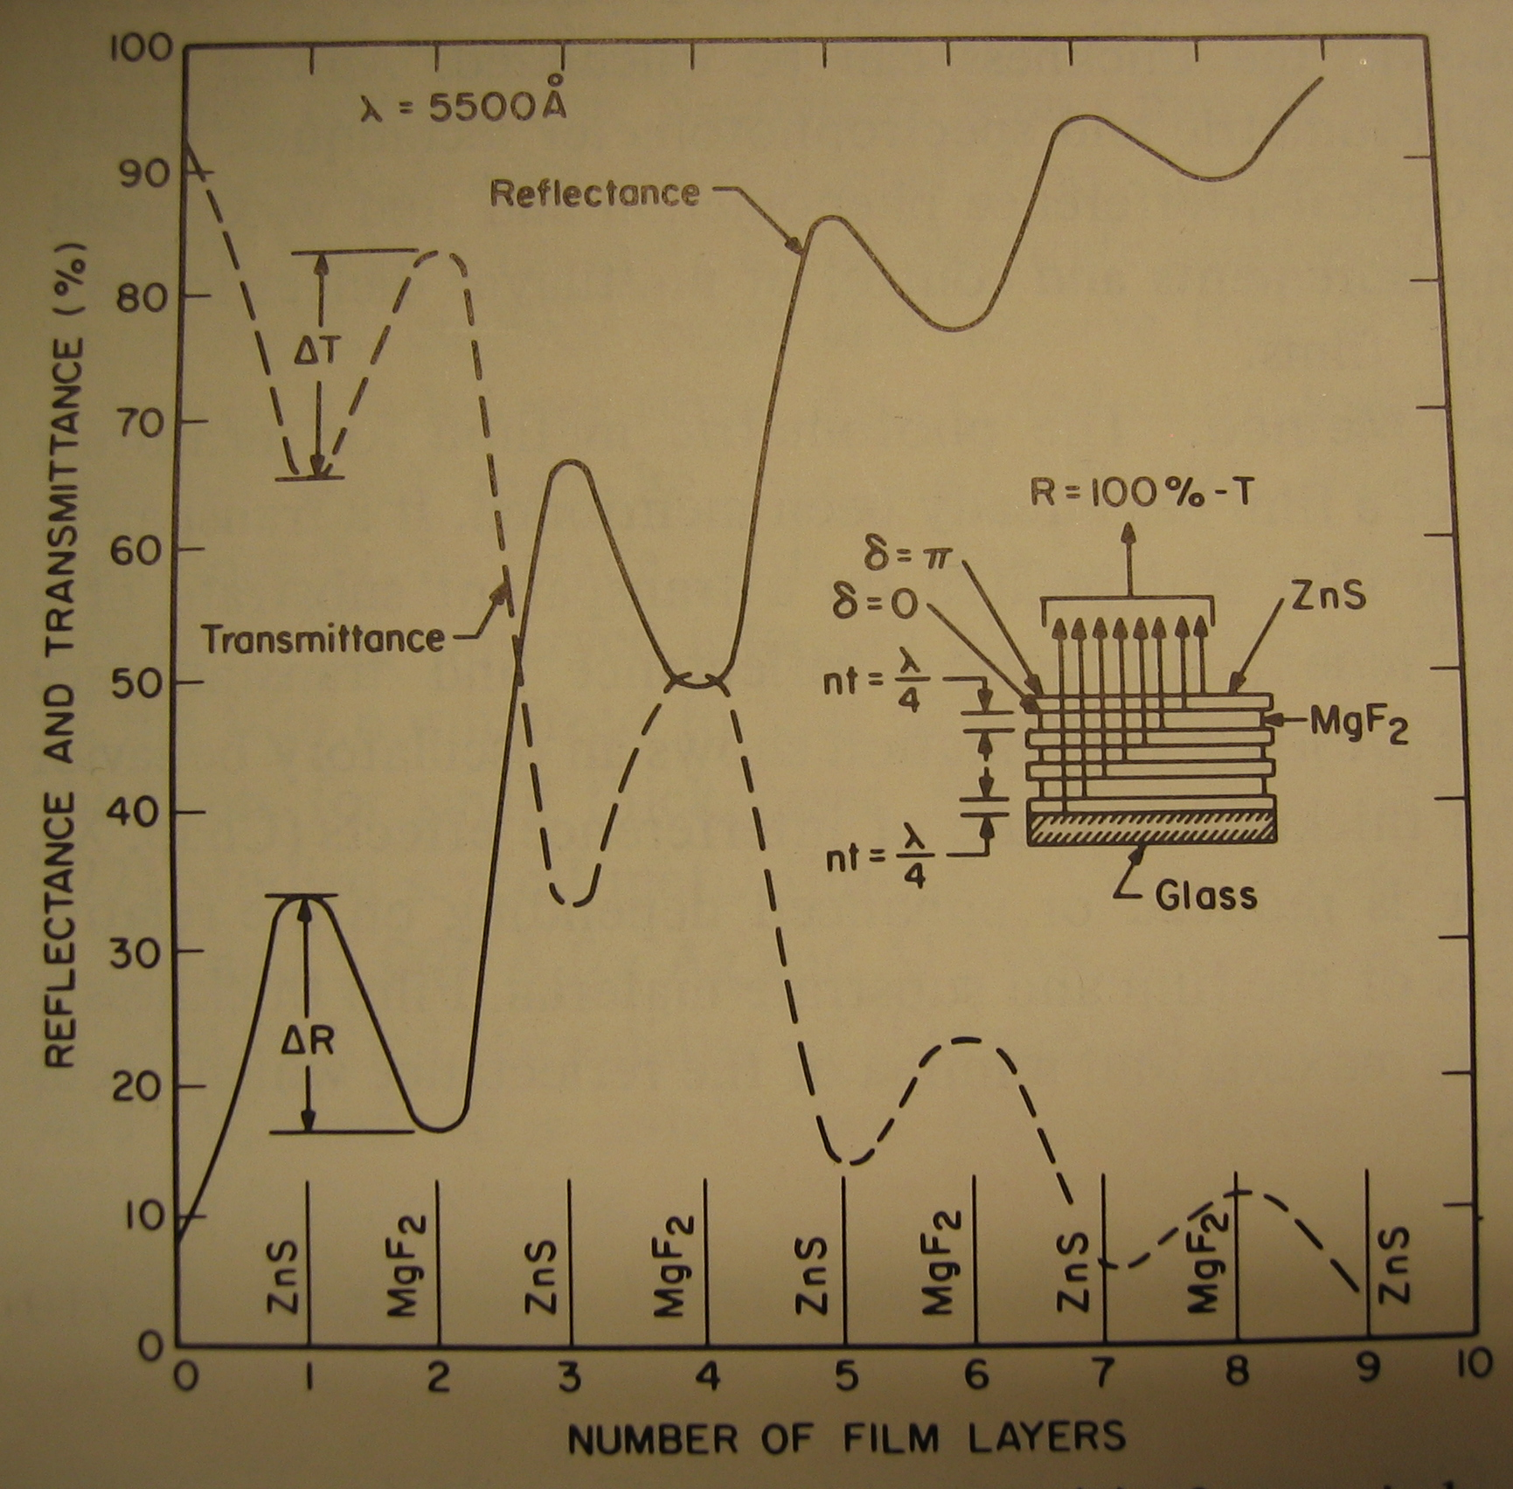
Figure 3. Reflectance and Transmittance of increasing number of multilayers
Steckelmacher et al., Vacuum, 9:171 (1959)

Question 3.4. Show that, after two maxima or minima are traversed (first being the value at zero deposition), thickness for a single layer film is quarter wavelength. (Hint: consider equation (12)).

Therefore by monitoring maxima and minima while depositing, the thickness of each film is controlled to be quarter wavelength.

Question 3.5. Calculate the actual thickness of quarter wavelength layers of ZnS, MgF₂, and cryolite (Na₃AlF₆) if blue light is monitored.

Question 3.6. Make predictions to the shape of the channel spectrum with respect to the filter used, indicating quantitatively the critical points.

3. Evaluating Optical Properties of Your Film
The spectrometer consists of a wavelength dispersive device and a photomultiplier. A prism is used to pick out photons of specified wavelength and transmit them to the photomultiplier. A mechanical system of gears and springs attached to the prism is adjusted to vary the specified wavelength. With your multilayer thin film at the slit opening, obtain transmission spectra by scanning through the visible wavelengths of light. (Hint: overlay the spectra on top of a white light source spectrum for ease of comparison.)

The Photomultiplier
Photomultipliers are extremely sensitive detectors of light, or photons. Incident photons strike the cathode material, and produce electrons as the result of photoelectric effect. These electrons are accelerated towards the electrode, while undergoing the process of secondary emission. Secondary emission effectively multiplies the electron signal. The electron multiplier consists of numerous small electrodes called dynodes. Each dynode is held at a positive voltage with respect to the previous one. When electrons leave the photocathode, they have the energy of the incoming photon. While traveling towards the first dynode, the electrons gain energy from the electric field. On arriving at the dynode with much greater energy, the electrons can cause emission of low energy electrons. The original electrons from the cathode, together with the newly generated low energy electrons, then are accelerated toward the second dynode. This process repeats and a cascading effect occurs, which result in a high accumulation of charge arriving at the anode. This effect induces a sharp noticeable current pulse in the device even if only a single photon enters the cathode.
Measure the channel spectrum of your multilayer thin film in the visible wavelength.

Question 4.1. Compare and contrast the measured channel spectrum with respect to theoretical predictions.

Question 4.2. How does the slit width of the spectrometer affect the shape of your spectra? What is a suitable slit width to yield a representative spectrum?

Question 4.3. With a narrow slit width (approximately 1000 µm), take spectra of your thin film at different positions on the thin film. Does this have an effect on the shape on the channel spectrum? If so, is it understandable? What part of the experiment most likely resulted in such changes in the channel spectrum?

Question 4.4. How would incident light at different angles affect the channel spectrum?

Some Discussion Questions
- What is a Fabry-Perot Filter? Describe its functionality and composition

- Why might one wish to use MgF₂ instead of cryolite in making thin films with ZnS?

- How does the addition of a silver deposition layer on top of the multilayer high reflectance thin film affect its performance? You may wish to add a silver deposition layer and contrast the channel spectrum from before and after.

- In an one-way mirror, the metallic/dielectric coatings on the surface of glass substrate actually result in a so called “half-layer” thin film. This just means that neither of transmittance nor reflectance is very high or very low. Then how does an one-way mirror work? (Hint: think about the slit width and the white light source in the spectroscopy section)

References
1) Chopra, K.L. (1969). Thin film phenomena. New York: McGraw-Hill.

2) Fowles, G.R. (1975). Introduction to modern optics. 2nd ed. New York: Holt, Rinehart and Winston.

3) Hecht, E. (2002). Optics. 4th ed. Reading, Mass.: Addison-Wesley.

