University of Toronto
ADVANCED PHYSICS LABORATORY
GAUS
Gaussian Beams and Near-field Diffraction

Revisions:
2021 September v1.3: Robin Marjoribanks
2020 September v1.0: Robin Marjoribanks
2020 August v0.8: Robin Marjoribanks
2020 February v0.7: Robin Marjoribanks (original author)

Please send any corrections, comments, or suggestions to the professor currently supervising this experiment, the author of the most recent revision above, or the Advanced Physics Lab Coordinator.

Copyright © 2020, 2021 Robin Marjoribanks
This work is licensed under the Creative Commons
Attribution-NonCommercial-ShareAlike 3.0 Unported License.
(http://creativecommons.org/licenses/by-nc-sa/3.0/)

Overview
The purpose of this experiment is to extend simplified notions geometric optics (ray-tracing) and of far-field (Fraunhofer) diffraction to the near-field regime essential for Gaussian beams in lasers, and for Fresnel diffraction which produces the phenomenon of the Spot of Arago (Poisson’s spot).
Introduction
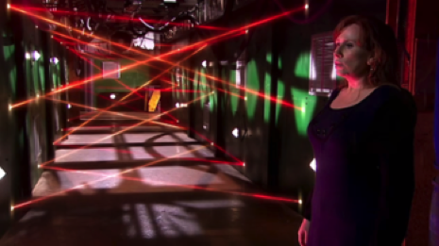
Laser beams in science-fiction, used to make an almost-impossible maze that spies must defeat.
It’s a common notion that light travels in straight lines, but this is only true in an approximation. In geometrical optics we can do ray-tracing, and determine where a bundle of parallel input rays passing through a lens will come to a focus.
The limitation of this approach is obvious — in geometrical optics, the rays all come together at a single point in space, resulting in infinite intensity, which is absurd. More than just ‘rays’ must be going on, in a more complete viewpoint, and the answer is known to anyone who has passed light through a fine slit: beyond a slit, light spreads out more and more broadly in angle as the slit is narrowed down.
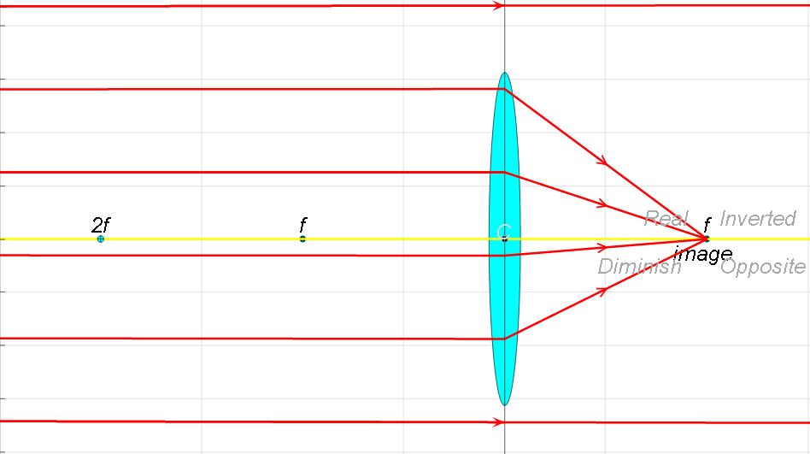 http://labman.phys.utk.edu/phys136core/modules/m9/diffraction.htm
Ray tracing through a lens to a focus. Ray-tracing is quite legitimate for modelling lots of classical optical systems such as DSLR camera lenses.
This is true for any wave, and ties both to the time-bandwidth product theorem for a brief musical note or other temporal waveform, and to Heisenberg’s Uncertainty Principle in quantum mechanics — once de Broglie had posited that particles have a wave nature, all of the ramifications of wave nature followed immediately, including the H.U.P. for position and momentum.
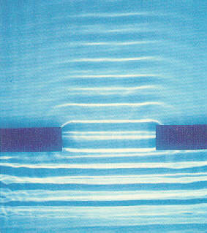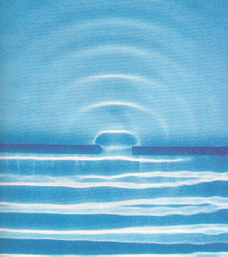
Wave-tank illustrations show how plane waves spread, or diffract, beyond an aperture. Smaller apertures Δx result in a bigger lateral spread Δk_{x} of wavevectors, which tie to momentum.
Waves for the win — It was Christian Huygens (1629-1695) who noticed that if one can draw the wavefront of any wave, one can deduce much about the future of the wavefront. In a small advancement of the wave, the new wavefront can be found by constructing a little spherical wavelet at every point along the wavefront and letting it expand slightly. The whole assembly of wavelets, all along the wavefront, set out the new position of the wavefront by taking a line tangent to all the tiny spheres.
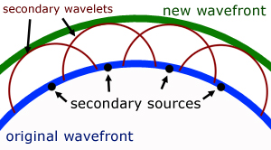
Huygen’s construction predicts the new wavefront after propagating a little distance. Fresnel took it further, and literally: the new wave is the mathematical sum, the net interference, of all the little wavelets, including phase.
From this, it’s immediately obvious that a concave-forward wavefront should converge to a focus, and a convex-forward wavefront should diverge.
Augustin-Jean Fresnel (1788-1827) carried Huygens’s geometrical construction one step further, taking not only the tangent to the spherical wavelets to identify the curve of the new wavefront, but the mathematical sum of wavelets, including their phase of oscillation, to find the evolution of the wave completely. This is the principle of superposition and interference which successfully proved how an opaque disk can nonetheless form a very bright spot in the middle of its shadow. (Though first observed by Delisle, and by Maraldi, a century beforehand, this spot is called by two names: Poisson’s spot, and the spot of Arago. Poisson was a theoretician who disbelieved Fresnel’s theory, and showed that it must predict a bright spot amid the dark shadow cast by a disk – which presumably proved Fresnel was wrong, by reductio ad absurdum. Arago was the head of the prize committee for the competition in which Fresnel presented his new theory – he took the question to his laboratory, and with a 2mm metallic disk he showed the absurd spot in fact existed. Though this was not in fact the turning point supposed in legend, and though much discussion about the fundamental nature of light and the meaning of Fresnel’s theory continued, the committee agreed on enough to award Fresnel the Grand Prix of 1819.)

Why waves don’t travel as rays
Only a plane wave possesses a perfectly well-defined (zero uncertainty) wave vector k, and the associated cost is that the wave must necessarily have infinite extent (complete uncertainty in position x). If we make a barrier, as to create a slit, to eliminate much of the transverse extent, we remove an infinite number of little Huygen’s wavelets along the wavefronts, left and right, which previously interfered to continually keep reconstructing a perfect plane wave going forward. The consequence is that the smaller we make such a slit, the more nearly the transmitted wave on the other side looks like a spherical wave coming from a single point without neighbours.
Turn this around, in order to understand what is required, to focus light down to a spot: we can simply run time backwards for the light leaving a tiny slit, to see that to make a smaller and smaller focal spot takes a wider and wider cone of waves converging. The no-longer-unique vectors k point in a bigger and bigger range of directions Δk, in order to define a smaller and smaller spot Δx.
In fact, diffraction theory teaches that the field pattern formed at a distance one focal length beyond a lens is the Fourier transform of the amplitude and phase of the light incident on the lens. You may already know that the Fourier transform of a gaussian function is another gaussian function. All these observations together lead us directly to gaussian beam optics.
Before going farther, read the attached Appendix on Gaussian Beams as solutions to the wave equation in the case of propagation of light nearly parallel to an axis — the paraxial wave equation.

Objectives

The study of the optical physics of gaussian beams, by:
- imaging the intensity distribution of a gaussian beam for a number of positions before and through its focal spot
- determining the relationship R(z) between wavefront radius of curvature R and axial position z, by reflecting the beam exactly back on itself from surfaces of different curvature R.
- investigating near-field diffraction, the optical physics that is in play for a gaussian beam near its smallest spot-size at focus. Real beams cannot focus to zero size, for the same reason that light passed through a fine slit naturally spreads out after passing.
New techniques:
- how the ABCD matrix method you may have learned for geometrical optics without diffraction is adapted and still valid for gaussian optics, where diffraction is a governing fact
- methods to align optics precisely
Associated software:
• ImageJ (free) — https://imagej.nih.gov/ij/
•

Equipment Provided For Your Investigations

Laser — HeNe laser at 632nm with smooth transverse profile, key-operated. Output power is 5mW and is safe without laser goggles, but you must never look directly into the beam, and should always protect against unintended reflections and other stray beams.

Beam expander — A two-lens 10x beam telescope expands the beam to about 1cm and collimates it to have minimum divergence.

Lenses — Several lenses of different focal lengths are mounted.

XYZ Positioner — Take the horizontal axis of the laser optical path to be z, the transverse horizontal axis x, and the tranverse vertical axis to be y. The 3-axis translation stage will give you measurements of its displacements in x, y, z.
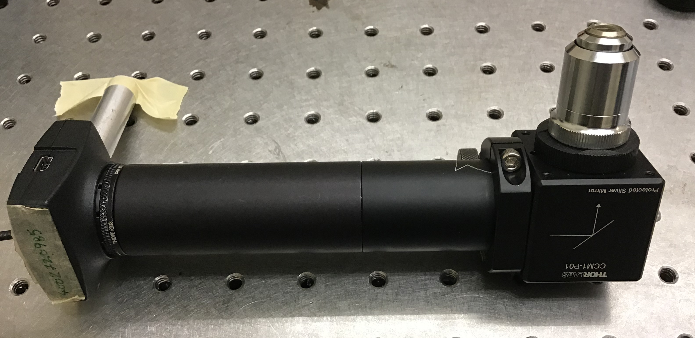
Beam microscope. The USB camera connected can be controlled and analysed using ImageJ software. Calibrate by moving the microscope sideways a distance measured on micrometers, and comparing to movement of the image on the camera.

Beam microscope (beam profiler) — A microscope objective coupled to a 1” lens tube, with a 90° mirror to make a compact setup, ending in a digital camera at the image plane. Magnification is the ratio of distances (objective-lens to camera sensor)/(object plane to objective-lens). The beam profiler can be mounted on the XYZ positioner.

Reflectors — A flat mirror, a number of steel or glass balls of different sizes are provided. The curved surfaces of different lenses also reflect light from the interfaces, where the index of refraction changes (Fresnel reflection).
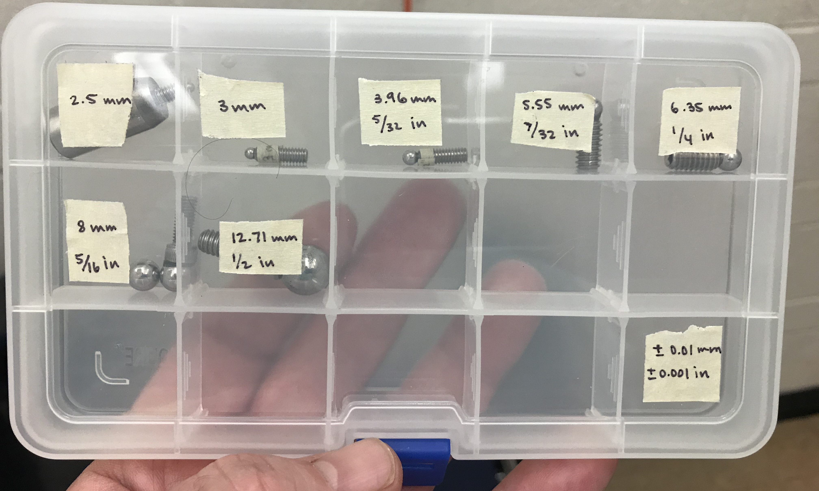
Mounted steel balls: spherical reflectors.
Consider also the mounted glass balls, especially also high-quality (better than λ/10) spherical-surface glass lenses of different focal length (provided).

If you have plans that require something else, please speak first to the supervising professor. Lab staff are happy to help, if components are available on the shelf or can be easily and quickly obtained.

Gaussian Beam Characterization

Beam Profiling — Use the beam profiling setup (microscope objective, 45° mirror, 1” lens tube, digital camera) to image the beam and plot w(z). from the geometrical limit, through the Rayleigh range around the beam-waist, and into the geometrical limit on the other side.

Obvious questions:
- how will you calibrate your camera, to know real sizes in your image?
- focused beams are much more intense than spread-out beams. What is the best way to manage this change of a few orders of magnitude, on an 8-bit or 10-bit digitizing camera?
Radius of curvature — As beams expand, the radius of curvature of the phase-fronts get larger and larger – they become flatter, and in the limit are plane-waves. However, gaussian beams have flat wave-fronts at their beam-waist. You can find the beam-waist by mounting a flat mirror on the XYZ translation stage, and finding the position that sends the beam backward on itself, exactly as it came in: same direction, same size at each point. This is retrocollimation.

At points away from the waist, the beam has a spherical radius of curvature R(z). For different spherical reflecting-surfaces, find the location at which the beam is precisely retrocollimated. Bear in mind that the wavefronts are flat at the beam-waist, and in the limit of z large they again approach flat. Therefore any for any smaller radius acquired, except the unique beam-waist, that same radius must appear again at some other location in the gaussian beam.
Mounted steel balls: spherical reflectors.
Consider also the mounted glass balls, also high-quality (better than λ/10) spherical-surface glass lenses of different focal length (provided).

Plot R(z) from your measurements. Plot this on a double-ordinate graph, to put your R(z)alongside your w(z)characterization.

Obvious questions:
- you will replace the flat mirror with a steel ball, and that with a glass lens spherical surface. How will you know the z-value for each? The flat mirror lets you find z=0 for the gaussian beam-waist, but how can you reference that position in space once you remove the flat mirror, and keep it to use with the balls?
- retrocollimation sends a beam exactly back on itself. How then can you visualize the returning beam, if a card or camera to view it would block the returning beam?
- How will you determine your error-bars, your confidence about the best position z to fit a given R of a ball or lens?

General Tips

- It’s generally helpful first to establish the optical axis from laser to XYZ stage, perhaps parallel to holes in the breadboards, and then add optics you want while preserving this axis
- The ABCD matrix method for ray-tracing will let you calculate beams through optics in the geometrical limit. The same matrices, applied differently, let you do the same optics but for gaussian beams. See the Appendix attached, for both ray-tracing and gaussian-beam methods
- The open-source code ImageJ available online for free for many platforms from the US National Institutes of Health, provides excellent tools for image analysis, including plotting profiles across images of gaussian beams, saving profiles to text files for curve-fitting, and enhanced visualisation like 3D plots and false-colour images.
- Videos teaching lab skills for optics are available, see the APL webpage for this experiment for links.
- Index-cards, business cards, of different sizes can be very helpful in alignment — punch a hole through the card with a ballpoint pen, fine scissors, hole-punch, etc..
Modelling and Theory

For the ray-trace picture, show that the ABCD matrices for your setup produce exactly one location where the ball might reflect and collimate the beam going backwards.
Repeat now for the same matrix elements, but using the fractional-linear transformation, the way that the q(z) gaussian beam parameter transforms at each point in your setup and leads to two different places where any ball may be placed. Is it true that this is possible for any size of ball?

Look online for apps that will let you lay out an optical system and transform a Gaussian beam, element by element, to simplify the modelling you need, and to reproduce your results.

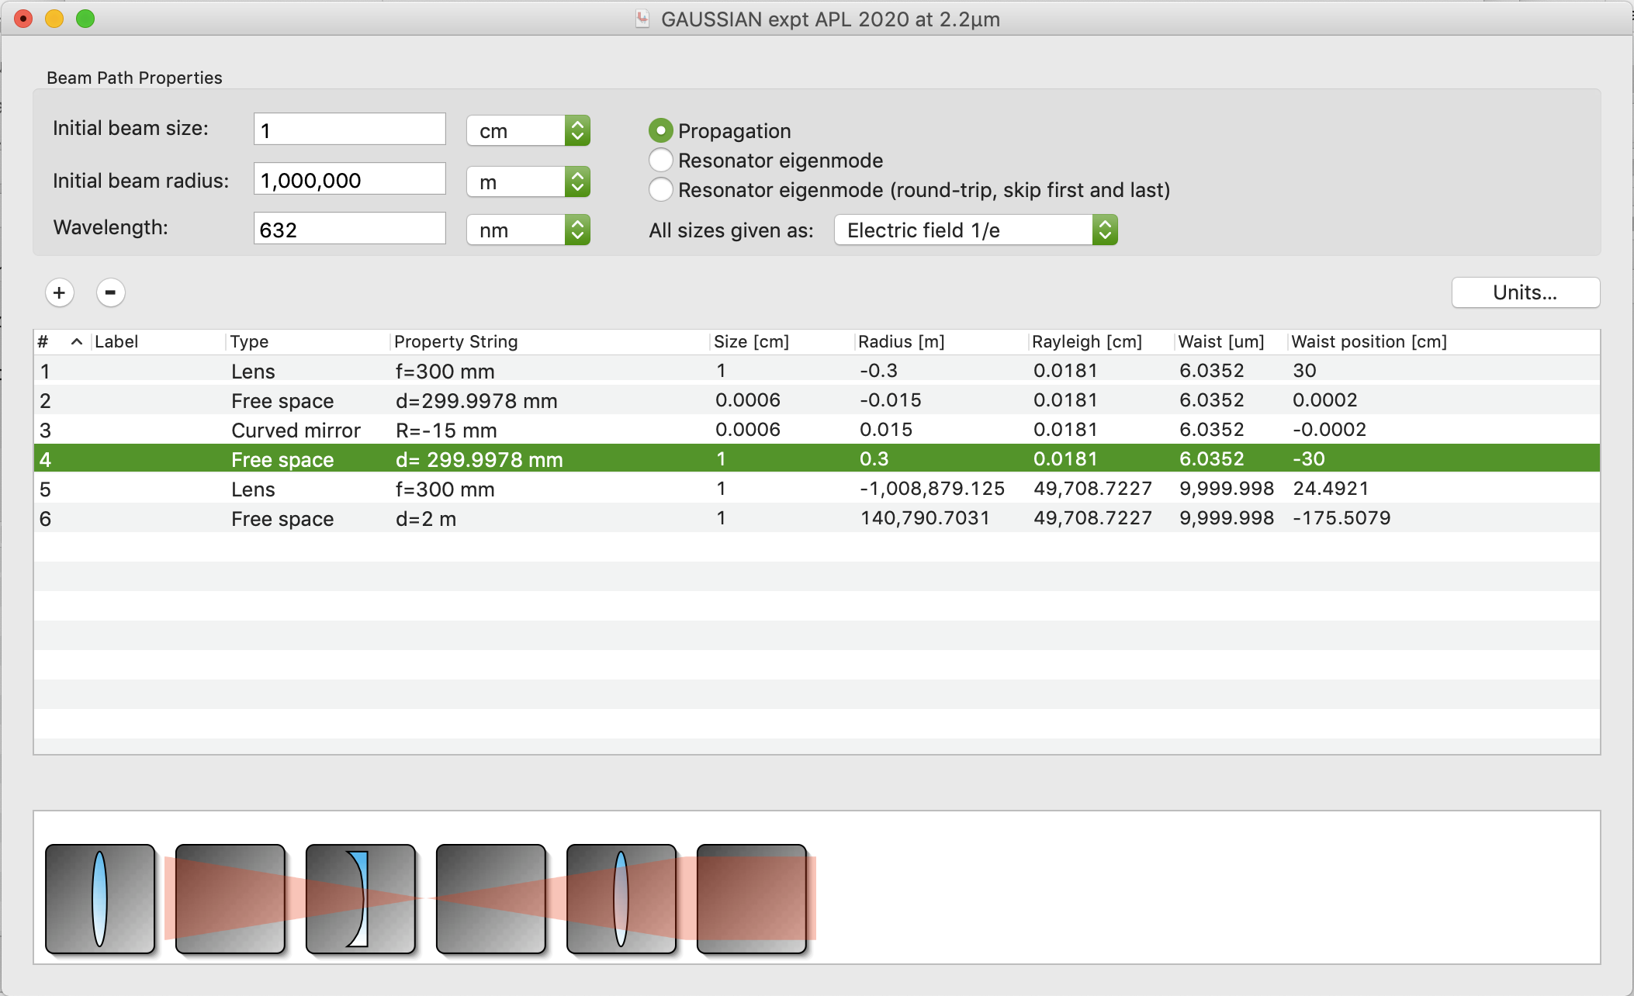

ABCD modelling routine from Professor Daniel Côté at Université Laval, a past graduate student in Physics at the University of Toronto. This code v3.1for Mac is for OSX 10.1 (buggy in 10.14), but similar software exists online in open-source and commercial software, as well as Python, MATLAB and Mathematica libraries.
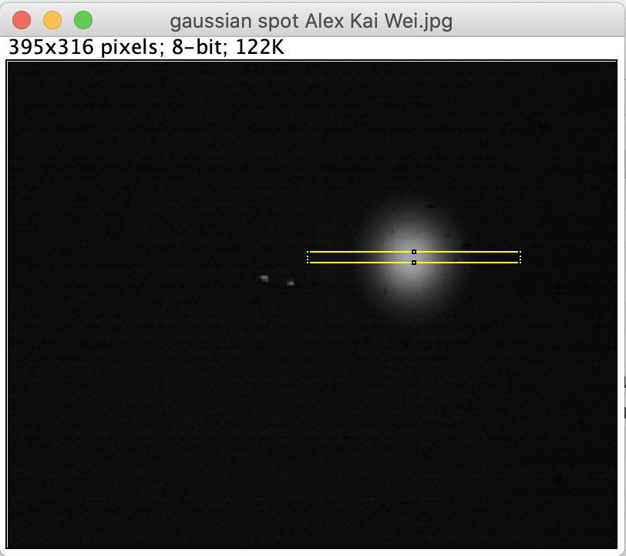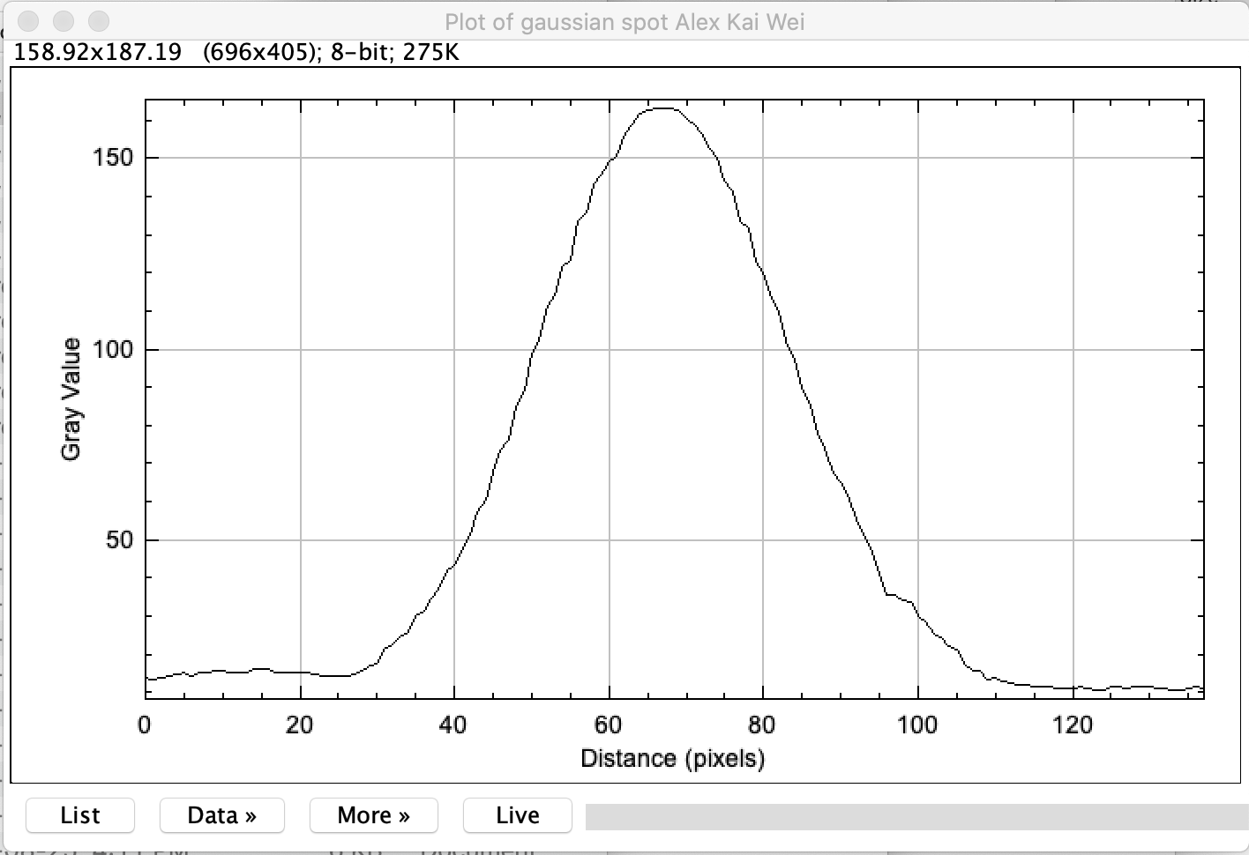

Example of image analysis of gaussian beam, using profiling in ImageJ. Further information available in separate instructions for Beam-Profiling using ImageJ.

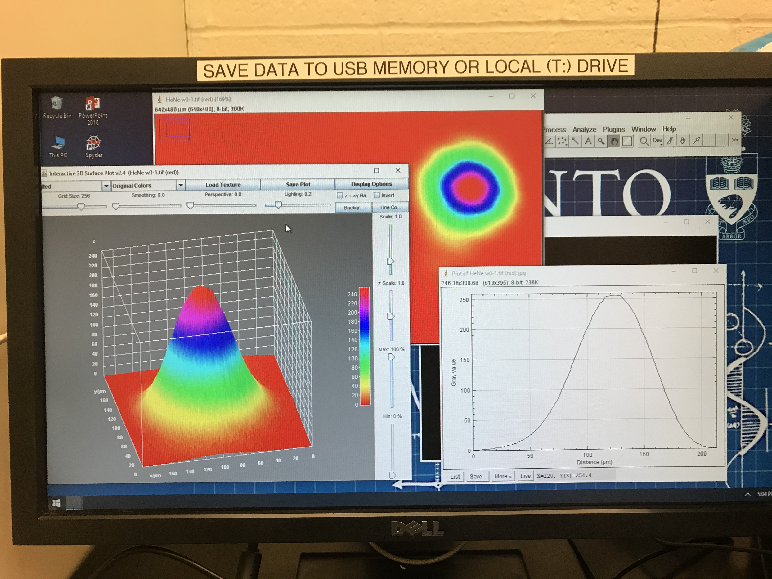

Example of 3D analysis of gaussian beam, using ImageJ

OPTIONAL RELATED QUESTIONS on diffraction

Near-Field Diffraction and the Spot of Arago

In the far-field limit (Fraunhofer diffraction), distances are such that from source to aperture, and onward from aperture to observation point, wavefronts are plane waves. Summing up all these plane waves exp{i$\vec{k}∙\vec{x}$}, leads to a Fourier transform of the amplitude at the aperture.

In the near-field limit (Fresnel diffraction), wavefronts from source to aperture, and aperture to observation point, are curved (i.e., spherical wavelets, of which gaussian beams are the paraxial approximation). Consider a circular aperture, centred on the optical axis, which can be increased in size (e.g., an iris diaphragm as inside a DSLR camera). Because the spherical wavefronts at the aperture are domed, and let’s say convex domes, the part of the wavefront which is on axis is closer to some distant on-axis point that the parts of the wavefront at the edge of the aperture. Therefore there are imaginary annular zones on the dome, for which the propagation phase difference can increase by an average amount π for each subsequently larger zone. These are called Fresnel zones.

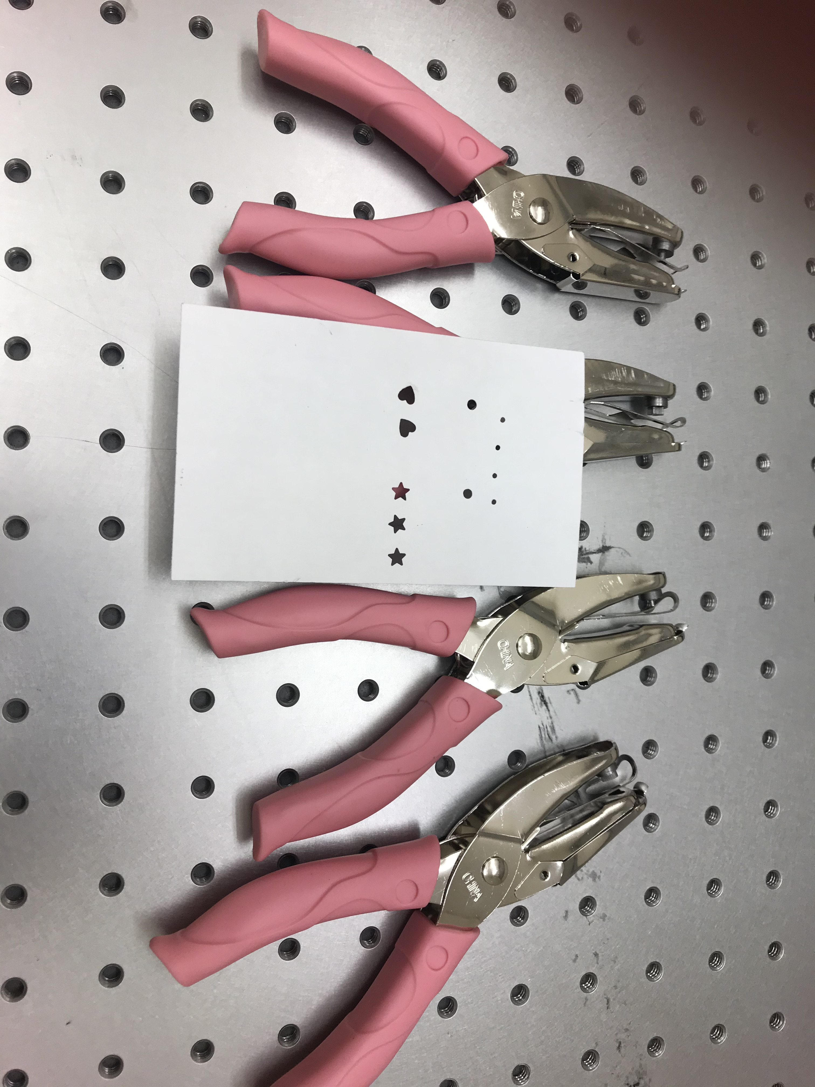
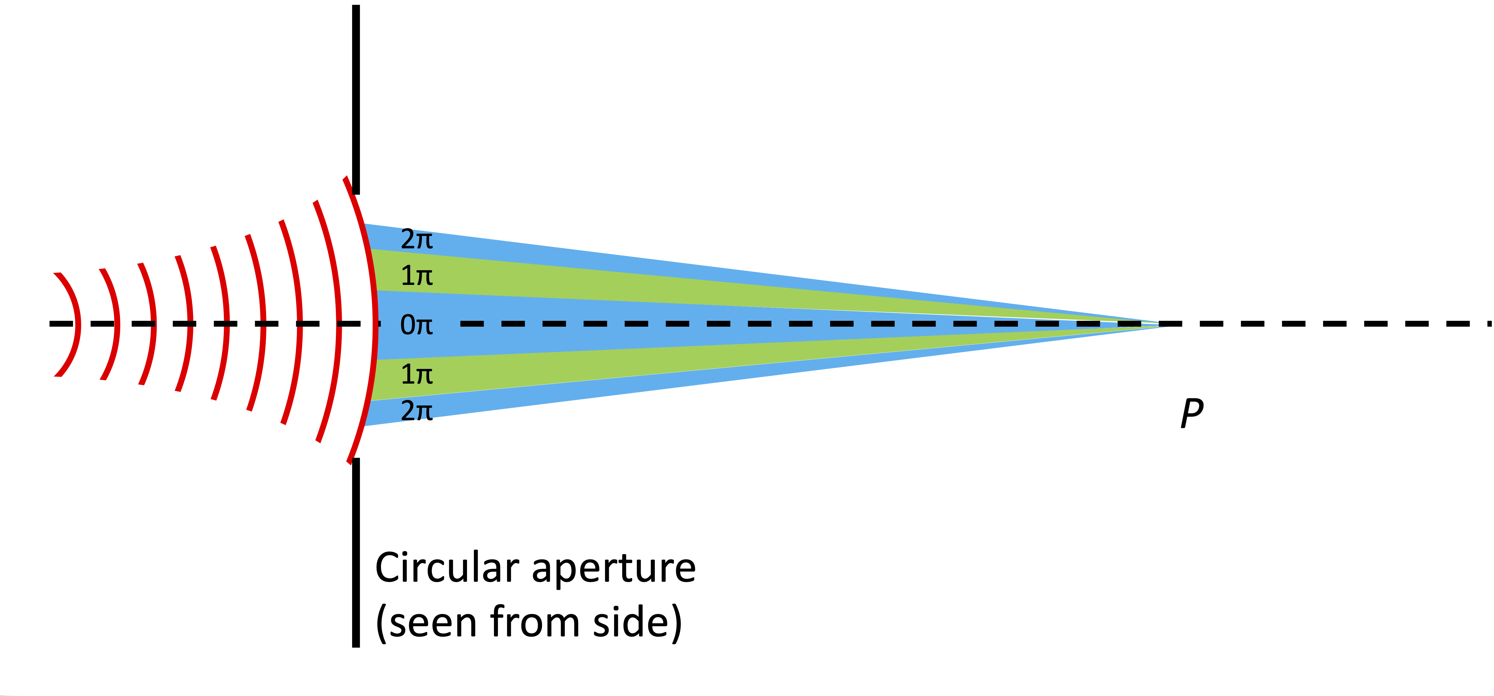

A spherically curved wavefront, at a circular aperture centred on-axis, makes a dome for surfaces of constant phase. All points on this dome start off in phase with each other. However, different points travel different distances when travelling to the axis. This defines annular zones, on the dome – rings – each ring travels to the axis with roughly the same phase. But the next ring will have an average phase-change of π: light from that ring interferes destructively with light from the first ring. Thus in the figure above, blue zones add nearly constructively with each other at the observation point on axis. An aperture which passes only the innermost blue zone above will give light at P, but a slightly larger aperture that admits the green zone as well will produce less light at P.

Using the expanded HeNe beam, show empirically that for the right setup, you can have a beam pass through an open circular aperture and yet have a completely dark spot in the centre of the apertured beam. Make the calculations necessary to explain what you see.

Special hole-punches are provided that create holes of different shapes. Using the expanded HeNe beam, record the intensity pattern at different distances from the apertures. At what distance does the pattern become that expected for Fraunhofer diffraction? What happens beyond that point?
Obvious questions:
- for the circular aperture, like an iris diaphragm, what happens at the observation point as you steadily increase the diameter?
- distance as a bare number means nothing, since one can choose different measurement units. However, the distance of one characteristic of your setup compared to another characteristic distance is dimensionless, and is about relationship. All meaning in physics comes from relationship. What is/are the relationship(s) that change(s), to go from one diffraction regime to another? Therefore, what’s another way to change the same natural relationship, besides changing the aperture size?
Tips:
- ImageJ lets you take an image you have recorded and produce from the intensity pattern an FFT which will correspond to Fraunhofer diffraction for perfect plane-wave illumination. In fact, you want first to convert to amplitude, then FFT, then afterwards convert back to intensity.
- When you use an imaging system, any focussed point in the image plane has collected rays that all travel the same optical distance from their one origin point in the object plane (Fermat’s principle). This means there’s no change in relative phase for the wavelets, no change in interference, no diffraction. If you use a lens and make an image of your different apertures, you’ll be able to collect diffraction patterns that start with in effect zero propagation distance from the aperture. As you back off the lens and camera, you image planes in space which are located at successively distant propagation distances, starting from zero.

Pinhole Interferometer (under development, Ask APL Coordinator)
Planar interference fringes between two slightly angled HeNe beams

Now adding pinhole interferometer, to measure wavefront curvature

A relatively simple interferometer can let you precisely determine R(z) for gaussian beams. You’ve seen that any wavefront passing through a small aperture will spread into spherical waves on the other side. This can make a reference beam, to be interfered against the original laser beam – for instance, a laser beam with flat wavefronts will interfere with the spherical waves to make a series of rings.

A thin gelatin-film plastic neutral-density filter (Kodak Wratten filter) has been prepared with a small hole (~30µm diameter) drilled through it with a focused pulsed laser. The attenuation value (about ND3) of the filter is chosen so that the intensity of the whole laser beam passed through, directly, ends up about the same as the intensity of the spherical wave that has expanded through the small hole (about the ratio of areas, expanded beam to drilled hole).

Various variations of this scheme are possible to explore.

Theory and Application of Point-Diffraction Interferometers
R. N. Smartt and W. H. Steel 1975 Jpn. J. Appl. Phys. 14 351
Images from the experiment, in different iterations

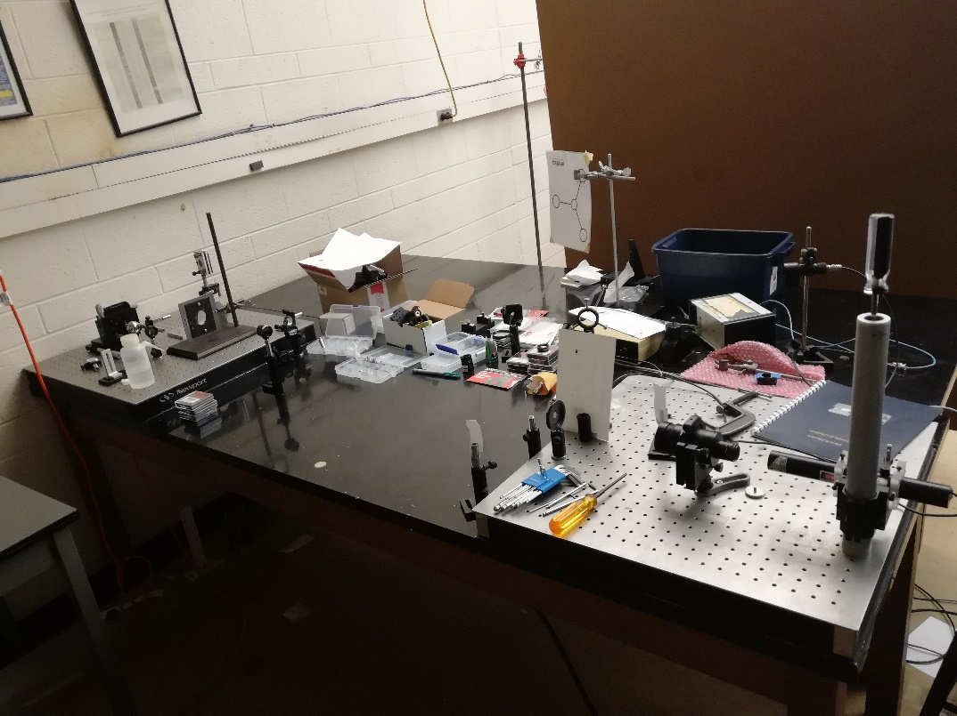
Fig. 1. An image of the overall original setup for the Gaussian Beam Experiment

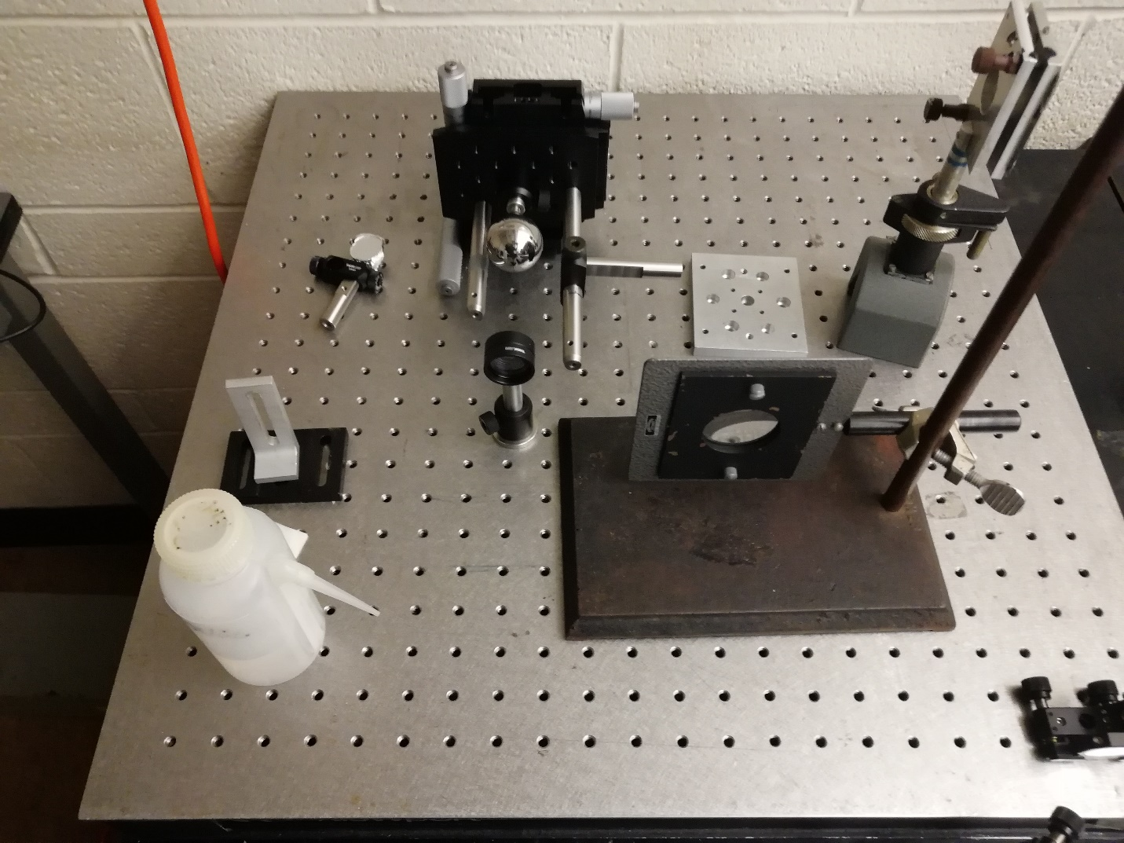
Fig. 2. An image of the steel balls attached to the translation stage setup with various lenses. Three separate translation stages allow for full control in the x,y,z planes at the micro scale.
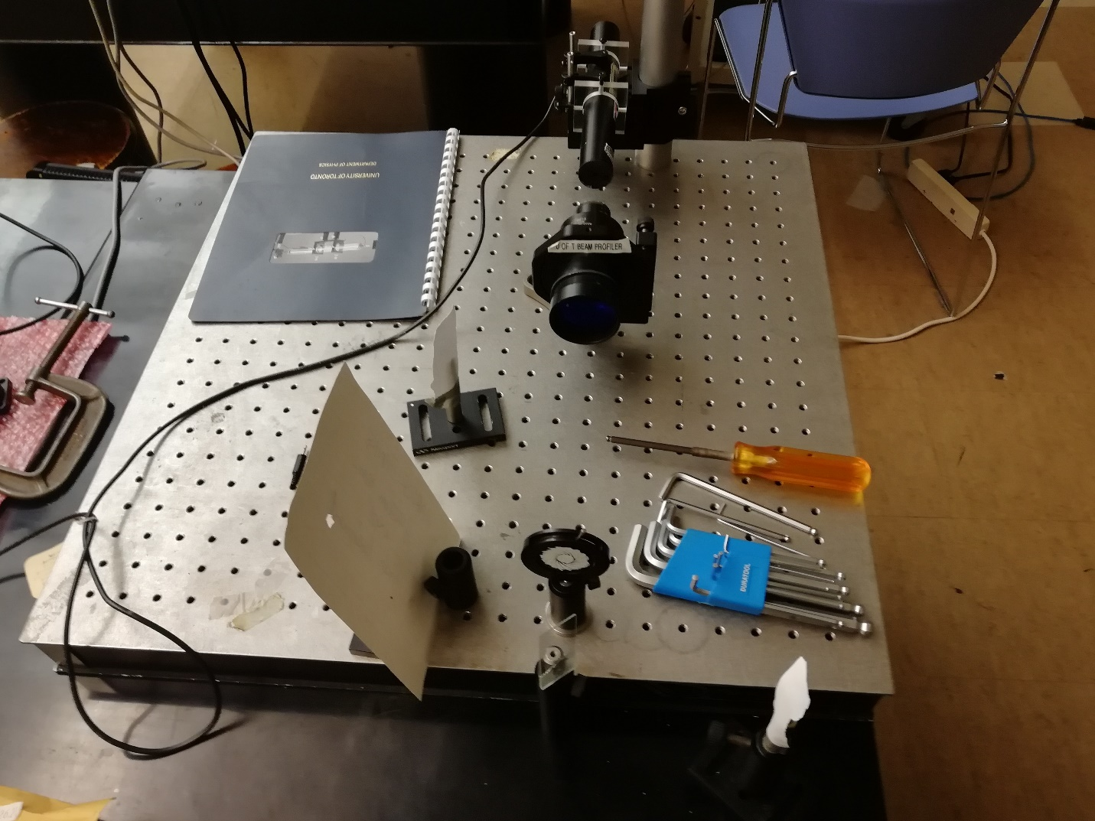
Fig. 3. An image of the HeNe laser into a beam expander and then into an iris. The painted iris allows for users to determine the position of the collimated beam, with the beamsplitter (microscope slide) in front of the iris, also contributing to user’s ease in determining the collimated beam size.

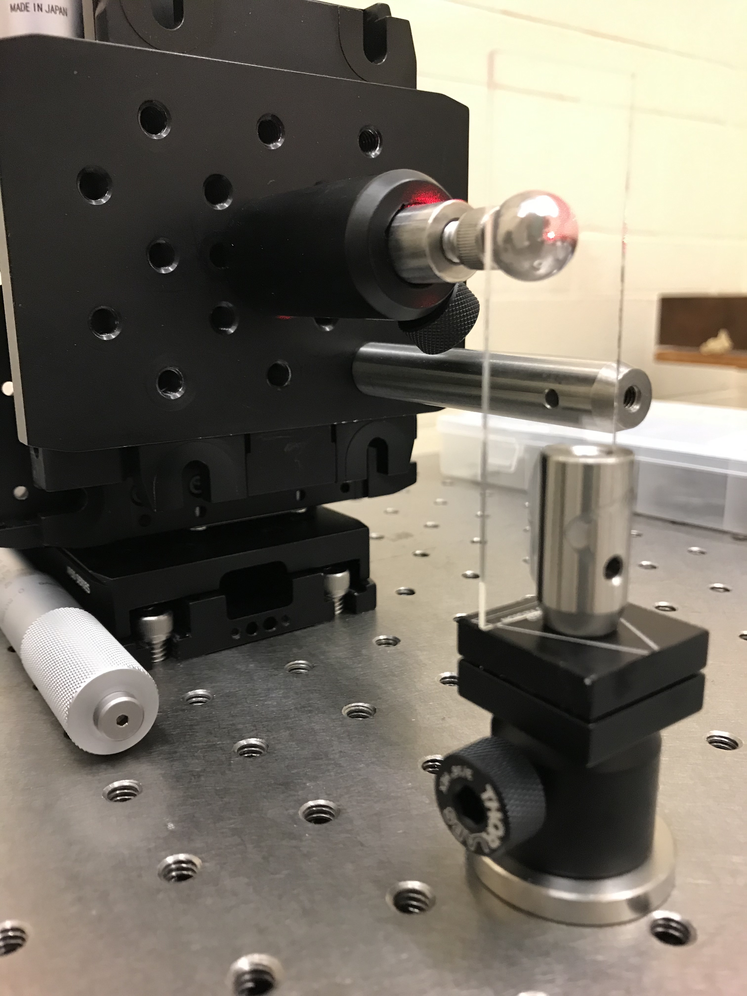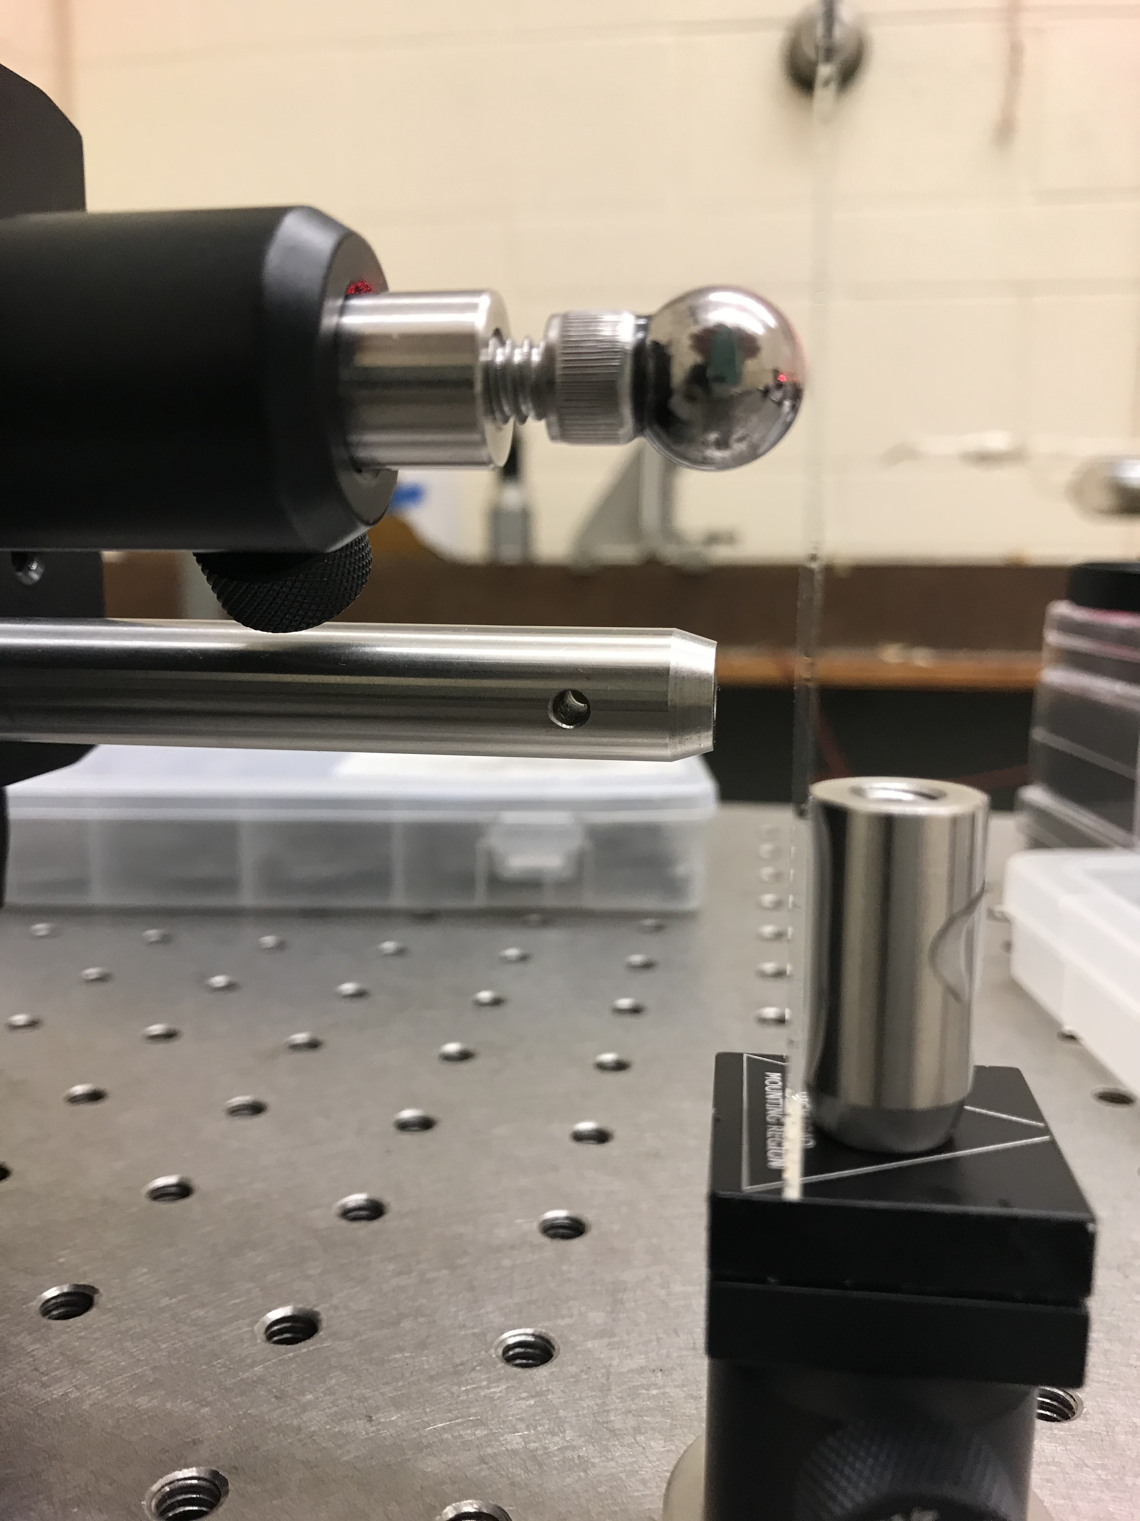
Fig. 4. One method for referencing absolute z-position in space: special mount with microscope slide – the reflected laser beam is very sensitive to the moment the ball touches the glass.
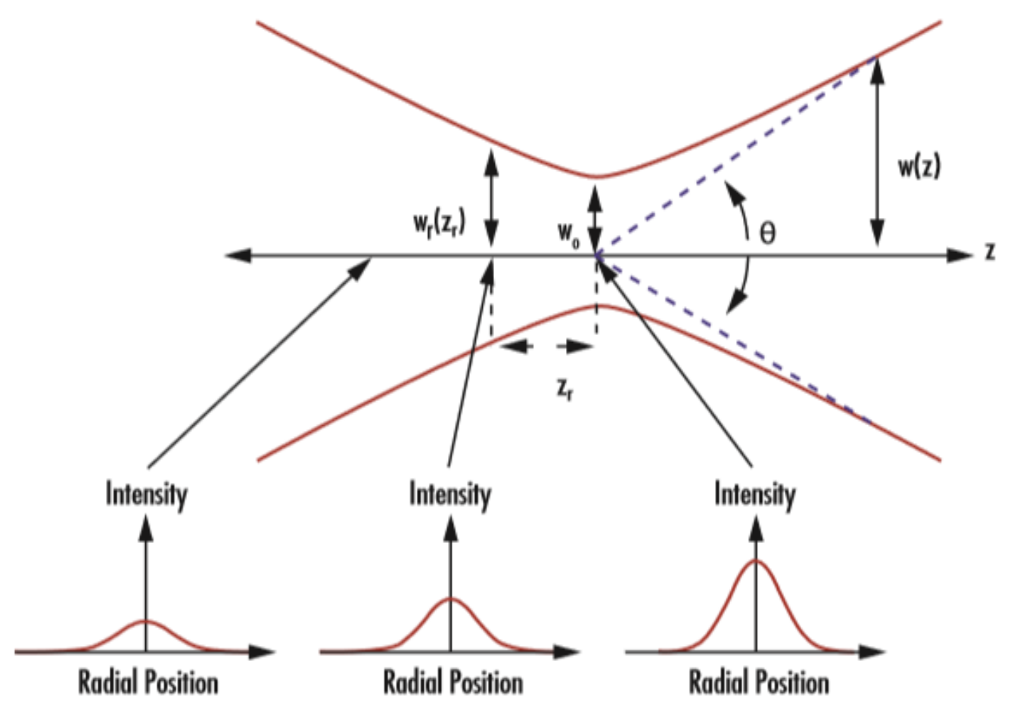

Fig. 5. Schematic of a gaussian beam: This figure makes clear that the hyperboloids which trace the 1/e-max surfaces are not surfaces of constant intensity, but just mark the width of the diminishing profile.

