APPENDIX I
Coupling Schemes and Notation
An extensive treatment of coupling schemes and notation is given by White or Kuhn. A brief review is given here to allow one to read this manual with some insight.
The motions of the electrons in an atom are governed by: (a) the electrostatic forces of attraction between the nucleus and electrons and of repulsion between pairs of individual electrons; (b) the magnetic forces due to orbital motions and the spins of the electrons. These interactions are complex but for particular configurations one may make simplifying assumptions in order to perform calculations. The assumptions specify a model for the system and different models will require different notations which specify the various angular momenta. Atomic states can be described by a set of numbers and letters which specify the angular momenta. Often a real situation can be described adequately by different models and the same set of states will be described in different books by different notations. In fact, for the same model there may be different notations used because a notation which doesn't specify as many quantities may be sufficient to describe a particular example and in fact may be easier to use. In the examples that follow one electron systems, such as the alkali metals, could be used but all examples will be two or more electron systems taken from He and Ne.
Russell-Saunders or L, S Coupling
Russell-Saunders coupling arises from the predominance of electrostatic over magnetic interactions. In this model, the spins $\vec{s}$ of the two electrons are strongly coupled together to give a resultant $\vec{S}=\vec{s_{1}}+\vec{s_{2}}$ while their interaction with the orbital angular momenta are much weaker. The origin of the strong interaction which couples the spins is the electrostatic repulsion between the electrons due to the Pauli exclusion principle. In this model the orbital motions of the two electrons couple together also because of electrostatic interaction. The orbital motions are described by the orbital angular momenta so we may say that the orbital angular momenta $\vec{l}$ couple together to give a resultant orbital angular momentum $\vec{L}=\vec{l_{1}}+\vec{l_{2}}$. Finally, both $\vec{L}$ and $\vec{S}$ couple to form the total angular momentum $\vec{J}=\vec{L}+\vec{S}$. Note that $\vec{J}$ has magnitude $h$J which is the total angular momentum of the atom. (From quantum mechanics, J is really $\sqrt{J(J+1)}$ where J is a non negative integer.
Russell-Saunders notation is given by
n^{2S + 1}L_{J}
Where n is the principle quantum number for the orbit which specifies the shell (larger n for larger orbits), where numbers are substituted for S and J, and where the letters S, P, D, F … are substituted for L = 0, 1, 2, 3, … respectively. Most often the designation of n is not included in the notation.
As an example, consider the ground state of He. Do not confuse the designation of the configuration of the electrons with the designation of the state. There are two s electrons in the n = 1 state and thus the configuration of the ground state is 1s². These two electrons have opposite spin so s₁ + s₂ = 0 and since both electrons have l = 0 then L = 0 and of course L + S = J = 0. Therefore in L, S notation the ground state of He is ¹S_{o}.
If one of the electrons is promoted to the n = 2 state we can have the configuration 1s2s. This can also be a ¹S_{o} state if the electron spins are opposite but since the excited electron is in the n = 2 state this is designated as a 2¹S_{o} or to emphasize that it is an excited state we write as in Appendix II, He*2¹S_{o}.
The ground state of Ne is also a ¹S_{o} state and can be described using Russell-Saunders notation. However, for excited states of Neon, calculations using this approximation do not give the correct energy levels and a different model using j, l coupling is employed.
j,j and j,l Coupling
In order to understand j, l coupling and to distinguish it from L, S or Russell-Saunders coupling one should first understand the mechanisms of interaction between the electrons and which mechanism is dominant is a particular atomic system. As mentioned above, in L, S coupling we have the extreme where the electrostatic interaction dominates the magnetic interaction and the coupling for two systems can be symbolically written
$$\left\{(\vec{l_{1}}\vec{l_{2}})(\vec{s_{1}}\vec{s_{2}})\right\}=\left\{\vec{L}\vec{S}\right\}=\vec{J}$$
At the other extreme, the primary interaction is the magnetic interaction between the spin and orbital motions of the individual electrons. The spin $\vec{s}$ and orbital $\vec{l}$ angular momenta of the individual electrons are strongly coupled to form $\vec{l}+\vec{s}=\vec{J}$ the total angular momentum for an individual electron. The electrostatic forces between the electrons now cause the different $\vec{j}$ to be coupled and to form the resultant $\vec{J}=\vec{j_{1}}+\vec{j_{2}}$. This extreme, which is the second most common type of coupling is called j,j coupling and may be symbolically written as
$\left\{(\vec{l_{1}}\vec{s_{1}})(\vec{l_{2}}\vec{s_{2}})\right\}=\left\{\vec{j_{1}}\vec{j_{2}}\right\}=\vec{J}$
A third intermediate type of coupling which is valid for Ne is called j,l coupling and it occurs when some of the magnetic interactions are small and others large compared with the electrostatic effects. In Ne, the configuration of the ground state is 1s², 2s², 2p⁶ and when one of the electrons is excited, the system is 1s², 2s², 2p⁵ + "excited electron" or for short, 2p⁵ + "excited electron", or "parent ion" + "excited electron".
The parent ion has one p electron missing from a closed shell and so the term diagram of the ion is the same as if it had only one p electron except that terms will be inverted. The parent ion core thus has levels ²P_{1/2} and ²P_{3/2} (with the ²P_{3/2} level lying deeper) and the energy levels in Ne approach these two limits as is shown in Figure 2. Russell-Saunders notation is used for the parent ion because the spin orbit interaction in the ion is large. When the excited electron is added to the system, the orbital and spin vectors in the ion core are not unlinked. This means that the electrostatic interaction between the external electron and the core is weak compared to the spin orbit interaction in the parent ion. However, the electrostatic interaction between the excited electron and the core is strong compared to the coupling of the spin of the electron to the core. This means that the $\vec{j}$ of the core and the $\vec{l}$ of the excited electron combine to form a resultant $\vec{K}=\vec{j}+\vec{l}$ and hence the name j, l coupling arises. The spin of the external electron then interacts with $\vec{K}$ to form a resultant $\vec{J}=\vec{K}+\vec{s}$ (i.e. J = K ± ½) and thus j,l coupling may be symbolically written as
$$\left\{[(\vec{l_{1}}\vec{s_{1}})\vec{l_{2}}]\vec{s_{2}}\right\}=\left\{[\vec{j_{1}}\vec{l_{2}}]\vec{s_{2}}\right\}=\left\{\vec{K}\vec{s_{2}}\right\}=\vec{J}$$
It should be noted that j, l coupling and j, j coupling are identical when the excited electron occupies an s orbit. In this situation, since l₂ = 0 then K = j₁ and j₂ = s₂ and hence $\left\{\vec{j_{1}}\vec{j_{2}}\right\}=\left\{\vec{K}\vec{s_{2}}\right\}$.
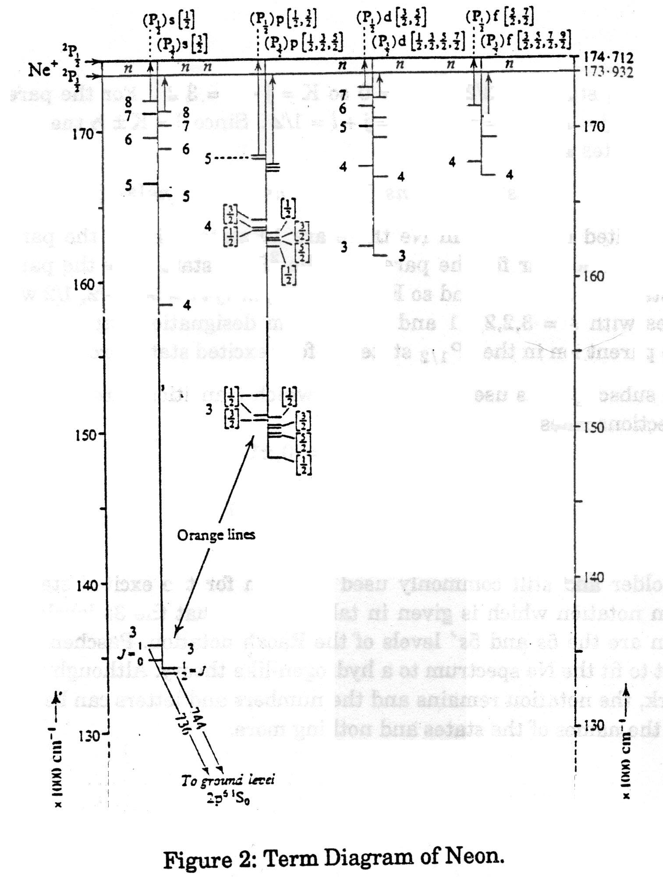
Racah notation is used to describe this coupling and is given by (^{2S+1}L_{J})nl[K]_{J} where the (^{2S+1}L_{J}) refers to the parent ion and for Ne can be either ²P_{1/2} or ²P_{3/2}. The n and l refer to the excited electron and for Ne in this experiment we will only consider s and p electrons where l = 0 and l = 1 respectively. This notation can be shortened by the use of primed and unprimed symbols as in the Racah notation of Table I (Appendix II).
$$\begin{aligned}(^{2}P_{1/2})\text{ns}Ûns^{'} \\ (^{2}P_{3/2})\text{ns}Û\text{ns} \\ (^{2}P_{1/2})\text{np}Ûnp^{'} \\ (^{2}P_{3/2})\text{np}Û\text{np}\end{aligned}$$
For an excited s electron in Ne, there are for states, two from the parent ion in the ²P_{3/2} state and two from the parent ion in the ²P_{1/2} state. For the parent ion in the ²P_{3/2} state, j = 3/2 and l = 0 so K = j + 1 = 3/2. For the parent ion in the ²P_{1/2} state, j = 1/2 and l = 0 so K = j + l = 1/2. Since J = K±½ then J = 2, 1, 1 and 0. The four states are
$$ns^{'}[1/2]_{1}ns^{'}[1/2]_{0}\text{ns}[3/2]_{2}\text{ns}[3/2]_{1}$$
For an excited p electron in Ne there are 10 states, six for the parent ion in the ²P_{3/2} state and four for the parent in the ²P_{1/2} state. For the parent ion in the ²P_{3/2} state, j = 3/2, l = 1 and so K = j + l - 1, … |j - 1| = 5/2, 3/2, 1/2 which gives rise to states with J = 3, 2, 2, 1, 1 and 0 and term designations np[5/2, 3/2, 1/2]_{3, 2, 2, 1, 1, 0}. For the parent ion in the ²P_{1/2} state the four excited states are $np^{'}[{3/{2,1}}/2]_{2,1,1,0}$.
The subscript J is used to determine which transitions are allowed according to the selections rules
ΔJ = 0, ± 1
where
J = 0 → J = 0
is forbidden.
An older and still commonly used notation for the excited states of Ne is the Paschen notion which is given in Table I. Note that the 3s levels in the Paschen notation are the 5s and 5s′ levels of the Racah notation. Paschen notation was an attempt to fit the Ne spectrum to a hydrogen-like theory. Although the approach did not work, the notation remains and the numbers and letters can be considered to be simply the names of the states and nothing more.
APPENDIX II
Excitation Transfer in He-Ne Mixtures
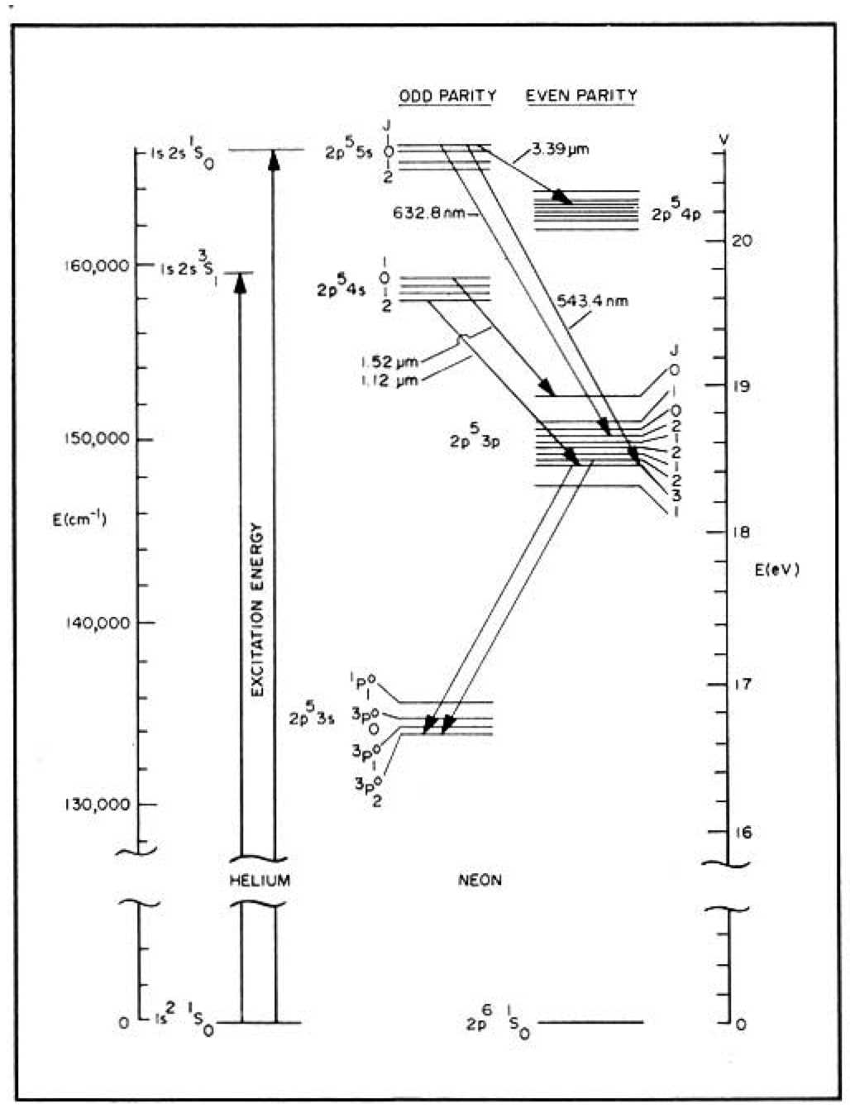
Figure 3: Energy Level Diagrams for Helium and Neon†
A collision involving interchange of potential energy between excited atoms such as
$$A^{}+BÛA+B^{}±DE$$
is called a "collision of the second kind". The difference in energy ΔE comes from or goes into kinetic energy of the colliding species. For resonant collisions, (ΔE → 0), cross sections two orders of magnitude larger than gas kinetic cross sections are realized. When ΔE → 800 cm⁻¹ (0.1 eV), the cross section for excitation transfer is negligible.
Total spin conservation (ΔS = 0) is favoured in a collision involving excitation transfer. Thus for the following two processes, the first is more likely.
$$A^{}(\text{­­})+B(\text{­¯})→A(\text{­¯})+B^{}(\text{­­})±DE$$
$$A^{}(\text{­­})+B(\text{­¯})→A(\text{­¯})+B^{}(\text{­¯})±DE$$
Figures 3 and 4 illustrate the energy level coincidence for the excitation transfer reaction from He 2¹S_{o} metastables to the Ne 3s states. The level 5s in figure 3 is the 5s′ (3s₂ and 3s₃) and 5s (3s₄ and 3s₅) of figure 4. Also the 3p[K] levels of figure 2 and table I which are in Racah notation, are the 2p levels in the Paschen notation of Table 1.
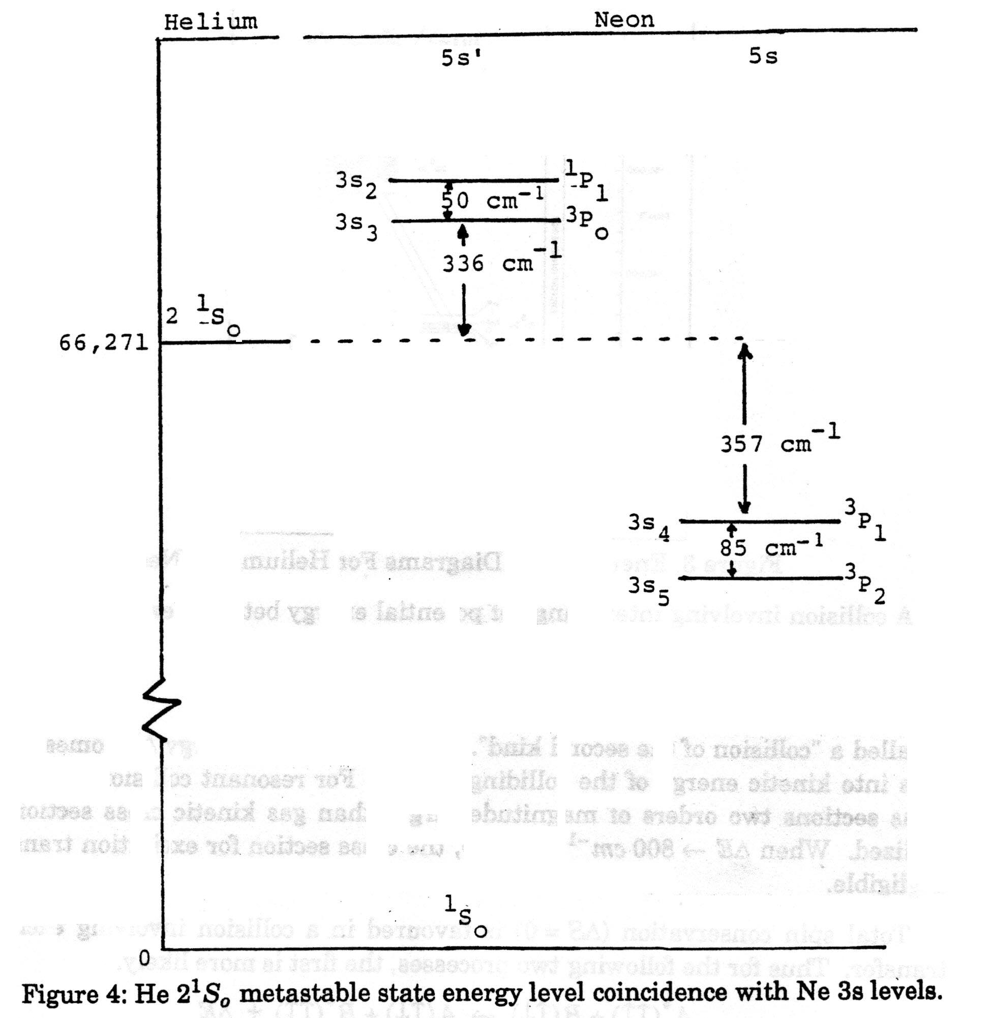
Although the ground states of He and Ne can be described in terms of L, S coupling, the excited states of Ne cannot as was pointed out in appendix I. If the excited s states of Ne could be described by L, S coupling, then, since there is one missing p electron (or hole) with (l = 1 and s = 1/2) and one s electron (l = 0 and s = 1/2), there would be four excited states. For S = 0 there would be a singlet ¹P₁ and for S = 1 there would be three triplet states ³P₂, ³P₁ and ³P₀ with the singlet state having higher energy than the triplet states. Why? The magnetic interaction produces an energy difference between the three triplet states and since the p electron is a result of the ion core being short one p electron from a closed shell, the three states are inverted in energy from what one would normally expect from a single p electron combining with an s electron. This means that in the triplet, the ³P₀ state is the highest in energy and the ³P₂ is the lowest. If L, S coupling were valid, one would expect the three triplet states to be close together compared to their separation from the singlet state. In figure 4, the four excited states arising from the ps electronic configuration are labeled with both Russell-Saunders and Paschen notations. It should be obvious that the predictions of L, S coupling are not really valid but the Russell-Saunders notation is included to indicate the state which would be a singlet (↑↓) if it were valid. As was pointed out in appendix I, the coupling is really j, l coupling which for the ps electronic configuration is equivalent to j, j coupling which may be easier to visualize (see White p 197). As Russell-Saunders coupling breaks down and proceeds toward j, j coupling (j, l coupling is intermediate between the two), the four states predicted by Russell-Saunders coupling change energy and move to states with the same J values in j, l coupling. Using Figure 4 and Table I one can see that this is true.
With this information in mind one can see why in a mixture of He and Ne the preferential selective excitation of the Ne 3s₂ level rather than the 3s₃ level occurs in the endothermic reaction
${\text{He}}^{}2^{1}S_{o}(\text{­¯})+{\text{Ne}}^{1}S_{o}(\text{­¯})→{\text{He}}^{1}S_{o}(\text{­¯})+\text{Ne}3s_{2}(\text{­¯})−DE(\text{386}{\text{cm}}^{−1})$
in which total spin is conserved, and a ΔE of 386 cm⁻¹ (about 2 kT) has to be provided from kinetic energy supplied by the discharge.
TABLE 1
Wavelength (nm) | Paschen Notation | Racah Notation
543.4 | 3s₂ - 2p₁₀ | $$5s^{'}[1/2]_{1}^{o}−3p[1/2]_{1}$$
588.1 | 3s₂ - 2p₉ | $$5s^{'}[1/2]_{1}^{o}−3p[1/2]_{3}$$
593.9 | 3s₂ - 2p₈ | $$5s^{'}[1/2]_{1}^{o}−3p[1/2]_{2}$$
604.6 | 3s₂ - 2p₇ | $$5s^{'}[1/2]_{1}^{o}−3p[1/2]_{1}$$
611.8 | 3s₂ - 2p₆ | $$5s^{'}[1/2]_{1}^{o}−3p[1/2]_{2}$$
629.4 | 3s₂ - 2p₅ | $$5s^{'}[1/2]_{1}^{o}−3p^{'}[1/2]_{1}$$
[632.8] | 3s₂ - 2p₄ | $$5s^{'}[1/2]_{1}^{o}−3p^{'}[1/2]_{2}$$
635.2 | 3s₂ - 2p₃ | $$5s^{'}[1/2]_{1}^{o}−3p[1/2]_{0}$$
640.1 | 3s₂ - 2p₂ | $$5s^{'}[1/2]_{1}^{o}−3p^{'}[1/2]_{1}$$
730.5 | 3s₂ - 2p₁ | $$5s^{'}[1/2]_{1}^{o}−3p^{'}[1/2]_{0}$$
544.9 | 3s₃ - 2p₁₀ | $$5s^{'}[1/2]_{0}^{o}−3p[1/2]_{1}$$
589.8 | 3s₃ - 2p₉ | $$5s^{'}[1/2]_{0}^{o}−3p[1/2]_{3}$$
595.7 | 3s₃ - 2p₈ | $$5s^{'}[1/2]_{0}^{o}−3p[1/2]_{2}$$
606.5 | 3s₃ - 2p₇ | $$5s^{'}[1/2]_{0}^{o}−3p[1/2]_{1}$$
613.7 | 3s₃ - 2p₆ | $$5s^{'}[1/2]_{0}^{o}−3p[1/2]_{2}$$
631.4 | 3s₃ - 2p₅ | $$5s^{'}[1/2]_{0}^{o}−3p^{'}[1/2]_{1}$$
634.4 | 3s₃ - 2p₄ | $$5s^{'}[1/2]_{0}^{o}−3p^{'}[1/2]_{2}$$
637.2 | 3s₃ - 2p₃ | $$5s^{'}[1/2]_{0}^{o}−3p[1/2]_{0}$$
642.2 | 3s₃ - 2p₂ | $$5s^{'}[1/2]_{0}^{o}−3p^{'}[1/2]_{1}$$
733.2 | 3s₃ - 2p₁ | $$5s^{'}[1/2]_{0}^{o}−3p^{'}[1/2]_{0}$$
Wavelengths are for transitions between 3s and 2p levels in Ne. Levels with odd parity have a "o" as a right superscript. Levels with even parity have no right superscript.
TABLE I (continued)
Wavelength (nm) | Paschen Notation | Racah Notation
566.3 | 3s₄ - 2p₁₀ | $$5s[3/2]_{1}^{o}−3p[1/2]_{1}$$
615.0 | 3s₄ - 2p₉ | $$5s[3/2]_{1}^{o}−3p[5/2]_{3}$$
621.4 | 3s₄ - 2p₈ | $$5s[3/2]_{1}^{o}−3p[5/2]_{2}$$
633.1 | 3s₄ - 2p₇ | $$5s[3/2]_{1}^{o}−3p[3/2]_{1}$$
641.0 | 3s₄ - 2p₆ | $$5s[3/2]_{1}^{o}−3p[3/2]_{2}$$
660.3 | 3s₄ - 2p₅ | $$5s[3/2]_{1}^{o}−3p^{'}[3/2]_{1}$$
664.1 | 3s₄ - 2p₄ | $$5s[3/2]_{1}^{o}−3p^{'}[3/2]_{2}$$
666.7 | 3s₄ - 2p₃ | $$5s[3/2]_{1}^{o}−3p[1/2]_{0}$$
672.1 | 3s₄ - 2p₂ | $$5s[3/2]_{1}^{o}−3p^{'}[1/2]_{1}$$
772.5 | 3s₃ - 2p₁ | $$5s[3/2]_{1}^{o}−3p^{'}[1/2]_{0}$$
569.0 | 3s₅ - 2p₁₀ | $$5s[3/2]_{2}^{o}−3p[1/2]_{1}$$
618.2 | 3s₅ - 2p₉ | $$5s[3/2]_{2}^{o}−3p[5/2]_{3}$$
624.7 | 3s₅ - 2p₈ | $$5s[3/2]_{2}^{o}−3p[5/2]_{2}$$
636.5 | 3s₅ - 2p₇ | $$5s[3/2]_{2}^{o}−3p[3/2]_{1}$$
644.5 | 3s₅ - 2p₆ | $$5s[3/2]_{2}^{o}−3p[3/2]_{2}$$
664.0 | 3s₅ - 2p₅ | $$5s[3/2]_{2}^{o}−3p^{'}[3/2]_{1}$$
667.8 | 3s₅ - 2p₄ | $$5s[3/2]_{2}^{o}−3p^{'}[3/2]_{2}$$
670.5 | 3s₅ - 2p₃ | $$5s[3/2]_{3}^{o}−3p[1/2]_{0}$$
676.0 | 3s₅ - 2p₂ | $$5s[3/2]_{2}^{o}−3p^{'}[1/2]_{1}$$
777.5 | 3s₅ - 2p₁ | $$5s[3/2]_{2}^{o}−3p^{'}[1/2]_{0}$$
When using this table one should be aware that not all lines listed actually appear because some transitions are forbidden. Also, some of the lines, especially those with lower p values in the Paschen notation may be very faint.
APPENDIX III
BEAM DIVERGENCE
The following formulae and facts are useful in determining the observed beam divergence.
- Equation (56) of Bloom (page 74) gives ω₁ the spot size at the mirror surface inside the cavity. Note that ω₁ is the 1/e radius of the field strength or the 1/e² point of the intensity. The radii of curvature of the mirrors, b₁ and b₂ are identical and are equal to 3 m. The separation of the mirrors is d.
- The exit mirror is really a thin plano-concave lens so that ω₁ inside the laser is very nearly ω₁ just outside the laser.
- The curvature of the wavefront inside the laser is just the radius of curvature of the mirror which is 3 m.
- Since the exit mirror is a plano-concave lens, the radius of curvature R₁ just outside the laser is the radius of curvature just inside the laser divided by n. You may take n, the index of refraction, to be about 1.5.
You may derive this change in curvature using single surface formulae (see Jenkins and White pp. 37-39). The curvature of the wavefront inside the mirror (which is now acting as a lens) is the curvature of the mirror. The curvature changes as it exits through the plane surface into air.
- Facts (1) and (4) allow you to calculate the beam radius ω₁ and the beam curvature R₁ of the gaussian beam just outside the exit mirror of the laser.
- Equation (69) of Bloom (page 103) allows you to find the effective distance z₁ of the beam waist or focus from the exit mirror. (This distance is different from what you would calculate if you were inside the laser.)
- Equation (70) allows you to calculate, ω_{o} the beam waist or beam radius at the focal point.
- Equation (71) then allows you to find the beam radius ω at any position z outside the laser. Here z is z₁ plus the distance from the mirror to the point of measurement.
- For very large distances z, the half angle of beam divergence in radians is just ω/z as z → ∞. This value of the half angle of the beam divergence is λ/(πω_{o}).
- Calculations using (71) should be compared with measurements of spot sizes at least two different distances.
APPENDIX IV
Chapter 1 of Principles of Lasers by O. Svelto
See http://site.ebrary.com.myaccess.library.utoronto.ca/lib/utoronto/docDetail.action?docID=10375078
or
http://books.google.ca/books?id=ioywRI5W2HEC&pg=PA1
APPENDIX V
Longitudinal Modes in a Laser
Consider the situation of two plane mirrors set parallel to one another. To a first approximation the modes of this plane parallel resonator can be thought of as the superposition of two plane e.m. waves propagating in opposite directions along the cavity axis. One should note the analogy with standing waves on a string. The resonant frequencies are obtained by imposing the condition that the cavity length L must be an integral number of half-wavelengths so that the electric field of the e.m. standing waves is zero on the two mirrors. So
$L=n\frac{λ}{2}$ (1)
and since
c = vλ (2)
the resonant frequencies are given by
$v=n\left(\frac{e}{2L}\right)$ (3)
This treatment is not sufficient to account for spatial modes because it assumes that the waves are travelling exactly parallel to the axis when in fact the plane waves may be propagating at very small angles to the z axis.
The modes of a rectangular cavity are well known and are given by
$v=\frac{c}{2}{\left[{\left(\frac{n}{L}\right)}^{2}+{\left(\frac{m}{2a}\right)}^{2}+{\left(\frac{l}{2a}\right)}^{2}\right]}^{1/2}$ (4)
where a is the lateral dimension of the cavity and n, m and l are integers giving the number of half-wavelengths in the z, x and y directions. To a good approximation the modes of the plane parallel resonator are described by the modes of the rectangular cavity when m and l are much less than n. From equation (1), one can see that this approximation is valid for any values of m and l that might be investigated. From equation (4), the frequency difference between two modes having the same values of m and l and whose n values differ by 1 is
${Dv}_{n}=\frac{c}{2L}$ (5)
These two modes differ only in their field distribution along the z axis (i.e. longitudinal). For this reason Δv_{n} is often referred to as the frequency difference between two consecutive longitudinal modes. Although the terms "longitudinal mode" and "transverse mode" are used, it is incorrect to think that there are two distinct types of modes. In fact, any mode is specified by three numbers n, m and l. The electric and magnetic fields of the modes are nearly perpendicular to the resonator axis. The variation of these fields in a transverse direction is specified by l and m while the field variation in a longitudinal (i.e. axial) direction is specified by n, When one refers, rather loosely, to a (given) transverse mode, it means that one is considering a mode with given values for the transverse indexes (l, m), regardless of the value of n. Accordingly a single transverse mode means a mode with a single value of the transverse indexes (l, m). A similar interpretation can be applied to the "longitudinal modes". Thus two consecutive longitudinal modes means two modes with consecutive values of the longitudinal index n [i.e. n and (n+1) or (n-1)[.
In practice one uses spherical mirrors instead of plane mirrors because the focussing property of spherical mirrors tends to concentrate the electric and magnetic fields along the resonator axis and thus light losses are avoided. For a spherical mirror the focal length is f = R/2. For this reason, the resonant cavity consisting of two identical spherical mirrors separated by their radius of curvature is said to be a confocal arrangement. For this arrangement light losses are minimal. The resonant frequencies for the confocal arrangement turn out to be
$v=c\left[\frac{2n+(1+m+l)}{4L}\right]$ (6)
The frequency spectrum is given in Figure 5.
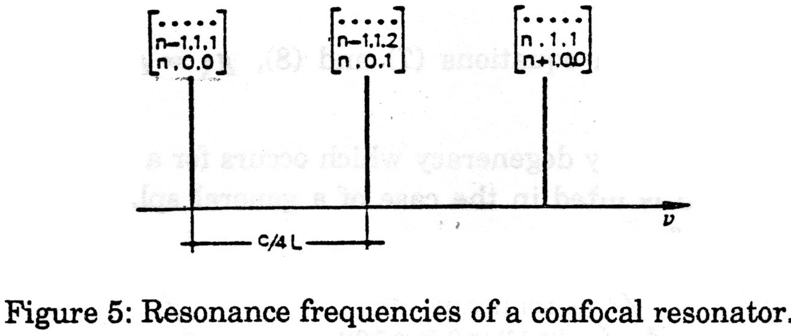
Note that modes having the same value of 2n + m + 1 have the same resonance frequency although they have different spatial configurations. These modes are said to be frequency degenerate. Note also that, unlike the plane mirror case where only plane waves were considered, the frequency spacing is now c/4L. The frequency spacing between two modes with the same (l, m) values (e./g. TEM₀₀) and with n differing by 1 (i.e. the frequency spacing between two adjacent longitudinal modes is, however, c/2L as for the plane case).
As a numerical example, if R = L = 3 m, then in the apparatus for this experiment there will be beat frequencies at 25 and 50 MHz.
If the mirrors are not identical or if the arrangement is not confocal, one generalizes to the case of a resonator consisting or two spherical mirrors with radii of curvature R₁ and R₂ separated by a distance L. For convenience g₁ and g₂ are defined by
$g_{1}=1−\frac{L}{R_{1}}$ (7)
and
$g_{2}=1−\frac{L}{R_{2}}$ (8)
The resonance frequencies for the general spherical resonator are
$v=\frac{c}{2L}\left[n+(l+m+1)\frac{{\text{cos}}^{−1}(g_{1}g_{2})^{1/2}}{p}\right]$ (9)
Equation (6) for a confocal resonator is a special case of equation (9) for if R₁ = R₂ = L, then from equations (7) and (8), g₁ = g₂ = 0 and equation (9) reduces to equation (6).
Note that the frequency degeneracy which occurs for a confocal resonator which is shown in figure 5 is lifted in the case of a general spherical resonator. This is illustrated in Figure 6.
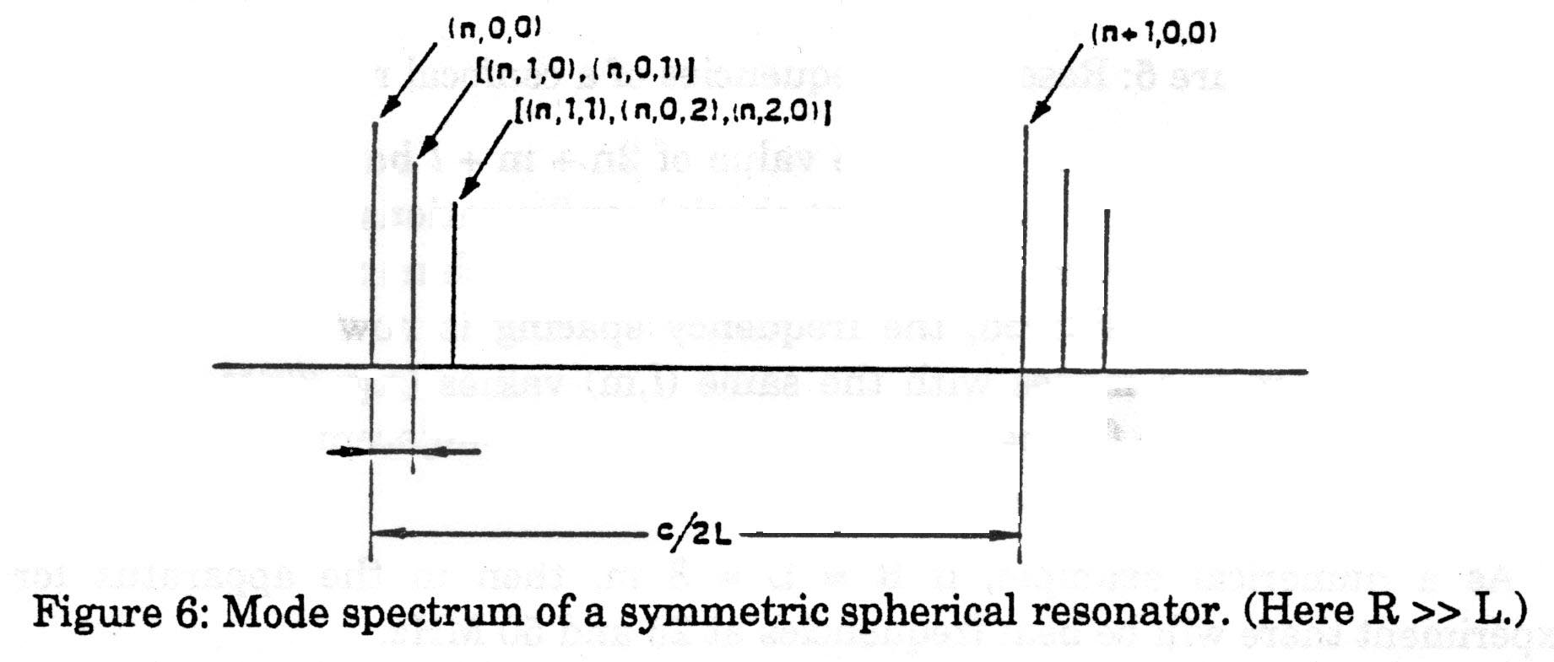
As a numerical example, one can show that if F = 3m and L = 2.8m then in the apparatus for this experiment there will be beat frequencies for 25.7, 27.9, 51.3, 53.6 and 55.8 MHz. The value of 53.6 MHz is the value that would be obtained if one simply assumed a confocal arrangement with L = 2.8m.
APPENDIX VI
Emission Spectrum of Neon
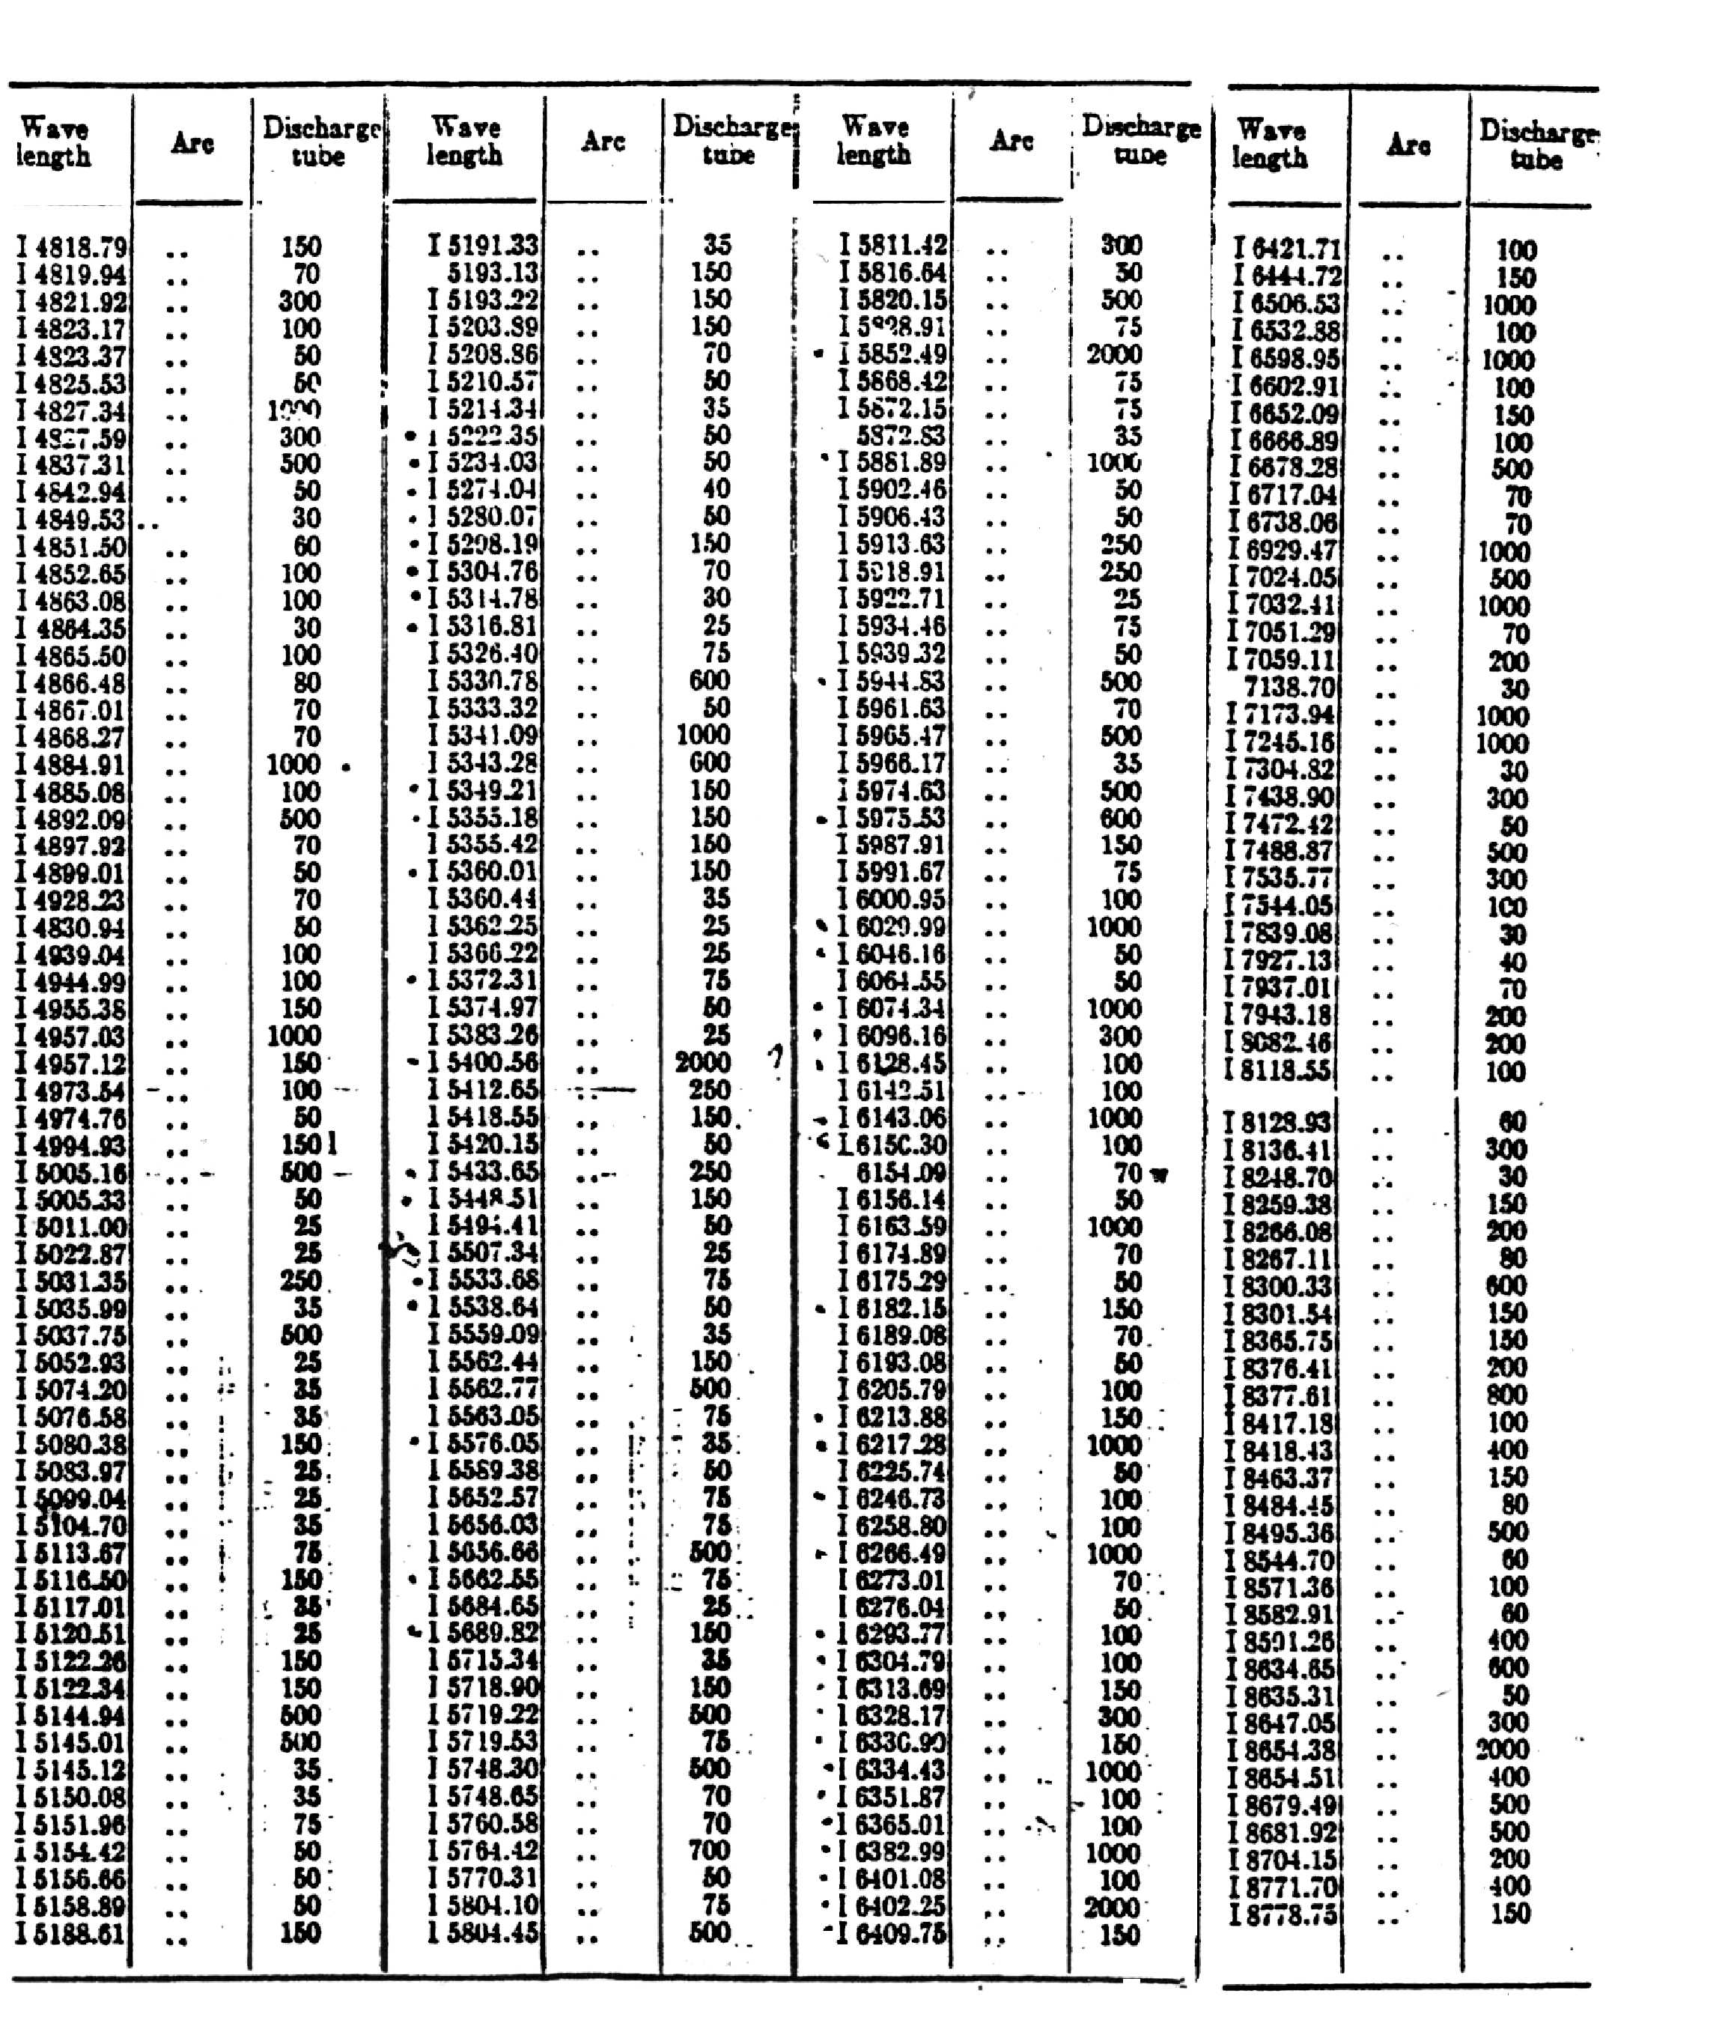
APPENDIX VII
Gaussian Beam Optics
Melles Griot provides a discussion of Gaussian Beam Optics in its catalogue at https://www.physics.utoronto.ca/~phy326/hene/Gaussian-Beam-Optics.pdf.
Gaussian beams are confusing only because there are many different choices of the important parameters that various authors use to describe them. It might help to keep in mind besides the wavelength there are only two independent parameters required. One possible choice for the pair is the minimum beam waist w₀ and its location in space. A common practice is to place the beam waist at the origin of a cylindrical coordinate system, with r giving the radial coordinate and z the displacement along the beam direction.
The catalogue gives the radius of curvature and the beam radius at a position z, in terms of z and w₀. Other possible choices involve replacing w₀ by the far field divergence θ or the Rayleigh range/distance z_{r}. The parameter z_{r} is often called z₀, the confocal parameter.
A better discussion, than that given by the Melles Griot catalogue, of the propagation of Gaussian beams through optical components is in terms of the ABCD law. See Yariv, Quantum Electronics, second edition equation 6.6-14a for a definition of the complex beam parameter and equation 6.7-6 for the ABCD rule. [Note w(z) of Melles Griot = ω(z) of Yariv.] Although not at all clear from Yariv, the values of A, B, C and D are the components of the 2 × 2 matrices $\begin{aligned}\left[\text{AB} | \right] \\ \end{aligned}$given on page 101 of Yariv. To relate the beam radius and curvature at one plane to the radius and curvature at another plane from the product of the 2 × 2 matrices for all optical elements between the two planes. This will give you the net A, B, C and D to use in equation 6.7-6. Thus you can find the new R and w. Once you have these, then the equations in the section on Real Beam Propagation in the Melles Griot catalogue permit you to find the location and size of the beam waist.
A discussion of laser or Fabry-Perot cavities can be given in terms of Gaussian beam parameters. The connection is simple. Mirrors are surfaces of constant phase. Thus apply subscripts to R and z for mirror 1 and 2 and demand that z₁ + z₂ = L, the length of the laser. You can then solve for z₁, z₂ and w₀. The simplest case is the symmetric cavity. You know that z₁ = z₂ = L/2. Thus w0 can be found immediately. A confocal interferometer has R₁ = R₂ = L. It has the advantage that all modes, not just the (0,0) or Gaussian mode have a frequency that is a multiple of c/(4L).

† Leon J. Radziemski, “Spectroscopic notation for the energy levels of helium and neon”, Optics News, January 1989, p15-16.

