ADVANCED UNDERGRADUATE LABORATORY

**HeNe**

**The Helium-Neon Laser**

Revisions:  
September 2019: David Bailey  
December 2011: David Bailey  
October 2004: Joseph Thywissen  
Original: D.A.L. Paul

Copyright © 2019 University of Toronto  
This work is licensed under the Creative Commons  
Attribution-NonCommercial-ShareAlike 3.0 Unported License.  
(<http://creativecommons.org/licenses/by-nc-sa/3.0/>) [](http://creativecommons.org/licenses/by-nc-sa/3.0/)

**Objective**

To observe and understand the fundamental properties of a laser.

**Section 1. Background**

A laser is an optical oscillator and thus consists of an amplifier with positive feedback. The amplification in a He-Ne laser arises in the glow discharge while feedback of the optical radiation is provided by two highly reflecting, well aligned mirrors. The conditions necessary for amplification are fulfilled as a consequence of the different ways in which an atom may emit or absorb radiation.

An isolated atom in an excited state will emit radiation spontaneously, with radiation from different atoms being uncorrelated in time and direction of emission. If, however, an excited atom is situated in an electromagnetic field of an appropriate frequency, it may be stimulated to make a transition to a lower state accompanied by the emission of radiation (Appendix IV, Fig 1.1). The probability for this stimulated emission will be the same as for the absorption of the same frequency to excite an atom from the lower state to the higher state, as long as the statistical weights of the upper and lower states are the same. If stimulated emission is to exceed absorption, the number of atoms, N, in the upper state must exceed the number in the lower state. If the states have different statistical weights, g, it is N/g rather than N which is the important factor. The stimulated emission is in phase and in the same direction as the stimulating radiation, which means that the emitted photon cannot be distinguished from the incident photon.

The basic principles of laser operation are described by **Svelto** (1982), and the relevant pages are reproduced in **Appendix IV**.

In a He-Ne laser operating at 632.8 nm there is an inversion of the populations of the (2p)5 5s and (2p)5 3p levels of Ne. The inversion arises principally from inelastic collisions between Ne atoms in their ground state and He atoms in their 21So metastable level. The details of the excitation transfer mechanism as well as the various atomic level notations are discussed in **Appendices I and II**.

Steady oscillation only occurs if the gain in intensity of a wave travelling along the laser tube is equal to the losses due to diffraction, absorption, spontaneous emission in directions unfavourable to lasing, and transmission at the windows.

Assuming the laser has been constructed and adjusted so that it is capable of lasing, the trigger mechanism that gets it started in a lasing mode is spontaneous emission. Since the neon atoms have considerable thermal energy (T~300K) the spectrum of photons available follows a Doppler-broadened profile as illustrated by the dashed line in Fig. 1. The precise frequencies at which lasing takes place within this profile are, however, determined by the longitudinal modes, that is to say, the possible standing waves that can occur. For plane-parallel mirrors the condition is N /2 = L, where N is a large integer,  the wavelength, and L the optical path length between the reflecting mirror surfaces. A discussion of longitudinal modes is given in **Appendix V**. Figure 1 shows a Doppler-broadened gain curve of a 30 cm-long laser supporting six possible longitudinal modes or cavity resonances. The gain curve is the same shape as the line profile in spontaneous emission. The maximum number of modes is limited by the Doppler width (Fig. 1) and the Doppler width will depend on the thermal motion of the neutral neon atoms in the laser.

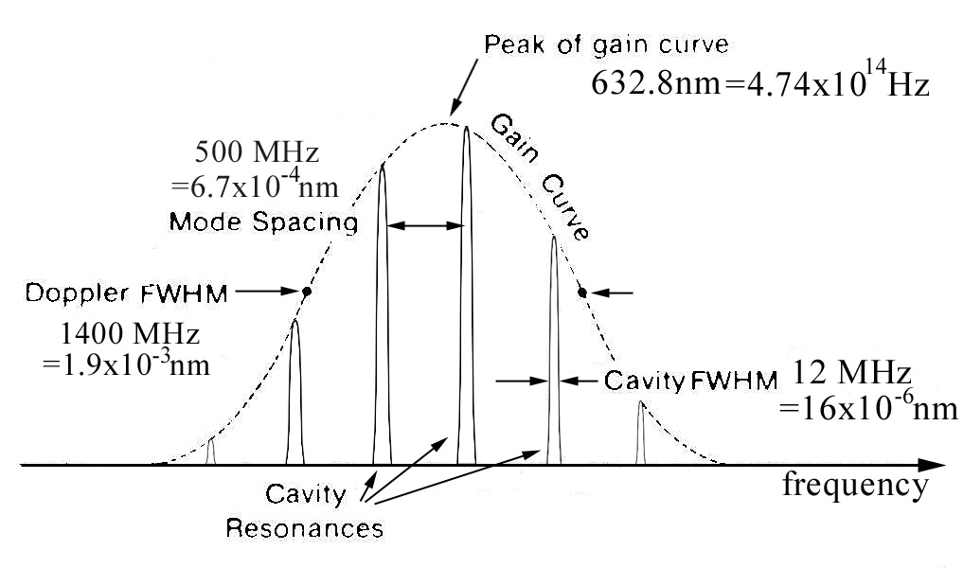

Figure 1. Longitudinal Modes in a laser.

For curved mirrors, transverse modes that have variations in intensity across the laser beam may be excited. These modes have slightly different frequencies and their difference frequency will produce longitudinal modes of correspondingly different frequencies. Transverse mode patterns are described in several books, e.g. **Bloom** (1968).

For the lasers in this laboratory, identical mirrors having a radius of curvature R = 0.6 m have (when new) a reflectivity >99.9% at 632.8 nm. Since these mirrors are outside the cavity, the end-windows are cut at Brewster’s angle to avoid reflection losses.[1]†

#### Safety Reminders

* **NEVER TAMPER WITH THE HIGH VOLTAGE CABLE AND CONNECTION.** Let lab staff know if you notice any damage to them
* Never look directly into the laser beam. This laser is low power and will not damage your eye permanently unless you stare into it fixedly, but you should practice “safe lasers”.
* **NEVER TOUCH THE END WINDOWS OF THE LASER OR THE SURFACES OF THE MIRRORS.** This will not hurt you, but it may hurt the laser. Even tiny scratches or smears will stop the laser working and it may take weeks to fix. **Ask the technologist for help if you think the windows or mirrors need cleaning.**

*NOTE: This is not a complete list of all hazards; we cannot warn against every possible dangerous stupidity, e.g. opening plugged-in electrical equipment, juggling cryostats, …. Experimenters must constantly use common sense to assess and avoid risks, e.g. if you spill liquid on the floor it will become slippery, sharp edges may cut you, …. If you are unsure whether something is safe, ask the supervising professor, the lab technologist, or the lab coordinator. If an accident or incident happens, you must let us know. More safety information is available at* [*http://www.ehs.utoronto.ca/resources.htm*](http://www.ehs.utoronto.ca/resources.htm)*.*

**Section 2. Suggested Exercises.**

After turning on the laser (see Section 3), try investigating several properties of the laser:

1. *Measure the wavelength of the laser light*. While you have the laser operating in the *TEM*0,0 mode at low power, reflect some of the laser beam into the spectrometer so as to measure the central wavelength of the light. Use the spectrometer with the entrance slit narrowed and without the focusing lens, in order to avoid overloading the detector. Make a search at higher sensitivity for other possible lasing lines between 500 and 650 nm. If none are found, set upper limits on the intensities of such lines.

2. *Transverse modes and cavity alignment*. Essential to the operation of this laser is a cavity in which allows sufficient gain before light leaves the laser cavity. If the cavity is misaligned, the lasing behavior will stop. Indeed, if you suspect this is the case, you should seek assistance to re-align the laser.

However, with only slight misalignment, you can excite several different transverse modes. Observe and identify several of the transverse modes. Simply look at the beam on the far wall and change the mode pattern by adjusting the position and size of the diaphragm or by adjusting the laser mirrors. Modes can be recorded using the camera and computer setup. Another way to excite transverse modes is to insert a hair into the beam between the Brewster window and the output mirror.

When the laser is as purely TEM00 as possible, is the output distribution a Gaussian, or still have higher modes mixed in? *Using the translating pinhole and detector*, record the intensity versus position across one axis. In measuring the profile it is important to measure the background intensity (if any) far enough out on each side of the profile that you should be well clear of it. Such data facilitate a better analysis of the gaussian itself. To verify the Gaussian form, you may wish to fit the profile to a Gaussian, e.g. using a Python (or other) curve fitter.

3. *Measure the longitudinal mode frequencies of the laser light.* Using the Fourier Transform spectrum analyzer, measure the beat frequency between two successive longitudinal modes. **Appendix V** tells you more about what to expect and how to interpret your results. (Remember you are not measuring the frequency of the laser light, but the *beat* frequency between two modes.)

4. [Optional:] *Measure the divergence of the laser beam*. Do this by measuring the width of the output beam at several positions, and compare to the theory in the Melles Griot notes at the end of the Appendices. Is this laser beam diffraction limited? See **Appendix III** for more information on comparing beam width measurements to beam divergence.

5. [Optional:] *Examine the spectrum emitted by a Ne lamp* and compare it to the spectrum of incoherent light emitted by the He-Ne discharge (side light). You can show that the He in the He-Ne discharge enhances lines arising from the upper laser level (see **Appendix II**), as is needed to achieve sufficient population inversion for the He-Ne laser. Find at least two examples that demonstrate the relative enhancement.

When deciding which lines to compare, make sure that you understand the excitation transfer mechanism described at the beginning of appendix II. All the information that you need to perform exercise 5 is in Appendix II. Also, some lines which are listed in Table I do not actually appear since they are forbidden due to the selection rules : ∆J = 0, ±1 are allowed; except that J = 0 J = 0 is forbidden.

A reasonably complete list of Neon lines in the region of interest with their approximate intensities is given in **Appendix VI**.

**Section 3. Guide to parts and components**

**Laser and power supply**

Complete nstructions for setting up the laser from scratch can be found in the Ealing HeNe manual (<https://www.physics.utoronto.ca/apl/hene/Manual_HeNe_Kit_v1.4.pdf>). Since adjusting the mirrors can be tricky and there is a chance that the laser is already well-aligned, **it is best to first simply turn on the laser and see if it lases**. (Give it a minute to warm up.) If this does not work, follow the steps in Section 5.7 of the Ealing manual.

**Spectrometers**

Two tools to measure frequencies are used in this lab. Be careful not to confuse them. The *grating spectrometer* is used to measure the wavelength of light with a resolution of a few nanometers. It uses the wavelength-dependent angle of diffraction of light off a ruled grating to measure frequency. The *Fourier transform spectrum analyser* measures an electrical signal as a function of time, and displays its Fourier transform. As indicated in Figure 1 on page 3, these devices need to operate at frequencies orders of magnitude apart.

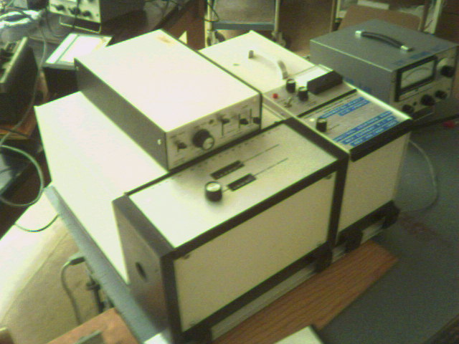

Figure 3: Old grating spectrometer

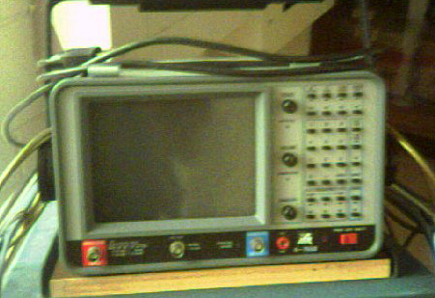

Figure 3: Old fourier transform spectrometer

**Beam profilometers.**

Both a scanning pinhole and a camera can be used to measure beam profiles in this lab. The camera provides two-dimensional pictures, especially useful when looking at higher-order modes. The pinhole provides simple voltage-versus-position data which is already calibrated (since it is on a translation stage) and easier to fit. If you choose to use the camera for all your measurements, be sure to calibrate it!!

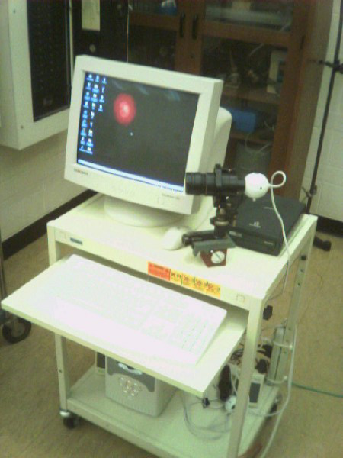

Figure 4: Camera and computer to measure beam profile

Pinhole photo-detector: For these measurements the AMPLIFIER/DETECTOR switch on the detector supply should be set to AMPLIFIER. The detector is a photodiode and the output current is proportional to the input light intensity. The manufacturer states that the maximum deviation from a straight line over the range of intensity from the limit of detectivity to 10 *mW/cm*2 is 2% but beyond this, major deviations in linearity will begin to occur. For this device, an output voltage of 2 V corresponds to an input intensity of approximately 10 *mW/cm*2.

**References**

A. L. **Bloom**, “Gas Lasers” (J. Wiley, 1968, TK 7871.3 B55)

F.A. **Jenkins** and H.E. **White**, “Fundamentals of Optics” 4th Edition (McGraw Hill, QC 355 J4)

H.G. **Kuhn**, “Atomic Spectra” 2nd Edition (Longmans, 1969, QC 451 K9)

O. **Svelto**, “Principles of Lasers” 3rd Edition (Plenum, 1989, QC 688 S913)

K. **Thyagarajan** and Ajoy **Ghatak**, , “Lasers : Fundamentals and Applications” , 2nd Edition 2010 Springer, 2010, available online at <http://site.ebrary.com.myaccess.library.utoronto.ca/lib/utoronto/docDetail.action?docID=10421207>)

H.E. **White**, “Introduction to Atomic Spectra” (McGraw-Hill, 1934, QC 451 W5 D)

A. **Yariv**, “Quantum Electronics” 2nd Edition (J. Wiley, 1989, TK 7870 Y3)

1. † See last paragraph of Chapter 11.5 of Thyagarajan and Ghatak.