University of Toronto
ADVANCED UNDERGRADUATE LABORATORY

HEP

High Energy Physics

Revisions:
2020 October: P. Krieger (minor corrections)
2014 December: Syed Haider Abidi, Nooruddin Ahmed, Christopher Dydula
2013 August: P. Krieger
2006 August: Jason Harlow
1992 January: John Pitre and T.S. Yoon

Please send any corrections, comments, or suggestions to the professor currently supervising this experiment, the author of the most recent revision above, or the Advanced Physics Lab Coordinator.

Copyright © 2014 University of Toronto
This work is licensed under the Creative Commons
Attribution-Non Commercial-Share Alike 3.0 Unsupported License.
(http://creativecommons.org/licenses/by-nc-sa/3.0/)

Introduction
In this experiment you are provided with a set of images showing the interactions of π+ mesons with the protons of a liquid hydrogen bubble chamber. Two of the images, which show evidence for "strange" particle production, have been selected. The purpose of this experiment is to give you an opportunity to learn about high energy, or particle physics by fully identifying the secondary particles emerging from these two reactions and by testing the validity of various conservation laws.
The section on Theory gives a minimum description of the things you will need to know to do this experiment. You should take some time to look at the introductory chapter(s) of least one of the books listed in the References.

Theory

Particle Physics
Around the 1930's the only known particles were the constituents of atoms (the electron, and the nucleons - i.e. the proton and the neutron), and the quantum of light (the photon). One outstanding mystery, at that time, was how nucleons manage to stick together to form the nuclei of atoms, since the positively charged protons will repel one another. Yukawa postulated a mechanism for the attractive interaction of two nucleons; this was provided by a new, hitherto unobserved particle which could be exchanged between them. This theory was “confirmed” in 1947 when a particle with all the correct properties, christened the pi-meson (π), was observed in the products of high-energy interactions of cosmic rays with the nuclei of photographic emulsion. It appears in three charge states, π+, π- and π0.
Immediately following this discovery it was realized that the high-energy collisions of nucleons produced not only π mesons, but also a host of other particles, distinguished by different masses, spins and other properties; see Appendix I for a partial list.

These particles can interact with each other through the action of four fundamental forces of nature:

First there is the strong interaction which accounts for the binding of nucleons, and the production of π mesons in nucleon-nucleon collisions. This force is so strong that it operates in a very short time: the characteristic time for two nucleons to interact is given approximately by the time a particle, (such as the π) travelling close to the speed of light (3 × 1010 cm s-1), takes to cross a nucleon (of size ≈ 10-13 cm), or about 10-23 seconds.

Second in strength is the electromagnetic interaction, which is responsible for the radiation of electromagnetic waves from an accelerated charge, or the Coulomb interaction between charged particles. Any interaction which involves the quantum of the electromagnetic field, the photon, is due to the electromagnetic interaction. This interaction, being about 1000 times weaker than the strong interaction, takes longer to act, with a typical time-scale of 10-16 seconds.

Third is the weak interaction, whose effects were first observed in nuclear physics. This interaction is responsible for the β-decay of nuclei (involving the emission of a positive or negative electron). It is approximately a factor of 10-11 weaker than the strong interaction, and has a characteristic time of 10-10 to 10-8 seconds. The electron (positive and negative, e±), the muon, μ±, and the neutrino, , and antineutrino, , belong to the class of particles referred to as leptons; neutral leptons interact only via the weak interaction while charged leptons interact via both the weak interaction and the electromagnetic interaction, the latter by virtue of their electric charge.
The fourth is the gravitational interaction, which is so weak (about a factor of 10-39 weaker than the weak interaction) that its effects are apparent only when huge masses (by particle standards) are present. This interaction is therefore not part of the Standard Model of Particle Physics.

The study of these four forces and their interrelation provide the central unsolved problems of particle physics. To whet your appetite for further reading, it is worthwhile to point out a few important discoveries since the middle of the 1960's.

- Most of the particles with which we are dealing in this experiment are not truly elementary but rather are composite particles. This is true for all hadrons (strongly interacting particles) such as the proton, π, Λ° and K°. Baryons are hadrons made of 3 quarks (e.g. proton, Λ°, …) and mesons are hadrons make of a quark-antiquark pair (e.g. π, K°, …) There are now known be 6 “flavours” of quarks, but only three were known of when this bubble chamber experiment was done [2, 3, 4]. The six flavours of quark are grouped into three generations. The final quark to be experimentally verified was the top quark, which was discovered in 1995.

- As stated earlier, the electron, muon and neutrino belong to a class of particles called leptons. So far, these appear to be elementary (i.e. fundamental or structureless). There are also three generations of leptons, each consisting of a charged lepton and an associated neutrino. These are (v_{e}, e-), (v_{μ}, μ-), (v_{τ}, τ-) [9].

- The electromagnetic force and the weak force are now unified under the name "Electroweak Force". The electroweak force is mediated by the combined effects of the photon, W± bosons and the Z° boson [8].

Mass, Energy and Momentum

It is in particle physics that the theory of special relativity really comes into its own, for the particles have so little mass that even relatively low-energy particles travel with speeds approaching the speed of light. The most striking feature of the theory, that mass and energy are equivalent (i.e. ) is illustrated in this experiment (for example) by the way in which particles are produced in the pion-nucleon collisions: some of the kinetic energy of the initial pion is converted to mass energy, with the consequent materialization of the particles in the final state.
In any interaction between particles, both vector momentum, and total energy must be conserved. This can be written symbolically as

$\vec{P_{i}}=\vec{P_{f}}$ (1)

and

$E_{i}=E_{f}$ (2)

where the indices i and f label the initial and final states, respectively. Note that in (1), since it is a vector equation, three equations, referring to the x, y and z directions are implied, and that in (2), E means total energy (i.e. mass energy plus kinetic energy).
The units most commonly used for energy are multiples of the electron volt (eV) which is the energy of an electron accelerated through 1V of potential difference. 1 eV is equivalent to 1.6 × 10-19 joules. 1 MeV is 106 eV, and 1 GeV is 109 eV. Modern particle colliders such as the Large Hadron Collider at CERN operate in the TeV energy range (1012 eV).
The mass energy of a particle of rest mass m_{o} (particle physicists almost always mean rest mass when they talk about mass) is given by E = m_{o}c2. From this equation it is clear that if energy is given in MeV, the units of mass can be written as MeV/c2. If the particle is moving with speed V, and β = V/c, its momentum is defined by p = γ m_{o}V, or p/c = γ m_{o}β where γ = (1 - β2)-1/2. Thus we see from this equation that if we measure m_{o} in unit of MeV/c2, the units of momentum can be written as MeV/c.
The general expression for the total energy of a particle of rest mass m_{o}, with momentum p is

E2 = p2_{o}c2 + m2_{o}c4, (3)

which is exactly equivalent to E = mc2 = γ m_{o}c2, which may be more familiar to you. If we measure energy in MeV, mass in MeV/c2 and momentum in MeV/c, equation (3) becomes:

E2 = p2 + m2 (4)

Note: A final complication of our use of units is that some books and tables drop the c2, or c, and quote all units as MeV or GeV. They mean the same thing! Equations (1), (2), and (4) are necessary for the calculation of the quantities you will need in this experiment.

Strange Particles

As can be seen from Appendix I, most of the particles decay to other particles soon after they are formed. These then decay until we are left with the completely stable particles, the p, n, e, γ and v. This, of course, is one of the reasons that the majority of particles escaped detection for so long. If you look at the decay times for the unstable particles in the tables in Appendix I, you will see that their mean lifetime seems quite short -- around 10-6 to 10-10 seconds. However as we have seen above, these times are long on the time-scale defined by the strong interaction (10-23 seconds). In fact these times are so long, that particle physicists refer to them as "Stable Particles". In fact, for example, a π± meson, with lifetime around 10-8 s, can travel a long way when you consider its speed is close to 3 × 1010 cm s-1. That is why we can make "beams" which deliver π± mesons to detection equipment many meters away from their point of production. (Question: In this experiment, you will see many π+ mesons travelling the 82 inches (≈ 200 cm) of the bubble chamber without decaying. Is this consistent with a lifetime of 10-8 s?)
For the case of the π meson, its relatively long lifetime has a natural explanation: the π meson mass (energy) is so low that it cannot decay into any other particles except the μ, the e and the neutrino. This can happen only via the weak interaction (why?), so takes place over the corresponding characteristic time-scale. In contrast, the K meson, which is produced via the strong interaction, has enough mass (494 MeV/c2) to decay to two π mesons, each of mass 140 MeV/c2. The π meson participates in the strong interaction (in fact, as discussed earlier, it was first postulated to explain this interaction). Thus we might expect the K to decay to two pions on the timescale characteristic of the strong interaction (≈10-23 seconds). Instead, as is shown in Appendix I, the K meson lifetime is close to what we would expect from a weak interaction. The K meson, and the Λ, Σ, Ξ, and Ω baryons, all of which exhibit similar puzzling behavior, were dubbed "strange" for this reason.
To provide a mechanism for explaining the properties of these strange particles, a new quantum number, S, "strangeness", was invented. The value assigned to each particle is shown in Appendix I and is appropriate only for particles that can interact strongly. Anti-particles have S values which are the negative of that of the particles. The rule for strong interactions is that the value of S may not change from one side of the interaction to the other (i.e. S is a conserved quantum number). For weak interactions, S may change by one unit. Thus

π- + p → K0 + Λ0

may proceed via the strong interaction strong (total S on both sides is zero) while

K0 → π+ + π-

can proceed only via the weak interaction (S is +1 on the left, but 0 the right).

(Question: How about the decay Λ0 → p + π-?)

This classification does not explain the underlying physics, but it is a useful empirical rule which has been well tested.

Conservation Laws

In writing down a particle reaction there are a number of quantities which must always be conserved (i.e. have the same value in the initial and the final state). Some of these are:

- Energy and momentum: equations (1) and (2) always apply.
- Charge: the total electric charge must be the same before and after the interaction.
- Baryon Number: it is observed (from the fact that we exist!) that the proton (or the bound neutron – why “bound”?) cannot decay into two pions, or to an electron and a pion, even though it has enough mass energy to do so. The proton, the neutron, and all particles made up of three quarks are called baryons, and are assigned a baryon number, B. The baryon number of the particles relevant to this experiment are indicated in Appendix I and, as with S, the anti-particles have B values which are the negative those of the particles. The sum of the B numbers for all the particles on one side of an interaction must be the same as the sum for all particles on the other. This is a complicated way of saying that the number of baryons is conserved in a particle interaction. No such conservation law holds for the photon or for the mesons. Many of these can be produced or absorbed in an interaction as long as overall energy is conserved.
- Strangeness. As discussed above, S must be conserved in all strong interactions. This means that if we produce one strange particle in a strong interaction, we must produce at least one other with it (more specifically, if a particle containing a strange quark appears in the final state (of a strong interaction process) there must be another containing an anti-strange quark. If the strangeness number does change by one unit however, we know the interaction is weak.

Apparatus

Bubble Chamber Theory

The bubble chamber was for many years one of the major pieces of equipment for detecting particles. In modern experiments it has been replaced by electronic detectors, but bubble chamber results still provide an excellent environment in which to visualize particle interactions. A bubble chamber basically consists of a tub of liquid hydrogen, kept superheated under pressure. A beam of particles, produced by a particle accelerator, is fired into the chamber. The particles, if they are charged, ionize (i.e. knock out electrons from) the hydrogen atoms which they encounter along their path. The electrons are too light and too loosely bound to affect the particle's momentum in any significant way: the electric (Coulomb) field which the charged particles carry along with them effectively strips the electron from the atom. Now and again one of the beam particles (in this case) will interact through the strong interaction with one of the protons in the hydrogen, and new particles may be produced. These, if they are charged, will also ionize atoms along their path. If the pressure is now slightly reduced, the liquid hydrogen gets closer to boiling. The ionized atoms form centres around which bubbles begin to grow. (The mechanism is similar to the one responsible for causing bubbles in boiling water to form preferentially from rough spots in a pan). When they have grown big enough to see, a photograph is taken (usually three different views are photographed). The chamber is then re-compressed, the bubbles are squeezed out, the ions and electrons recombine and the chamber is ready for the next burst of beam particles. (Question: is the interaction responsible for ionizing the atom due to the weak, electromagnetic, or strong interaction?)
The "ionization density" tells us something about the nature of the particle causing the track. It turns out that the slower the particle, the greater its chance of ionizing the atoms it passes close to. In fact, the number of bubbles per unit length of track is proportional to c2/V2 where V is the speed of the particle. When V approaches c, i.e. when the particle is moving with high momentum, the ionization density approaches a constant minimum value. Such particles are referred to as “minimum-ionizing”. If this value, which corresponds to the ionization density of the high momentum beam tracks, is given a value of 1.0, all other tracks can be given a numerical value of ionization density relative to this. Thus a track with a value of 2.5 has two and a half times as many bubbles per unit length as a minimum ionization beam track. In order to calibrate your eye, note that when two beam tracks happen to overlap in the chamber, then the ionization density is 2.0.

Figure 1 shows the range and energy loss of π and K mesons and also of protons as a function of momentum. Relative ionization density values are obtained from the energy loss curves by the method described in the caption of Figure 1.
Make sure you understand the gross features of Figure 1. Why, for instance does the dE/dx curve for the proton lie above that for the K, and that above the curve for the π? Where would you expect the curve for the electron to lie? Note that the abscissa of this graph is momentum rather than velocity, since momentum is the quantity that is experimentally available. So for a known momentum, the ionization density sometimes allows the particle to be identified, provided it is in a relatively low momentum region (where the curves for different particles can be distinguished).

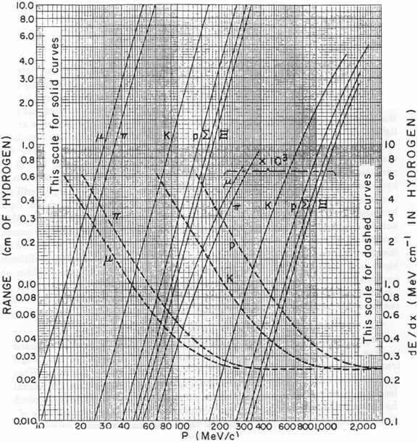

Figure 1. Range and Energy Loss (dE/dx) in liquid hydrogen. Dashed curves give the ionization energy loss, dE/dx; its scale is given on the right side. To obtain relative ionization density, one divides the dE/dx value by the dE/dx value of the pion at 10 GeV/c, which is seen to approach about 0.24 MeV/cm. For example, at 700 MeV/c, the proton has dE/dx of 0.48 MeV/cm which corresponds to 2.0 in relative ionization density.

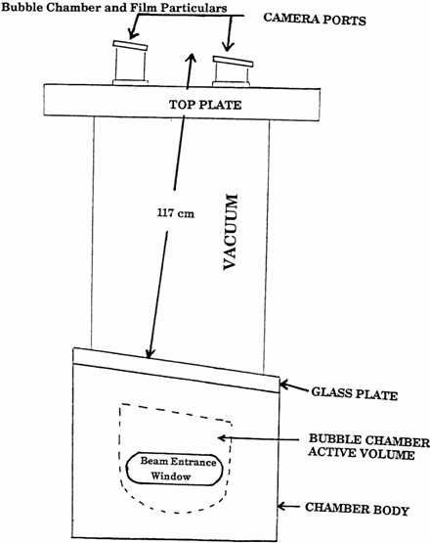

Figure 2. View of the 82 inch Chamber (viewed along the beam path).

The images used in this experiment are from the 82 inch long hydrogen bubble chamber (shown schematically in Figure 2) which was located at the two mile long Stanford Linear Accelerator Centre (SLAC). The beam consists of π+ mesons of momentum 10.3 GeV/c. The entire chamber sits in an almost uniform magnetic field of 15.5 kG, which explains the curvature of the tracks. (Question: Which tracks curve the most - those of high or low momentum particles? Is the field into or out of the plane?)

Figure 3 shows how the chamber looks from the cameras; the following things are worth noting:

- There are three cameras whose locations are indicated in figures 2 and 3. Each camera has its own roll of film, and each roll of film is labeled by view number 1, 2, or 3 (view 1 is specified if the first two digits are 10 in the picture number at the bottom of the film frame). In the present experiment, two pieces of film from two different views (1 and 2) have been spliced together.
- A set of numerals are used to produce the picture number. In addition to the view number, the roll number, (a typical experiment will take 500 rolls of film per cameras, each with 1000 exposures), and the frame number or the number of exposure within that roll. The way these numbers appear is shown in figure 3.
- The "rake" numbers, which run along the side of each frame, give a rough way of locating an event of interest within a frame.
- In order to allow the full 3-dimensional reconstruction of an event from the measurement of 2 or 3 one-dimensional views, it is convenient to have some points which appear on all views, and whose absolute location in space can be very well measured before or after the experimental run. These are called "fiducial marks" and appear as crosses on the film. Since this experiment has been arranged so that a 3-dimensional reconstruction is not necessary, these are of little interest to you.

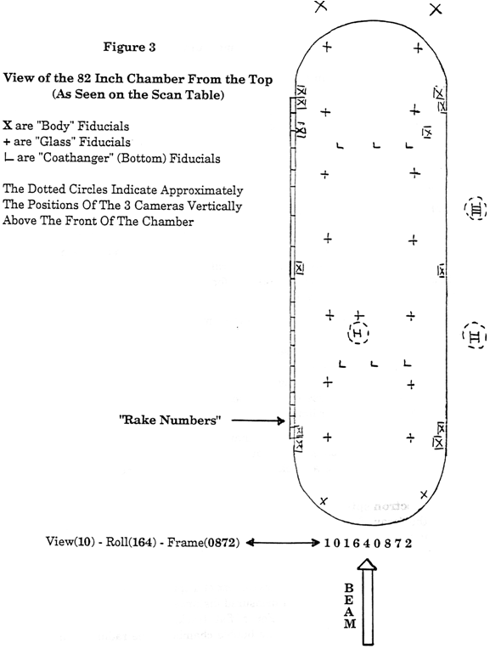

Preliminary Investigations

To start with the preliminary investigations, you should first open the scanned images for the bubble chamber events (the low-resolution images are adequate for this). Make sure you know how to read the view, roll and frame numbers. Browse through some of the pictures and look for some typical interactions, some of which are described below. Sketch all events relevant for the preliminary investigations, and record the location (view-roll-frame, rake). Answer all of the questions below.

- Strong interactions: Find a few examples of (π+ + p) interactions. Check for charge conservation. Can you identify a proton track emerging from one such interaction? Does there seem to be a limit to the number of particles produced in such interactions? In bubble chamber terminology such interactions are often labeled as "N-prong events" where N counts the number of outgoing tracks. What values of N are possible for small values of N? What factor would set an upper limit on N?

- Delta-rays: Occasionally a charged particle will ionize an atom of the hydrogen in such a way that the emitted electron is energetic enough to emerge and make a track in the bubble chamber. See if you can find a few examples.

- Electron spirals: Occasionally a low energy electron produced as in (b) or by the decay of a particle, will have enough energy to spiral several times, before it loses all its energy or exits the chamber. Find some examples of this.

- γ conversions: A photon (γ ray) can "convert" to an electron-positron (e+ - e-) pair in the presence of nuclear matter, as long as the γ energy is sufficiently high. Explain why, in this context, "sufficiently high" means at least 1.022 MeV? In this image, high-energy photons are produced when π0 mesons produced in the strong interactions (π+ + p) decay via π0 → γ + γ. These γ rays can then convert some distance from the decay point. Give the view-roll-frame and rake numbers for at least one of these events. Can a γ conversion take place in vacuum? Justify your answer.

- Neutral strange particle decays (e.g. Λ0 → p + π- or K0 → π+ + π-): these will have features that are similar to a γ-conversion, since in both cases a neutral particle which leaves no track, decays into two charged particles. The γ conversions, however, always have an opening angle between the two charged tracks of exactly 0° so the "V" always has a very sharp point (for kinematic reasons). In γ conversions also, both charged tracks must be minimum ionizing (why?), and, most probably, the available energy will be shared in a closely symmetric way between the positron and the electron. Neutral strange particle decays are featured in the events you will study in this experiment. Explain how these are different.

- Charged particle decays: Occasionally, charged particles produced in the strong interactions will decay before leaving the chamber. If the particle decays "in flight", such behavior may be difficult to distinguish from small angle scatters (see (g) below). However, if the particle comes to rest in the chamber before decaying, the identification is much easier. One characteristic decay, of which that are at least 3 examples in the picture you have, is that of a π+ meson. The π+ slows down and comes to rest in the chamber. In the examples, some of the π+ mesons are not produced in beam interactions, so don't limit your search. The π+ then decays via π+ → μ+ + . The μ+ has a unique energy, and travels a about 1 cm before coming to rest in the chamber. It then decays via μ+ → e+ + v + $\overline{v}$, and the low-energy electron typically spirals before leaving the chamber. Give the view-roll-frame and rake numbers for at least one of these events. Why might we expect not to see this sort of characteristic decay for a π- meson: π- → μ- + , then μ- → e- + v + $\overline{v}$? Measure the range of the μ from a π→μ decay and deduce the muon’s momentum using the momentum curve of figure 1. Is this momentum consistent with the hypothesis of a two-body decay of the π, via π+ → μ+ + v?

- Secondary interactions: Occasionally a particle produced in a strong interaction will interact strongly with another proton in the hydrogen before it leaves the chamber. In some cases, a multi-prong secondary interaction is thus produced. Often the produced particle scatters "elastically" (i.e. bounces off the target proton, producing no new particle). In these cases, a 2-prong event will be observed with at least one outgoing track having the characteristics of a proton. In rare cases a track may be observed to suddenly deviate from its smooth path at some point. This is often a "small angle scatter", in which the target proton does not receive enough energy from the scattered particle to leave an observable track in the chamber. Such small angle scatters are often hard to distinguish from the decay of a charged particle.

The Experiment

You are now ready to attempt the main part of the experiment. Two events have been chosen in which, to a good approximation, all outgoing tracks lie in the plane of the viewing camera. This plane is close to perpendicular to the magnetic field. The view-roll-frame number, the rake number and sketches of these events are provided in figure 4. The purpose of the experiment is to reconstruct the interactions and identify all of the final state particles (i.e. all the particles emerging from the collision). Normally this is a complicated process, requiring information from at least 2, and usually 3, views, and a computer program for processing this information. Due to the fact that, in the two selected events, all tracks are within 10° of the plane of the photograph, this view is sufficient.

The ultimate aims of the detailed study of these events are to:

- Identify all visible charged and neutral final-state particles (remember, only the charged particles produce visible tracks). Identification can either be positive or by process of elimination of other possible interpretations.

- Measure the vector momenta and energy of the particles. This will allow you to verify the conservation laws (both in collisions and decays) for electric charge, baryon number, lepton number, strangeness and energy-momentum. Once you have learned how to measure and calculate things it would be a good idea to make a table of all relevant variables for quick reference. (Most students find it useful to have this information in a spreadsheet: this is particularly useful when doing error propagation.)

Keeping these issues in mind, the following is the outline of the experimental procedures.

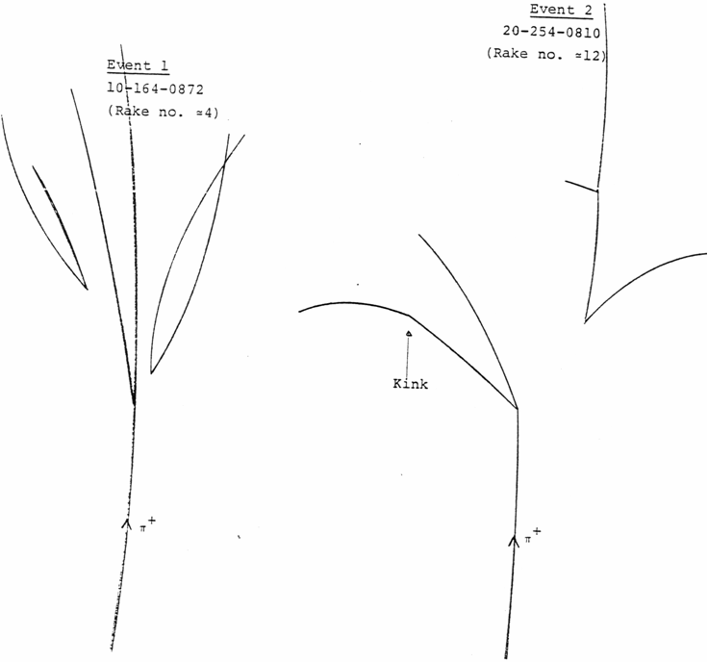

Figure 4. Sketch of the two events to be analyzed in this experiment.

- Make sure you have gone through the “Preliminary Investigations” section.

- Read the user guide for the traxis software. This software can be used to aid in the analysis of an event as it can digitally analyze the scanned bubble chamber events and provide much of the needed information about different tracks.

- Load the high-resolution image of the desired event. Identify which tracks are caused by positive and which by negative particles.

- Choose an initial track. Calculate the track radius (R) and the track momentum (P) of the track by following the instructions given in the user guide. The track radius and track momentum are related by the following equation: P [MeV] = 0.3 [giga-metres per second] * B [kG] * R [cm]. The uncertainties provided on the measurement by the software are due fitting procedures and calibration uncertainties. These may not correspond to the actual uncertainties in the measurements because when placing track markers, assumptions about the true paths of the particles are made.

- For the chosen track, calculate the optical density by following the instructions in the user guide. The optical density or the ‘blackness’ of the track is related to the dE/dx (figure 1) of the particles at its given momentum. As the optical density depends on the quality of the picture, no general calibration can be provided to transform the measured value to dE/dx. However, by measuring the optical density of the 10.3 GeV tracks of the incoming pions, relative measurements of optical density can be constructed and compared to relative values of dE/dx of different particles. The uncertainties provided by the software are only due to the bounding area cutoff and may not correspond to the true uncertainties.

- Using dE/dx information (if available) from point 1 (above), the measured charged particle momenta from 2, and the particle properties listed in Appendix I, identify the strange particles produced in the events you are analyzing. During all of this you should be considering only reactions which are consistent with all of your measurements and which conserve the necessary quantum numbers discussed in the THEORY section. You may assume that the neutral particles which decay are either K0 or Λ0 particles. In these strong interactions, π mesons are by far the most copiously produced particles. So if you have to guess at the nature of a particle, the best guess is that it is a pion.

Note that event number 254-810, the track of the charged particle from the primary interaction which has a small "kink" in it, is a π+.

- To resolve the directions of the momentum along a given track, follow the instruction in the user guide to measure the opening angle. It is recommended to resolve the momentum along/perpendicular to the direction of travel of the mother particle. Note that uncertainties on the angle measurements provided are only due the fitting procedure.

If you have difficulty determining the exact spot where the primary interaction took place then err in the upstream direction rather than the downstream direction. Think about how the uncertainty on your ability to locate this primary vertex affects your results.

First, resolve the momenta of the decay products of the neutral particles both parallel and perpendicular to the direction of the neutral particle. Is momentum conserved in the direction perpendicular to the neutral particle's path? How would an error in determining the position of the primary interaction affect your results? Determine the momenta of the neutral particles. The effective mass (more properly referred to as the invariant mass) of a system of particles is defined as . Calculate the effective mass (and its uncertainty) for the secondary particles of each "V" and compare the result to the masses of the K0 and Λ0.

- For decaying particles, it is suggested that you compare the observed decay distance with the expected mean decay distance which is given by c *τ *p/m, where c is the speed of light, τ is the mean lifetime, p is the momentum in MeV/c and m is the mass in MeV/c2.

- Now resolve the momenta of the particles emerging from the primary interaction vertex, including the strange particles, both parallel and perpendicular to the beam direction. Is momentum conserved? Use a value of 10.3 GeV/c for the beam momentum. Does the uncertainty in the momentum or any one particle influence the balance in the momentum equation more than the others?

- If momentum is not conserved then you may postulate a missing neutral particle to conserve momentum: assume that there is, at most, one missing neutral particle. If there is a missing particle, do the uncertainties in your measurements allow you to determine its mass?

- Postulate a reaction and check that energy is conserved as well as all the necessary quantum numbers. Be able to explain how the uncertainty in your measurements may affect your postulate for the reaction.

- If there is a missing particle, calculate the direction in which it would be moving and look at the image to see if there is anything that might be interpreted as decay products of the neutral particle.

Further Studies

If time is left, the following are a few suggestions on what other properties can be investigated from the bubble chamber pictures:

- For almost all the other events available for analysis, the tracks produced in the interactions are not in the plane of the camera. When the momentum of these tracks is computed, only the projection of the momentum vector to the plane of the picture is measured. Hence, when combing the 4-momentum of the decayed particles, the invariant mass of the mother particle will be underestimated. However, this can be used to place lower limits on mass of different decaying particles.

- Continuing the “missing momentum” problem as mentioned above, if the identity/mass of the decaying particle is already known, then the relative dip angle (the angle between the momentum vector and the plane of picture) of the decaying particles can be estimated.

- In obtaining the momentum of tracks, it is assumed that no energy is lost as the particle traverses the bubble chamber. However, this is not true and it is most apparent in the decaying electron spiral. Investigating the momentum loss of a particle as it travels can provide interesting information on particle’s interaction with liquid hydrogen. Graphs similar to figure 1 can be constructed. Furthermore, you may extend the momentum measurement by fitting either a helix or taking into account the energy loss using the Bethe-Bloch function.

- The momentum of the incoming pion beam is not exactly 10.3 GeV and it varies with position. You can investigate the spread of the energy and create a model to predict the energy of the incoming particle. As the 10.3 GeV tracks have a large radius of curvature and are, hence, prone to fitting instability, care must be taken when measuring momentum of these tracks.

References

- Chew G.F., Gell-Mann M. and Rosenfeld A.H., Strongly Interacting Particles, Scientific American, February 1964.
- Glashow, S.L., Quarks with Color and Flavor, Scientific American, October 1975.
- Isgur N., and Gabriel K., Hadron Spectroscopy and Quarks, Physics Today, November 1983, p. 36.
- Schwitters A.F., Fundamental Particles with Charm, Scientific American, October 1977.
- Hughes I.S., Elementary Particles, Penguin, 1972. (QC 793.2 H83) ON RESERVE.
- Longo M.J., Fundamentals of Elementary Particles, McGraw Hill, 1973. (QC 721 L8).
- Perkins D.H., Introduction to High Energy Physics, 3rd ed., Addison Wesley, 1987, (QC 721 P329) ON RESERVE.
- Cline D.B., Rubbia C. and Van der Meer S., The Search for Intermediate Vector Bosons, Scientific American, March 1982.
- Perl M., Heavy Leptons, Scientific American, March 1978.

The images investigated in this experiment were selected from film actually used in particle physics research. The following two papers which are available in the physics library are examples of publications which used this film.

- Goddard, M.C., Gilbert D., Key A.W., Gordon H.A. and Lai K.W., Search for π+p → ${\overline{D}}^{0}$C++₁ Near Threshold, Phys. Rev. D, 16, 2730, 1977.
- Kennedy C.N., Zemany P.D., and Key A.W., Study of the Reaction π+p → π+pp$\overline{p}$ at 10.3 GeV/c Phys. Rev. D 16, 2083, 1977.
APPENDIX I
Now available at https://www.physics.utoronto.ca/apl/hep.
APPENDIX II
Determination of Particle Direction
In order to check momentum conservation, the angles between the direction of the initial particle and the secondary particles must be found. If the initial directions of the secondary particles are found by drawing tangents to the tracks at the vertex, the results will have large errors. Also, angles found by this method have, in general, been found to be too large. The following procedure is suggested.
Consult figure 5 before you proceed. Let V be the vertex of the interaction.
- First draw a tangent to the incident beam direction such that IV represents the incident direction with respect to which we wish to measure the angle of the secondary tracks.
- Pick a chord QV, long enough so that you can measure its length with a few percent accuracy, but short enough so that the curvature does not decrease noticeably from the point V to the point Q. Extend the chord QV backward to draw a line QVR.
- Measure the angle IVR = ϕ. Measure the chord length VQ. Then the desired angle is θ = ϕ - α = arcsin (x/r), where r is the radius of curvature of the track and x = VQ/2. The value of r can be determined from the momentum measurement using the formula r(in cm) = 189 p(in GeV/c). The value of r can also be obtained by measuring the sagitta d and using r = (x2 + d2)/(2d).
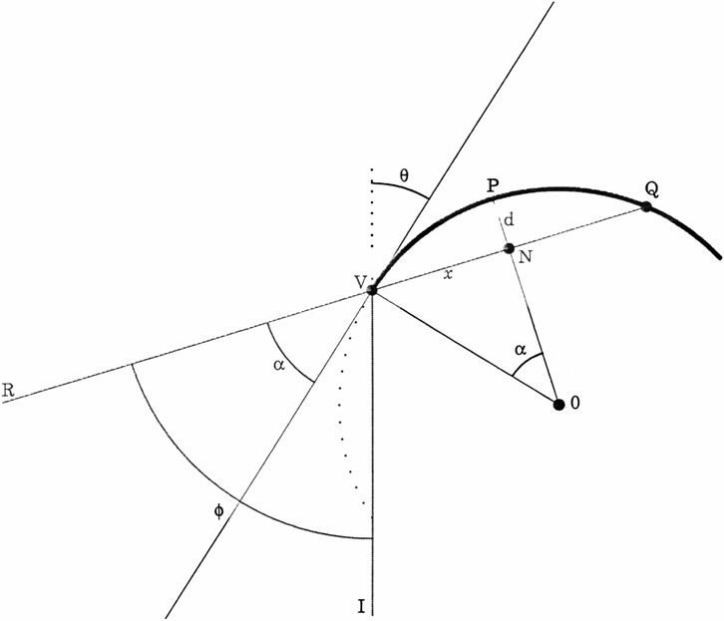
Figure 5. Geometrical construction to determine a particle’s direction.

As of 2011 the lower limit on the proton lifetime is about 1035 years. However, proton decay is predicted by many theories of physics beyond the Standard Model, and experimental searches for proton decay continue.

