Advanced Physics Laboratory
LENSES

PART I. A Chi-Squared Test of
the Thin Lens Equation

PART II. Study of Aberrations

Modified by J.H. Thywissen
v2.5: 24 March 2006
Part II was added by N.N.Krasnopolskaia
in December 2014
Part I.
Objectives
Primarily, the goal of this lab is to test the thin lens law, using experimental measurements from several lenses. In so doing, you will get a chance to review quantitative methods of testing a hypothesis using Chi Squared.

Section 1. Background

Thin lens relations. The relationship between the image distance q, object distance p, and focal length f is given by the thin lens law
$\frac{1}{f}=\frac{1}{p}+\frac{1}{q}$, (1)
where these quantities are specified with respect to the principle planes of the lens as described in Figure 1. The magnification M of the object is given by the ratio
$M\text{=-}\frac{q}{p}$, (2)
where the minus sign reflects the fact that the image is inverted with respect to the object. The fundamental assumption of equations (1) and (2) is that each lens has a characteristic focal length f, with which you can predict the image location and magnification given any object location p. It should simply be a matter of finding the correct principle planes (see Figure 1)! This is the hypothesis that you should try to test.
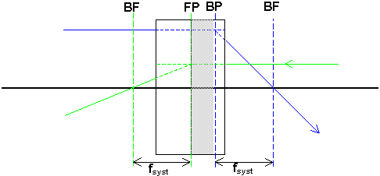
Figure 1. Rays going through a lens or lens system, with front principal plane FP, back principal plane BP, and focal length f marked. As an exercise, show that the front and back focal planes of the spherical lens are at one radius from its center, i.e., tangent to the front and back surfaces. What is the relation between f and R, the radius of the spherical lens?
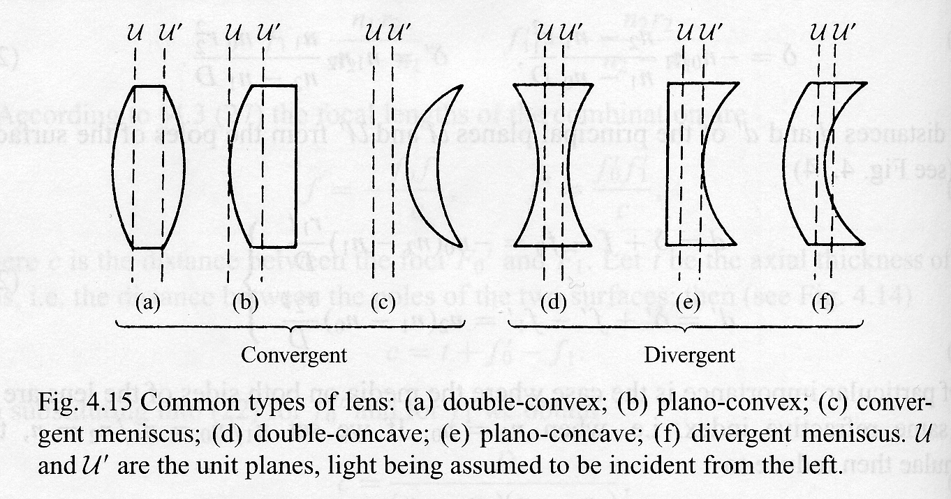
Figure 2: Principle planes of common types of lens: (a) double-convex; (b) plano-convex; (c) convergent meniscus; (d) double-concave; (e) plano-concave; (f) divergent meniscus. U and U' are the principal planes, light being assumed to be incident from the left.
Three important instances of equation (1), depicted in Figure 3, should be kept in mind. First, when p = q, then both the object and image are 2f from the lens. The magnification is M = –1. Note that this configuration is the minimum image-object separation (p + q = 4f) with which an image can be formed. Second, when the object is f away from the lens, then q is infinite. This corresponds to a situation in which rays from a point source are collimated into parallel propagation. Third, when the source is infinitely far away (i.e., p is infinite), parallel beams are incident on a lens, and q = f. This can be used to get a rough idea of the focal length of a lens: focus an image of the door at the end of the hallway onto the wall, and see how far the lens is from the wall.
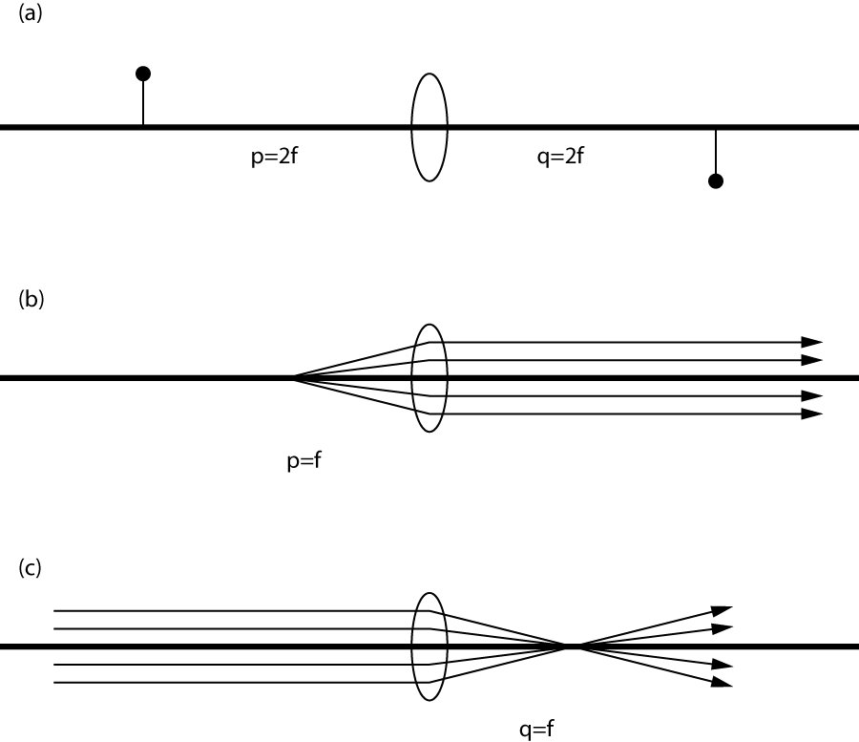
Figure 3. Three important examples of the thin lens equation: (a) Unity magnification (with inversion); (b) collimation of a point source; (c) collimated input to a lens.

Aberrations. Lenses are subject to 6 different aberrations, i.e., departures from a perfect mapping of object to image. Here are some types of aberrations:
- Spherical aberration. If parallel beams incident on the edges of the lens are focused closer than beams incident on the inner part of the lens, there will be an imperfect focus. Another way of saying this is that f varies with the distance from the optical axis.
- Astigmatism. This off-axis effect will cause vertical features to be focused at a different location than horizontal features. This is because the lens “looks” more curved when turned at a slight angle.
- Distortion. When the appearance of the object is somewhat re-arranged in the image plane, we call this distortion. As discussed in the references, distortion can be either “barrel” or “pin cushion”.
- Chromatic Aberration. Different frequencies of light see a different index of refraction of glass, and thus refract differently. Thus red and blue light may have a different focal length passing through the same lens.
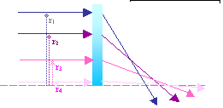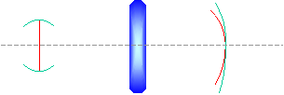
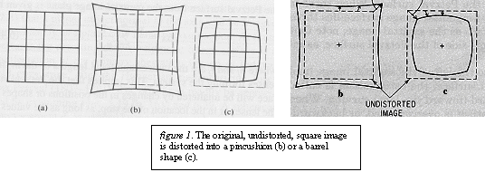
Figure 4. Spherical aberration, Astigmatism, and Distortion.

Detailed study of aberrations is offered in Part II of the “Lenses” experiment.
Section 2. Experiment.

In this experiment, you will set up lenses on a 1.5 m optical bench to study lens operation. The apparatus will be in the classic configuration of object, lens and image.

Start by measuring the properties of a thin (perhaps biconvex) lens. Then repeat the measurements for the spherical and hemi-spherical lenses. These three lenses will have qualitatively different behavior.

A. Alignment.
First, the lamp, aperture, and lens must be aligned to the right heights and angles. The goal of this alignment is to have the optical axis parallel to the optical bench, and centered on the lens. If the optical axis is not parallel to the bench, the distances you read of the ruler on the optical bench will not be measuring true distances between the optical elements. If the optical axis does not pass through the center of the lens, aberrations will be induced that will complicate the measurement.

How to align:
- Plug in the lamp, put a diaphragm in front of it. Close the diaphragm down to a few mm diameter.
First, make sure the center of the diaphragm is at the height of the filament in the lamp:
- Tape a piece of paper to the screen, and place it close to the diaphragm. Mark the light spot illuminated on the paper.
- Move the screen away from the diaphragm and source, and see if the expanding light circle stays centered on the mark you made. This would be an indication of light coming out of the source parallel to the optical axis whose height is defined by the aperture.
- If not, move the diaphragm and lamp around to line up the filament inside the light source and the center of the diaphragm. Repeat steps 2-3.
Now, choose the angle, height, and transverse position of the lens:
- Move the lens approximately 7 cm away from the diaphragm, to find the back-reflection onto the surface of the diaphragm. Chose the angle and height to retro-reflect back through the center of the diaphragm.
- Open up the aperture and look at the far-field focus (screen about 1m away) of the lens. Translate the lens transverse to the optical bench until the focused spot aligns with the original mark made on the paper taped to the screen.
- Look also at the height of this far-field image. It should align with the original mark made.
- Check the back-reflection to see if still good. If not, iterate.

B. Distance Offsets.
We will measure p and q by reading positions off the ruler built into the optical bench. However, to make sense of these readings, you need to establish the relation between the location of the edge of the mount (where you can read the ruler) and the center of the optical element (lens, screen, etc) in question.
Use a pair of calipers to measure the dimensions of the optical mounts necessary to calculate the centre of the optical element being held from the recorded position of the edge of the mount. Aim for 0.1 mm precision. Note the any uncertainty in this calibration is a systematic error, because it would shift all of your data in the same direction. We'll talk more about this later.
An alternate way of measuring these offsets is depicted in Figure 5. You can slide two objects so that a "reference object" (a short bar, for example, with flat ends) touches both of the planes whose position you are trying to measure. Based on the figure, you can see that o₁ = L_{ref} - o₂ - (x₁-x₂), where the x's are positions measured on the optical bench ruler, the o's are distance offsets, and L_{ref} is the length of your reference object. If you can measure L_{ref} and o₂ well, then you might be able to extract an accurate value for o₁, even if the mount is very complex.
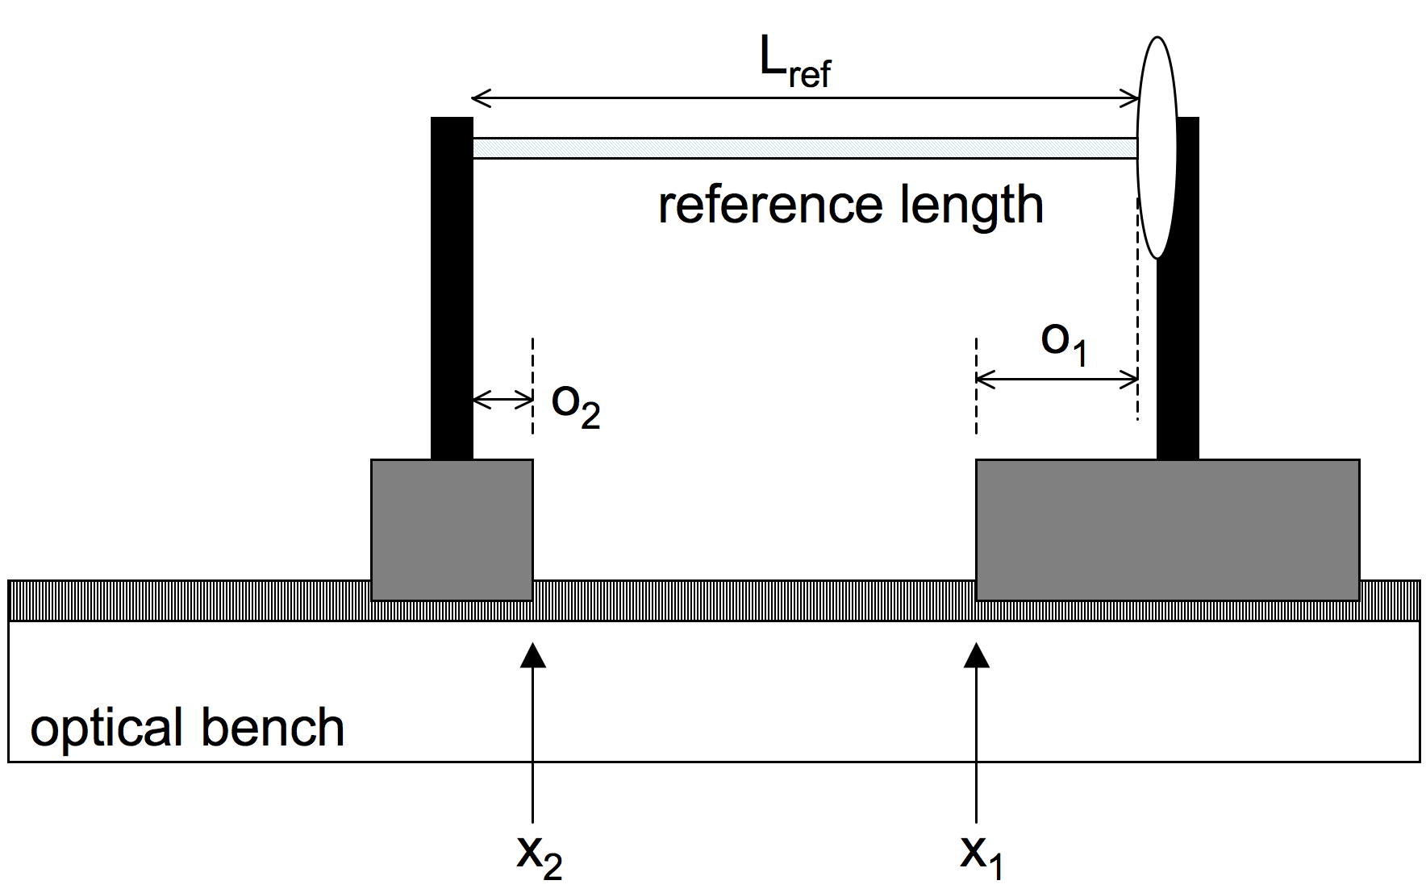
Figure 5: Using a reference length to estimate offsets.
C. Estimating uncertainty in measurements
A good way of estimating the uncertainty of each measurement is to repeat it several times. For instance, when measuring the width of the base of the optical mount, take the calipers, make the measurement, then reset the calipers to fully closed again, and repeat the measurement from zero. Try not to remember your previous measurements, but simply record them and take three to five measurements. The uncertainty can be estimated by the standard deviation of the measurements made. This technique is especially interesting to avoid such subjective judgments such as an estimation of read error. How well can you read a ruler? A set of measurements will tell you.

D. Estimation of focal length
With the lens far from the source, estimate the focal length by finding the image distance. You might also try, in a room with a window, imaging the sun or clouds into a piece paper. This will give you an order of magnitude for f to guide your choices for data in D.
You can also measure the curvature of the lens faces to estimate f. For a thin lens, f=R / [2(n-1)], where R is the radius of curvature and n is the index of glass. Similar relationships can be found for other lenses.

E. Data for p, q, and M.
You are now ready to take a set of data. Set up your optical bench with the source, a diaphragm, the transparent grid “object”, a lens, and the screen (without any paper taped to it). Start with the thin lens.

Choose a location for the lens, and find the position of the screen which shows the sharpest focus. Record the positions of all elements. Measure the spacing of the grid lines in the image, from which you can determine the magnification. Repeat these measurements 3 to 5 times for the same lens position, in order to determine the measurement uncertainty.

Repeat these measurements for a variety of lens positions. Try to sample the range between q = f and p = f. (Look back at Figure 3 to see why these are extreme cases)

F. Your first fit, and iterations
After taking a first set of data, try to plot the data and analyze it as soon as possible. The results of your analysis will tell you about what to do next in the lab: did you take data with the right range of p and q? Did you take enough measurements for each configuration? Are some parts of your data seemingly off? Is the Chi Squared reasonable?

Try to "iterate" a few times: take a data set, analyze it and then improve the data. If you are happy with the quality of the fit, then start trying to understand the results of the fit: focal length, front plane, and back plane. To see if these results are significant, you will at this point need to include the systematic uncertainty, discussed in the analysis section.

G. Thick lenses
Finally, repeat parts D, E, and F for one or two of the thick lenses! Does the thin lens equation work for thick lenses?

Section 3. Analysis.
The goal of the analysis is to measure the properties of each lens (focal length and front and back principal planes) assuming that the lens follows the thin lens equation (1). Out of the analysis, a test of the validity of this assumption will naturally arise.
Let’s call the true position of the of the lens l, the image screen i, and the object screen o. (Remember that the position of each of these includes some offset measured in section 2.B.) If the principle planes were both located at the center of the lens, then p = |o-l| and q=|i-l|. However, there is some additional offset due to the fact that the principle planes are not necessarily at the center of the lens, so p=|o-l|-fp and q=|i-l|-bp. These quantities should follow the ideal lens law, so we can write
$\frac{1}{f}=\frac{1}{\left|o−l\right|−\text{fp}}+\frac{1}{\left|i−l\right|−\text{bp}}$, (3)
where f, fp, and bp are parameters to be determined, and o, i, and l are measured parameters.
Using your data, and standard function fitting analyses, find the lens parameters for each lens. State the Chi Squared per degree of freedom of your fit, and whether the ideal lens law is a valid assumption for each lens. When possible, compare to the expected focal length and locations of fp and bp.

Using the MATLAB suite: datacrunch.m and fitter.m
It is recommended that you use MATLAB to analyze your data. MATLAB is available on all computers in the Advanced Labs. The MATLAB web site (http://www.mathworks.com/support/) has help files, if they are not installed on the computer; there should also be a paper manual floating around. The custom MATLAB files for this experiment are available on the course web site:
http://www.physics.utoronto.ca/~phy326/lens/
Updates and new software will also be posted on this site.

How to prepare your data and use in this code:
- Create a text file with all your data, with four columns, in order
(source_position) (image_position) (lens_position) (grid_image_size)
Skip a line between each set of measurements, for instance
129.100 40.030 115.600 39.470
129.100 40.102 115.600 39.390
129.100 40.050 115.600

129.100 40.260 59.490 2.510
129.100 40.450 59.490 2.533
129.100 40.330 59.490 2.420
etc. You can use whatever units you want (mm, cm, inches…) so long as you are consistent.
- If you didn’t always measure the image grid size, just leave it out – don’t just copy one value several times. The program takes the mean and deviations of the measurements made.
- Save the file to the working directory you will use. [If you are using excel, save as a MS-DOD .txt file.] Also, include a copy of this file for your lab book.
- The next step is to determine the uncertainties and real (ie, offset) values of the optical elements and magnification. Run datacrunch2.m. for example:
datacrunch2('ThinLensData.txt', 'ThinLensData.out', 9.930, -2.979, -1.945, 1.886)
where 9.930 means an grid size of 9.930 mm, and the other numbers are offsets. A full explanation of inputs and outputs can be seen by typing help datacrunch2.
- Print out the output file for your lab book.
- Now we use these numbers to fit the thin lens equation to the data. Run fitter.m, following the directions from its manual. Both of these are available at http://www.physics.utoronto.ca/~phy326/matlabfit.htm .
- Keep a hard copy of the data file created from the fits, as well as a printout of the curves made.
- The goal of the above calculations is to measure the properties of the various lenses, and test the thin lens equation. The conclusion of your lab should address these goals.
- What is the uncertainty with which you have measured the properties of the lenses? What does the Chi squared tell you? To answer these questions, feel free to modify the analysis programs – they are provided here only to get you going.

Systematic uncertainty
In your final answers, you can quote statistical and systematic uncertainty separately:
f = 15.023 +/- 0.015 +/- 0.250
where the first number is statistical uncertainty and the second is systematic. So far, we have only discussed ways of getting the statistical error: i.e., from the fit program and data that gives a good Chi Squared value.

Systematic errors are those shift affect all data points in one direction or another. In this lab, a primary systematic error is the uncertainty on the offsets, estimated in part 2B and 2C above. You can calculate the effect of these by re-analyzing your data with a distribution of offset values. Say the object offset was measured to be 9.9 +/- 0.2. To estimate the resultant systematic error in "bp" (the back plane position), for example, run datacrunch2.m and fitter.m with 9.7, with 9.9, and with 10.1 as the object offset, and keep track of the best fit bp in each case. The spread in bp (due to variation of all offsets over their one sigma range) is the systematic error. This should be calculated for f, bp, and fp. In this same way, you could also include systematic error from sources other than the offsets.

References

M. Born and E. Wolf, Principles of Optics, (Cambridge University Press,1999).

E. Hecht, Optics, 2002.

G. R. Fowles, Introduction to Modern Optics (Dover, 1975), pp. 294-299. [Physics, Gerstein: QC395.2 .F68 1975]

F. A. Jenkins and H. E. White, Fundamentals of Optics. 1976.

F. W. Sears, Optics (Addison-Wesley Press, 1958) [Gerstein: QC355 .S45]
http://www.physics.georgetown.edu/~vankeu/webtext/
Part II.
The goal of this part of the lab is to study the spherical lens aberrations. There are three optional experiments of your choice, each giving an opportunity of studying a specific aberration type and describing it in both qualitative and quantitative ways.

Optional experiment 1. Dispersion and Chromatic Aberration.

- Introduction.
Chromatic aberration is a result of light dispersion in a material of a lens. Chromatic aberration in the lens manifests itself as different position of a focal point observed in light of different wavelengths. The dispersion equation for a dielectric medium that relates the index of refraction, n, to the frequency ω of electromagnetic wave in the glass or plastic lens is given by [1]
$n^{2}\left(ω\right)=1+\frac{{\text{Ne}}^{2}}{ε_{0}m_{e}}\frac{1}{ω_{0}^{2}−ω^{2}}{}_{}^{}{}_{}^{}{}_{}^{}(1)$

To obtain n (λ), the Eq.(1) can be modified as follows
${\left(n^{2}−1\right)}^{−1}=−{Cλ}^{−2}+{Cλ}_{c}^{−2}$ (2)

where C and λ_{c} are constants; [1], p.70.
The refractive index n can be calculated using the lensmaker’s equation for a lens in air:

$\frac{1}{f}=\left(n−1\right)\left[\frac{1}{R_{1}}−\frac{1}{R_{2}}+\frac{\left(n−1\right)d}{{\text{nR}}_{1}R_{2}}\right]$ (3)

where R₁ and R₂ are the radii of curvature of the lens’ surfaces, and d is the lens’ thickness in the middle. The measured quantities are the radii, the thickness d and the focal length f, obtained as in the exercise of the Part I of the LENS experiment. If you measure the focal length for different quasimonochromatic light, produced by filters, you will find the different focal lengths. The goal of this experiment is to measure the focal length of a thick plano-convex lens in red, green, blue and other colors produced by filters, to calculate n using Eq.(3); and to verify Eq.(2).
The transmitted wavelength for each filter is measured with a spectroscope.

- Calibration of the tri-prism spectroscope.
The spectroscope must be calibrated with the line spectrum of a known gas. Each kind of an atom has a specific (characteristic) set of stationary states with particular energy levels. A transition between the states results in emission of a characteristic photon. A beam of photons with same energy is registered as a spectral line. For calibration, you can use a hydrogen and/or a helium lamp spectrum.
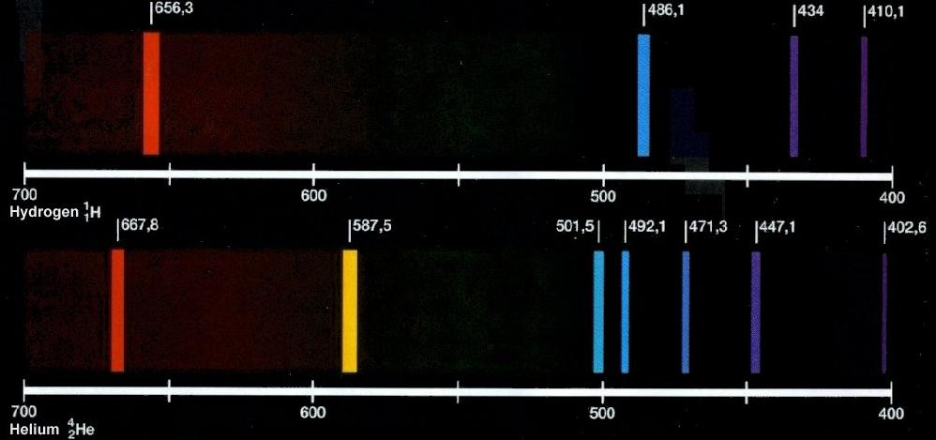
Fig.1. Emission spectra of ${}_{1}^{1}{}H$and ${}_{2}^{4}{}\text{He}$ (http://poozacreations.blogspot.ca/2012/03/types-of-emission-and-absorption.html).
Table 1. The strongest lines of emission spectra of hydrogen and helium in visible range.

Hydrogen |  | Heleum
Wavelength, nm | Color | Wavelength, nm | Color
 |  | 667.8 (med) | red
656.3 (strong) | red
 |  | 587.6 (strong) | yellow
 |  | 501.6 (strong) | cyan
 |  | 492.2 (med) | blue
486.1 (strong) | blue
 |  | 471.3 (med) | blue
 |  | 447.1 (strong) | violet
434.0 (med) | violet
410.2 (med) | violet

The tri-prism spectroscope (Fig.2) permits observation of four visible hydrogen lines
(http://hyperphysics.phy-astr.gsu.edu/hbase/tables/hydspec.html) and six helium lines of strong and medium brightness (http://hyperphysics.phy-astr.gsu.edu/hbase/quantum/atspect.html).

The light from the lamp enters the slit, and due to diffraction diverges from the slit opening. The slit is situated at the focal point of the collimator lens, so after passing through it, the light is in a parallel beam. It then passes through the tri-prism. The central prism is the one which disperses the light. The first and third prisms are employed to straighten the beam, thus making the spectrometer easier to handle. After leaving the prism the dispersed beam passes into the measuring telescope. Real images of the slit are created in the plane of the cross-hairs, and these are examined using the eyepiece as a simple magnifier.

(1) Focusing. Focus the cross-hairs by moving the eyepiece in and out using one of the strong lines of the lamp. Use the slit width adjustment to get an appropriate brightness of the line. Loosen the main focus adjustment and, using the knurled part of the eyepiece tube, rotate the cross-hairs to obtain an “×” rather than a “+”. Measure the wavelength of lines by precisely splitting the line with the centre of the cross-hairs, and then reading the scale and vernier. When making observations in the violet it may be necessary to push-in the eyepiece slightly to keep the cross-hairs in focus.

(2) Slit adjustment and line focus. Use a blue line of the hydrogen lamp for slit width adjustment. With a proper width of the slit the line is clearly focused. At this step, tighten the focusing clamp. The paint dot on the slit adjustment should be kept on the upper side of the spectroscope to maintain calibration. The spectroscope is now ready for use. When observing spectra the slit may be opened or closed, as desired. Opening the slit will increase the brightness but decrease the resolution.

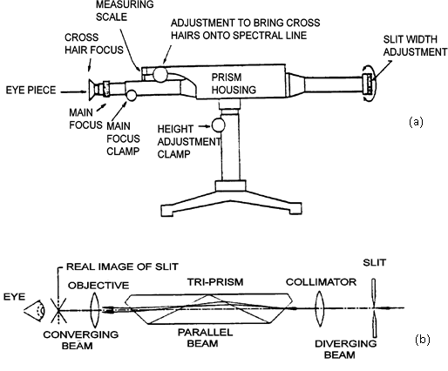
Fig. 2. The tri-prism spectroscope.
Examples with reading the vernier scale on the spectroscope are shown below.
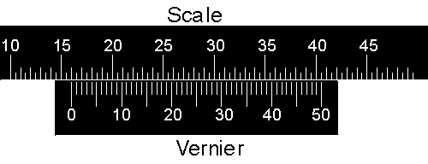
In the first diagram the "pointer" of the vernier, the line labeled with 0, lines up almost exactly with the 16th division of the scale. The units of the scale are arbitrary so the reading is 16.00 units. However, notice that the vernier goes from 0 to 50 instead of 0 to 100.
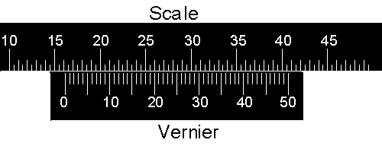
Now the pointer is between 16.00 and 16.50 units. The mark 15 on the vernier lines up almost exactly with a mark on the scale, so the reading is 16.00 + 0.15 = 16.15 units.
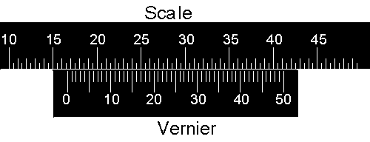
Now the pointer is between 16.50 and 17.00 units, and again the mark 15 on the vernier lines up almost exactly with a mark on the scale. So in this case the reading is 16.50 + 0.15 = 16.65 units.
The goal of the calibration is to find a relationship between the scale reading y and the wavelength λ as given by the Hartmann dispersion relation for prismatic spectrum [2], which is:
$y=\frac{m}{λ−λ_{0}}+b$, (4)
where λo, m and b are constants. For your convenience, the constant λo, which is specific for the optical system of your spectroscope, has been measured by lab technicians for each spectroscope and is marked on the top of the apparatus.
Turn on the power supply with one of the lamps plugged in. Bring the spectroscope objective close to the lamp and turn off the room lights. With data of Table 1, find the wavelengths of all visible lines in the spectrum of the lamp. Make similar measurements with the 2nd lamp. By interpreting (λ - λo)⁻¹ as a variable of the function y, you can apply a linear fitter to find m and b.
In your notebook, show the function y(λ) or y[1/(λ - λo)] with a fitter and defined constants m and b for your spectroscope with their uncertainties.

- Measurement of a filter wavelength
To measure the wavelength transmitted by a filter, replace a calibration gaseous lamp by a source of white light covered by a color filter. Find readings of the scale for all lines in the spectrum of the filter and then calculate their wavelengths according to Eq. (4). The ideal filter should be transparent to just one wavelength, but the real filters are quasimonochromatic, i.e. they are transparent for a set of wavelengths or for a rather broad wavelength band. You can try to combine a number of plastic filters to produce monochromatic light for the experiment with chromatic aberration. All filters absorb light and reduce brightness of the spectral line.

- Verification of the dispersion equation (2)
a) For three or more filters with found wavelength repeat the experiment of the Part I and determine the focal length of a thick plano-convex lens. Estimate the uncertainty for f(λ) .
b) Calculate the indices of refraction of the lens for different wavelengths using Eq. (3). Include the uncertainty.
- Try to verify Eq.(2) with obtained n and λ . If the number of measurements is insufficient, add more filters to find n(λ). Plot the function (n² – 1)⁻¹ vs. λ⁻² in units of 10⁻⁶ nm⁻².

- Questions
1. In the cited article [2], Hartmann equation is given as
$$λ=λ_{0}+\frac{c}{n−n_{0}}$$
where n is the refractive index for the wavelength λ; and λ₀, c and n₀ are constants.
Why is it possible to rewrite the original formula as Eq. (4) of our handout?
2. Explain all quantities used in Eq.(1).
3. Derive Eq.(2) from Eq.(1) (Problem 3.53 of [1]).
4. Does the behaviour of n(λ) in your experiment correspond to the normal dispersion of the visible light in the material of the lens, or the function demonstrates the anomalous dispersion? How could you confirm your statement about normal or anomalous dispersion in the lens without the performed experiment?
5. Describe qualitatively the behaviour of the function v(λ), where v is the phase velocity of the wave in your experiment. Does the group velocity of the waves exceed the phase velocity in your experiment?
6. Use the values of n(λ) obtained in your experiment and Fig.3.40 of [1] to make a reasonable guess about the material of the lens.
7. Treating the maximum axial distance between the focal points in the violet and the red light as a measure of axial chromatic aberration, or A∙CA, and comparing the value of A∙CA with the uncertainty in f, conclude on significance of accounting for chromatic aberration in the Part I of the LENS experiment with the thick lens.

References
1. E.Hecht, Optics, 4th ed., Pearson, 2002. Chapters 3.5.1 and 6.3.2.
2. J. Hartmann, “A simple interpolation formula for the prismatic spectrum”, Astrophysical Journal, V. 8, p.218 (1898). http://adsabs.harvard.edu/full/1898ApJ.....8..218H .

Optional experiment 2. Spherical Aberration and Coma.
- Introduction.
For monochromatic light, the spherical aberration is a result of spherical shape of the lens surface and a non-zero thickness of the lens d. Refraction of the rays emerged from the focal point of a hyperbolic surface will result in mathematically perfect parallel beam of rays [1, pp. 151, 152] which is not so for the spherical interface. For thick lenses, aberrations are more significant than for thin lenses.
f.f.l.
f
b.f.l.
f

Fig.1. First and second principal planes of a thick spherical lens crossing the optical axis at principal points H₁ and H₂.

In a thick lens, the principal planes are not flat but curved surfaces that approximate a plane in the paraxial region where the rays are very close to the optics axis. Therefore, the peripheral rays of a parallel beam of light are not refracted exactly at same focal point as paraxial rays.

Going away from the optical axis, the rays converge closer to the back vertex of the lens than the paraxial rays. This phenomenon is known as spherical aberration shown in Fig.2.

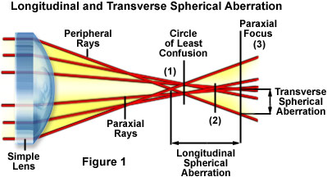

Fig.2. Longitudinal and transverse spherical aberration (http://www.micro.magnet.fsu.edu/primer/java/aberrations/spherical/index.html).

The measure of the longitudinal spherical aberration (or L∙SA) of a ray is the distance between the axial intersection of the ray and the paraxial focus. L∙SA > 0 for a converging lens and is negative for a diverging lens [1].

Reducing the diameter of the incident beam, positioning the object closer to the optical axis and choosing the lens with non-spherical surface can minimize the spherical aberration (we can see a similar effect in a camera with variable aperture).

The goal of the experiment is to find the L∙SA produced by a thick lens as a function of the distance between the ray of the incident parallel beam of light and the optical axis. For this purpose you can use a diversity of thick plano-convex lenses closing them at the middle with stoppers of different diameter, or opening the middle of the lens with a variable aperture.

- Measurement of the focal length in the paraxial region.
The goal of this part of the experiment is to find the paraxial focus of the lens. Before making measurements with the diversity of lenses, you must be sure that all of them are manufactured of same material. You may deal with either acrylic (n = 1.491) or polycarbonate (n = 1.585). Comparing the focal lengths of the lenses produced of different materials and closed with different stoppers, you will be unable to determine the aberration vs. diameter of the stopper quantitatively. Design your experiment in the way that will exclude comparison of the results for different diameters of the stoppers measured for lenses produced of different materials.

Suppose you have chosen a lens of a specific material. Providing the perfectly parallel beam of light from the source and making the aperture as small as possible to approach the paraxial approximation, find the paraxial focus f_{p} of the chosen lens. Use your expertise acquired in the Part I of the LENS experiment. Calculate, or at least estimate the maximum radius h_{p} of the beam that confines paraxial rays to the accuracy of your measurements. Determine the uncertainty of the value of the paraxial focal length. Measure the radius of curvature of the lens, its thickness and, using the lensmaker’s equation
$\frac{1}{f_{p}}=\left(n−1\right)\left[\frac{1}{R_{1}}−\frac{1}{R_{2}}+\frac{\left(n−1\right)d}{{\text{nR}}_{1}R_{2}}\right]$ (1)
calculate the refractive index of the lens.
What material is your lens made of?
If you used same lens in the Part I of the LENS experiment, how different is your 1st result from the obtained f_{p}? Is the difference within the uncertainty range?

- Measurement of the longitudinal spherical aberration
You are expected to measure about 5-6 different diameters of the incident parallel beams of light (either using stoppers, or somehow interpreting experiments with different apertures) to find the function SA(h). Plot your data, fit the data points with an appropriate function and give your explanation of the obtained function.
Did you expect the result of the fitting procedure?
Turn the lens 180º about the vertical axis and repeat the measurements.
How has the SA changed?
How has the function SA(h) changed?
Try to explain why the lenses of plano-convex shape differently oriented relative to the source of light but with same focal length produce the different spherical aberration effect.

- Obtaining the comatic aberration
When an object or a source of light lies even slightly away from the optical axis, the comatic aberration can be observed due to the properties of the principal planes of being not flat surfaces that was mentioned above [1, pp.258-261].
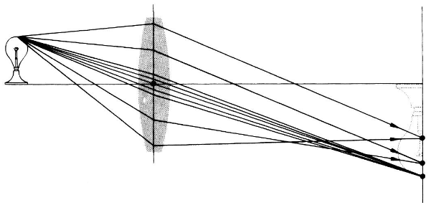

Fig.3. Negative coma: peripheral rays converge closer to the optical axis than the bunch of rays near the principal ray that passes the lens through its center.

The comatic aberration is corrected by an additional lens or by creating a non-spherical shape of the lens (like the spherical aberration. If you observe coma on a plane screen, you will see a deformed image and interference pattern like that shown in Fig. 4b.

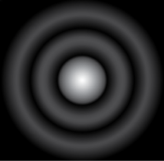

(a) (b)
Fig.4. Instead of a perfect Airy image (a) the typical comet-like image of a star taken by a telescope looks as in (b) and explains the name of “coma”
( http://starizona.com/acb/basics/equip_optics101_coma.aspx ).
In your experiment, you can scarcely observe the interference pattern.

The best way to observe the comatic aberration is to produce a source of light of a circular shape, e.g. with an aperture in front of a light source. To make the experiment more efficient, a lens of a large magnifier is recommended that permits moving the source of light farther from the optical axis. In your experiment it is more convenient to displace the object from the optical axis of the lens in horizontal direction, or to slightly rotate the magnifier about the vertical axis. Thus, the object on the optical bench will move away from the optical axis of the lens.

The arrangement of elements of your setup is shown in Fig. 5 and 6.
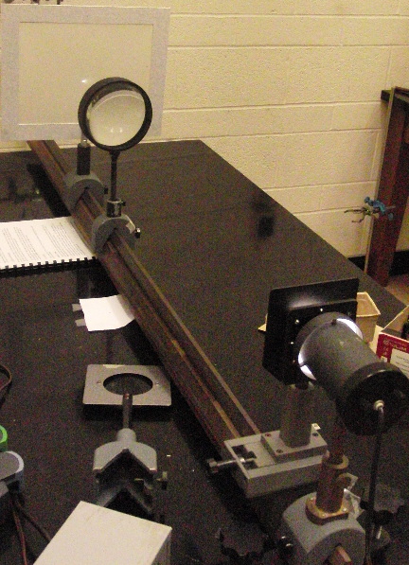

Fig.5. Possible alignment of the setup for coma observations.
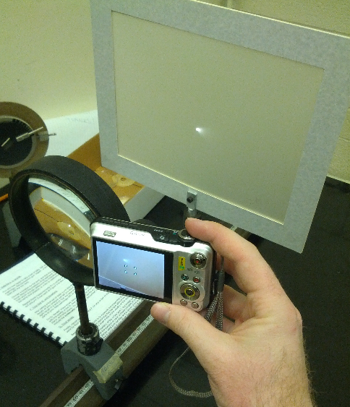

Fig.6. Observation and photographing coma on the screen in experiment LENS.

Make photos of coma for two orientations of the lens like in the exercise with measuring spherical aberration.
What has changed to the coma position and sizes on the screen after the lens was turned 180º about the vertical axis?
Rearrange the setup bringing the source of light closer to the lens.
What has changed to the coma position and sizes on the screen after the change of the mutual position of the source of light and the lens? Try to explain this phenomenon by means of a ray diagram.
It is known that the lens doublet can have both, coma and spherical aberration cancelled. Can you explain how this system works?

Reference
E.Hecht, Optics, 4th ed., Pearson, 2002. Chapters 5.2.1- 5.2.3 (pp.150-165), 6.1 and 6.3.1.

Optional experiment 3. Distortion.

- Introduction.
Distortion appears because different areas of the spherical lens have different focal lengths and thus the transverse magnification M_{T} is a function of the off-axis distance.
Distortion is noticeable on the image of an extended object and is not visible for a point source.

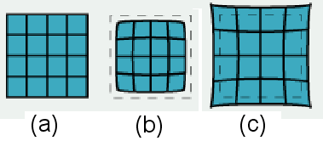

Fig.1. Zero distortion (a), negative, or barrel distortion (b), and positive, or pincushion, distortion (c).

Figure 1 shows the image of a rectangular grid on a screen behind a spherical lens. The negative distortion occurs when M_{T} decreases with axial distance; and the positive distortion is a result of increase of M_{T} with the distance y from the center of the lens. While the image of the object is deformed, each point of the image is sharply focused.
Quantitatively, the distortion is measured as
$δ=\frac{M_{y}−M_{0}}{M_{0}}⋅\text{100}\text{\%}$ (1)
where M_{y} is the lateral magnification at a distance y from the center of the lens, and M₀ is the lateral magnification at the center of the lens. Figure 2 shows the distortion as a function of a lens radius.
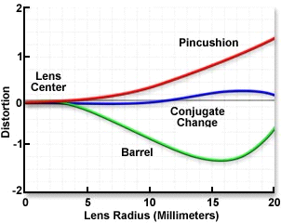

Fig.2. Example of distortion δ vs. radius of a spherical lens, or actually vs. the off-axis distance.

It is interesting to investigate the effect of a stop on the sign of distortion. Distortion is very small for a thin positive (converging) lens if the aperture is located at the lens (Fig.3b). The chief ray is passing the center of the lens and is not refracted.

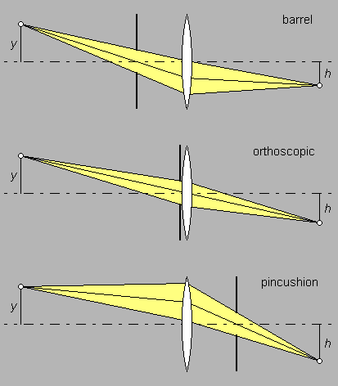
(a)

(b)

(c)

Fig.3. Distortion for different position of a stop relative to a lens
(http://toothwalker.org/optics/distortion.html).

A stop before the lens causes negative distortion (Fig.3a). A stop after the lens causes positive distortion (Fig.3c). With the stop in front or in rear, the chief ray is refracted.
Two perfectly symmetric lenses with a stop between them can cancel distortion.

- Measurement of distortion.
  - Take a film with a rectangular grid, measure the size of a cell of the grid and mount the grid in front of the source of light. Use a semitransparent sheet for the screen to photograph the image from behind the screen.
  - For a small aperture in an iris diaphragm in contact with a thick lens, arrange the optical system that gives the best quality of an image on the screen. The image is expected to give no evidence of aberration as in Fig.3b if the aperture is small enough. If you cannot bring the diaphragm very close to the lens to get undistorted image, use a thick plano-convex lens with the smallest paper aperture stuck to its plane surface. Make a photo picture of the image on the screen and fix the position of the camera for future use. Calculate the lateral magnification.
  - Turn the lens 180º about the vertical axis and repeat the procedure. Calculate the magnification. Save the images in the computer in *.jpeg format.
  - Read the document LensDistortionManual.pdf to get familiar with the software to process images (the shortcut is placed on the desktop of all computers in the room).
  - Increase the aperture and make experiments with the stop in front and behind the thick lens. Now, you will observe distortion and follow the guide of the Lens Distortion Manual. Record the lateral magnification M_{y} and M₀ and distortion.
  - Turn the lens 180º about the vertical axis and repeat the experiment. Record your observations.
  - Finally, remove the diaphragm and repeat your measurements of distortion according to the Lens Distortion Manual without a stop.
  - Put the results of measurements of distortion and lateral magnification M_{y} and M₀ in a table.

3. Questions

- Do your results match expectations based on Fig.1 and the Fig.2 graphs? Prove your statement with pictures, experiment data and diagrams.
- Fig. 3 shows that the magnification h/y depends on the position of the stop. Does it agree with your results?
- Suggest a system of two lenses with a stop between them to cancel distortion. Prove theoretically with the ray diagram or matrix method that this system will work.
- Build the designed system of two lenses and prove its effect with your own experiment. Include the pictures of the system and the corresponding image on the screen in your lab report.

Reference
E. Hecht, Optics, 4th ed., Pearson, 2002. Chapter 6.3, pp.266-268.

