University of Toronto
ADVANCED PHYSICS LABORATORY
QIE
Quantum Interference
and Entanglement

Revisions:
16 September 2016: David Bailey <dbailey@physics.utoronto.ca>
January 2014: Henry M. van Driel
Original 2013: Engineering Science Capstone Group (Seth Strimas-Mackey, Shashwat Sharma, Debbie Lo, Tatsuhiro Onodera)

Please send any corrections, comments, or suggestions to the professor currently supervising this experiment, the author of the most recent revision above, or the Advanced Physics Lab Coordinator.

Copyright © 2014-2016 University of Toronto
This work is licensed under the Creative Commons
Attribution-NonCommercial-ShareAlike 4.0 Unported License.
(http://creativecommons.org/licenses/by-nc-sa/4.0/)

Introduction
The purpose of this experiment is to investigate two fundamental aspects of quantum mechanics, namely entanglement and non-locality. Entanglement of two quantum entities implies that they cannot be described independently as they would through, e.g., a single product state. Rather, they can only be described by a superposition of product states so that one constituent cannot be fully described without considering the other. Non-locality here implies that there is a correlation between spatially separated events. The basic quantum-mechanical entities that are studied here are photons. One way to generate entangled photons is by passing a laser beam through a nonlinear optical crystal whereby two weak beams of photons are generated, each with approximately half the frequency of the incident photons, a process known as spontaneous down-conversion. For historical reasons the two down-converted (DC) beams are referred to as signal and idler beams. In certain composite nonlinear crystals the photon pairs are described by a superposition of quantum states corresponding to both being linearly polarized along one direction or the orthogonal direction. It is the goal of this experiment to demonstrate such entanglement and, possibly non-locality, by measuring the photons’ polarization properties with single photon detectors in different locations. Bell’s inequality puts a constraint on how correlated the photon pair can be under the assumption that nature is local (see Dehlinger & Mitchell). However, for quantum mechanics this inequality is broken. If you can demonstrate violation of Bell’s inequality, you will have shown that nature can be truly non-local.

Some Theoretical Background
The theoretical background offered here is based on the more thorough treatment given by Dehlinger and Mitchell, a paper that you are strongly encouraged to read. It is accessible to students who have taken a mid-level course in quantum mechanics that uses bra-ket notation; for convenience that paper’s notation is also used here.
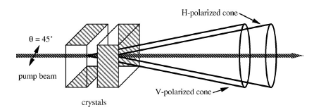
Figure 1: Illustration of the process leading to entangled photons from a pump beam (reproduced from Dehlinger & Mitchell).
Entangled photons are generated through a process shown in Fig. 1. Two identical “Type I” Beta Barium Borate (BBO) nonlinear crystals are contacted, with the “ordinary” axis along the vertical in the first crystal and along the horizontal in the second.
For a pump (p) beam linearly polarized at 45° with respect to the vertical/horizontal, in the first crystal the horizontal component produces vertically polarized signal (s) and idler (i) DC photons; by symmetry, in the second crystal the vertical component of the pump beam produces horizontally polarized signal and idler photons. Momentum conservation dictates that the simultaneously emitted DC photons propagate on opposite sides of a cone with an apex angle of ~6°. For thin crystals the cones are essentially overlapping. Hence, for pump photons undergoing down-conversion (and only a tiny fraction due so in this spontaneous process!),
 | and | (1)
where |V⟩ and |H⟩ refer to vertical and horizontal polarization states and the (relative) phase Δ accounts for dispersion and birefringence in the crystals. Arbitrarily polarized pump photons can be represented by the normalized state function
(2)
This state is obtained by rotating the plane of polarization of a vertically polarized laser beam by θ_{l} and phase retarding the horizontal component relative to the vertical component by φ_{l}. Individual pump photons can down-convert into a pair of s- and i-photons in either crystal and which are therefore entangled with the state function
(3)
where . If θ = 45° and φ_{m} = 0 signal and idler photons are in the Bell state, the maximally entangled state:
(4)
To determine the signal and idler polarization properties, linear polarizers are placed on opposite sides of the emission cone. The probability that a photon is transmitted by a polarizer, and recorded by a detector, depends on the projection of the photon polarization on the polarizer’s transmission axis. Ideally, the probability of passage is 100% when light is polarized along the transmission axis and 0% when it is polarized along the orthogonal axis. In quantum language, the photon’s wave-function is projected onto the polarizer’s orthogonal basis states. For the (arbitrarily assigned) signal photon, if α is the angle the polarizer’s transmission axis makes with the vertical, the basis states are (transmission state) and . Similar basis states exist for the idler beam with β replacing α . The probability that a measurement of signal and idler photons in state reveals that both are polarized along the polarizer’s transmission axis (VV state) is:
(5)
The number of coincidences recorded is
(6)
where A is the total number of entangled photon pairs produced and C are counts due to imperfections in the polarizers, correlated unentangled photons, etc. (See Appendix-A for more discussion.) The total number of pairs produced is obtained from coincidence count measurements for HH, HV, VH and HH polarizers orientations so that
 | $$\begin{aligned}A=N_{\text{tot}} \\ N(α,β)+N(α+\text{90}°,β+\text{90}°)+N(α+\text{90}°,β)+N(α,β+\text{90}°)−4C \\ N(0°,0°)+N(\text{90}°,\text{90}°)−2C\end{aligned}$$ | (7)
where
 | $$C=\frac{1}{2}\left[N(0°,\text{90}°)+N(\text{90}°,0°)\right]$$ | (8)
Note: Dehlinger & Mitchell assume that C is small enough that it can be ignored in equation (7).
The values of A and C can be determined from a few measurements but more accurately by keeping either α or β fixed, varying the other and performing a fit based on equation (6).
It follows that
(9)
The degree of signal-idler polarization correlation is determined through the quantity
(10)
This quantity, which requires at least 4 measurements, varies from +1 when the polarizations always agree to -1 when they always disagree.
A second measure of the polarization correlation is contained in the “S” parameter defined as
(11)
where α, α’, β, β’ are four different angles; The S parameter requires at least 16 measurements. Bell’s inequality states that for any theory of nature that is entirely local
 | |S| ≤ 2 | (12)
The quantity S does not have a simple physical meaning but quantum mechanics predicts its maximum value to be for the particular entangled state known as the Bell State, and α = −45°, α’ = 0, β = −22.5°, β’= 22.5° (Note “sign” typo for β in Dehlinger & Mitchell). By measuring S for these angles and the Bell state (or closely related ones), one can determine if the inequality is wrong (and thus quantum mechanics is incorrect), or quantum mechanics is correct and nature is truly non-local.

Safety Reminders
- The 405 nm diode laser is a powerful class 3B laser that could permanently damage your eyes. You are protected by the following safety features and protocols, so keep reading.
- The black safety enclosure box protects you from the 405 nm pump beam. The lid to the enclosure has a safety interlock that should turn off the 405 nm beam if you forget to do so, but this should NOT be taken for granted so you should never open the lid while the laser is on. Turn the beam off first, then open the lid.
- Laser safety glasses are provided and must be worn by everyone inside the room as specified by the rules on the following page.
- Do not attempt to disengage, bypass, or in any way tamper with the interlock mechanism (the micro-switch inside the box as well as the circuitry behind the laser controller). Any attempt to do so will result in a grade of zero for the experiment, and possible expulsion from the course. Similarly, do not tamper with the diode laser or remove any of the tubing that encloses the 405 nm beam inside the box.
- If the interlock system is not working properly, do NOT open the lid. Contact the staff immediately to have it checked and fixed.
- The apparatus must not be left unattended when the laser is on.
- Do not attempt to move the safety enclosure. It has been positioned to ensure that DC photons are not blocked, while ensuring proper safety.
- The diode laser must not be turned on if there is anything between the BBO crystal and the beam stop. Do not store anything inside the enclosure box except the alignment block. Other objects could accidentally steer the beam through the holes in the box.
- The diode laser must not be turned on if the beam stop is not in position.
- Never have eyes on the same plane as the laser beam, approximately 10 cm above the tabletop.
- If you think the 405 nm laser beam is misaligned, do not try to adjust it yourself. Tell your professors or demo.
NOTE: This is not a complete list of all hazards; we cannot warn against every possible dangerous stupidity, e.g. opening plugged-in electrical equipment, juggling cryostats, …. Experimenters must constantly use common sense to assess and avoid risks, e.g. if you spill liquid on the floor it will become slippery, sharp edges may cut you, …. If you are unsure whether something is safe, ask the supervising professor, the lab technologist, or the lab coordinator. If an accident or incident happens, you must let us know. More safety information is available at http://www.ehs.utoronto.ca/resources.htm.

Rules for wearing laser safety goggles/glasses
If diode laser current supply completely off  (as shown to the right)  - enclosure lid may be open  - laser glasses not needed  - room door may be open | 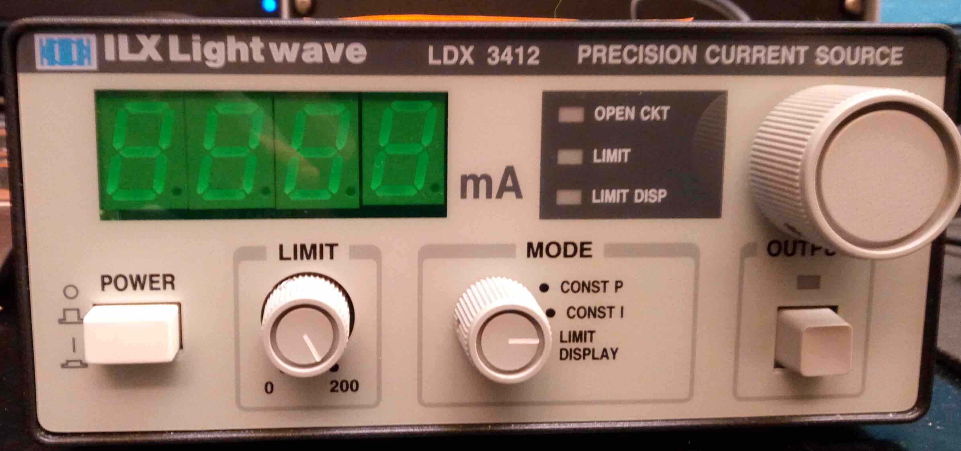
If diode laser supply on, and diode output current off,  and enclosure lid closed  - laser goggles not needed  - room door may be open | 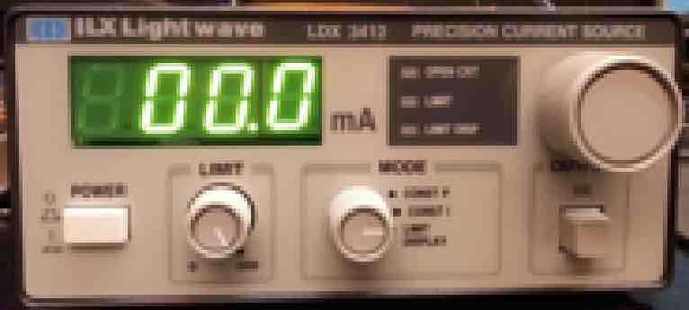
If diode laser supply on, diode output current off,
and enclosure lid open
- laser goggles must be worn by everyone
- room door must be closed
If diode output current is on (even if set to zero)  - laser goggles must be worn by everyone  - room door must be closed  - enclosure lid must be closed | 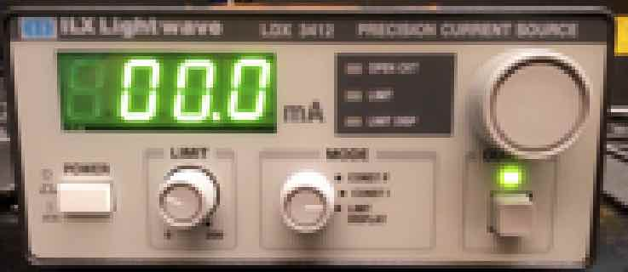

Equipment warnings
- The avalanche photo detectors (APD) could be destroyed by too much light. The APD power should be switched off whenever the room lights are turned on. Even when the power is off, all APD detector box inputs should either have fibre optic cable connected or be covered by the black plastic caps provided.
- The surfaces of optical components can be easily damaged. Even the oil from your skin can permanently mark a mirror, lens, crystal, plate, filter, …. All the optical components you use are usually already mounted in holders, so you should not need to touch them directly. If you do need to mount an optical component into a holder, use nitrile gloves. Try to avoid getting dust and dirt on the optical components.
- After turning on the laser current supply, the diode will warm up and the light output will vary. It is important to measure the singles rate as a function of time, so you know how long you must wait after turning on the current before laser stabilizes. When later taking data, it is best practice to occasionally measure the singles rates for zero polarizer position to track and possibly correct for any drifts in the laser diode light output.
- You will be turning off the laser diode current supply output frequently when adjusting the HWP and QP, so it is worth checking that these short current outages, don’t significantly change the diode light output.
- Always keep your eyes out for equipment anomalies, especially those that might affect your analysis. For example, the singles and coincidence rates should be unchanged if a polarizer angle is changed from θ to θ+180°, but small but very statistically significant differences are often reported by students. This issue is not yet understood, although there are hypotheses.

Experiment
The overall configuration for the experiment is shown in Figure 2. A laser pump beam is prepared in a certain polarization state before interacting with a nonlinear crystal. These are contained within a safety enclosure to protect the user from the laser beam. The down-converted entangled beams are measured using polarizers and detectors.
Figure 2: Schematic of apparatus.
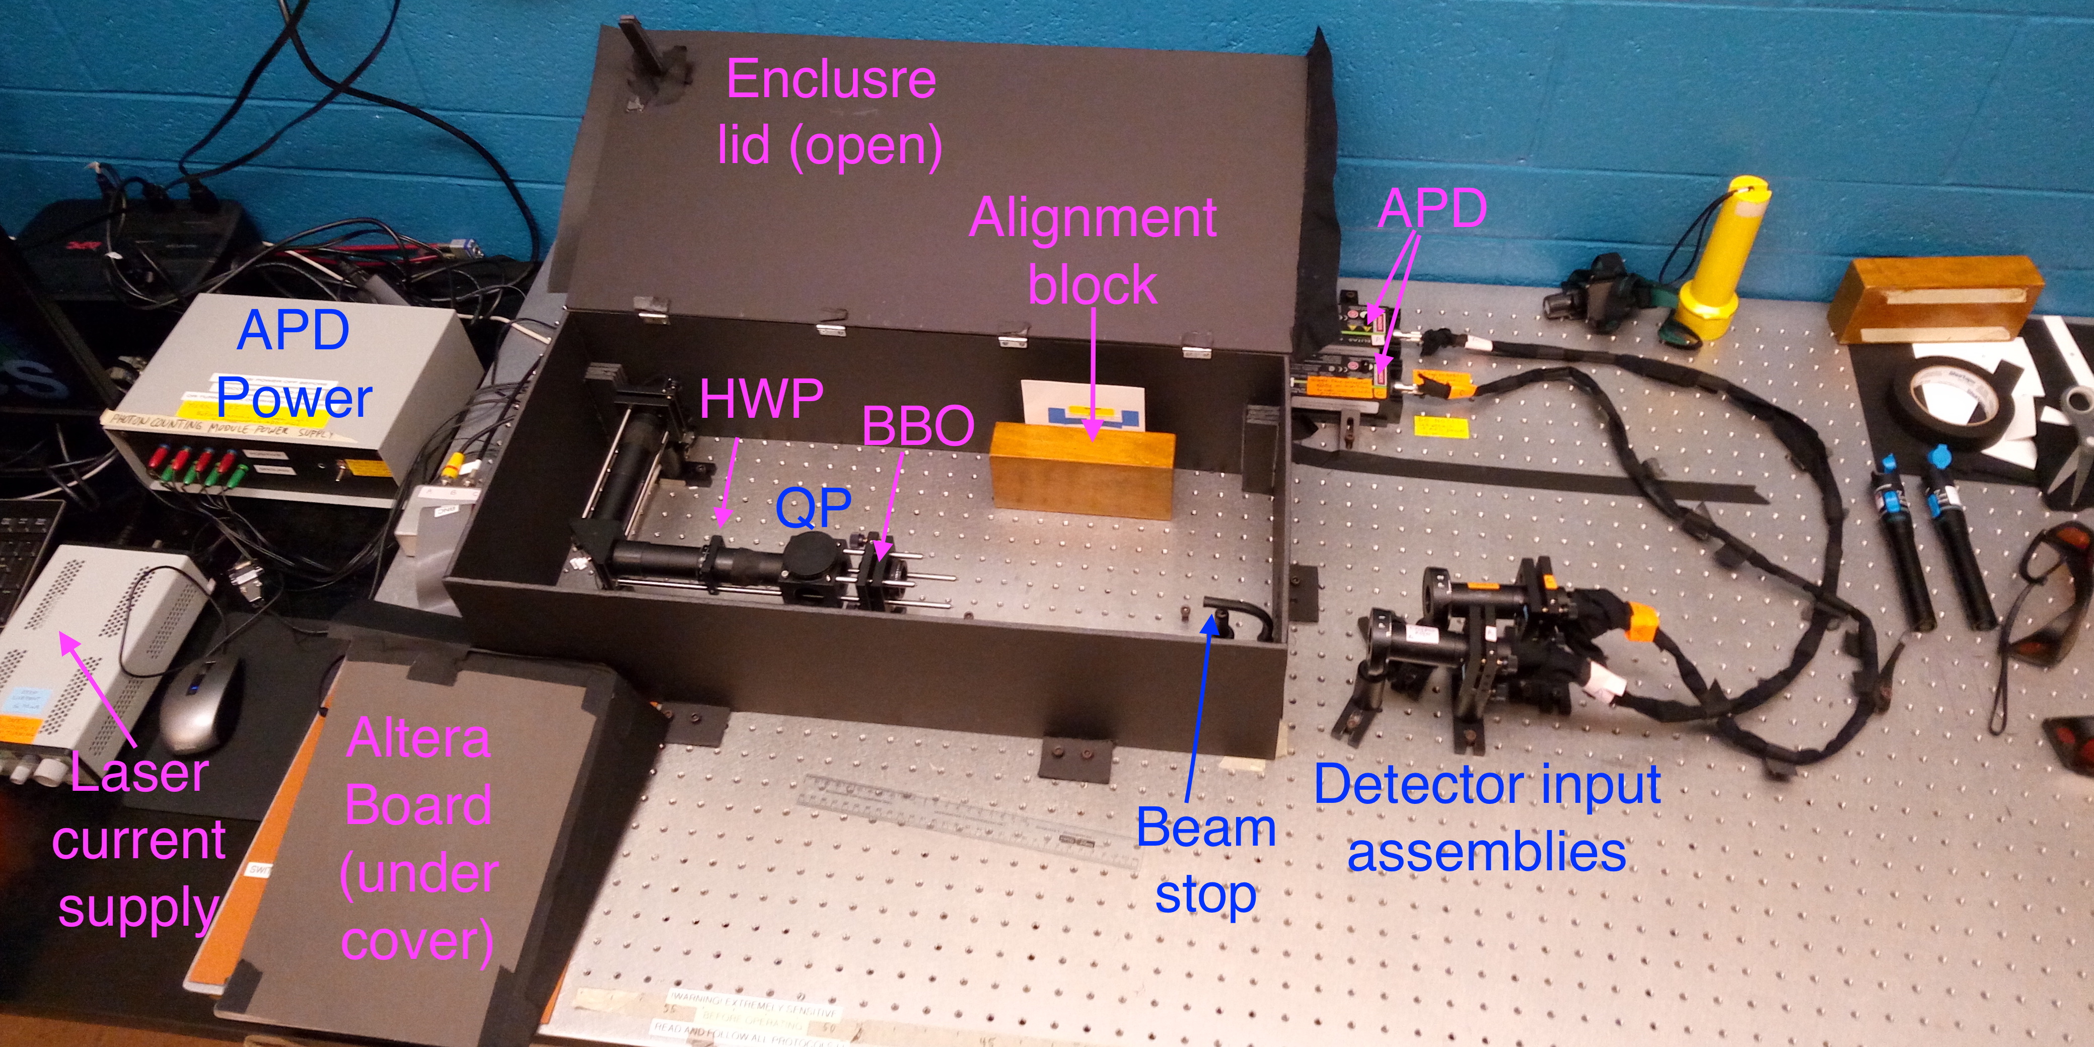
Figure 3: Photo of apparatus.

Components
The pump laser produces 405 nm, linearly polarized light. Turn the laser on by pushing the POWER button and the OUTPUT button below the large knob that adjusts the current. The threshold current for laser action is about 33 mA and the maximum power (~100 mW) is achieved with ~100 mA, although there is little benefit to operating the laser above ~50 mA, and lower output (e.g. 40 mA) offers a safer environment. Nonetheless, there is an interlock feature that will turn the laser off if the safety enclosure is opened (as you know since you have already read and understood the Safety Reminders).
After reflecting from a fixed mirror, laser light passes through a half-wave plate (HWP) and then a quartz plate (QP). The HWP rotates the plane of polarization of the incident beam and mainly controls θ_{l}. Note that the plane of polarization of the beam exiting the HWP is oriented at TWICE the angle between the incident polarization and the HWP fast axis (see Hecht). Rotation of the QP about its vertical axis mainly controls φ_{l}, which can compensate for the phase Δ introduced by the BBO crystals. The QP is oriented so that the entering beam’s horizontal component experiences the ordinary refractive index (1.558) while the vertical component experiences the extraordinary index (1.567). By considering the difference in path lengths for the two components in the 0.5 mm thick crystal, one finds that φ_{l} changes by ~π radians if the QP is rotated in either sense by ~15° from its value at normal incidence (0° on mount); the change in φ_{l} varies quadratically with QP rotation angle for small angles.
Upon exiting the QP the pump beam passes into the nonlinear BBO crystals and entangled down-converted 810 nm photons exit the safety enclosure with residual pump light captured by a beam stop, although some scattered (blue) pump light may also emerge. Note that there is no simple relationship between the HWP and QP orientations and the actual θ_{l} and φ_{m} of the down-converted photons; the θ_{l} and φ_{m} can ONLY be determined from coincidence count measurements as shown below.
The polarizers have been oriented so that an ~ 0° setting passes vertically polarized light. The polarization contrast is approximately 100:1, meaning that the relative probability of horizontally polarized light passing through a polarizer with vertical and horizontal transmission axes is about 1%. For the polymer polarizers used here, even when a photon’s polarization matches the polarizer’s transmission axis, the transmission is < 100% due to absorption effects.
Signal and idler photon collectors (black tubes) contain a variable aperture, to control background light, and a filter that passes light with wavelengths longer than ~780 nm. Behind the filter is a lens that focuses light into a multimode optical fibre connected to single photon detectors. The knobs on the collector gimbal mount are used to orient the collector for optimum photon collection.
A yellow LED lamp (whose light does not pass through the long pass filters) and a green LED flashlight are provided so that one doesn’t have to work in the dark.

Procedures
The goal of the experiments is to measure the polarization properties of the entangled photons and to determine a value for S to allow assessment of the Bell inequality. This requires three main tasks.
Initial set-up, calibration, and optimization: After turning on the LabVIEW program for data collection (see Appendix-B), determine the coincidence time window (see Appendix-C). Adjust the pump beam and signal/idler beam optics to obtain a suitably high rate of raw single photon and coincidence counts (see Appendix-D).
- Tune the entangled state towards the Bell state: Use the QWP and HWP to adjust θ_{l} and φ_{m} as close as possible to 45◦ and 0◦, so that the entangled state is close to the Bell state. As shown in Dehlinger & Mitchell, these angles can be expressed in terms of the number of (corrected) coincidence counts N (α, β). One finds:
(13)
(14)
Adjust the HWP to make N (90◦, 90◦) and N (0◦, 0◦) approximately equal, yielding θ_{l} close to 45◦. (Note: Now adjust the quartz plate to maximize, i.e., tune φ_{m} as close to 0◦ as possible; monitor/change θ_{l} to keep it near 45◦.) Determine $C=\left[N(0°,\text{90}°)+N(\text{90}°,0°)\right]/2$. Is N (0◦, 90◦)=N (90◦, 0◦) as expected, and if not, do you have any idea why not?
Although θ_{l} and φ_{m} can be obtained from just four coincidence measurements, more accurate values are obtained by recording coincidence counts as a function of one polarizer orientation (with the other polarizer fixed) and fitting the data. Note that the words “vertical” and “horizontal” here are only used in a relative sense. Precisely measure polarizer angles to determine your “vertical” and “horizontal” states as carefully as possible. Also, consider that when you make one adjustment you may influence how the beam polarization is altered downstream. The pump state is very sensitive to wave plate orientation, so an adjustment by a few degrees can make a noticeable difference to the entangled state. Also note that while the HWP and QP primarily control θ_{l} and φ respectively, but they are to some extent coupled so that an adjustment of the QP can also influence θ_{l}. For example, as the quartz plate rotates, the transmission of the vertical and horizontal components experience different changes, slightly altering θ_{l.}
- Measure S: The DC beams pass through polarizers, and coincidence counts are measured. By repeating this process for a set of 16 polarizer angles, S is determined. To find E(α, β), measure and the related HH, HV, and VH quantities using the fact that
(15)
Compute E(α, β) from 4 coincidence counts to obtain:
 | $$E\left(α,β\right)=\frac{N(α,β)+N(α+\text{90}°,β+\text{90}°)−N(α+\text{90}°,β)−N(α,β+\text{90}°)}{N(α,β)+N(α+\text{90}°,β+\text{90}°)+N(α+\text{90}°,β)+N(α,β+\text{90}°)−4C}$$ | (16)
Determining thus requires recording coincidence counts for at least 16 sets of polarizer angles, 4 for each measurement of E. The polarizer angles α = −45°, α’=0, β =−22.5, β’= 22.5 ideally give the maximum value of S. Again, graphs of coincidence counts as a function of polarizer angles may offer more accurate results than just the minimum 16 measurements.
Obtain the maximum value of S and associated error as well as the corresponding experimental values of θ_{l} and φ_{m}. Compare the S value with that obtained when the pump beam is vertically polarized, corresponding to a classical photon state.
Notes:
- Following from equation (7), equation (16) differs from Dehlinger & Mitchell by the “-4C” term in the denominator. Ideally C should be small enough that it can be ignored. C in your measurements will, however, likely be large enough that the “-4C” term must be included to observe S>2, although this may change as our methods and apparatus improve.
- The “N” values are the corrected coincidence counts after the random uncorrelated coincidence counts have been subtracted. One should always record the singles and raw coincidence counts for any measurement in addition to the corrected coincidence counts. This allows for re-analysis in case you later make an improved measurement of τ, and the singles rates may contain important clues in understanding issues that arise in your analysis of the experiment, e.g. if the laser power changes, you may be able to renormalize the coincidence rates based on the changes in the singles rates.

Questions
1. S can be computed theoretically for an entangled state with arbitrary θ_{l} and φ_{m}. Compute S for the values of θ_{l} and φ_{m} of the state you used. In theory, should this state violate Bell’s inequality? How does this theoretical prediction correspond to what you measured for S? Theoretically, for α = −45°, α’ = 0, β = −22.5, β’ = 22.5, over what range of θ_{l} and φ_{m} should it be possible to violate Bell’s inequality?
2. Are you able to account for the errors in your final results? How could these errors be reduced? Which optical component provides the major source of error?

Bibliography
D. Dehlinger and M. W. Mitchell. “Entangled photons, nonlocality, and Bell inequalities in the undergraduate laboratory” Am. J. Phys. 70 (2002) 903-910; http://dx.doi.org.myaccess.library.utoronto.ca/10.1119/1.1498860 or http://arxiv.org/abs/quant-ph/0205171.
E. Hecht, Optics, (Pearson, 4th Edition). This is a good general reference for elementary optics.

Appendix-A | What is C?
The constant C first introduced in equation (6) has multiple components, but it does not include the uncorrelated random coincidences that can be calculated from equation (17). The “N” coincidence counts referred to here are always the corrected coincidence counts after this random background has been subtracted. It is not certain that all contributions C are independent of α and β, but we make this assumption in our analysis.
If only the minimum number of measurements are made, then one contribution to C would be if the polarizer angles have systematic offsets, so the nominal (0°, 90°) & (90°, 0°) minima and (0°, 0°) & (90°, 90°) maxima are not the true maxima. The effect of any such offsets can be corrected in measurements if more α & β angles are made, so the true minimum and maximum coincidence rates can be determined.
Another contribution to C is from polarizer imperfections, e.g. wrong polarization light leaking through allowing coincidences that should not happen.
If there are processes producing classical unentangled correlated photons this would contribute to C. For example, can initially entangled photons scatter and become an unentangled classical correlated pair?
To help constrain the contributions to C, it might be interesting to make measurements with the detectors at different distances from the BBO crystal. The rate of entangled coincidences should fall off linearly since entangled photons are in a cone, but if there is a contribution to C fro isotropically distributed correlated photons, the rate should fall off at distance squared. Moving farther away would allow room for lens between the BBO crystal and the detector inputs, which might improve the measurement by partially collimating the entangled photons before they pass through the linear polarizers to the detectors. (There are a couple of 25cm focal length lens in the QIE cupboard, but they are not included in the initial setup because they would complicate the optical alignment and it is not clear whether adding the lenses would improve or worsen the measurement.)

Appendix-B | Data Acquisition and LabVIEW Program
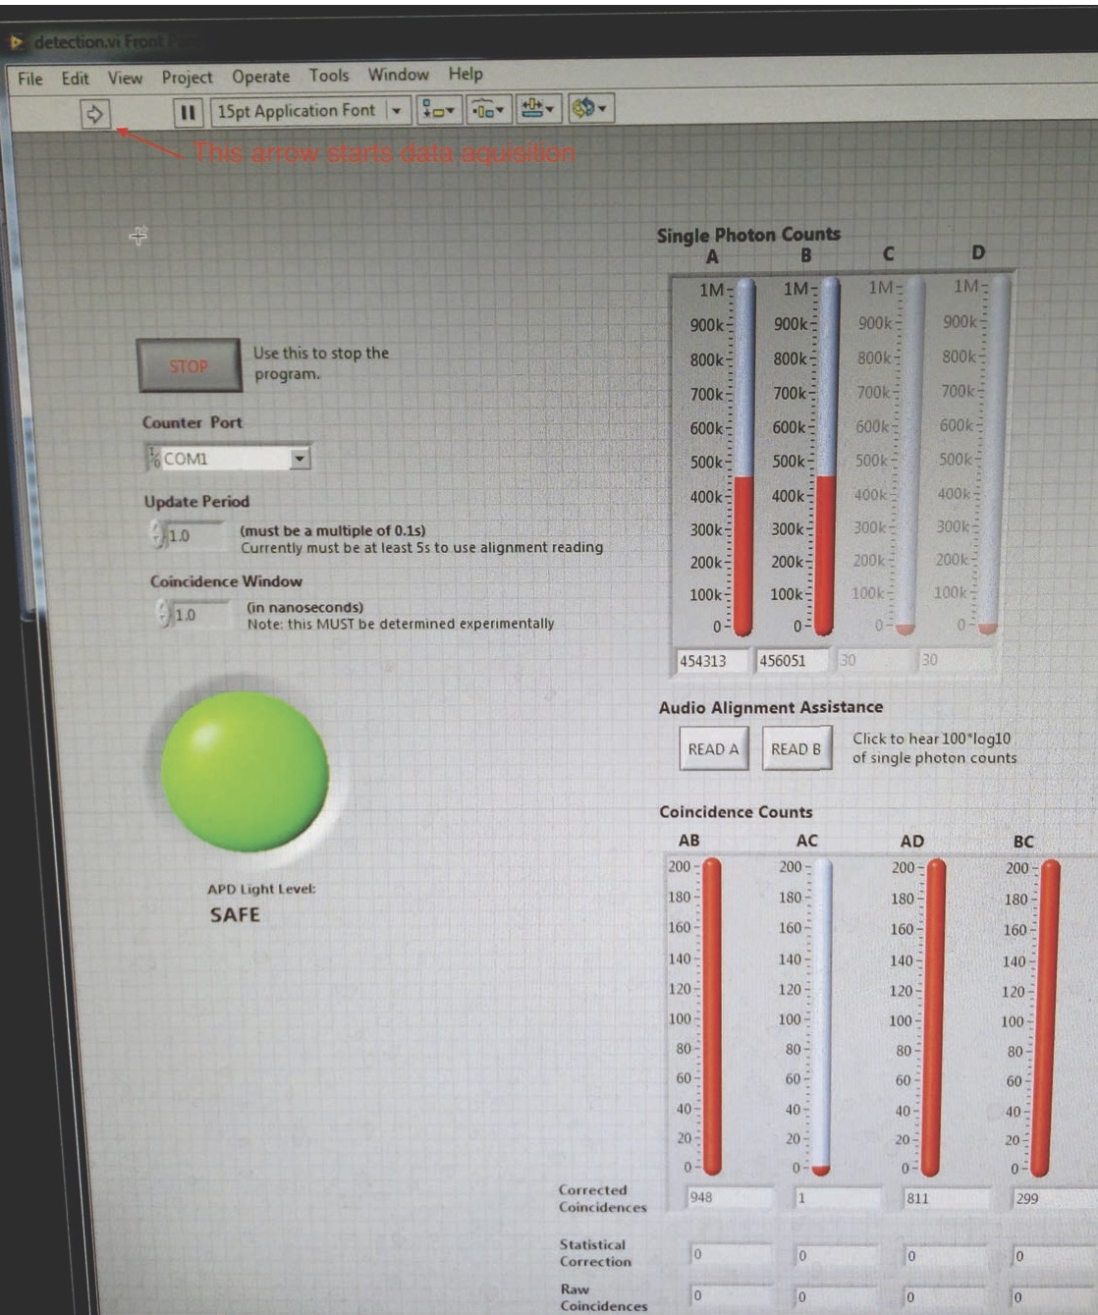
Figure 4: The LabVIEW detection screen before starting data acquisition.
To open the Lab View data acquisition program
- Turn on monitor and log in if not already done.
- Click on Windows icon in lower left corner of screen.
- Click on “Detection”
- LabVIEW should open and the LLB manager window should appear.
- Double click on “detection.vi”
- The interface window shown in Fig. 4 should appear.
The LabVIEW software can report counts for up to 4 detectors.
- Single photon counts (e.g. A and B channels) indicate the total raw number of single photons (e.g. N_{A} or N_{B}) detected by a particular detector within a given time window (typically several nanoseconds). The LabVIEW software can report counts for up to 4 detectors, so you need to check which two are currently connected.
- Raw coincidences (e.g. AB): This indicates the number of “clicks” that occur when signal and idler photons are detected within a pre-selected time window (coincidence window), typically measured in nanoseconds.
- The coincidence window (τ) is how close in time two photons must arrive for them to be counted as being a coincidence.
- The update period (T) defines the time for count collection, after which counts are refreshed.
- Statistical correction The raw counts include detection of ambient (background) photons that may coincidentally trigger the two detectors within the coincidence window. Using the statistical estimate (~N_{A}N_{B} τ/T) of coincidence counts due to random photons, the software attempts to correct for these background counts. Note, however, that it does not correct for all sources of “false” coincidences, such as those due to imperfections in the optics and you should experiment with this.
- Corrected coincidences are the number of coincidence counts after applying the statistical correction to remove random uncorrelated background effects. When the laser is off and the detectors are only measuring classical ambient light, the corrected counts should be zero since all coincidences are statistical (i.e., random).
- Large green/red indicator turns red if displayed counts have reached their maximum values. This is a software warning, and does not necessarily mean the detectors are being damaged. Nonetheless, try not to saturate the detectors.
To start data acquisition
- Press the red power button on the Altera board
- Click the arrow box near the top left of the screen. (If you get a “VISA Read” error, you forgot to turn on the Altera power. Turn it on and click on continue.)
- Turn on the yellow diode desk lamp and make sure you have a flashlight handy.
- Make sure all APD detector box inputs are either blocked by a black cap or have fibre optic cable connected. Close the room door and turn off the room lights.
- Turn on the APD power.
- Counts should start to appear in the LabVIEW interface window.

Appendix-C | Measuring the Coincidence Window
The length of the coincidence window (τ) must be experimentally measured using random photon coincidences. For random uncorrelated photons entering two detectors, the number of coincidences (N_{coinc}) recorded in a time T is expected to be
 | N_{coinc} = N₁N₂ τ/T | (17)
where N₁ and N₂ are the number of single counts recorded by each detector in the same time. (We are ignoring possible “dead time” effects that would be important at count rates much higher than you will be measuring.) τ can calculated if N_{coinc}, N₁, N₂ are measured or known T. To do this, however, we need a source of random uncorrelated photons, and many light sources are not suitable. For example, a simple AC lamp may flicker at 60 or 120 Hz; faster than the eye can notice, but sufficient to give incorrect values for τ. A simple battery powered flashlight with an incandescent bulb should be suitable.
Turn off the room lights off and set the update period on the LabVIEW program to several seconds. Shine the flashlight near (but not directly at) the collectors, and measure the (raw) coincidence rates for a range of singles count rates. Adjust the flashlight position to vary the amount of light, and take sufficient measurements to confirm that the coincidence rates obey equation (17) and to calculate τ. This value should be used for the Coincidence Window setting in the LabVIEW program.

Appendix-D | Optical Alignment
We want to align the detector inputs so they are pointing at the BBO crystal and are horizontally 3° on either side of the direction of the original 405 nm pump beam. The 405 nm beam has been adjusted so it is horizontal and hits the centre of the BBO output iris and the spot marked on the position card attached to the wooden alignment block. Because this has been problematic in the past, we give more detailed instructions here than is usual in the Advanced Lab.
- Place the detector assembles so they are (by your measurement and calculation) 3° on either side of the pump axis. Turn off both the APD and Diode Laser power supplies; turn on the room lights. Open the lid of the black safety enclosure.
- Disconnect both fibre optic cables from the APD boxes (and cover their inputs with black caps).
- Remove the longpass filters from the inputs to the fibre optics.
- Open the iris attached to the one of the inputs to the detector fibres; close the other detector iris and the iris at the output of the BBO crystal.
- Gently insert the white tip of the fibre optic into the visible fault detectors. (Eventually we will get proper connectors, but for now just be careful. A “visible fault detector” is just a light source that can be connected to a fibre optic cable; they are designed to detect spots on the fibre cabling were defects allow light to leak out.)
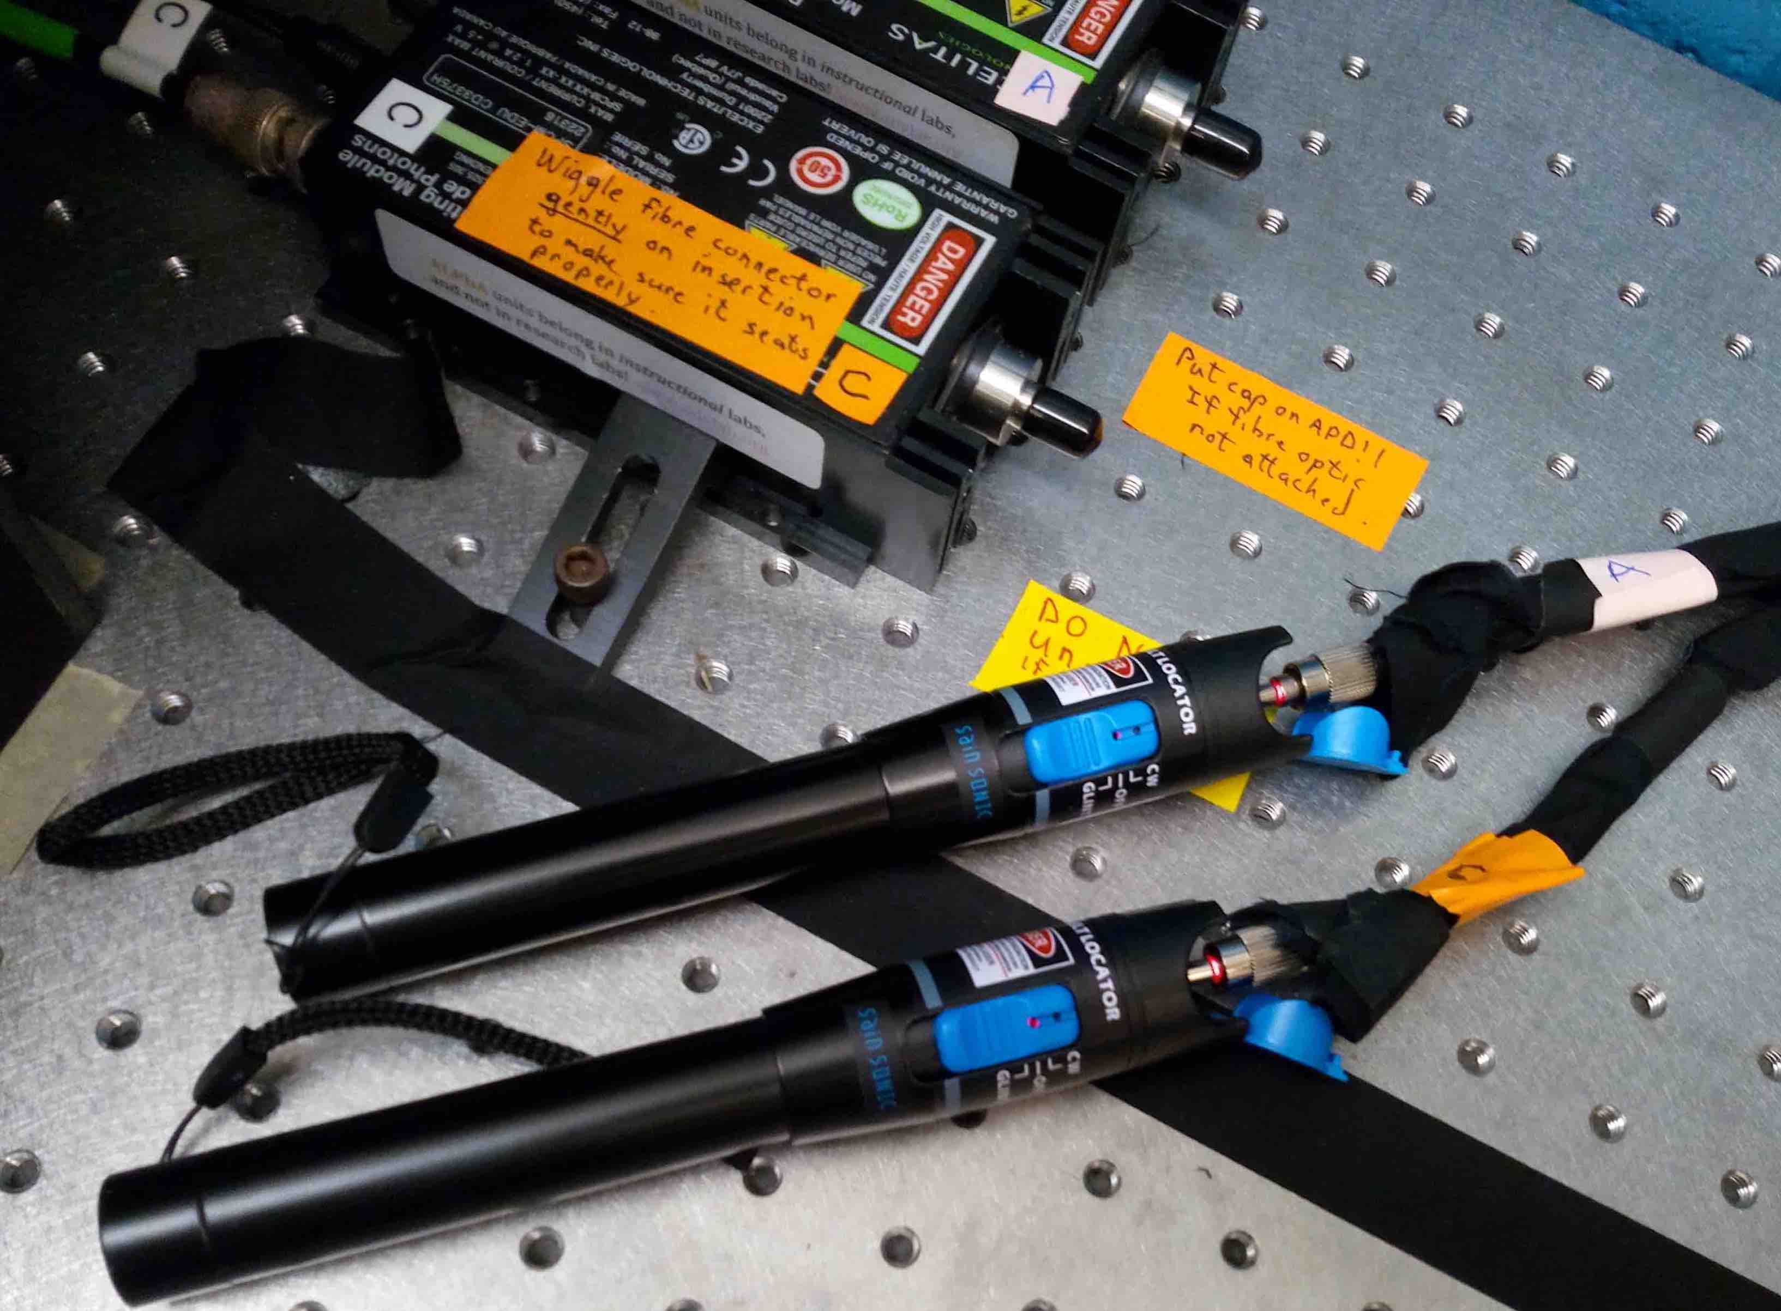
Figure 5: Both fibre optics inserted into visible fault detector. Note that the APD inputs are properly capped.
Warning: If you were to connect the fault detector to the wrong end of the fibre optic and inject light into the APD, you would probably destroy the (expensive) APD.
- Turn on one of the fault detectors. You should be able to detect (e.g. using a white card) a red beam coming out of the detector assembly.
- You want to adjust the detector input assemblies and the BBO crystal orientation until
  - the red beam from each detector hits the centre of the BBO output iris , and
  - when the BBO iris is open, the red beam is reflected from the front face of the BBO crystal onto the centre of the other detector’s input iris, and
  - when the alignment block is put in place, the red spots appear on the alignment card at positions that correspond to the desired angles of +3.0° for one and -3.0° for the other.
(a)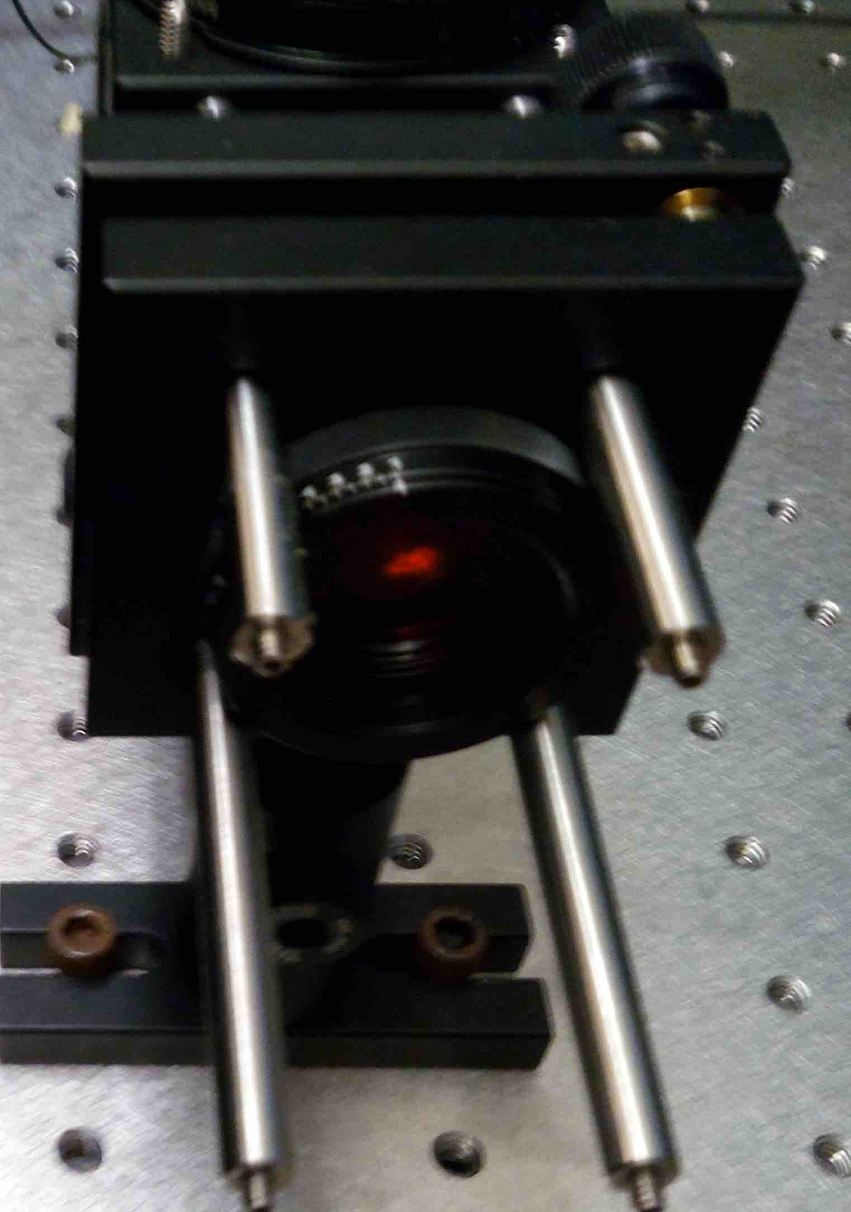 (b)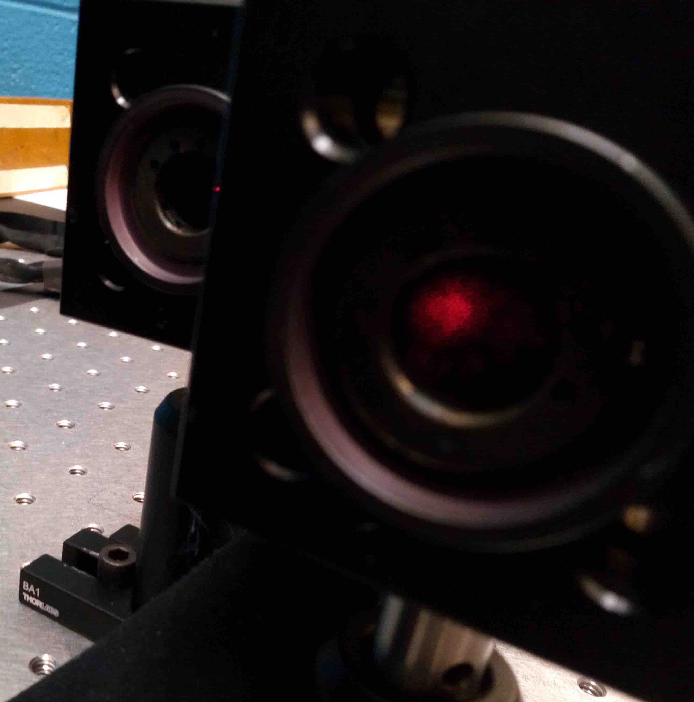 (c)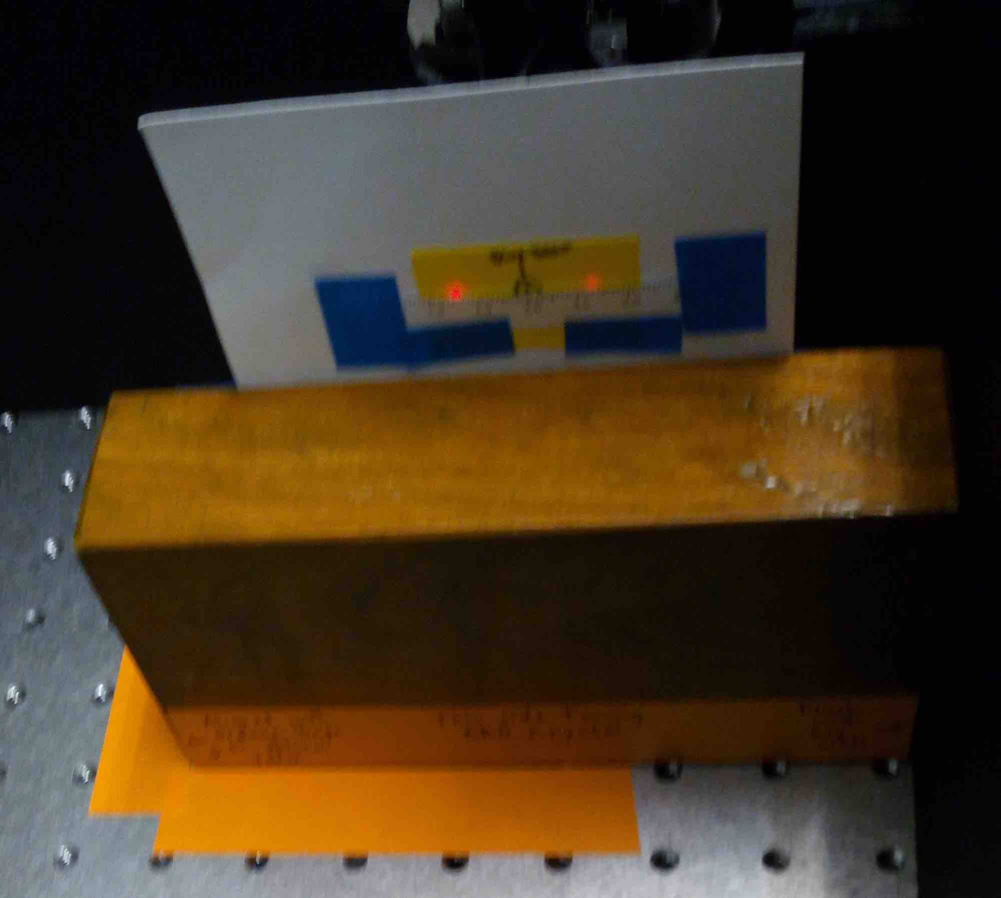
Figure 6: (a) Red spot visible on closed BBO iris, (b) Red beam from left detector is visible on the closed iris of right detector after being reflected from the surface of the BBO crystal (with BBO iris open), (c) Red spots visible on alignment block card with both fault detectors connected.
- Coarse positioning and orientation of the detectors should be down by moving the detector by hand; fine changes in the orientation of the detector inputs and BBO crystal can be made by turning the three screws on each of their mounts.
- You will need to iterate until you achieve the criteria specified in step 7 above.
- Turn off the visible fault detectors and plug the fibre optics back into their respective APD detector boxes. Make sure all irises are open, and remove the alignment block from the path of the beam. Close the lid of the enclosure box. Reinstall the longpass filters on the inputs to the fibre optics. Do not place the polarizers in front of the fibre optics yet.
- Following all safety procedures, turn off the room lights and turn on the laser diode to ~40mA.
- When you turn on the data acquisition you should see a very statistically significant corrected coincidence rate. If the corrected coincidence rate is consistent with zero, you should probably go back step 1 and recheck your measurements and calculations.
- To fine tune the coincidence rate, tweak the orientation adjustment knobs on the detector input mounts in increase the corrected coincidence rate. The singles rates should also increase, but the goal is to maximize the corrected coincidence rate. You can also try adjusting the height of the mount and position on the table, but this is very hard to do this in controlled small steps. (Once you release the screws holding the post or the base, things tend to move too much. We may eventually get some precise linear positioners, but it is not yet clear if they are needed.)
- Once you are happy with the rate, place the polarizers in front of the longpass filters, and you are ready to take data.

Thanks to Physics Student Anthony Ardizzi for pointing out that the “-4C” term is missing in Dehlinger & Mitchell.
Simple Bell’s measurements typically have assumptions and loopholes. The first “loophole-free” (?) demonstrations of violation of Bell’s inequality were only made in 2015, see https://dx.doi.org/10.1038/nature15759, http://dx.doi.org/10.1103/PhysRevLett.115.250401, and http://dx.doi.org/10.1103/PhysRevLett.115.250402.

