University of Toronto
ADVANCED PHYSICS LABORATORY
RAM
Raman Effect

Revisions:
2021 September: Robin Marjoribanks (Minor changes, safety) v1.4
2020 August: Robin Marjoribanks (Major revision, laser version)
2019 August: David Bailey (Minor changes)
2014 October: Henry van Driel
1991 September: John Pitre

Please send any corrections, comments, or suggestions to the professor currently supervising this experiment, the author of the most recent revision above, or the Advanced Physics Lab Coordinator.

Copyright © 2020 University of Toronto
This work is licensed under the Creative Commons
Attribution-NonCommercial-ShareAlike 3.0 Unported License.
(http://creativecommons.org/licenses/by-nc-sa/3.0/)
Overview
The purpose of this experiment is to introduce Raman scattering, a powerful tool that allows one to determine vibrational and rotational properties of molecules. It is used here to measure the frequencies of some vibrational modes of sulphur in the solid state, and carbon tetrachloride and benzene in the liquid state.
Introduction
Light scattering can be classified in many different ways. In general, elastic light scattering produces light with no change in frequency from the incident beam. An example is Rayleigh scattering, which occurs from particles much smaller than an optical wavelength such as atoms or molecules; it is responsible for, e.g., the blue sky. In inelastic light scattering the scattered light has a different frequency from the incident beam. Stokes scattering occurs if the wavelength shift is to a lower frequency while anti-Stokes scattering involves a shift to higher frequency. Inelastic light scattering is a sensitive probe of time-dependent material phenomena, including material excitations such as molecular rotations or vibrations. Common forms of inelastic light scattering are Brillouin and Raman scattering. Brillouin scattering is inelastic light scattering from collective excitations of a condensed matter system (solid or liquid) such as acoustic phonons (sound waves) that produce time-dependent density changes. Raman scattering occurs from individual molecules in which there is a change in the electronic or nuclear configuration (e.g. through a vibrational or rotational mode). If the molecule gains energy in the scattering process, one has Stokes scattering. If the molecule is initially in an excited sate and loses energy in the scattering process, one has anti-Stokes scattering. Adolph Smekal predicted the existence of Raman scattering in 1923 but the effect is named after C.V. Raman, an Indian scientist, who first observed it experimentally together with K.S. Krishnan in 1928. Raman received the Nobel Prize in physics for discovering the effect, although in some of the German literature the effect is often referred to at the Smekal-Raman effect. Because molecules have distinct vibrational and rotational frequencies Raman scattering has become an essential fingerprinting technique in modern diagnostic methods allowing one to determine the composition of materials.
Classical Explanation of Rayleigh and Raman Scattering
To understand the basic idea behind Rayleigh and Raman scattering, we initially offer a classical approach. Consider a light beam with angular frequency ω₀₀ whose electric field at a given point is given by
. (1)
If this beam is propagating inside an isotropic material it induces an electric polarization density whose strength is governed by an electric susceptibility. For a crystal the susceptibility is typically a matrix but for a fluid, as considered here, one can employ a scalar χ, so that

. (2)
This oscillating polarization density is the source for all re-radiated light including reflected, transmitted and scattered light. The susceptibility χ consists of a time-independent piece that leads to the reflected and transmitted light along particular directions and Rayleigh scattered light that propagates in all directions. However, since the susceptibility depends on the atomic or molecular coordinates, which, in turn, depend on the time-dependent vibrational and rotational modes of the molecules, the susceptibility has a time dependent part. To avoid becoming bogged down in notation we ignore rotational modes of the molecule and only consider one vibrational mode (as would be the case for, e.g., molecular hydrogen, oxygen, etc.) considered as a single harmonic oscillator. The amplitude of vibration can be written as and the susceptibility can be expanded in a Taylor series as
(3)
where the first term on the right-hand side is time independent and Ω and Q are the (angular) frequency and generalized co-ordinate (bond vibration amplitude in the case of molecular hydrogen) of the mode. Hence the polarization density can be written:
(4)
The first term on the right-hand side, and which has the same temporal frequency as the incident light beam, corresponds to an oscillating electric polarization density responsible for all the elastically scattered light (reflected, transmitted, and Rayleigh) at the same frequency as the incident light. The last two terms are responsible for Stokes and anti-Stokes inelastically scattered light at frequencies different from that of the incident light. In essence, the time-dependence or modulation of the electric susceptibility produces “side-bands” at higher and lower frequency than the incident light.
We now consider more complex molecules with N atoms. In general 3N coordinates are needed to specify the locations of all the atoms; the molecule is said to have 3N degrees of freedom. However, if we confine ourselves to motion about the centre of mass (rotational or vibration) we can take away the 3 degrees of freedom associated with centre of mass motion. For a linear molecule there are 2 degrees of rotational freedom (about two orthogonal axes passing through the centre of mass) while for non-linear molecules there are 3 degrees of rotational freedom. Hence for a linear molecule there are 3N-5 vibrational degrees of freedom or distinguishable vibrational modes, while for a non-linear molecule there are 3N-6 degrees of vibrational freedom. For example, In the case of carbon tetrachloride (CCl₄) studied here there are 9 distinct or normal vibrational modes, while for Benzene there are 30. However, some of these vibrational modes are degenerate, meaning that they have the same frequency. A detailed analysis of the vibrational dynamics shows that for CCl₄ there is one non-degenerate mode, one doubly degenerate mode and two three-fold degenerate vibrational modes, hence only four distinct vibrational frequencies. For these more complicated molecules the first two terms of the Taylor expansion of Eq. 4 has possible contributions from all these modes and becomes
(5)
where the summation is taken over all the different vibrational and rotational modes of the molecule with generalized co-ordinate Q_{i} and normal mode frequency Ω_{i}. The strength of the Raman scattered light for a particular mode depends on the value of . If the value is non-zero the mode is said to be Raman-active. Note as well, that if for a complex molecule we extend the Taylor series expansion of Eq. 3 to second order terms we introduce terms such as
(6)
It is straightforward to show that such higher order terms will add oscillating terms at frequencies ω₀ ±(Ω_{ι} ± Ω_{ϕ}) to Eq. 5. Light emitted at these additional frequencies are referred to as overtones. In general this scattered light is much weaker than the Stokes or anti-Stokes radiation, but you may actually observe one or more overtones in the CCl₄ Raman spectrum.
The rotational Raman shifts are generally much smaller than the vibrational Raman shifts and our experimental arrangements are not able to resolve them. We therefore ignore them in our subsequent discussion and focus on the Raman spectra of the vibrational modes. In the case of CCl₄, for example, we can expect 4 Stokes and 4 anti-Stokes lines of varying strength.
Quantum Basis of Rayleigh and Raman Scattering
The classical explanation cannot account for all details of Raman scattering such as why certain modes are Raman active and the actual relative intensities of Stokes and anti-Stokes light. These depend on a fully quantum treatment of the electronic, vibrational and rotational motion as well as incident photon absorption and scattered photon emission processes. However, a full treatment of this is beyond a typical undergraduate course in quantum mechanics, invoking concepts such as time-dependent perturbation theory and group theory. We therefore only provide some insight into the key quantum concepts needed beyond the classical model.
We consider a molecule whose complete quantum state at any time is specified by electronic, vibrational and rotational quantum numbers of all the modes. For simplicity, as with the classical case we suppress all reference to electronic and rotational parameters and focus only on one vibrational mode (v) whose energy is , where n_{v} is the mode quantum number. When a photon interacts with a molecule, the quantum state of the molecule may or may not be altered. In the case of Rayleigh scattering, an incident photon of energy is absorbed and the molecule makes a transition to an excited state as shown in Figure 1 below. The molecule then makes a transition back to the initial (usually the ground) state and a photon of the same energy is emitted.
In the case of Stokes scattering, following absorption of the incident photon, the molecule makes a transition to an excited state with vibrational quantum number n_{v} +1 and a photon of energy is emitted as shown in Figure 1. In the case of anti-Stokes scattering the incident photon is absorbed from a molecule in an excited vibrational state with quantum number n_{v} +1 and the molecule makes a transition to a less excited state of vibrational quantum number n_{v} with emission of a photon of energy . Hence in Stokes scattering, energy is imparted to a molecule while in anti-Stokes scattering it is taken away.
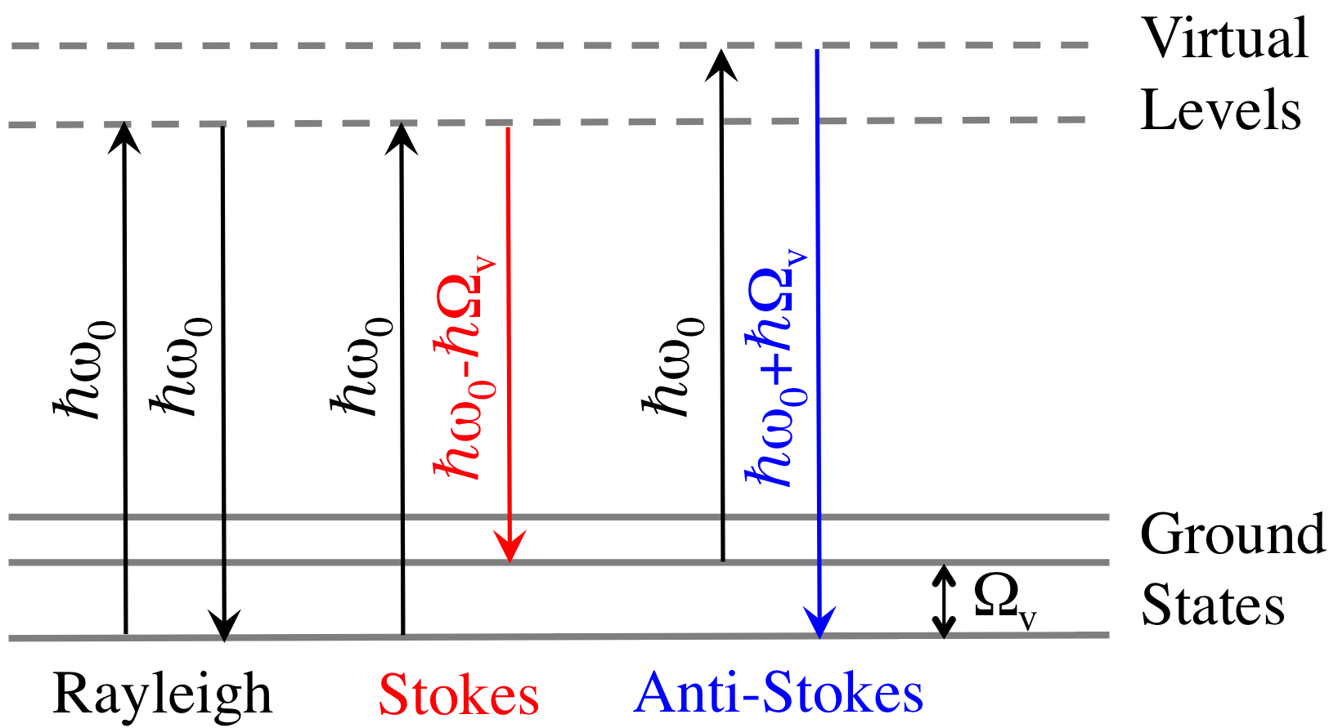
Figure 1: Scattering energy level transitions
Assuming that the scattering medium is in temperature equilibrium at absolute temperature T, there is a Boltzmann distribution of molecules over the energy states and the ratio of the number of molecules N (n_{v} +1) in a state of energy to the number of molecules N (n_{v}) in a state of energy is given by**
(7)
Since quantum mechanics also shows that the total amount of scattered light is proportional to the fourth power of the frequency then the relative total number of anti-Stokes to Stokes photons is given by
(8)
where k is Boltzmann’s constant. Note that in general the number of anti-Stokes photons is less than the number of Stokes photons. Because the emission process is governed by molecular lifetime effects the emitted light has a small spread in frequencies giving rise to a linewidth for the emission process. The total number of photons is therefore that emitted over the entire linewidth and not just the peak value recorded in a spectrum. The above analysis applies to all the modes observed in Raman scattering.
As noted above we have not considered the Raman process in connection with rotational or even electronic degrees of freedom. In the case of rotation the Raman shifts are too small to be resolved with the spectrometer available to you.
Since Raman shifts are equal to molecular vibration or rotation frequencies, they are equal to frequencies that might appear in the infrared spectrum. This does not mean that the Raman spectrum is merely the infrared spectrum transferred to a higher frequency region. Different selection rules govern Raman transitions from those that govern radiative transitions. This means that some transitions may be Raman active but may not appear in the absorption spectrum. The two are often complementary.

SAFETY REMINDERS
- Prolonged exposure to carbon tetrachloride, benzene, chloroform, or fumes from other samples used in this lab may be harmful to your health, so you should read the MSDS (Material Safety Data Sheets) for CCl₄ (https://bit.ly/2zaHHAa), C₆H₆ (https://bit.ly/1vrRT0N), or other samples you use. These sheets are also available nearby the apparatus and from the lab technologists. Risk is minimal since the Raman samples are just a few mL, and are sealed, but if there is an accidental spill of any chemical the room should be calmly evacuated and lab staff consulted immediately.
- The 40mW 532nm laser output is Class 3B and can damage eyesight, if directly exposed, or if an accidental unanticipated reflection is created. It does not produce a hazard for skin exposure, and will create no sparks or ablation. Alignment: It is possible to view the laser beams safely to align, provided that the current to the diode is first reduced below 140 mA. This reduces the laser power below 5 mW. Even so, care should be taken not to allow any direct or accidental beam to enter the eye.
- The 60mm rail system with all optical components has an enclosure with an interlock: if the case is removed, the laser is switched automatically to 5mW maximum power. It is not necessary to operate the laser at full power with the enclosure open, and the interlock must not be interfered with. Speak with a Supervising Professor before attempting any open-enclosure operation. https://ehs.utoronto.ca/our-services/laser-safety/
- The sample heater is capable of being hot enough to be a concern, and it may take a long time to cool down. Attention and caution should be used. The heater controller in this experiment has a set temperature limit of 50 °C.
NOTE: This is not a complete list of all possible hazards; we cannot specifically warn against all possible creative failures of judgement. Experimenters must use common sense to assess and avoid risks, e.g. never open plugged-in electrical equipment, watch for sharp edges, don’t precariously balance heavy objects, etc. If you are unsure whether something is safe, ask the supervising professor, the lab technologist, or the lab coordinator. If an accident or incident happens, you must let us know. More safety information is available at http://www.ehs.utoronto.ca/resources.htm.

Experimental
Raman spectra of sulphur, carbon tetrachloride (CCl₄) and benzene are studied in this experiment. Advanced versions may include chloroform and deuterium-substituted chloroform (to change vibration frequencies). Discuss with the Supervising Professor, if you want to try something else.
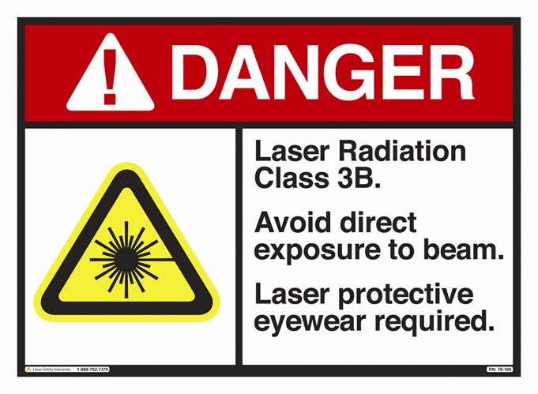
The Raman-source laser – The source of light used is a DJ532-40 diode-pumped solid state infrared laser which is frequency-doubled to 532nm. It consists of a combination of Nd:YVO₄ and KTP crystals within a mirror cavity, together with a 808 nm laser diode. Its maximum power output is 40 mW of green light, controlled by the current supplied to the 808 nm laser diode which pumps the Nd:YVO₄ laser medium. A current of 325mA is suitable for collecting spectra; a current below 140mA provides low-power output safe for viewing by eye. The system must not be operated above 140mA except that the whole system is completely enclosed (or else everyone in the room is wearing specific, appropriate, laser goggles). Currently, the whole laser and sample system is contained within an enclosure that contains the laser beam. The enclosure has an interlock installed: with the case fully in place, the laser automatically runs at maximum power; with the case removed, the laser automatically runs at a power which is less than 5mW, similar to a strong legal laser-pointer. No-one must interfere with safety interlocks. If you suspect anything may be irregular, turn off the laser power and report the issue immediately to a Supervising Professor.
The power and spectrum of the laser are only stable if its temperature is, also. The unit contains a thermoelectric cooler operated by a separate controller unit.
Note: this is not a laser pointer, its maximum power is an order of magnitude greater than an eye-safe consumer pointer used in presentations. This is a Class 3B laser, for more information on laser Classes and laser safety see https://ehs.utoronto.ca/our-services/laser-safety/.
Turning on the pump laser –
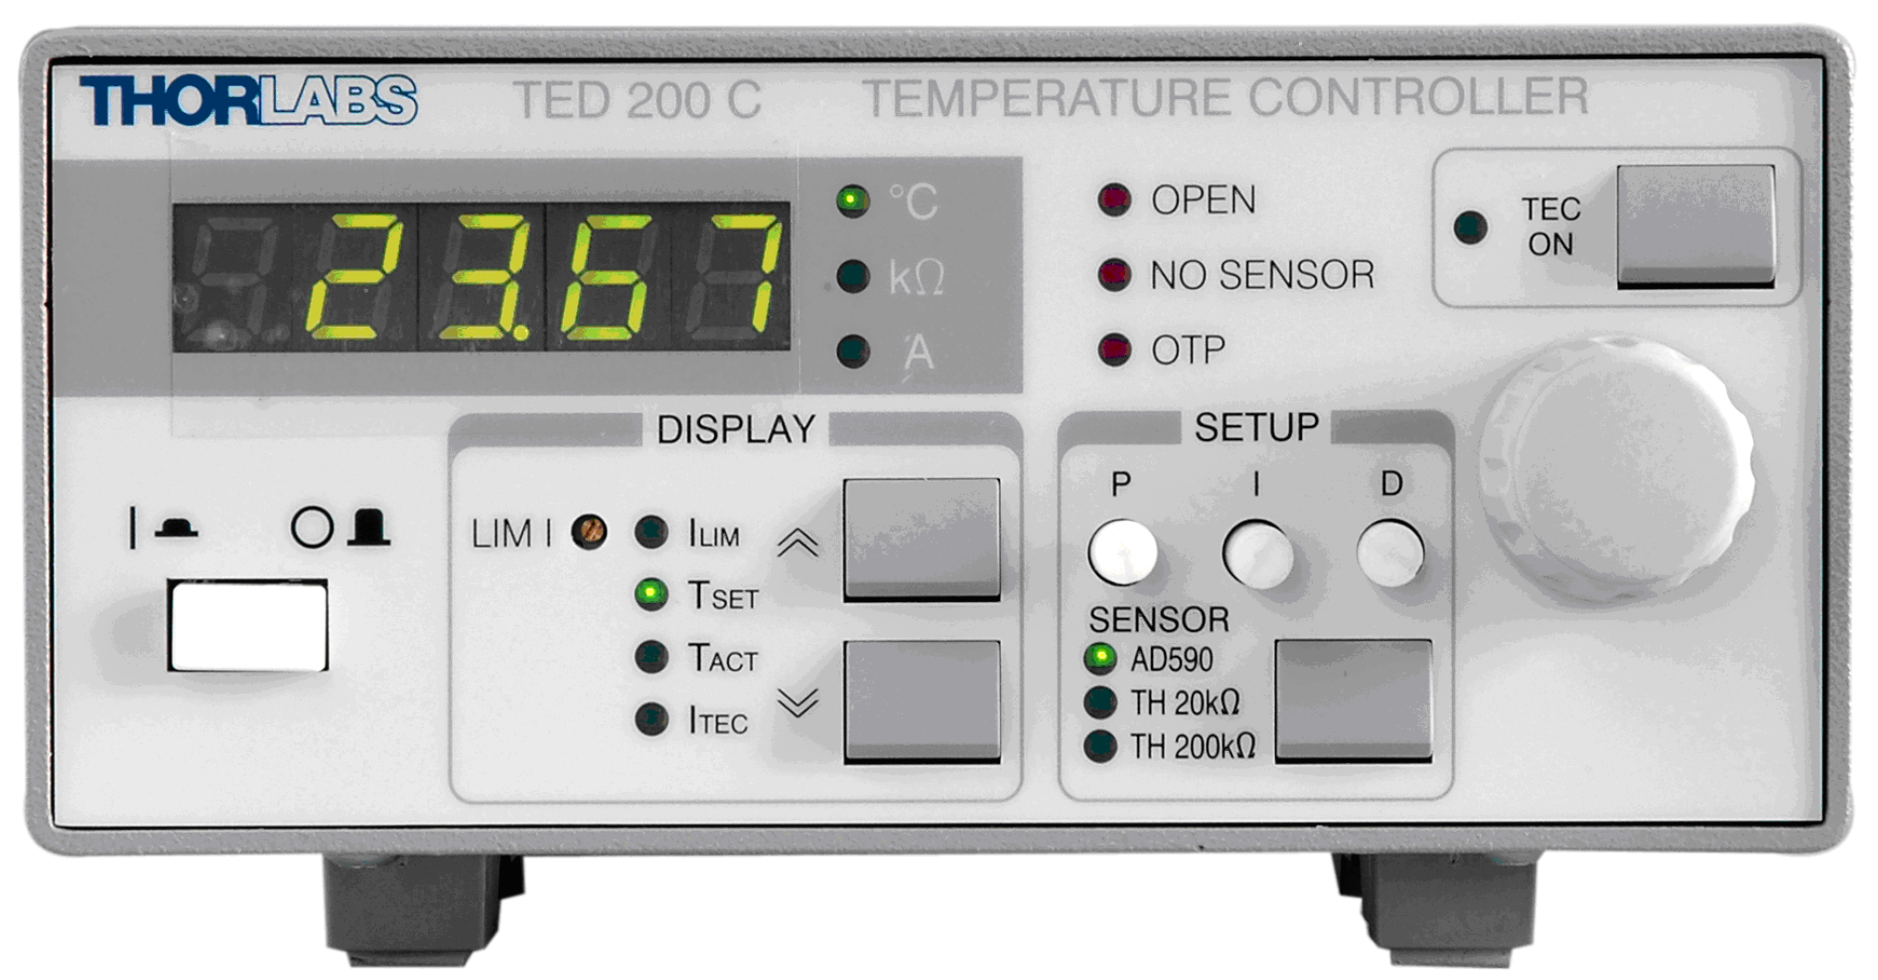
TED200C Temperature Controller
1) TED200C – Turn on the thermoelectric cooler controller for the diode-pumped laser: first the main power, and then the TEC ON button. Cooling is necessary to protect the laser and to stabilize its output wavelength, it should stabilize in 10 minutes at ~22.5°C. Do not adjust the PID (proportional-integral-derivative) control settings, they’re optimized and take an hour to set properly.
2) LDC205C Turn on the laser diode controller: first the main power and then the LASER ON button. Currently, the interlock system on the case controls the laser power to be at one of two levels: FULL, with the case in place, and 5mW with the case removed. There are currently no student-adjustable settings, and the controller must operate in constant-current mode (CONST: I). You may wish to record the current ILD, which you can display, but this model of laser-diode (DJ532-40) is not equipped with a photodiode to read out actual laser power, thus that function of the unit is not available here. You must not adjust LIM or CAL. Both TED200C and LDC205C controllers must be on, for temperature to stabilize correctly.
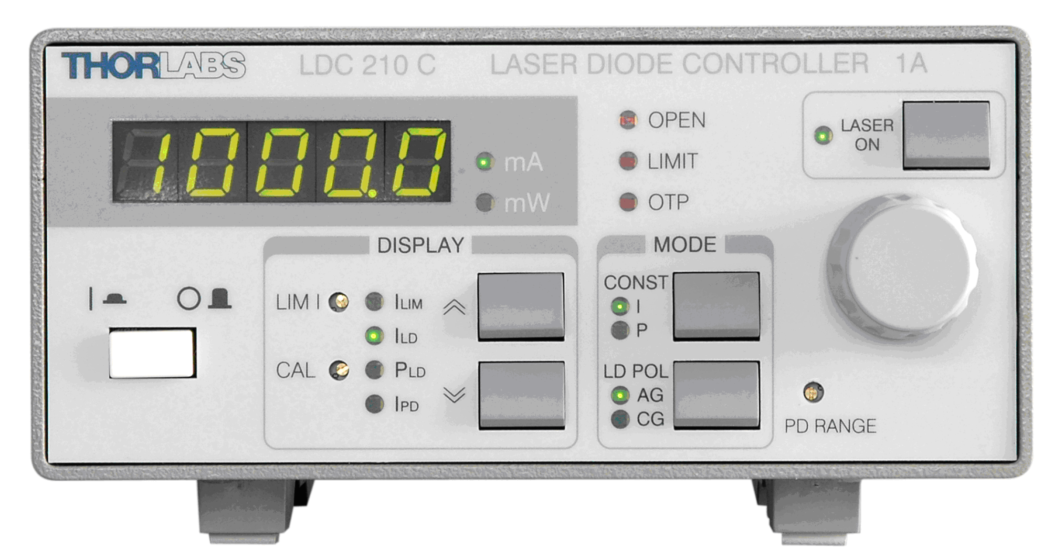
LCD200-Series Laser Diode Controller
Collection of light from sample – CCl₄ is a classic sample for study because of its symmetry, which makes it easy to picture all the normal-mode oscillations, and makes it simple for group-theory representation analysis. Only a small fraction (often less than a part in 10⁶) of the incident light is scattered by the liquid and of this, most is found in the Rayleigh line. To observe the Raman lines, it is necessary to illuminate the sample very strongly and to ensure that only scattered light can enter the spectrometer. In the apparatus provided, the laser is introduced from the side and a small mirror puts the pump beam aligned with the optic axis of a beam telescope. The 100 mm lens serves two purposes: to focus the pump laser onto the sample; and to efficiently collect scattered light from the sample and relay it along to the 250mm lens which puts the light onto the entrance slit of the scanning spectrometer. The scanning spectrometer is lined up with the axis of the telescope design so that it accepts only light introduced to it along the axis.
The arrangement of image-relaying from sample cell to spectrometer input slit is shown in Fig. 2.
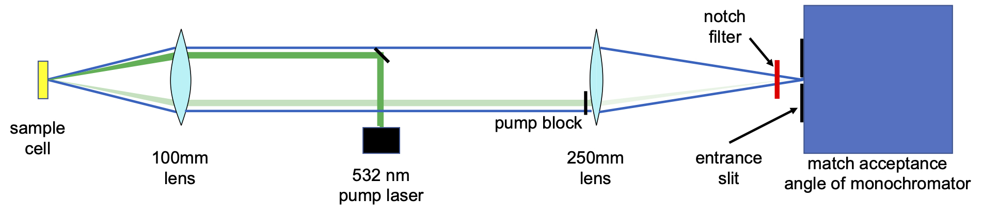
Fig. 2: This is a telescope design with a small f/-number at the source to collect light efficiently. At the input of the monochromator the f/number of the delivery lens is designed to match the acceptance angle of the optics inside.
Pump block: The specular reflection of the pump laser, from the sample holder, occupies just a small part of the solid angle collected by the 100mm lens, and this gives an opportunity to block the reflected 532nm light before it is sent to the spectrometer and photomultiplier tube, which can be destroyed if exposed to bright light. This is currently done near the surface of the 250mm lens, before all the collected diffuse light from the sample is gathered up to a focus at the entrance slit.
Notch filter: Another opportunity to cut down the super-bright pump light is a notch filter – an interference filter which creates a narrowband spectral mirror 17nm wide at around 533 nm (see Fig. 3). Since this is a mirror, when the case is open, be careful about where the strong reflection of intense laser light goes – eye injuries often come from uncontrolled stray beams. At its peak, the notch filter attenuates by a factor of about 10⁶.
This filter is sensitive to angle-of-incidence, as all interference coatings shift their action to shorter wavelengths when tilted. Slight tilting will permit you to look at Raman lines close to the pump wavelength which are blocked by the notch filter when it is used at normal incidence. To permit wavelengths near to the pump frequency to pass, but still to block the 532nm laser pump, the filter should not be tilted to more than about 15° angle of incidence.

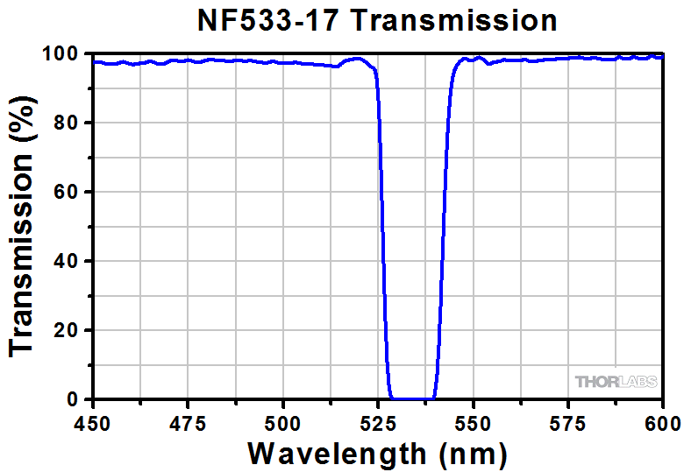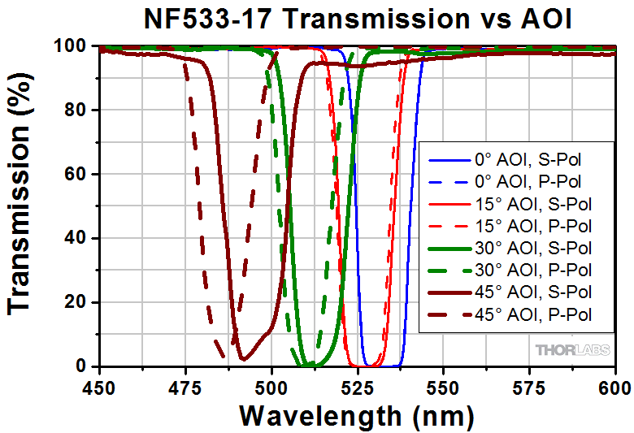
Fig. 3: The notch filter greatly reduces Rayleigh-scattered pump-laser light reaching the photomultiplier. It may block a bit more spectrum than is strictly necessary, but the filter can be ‘tuned’ to shorter wavelengths by slight tilting of the filter. Caution: tilting too much will permit the laser light to pass freely, and damage the PMT.
Photomultiplier (see Appendices for specifications) — The photomultiplier voltage should be ~800 V, and the shutter should remain closed except when recording to protect the photomultiplier. Data on the scanning monochromator and photomultiplier unit are given in Appendix II. One should understand what is going on inside the scanning monochromator and not treat it just as a "black box". The cover of the scanning monochromator can and should be removed (or see figures attached here after Bibliography) so that the optical configuration of the unit can be examined. Never touch any of the optical surfaces — some types of mirror can be cleaned, but unprotected front-surface mirrors and diffraction gratings require special heated-vapour cleaning, if they can be cleaned at all.
Alignment: Rarely, the system may need realignment. This is done principally by tiny horizontal adjustments to the tiny mirror for the pump laser, in the middle of the 60mm cage system, at low power with the enclosure removed and room lights out, while monitoring photodiode signal (preferably with the monochromator set to the wavelength of one of the lines in sulphur). A Thorlabs 5/64” ball-end driver is provided for this adjustment.
A full level-zero alignment procedure is documented by video and available to TAs and professors on the password-protected webpages for the experiment (RSM).

Sample Heater Controller (in development)
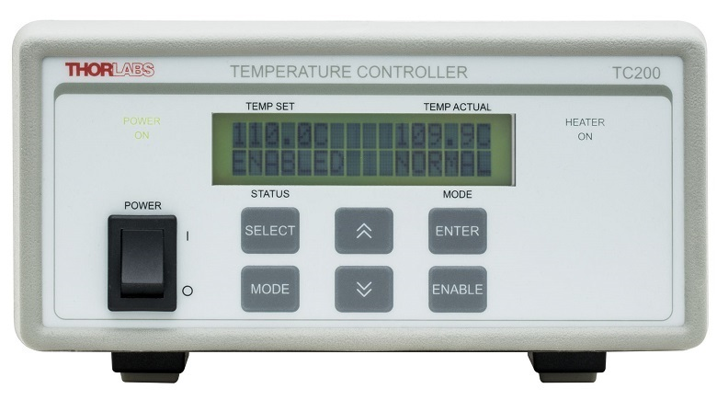
TC200 Sample Heater Controller
1) TC200 – This unit can heat the entire sample holder, and read out the temperature. Currently it provides a maximum of only 34C (it should heat more, if fully working). Consult with the APL Supervisor if you wish to go beyond what this unit currently provides.

SUGGESTED EXERCISES
- Begin with the cuvette of powdered sulphur, it makes strong signals and a well-known spectrum. Find good ways to record your wavelengths, given that your chart-recorder software records only time on the abscissa. Spectroscopy often uses convenient units of wavenumber (cm^{–1}), proportional to frequency and to energy. Remember that a spectrum is a distribution, and the integral in each photon range should be preserved, regardless of units — therefore the distribution values must also be changed, whenever changing units (the Jacobian).
Convert your recorded data to plots which use this unit, with the zero set to the 532nm pump wavelength, so you identify shifts in energy for each line. Sulphur is a good sample to tinker with, for small changes in the angle of the notch filter, changes in scan speed, slit width, and other adjustments you may wish to optimize.
- Record the Raman spectrum of CCl₄ at two or more temperatures, and that of C₆H₆ at one temperature. Use the heater controller provided, driving the heater-block into which the cuvettes are inserted. Consider how long it may take to reach equilibrium in your sample, when changing temperature.
- Measure the frequency shifts of the Stokes Raman lines excited by the 532 nm pump.
- Determine the ratio of the intensities for each pair of anti-Stokes and Stokes lines for CCl₄. Compare your results to equation (17).
- Other liquids and materials are possible, including regular chloroform and deuterated chloroform, for which atomic mass changes shift the frequency of some vibrations. Consult with your supervising professor about other materials you may be interested in, such as paint pigments, tooth enamel, ceramics, mixed alcoholic drinks, soft drinks, Jello, Kool-Aid, etc. The laboratory has a few other cuvettes, depending on type of material it must contain.

QUESTIONS
- CCl₄ molecule basic ideas.
- What is the shape of the CCl₄ molecule?
- Are the distances between the chlorine atoms all equal?
- Are the carbon to chlorine bonds all of the same length?
- Are the Cl-C-Cl bond angles all the same?
- Where is the center of mass situated? (Herzberg p. 165)
- How many fundamental frequencies does CCl₄ have?
- Vibrations and degeneracy.
- Which fundamental mode is associated with each Raman Stokes line that you observed.
- For CCl₄ why does the v₂ vibration have the least energy associated with it?
Hint: Think in terms of changing bond lengths during the vibration and the associated bond strengths.
- Which vibrations are degenerate and what is the degree of their degeneracy?
- Be able to describe the normal modes of vibration of the CCl₄ molecule using drawings or a physical model. (Herzberg pp. 99-101).
- How many of the fundamental frequencies did you see in your Raman spectrum? (Herzberg pp. 310-312)
- Symmetry.
- What is a centre of symmetry?
- Does the CCl₄ molecule have a centre of symmetry? (Wheatley p. 16)
- What is the condition for a molecule to be Raman active?
- Dipole moments.
- Does CCl₄ have a permanent dipole moment?
- Does H₂ have a permanent dipole moment?
- Does HCl have a permanent dipole moment?
- In the Raman effect the induced dipole moment changes with the electric field. Do and have the same direction in general? Explain. (Herzberg p. 243).
- Comment on the truth or falsehood of the following statement. "In CCl₄ the direction of the induced dipole moment does not coincide with the direction of the field producing it". (Herzberg p. 244).
- Comment on the statement: "Any set of mutually orthogonal axes for the CCl₄ molecule are principal axes of the polarizability ellipsoid and so α_{xx} = α_{yy} = α_{zz} and all the other components of the polarizability tensor e.g., α_{xy}, α_{yz}, etc. are zero". (Herzberg p. 244).
- The following statement is true. "In order to observe vibrational Raman spectra, the amplitude of the dipole moment induced by the incident radiation must change during the vibration considered". Show that this is consistent with the statement that the normal vibration v_{I} will appear in the Raman spectrum if and only if at least one of the six components of the tensor which is the change of polarizability, … etc. is different from zero. (Herzberg pp. 242-245).
- Knowing the structure of the CCl₄ molecule, comment on the following statement. "In each of the lines of the Raman spectrum of CCl₄ as observed in the undergraduate laboratory at the U. of T. there is a superposition of rotational and vibrational Raman spectra but the resolution of the equipment is not great enough to allow one to see the rotational structure which is present in each of the lines". (Herzberg p. 458).

OPTIONAL QUESTIONS
These questions draw on materials available to all students, in the references. Students who’ve taken group and representation theory, or atomic and molecular physics, will especially benefit from engaging with these questions.
- Spherical and symmetric top molecules.
- What is meant when it is said that CCl₄ is a spherical top molecule?
- What is the difference between a spherical top and a symmetric top? (Herzberg p. 22 and p. 37)
- CCl₄ belongs to the point group T_{d} (or 3m). What are the symmetry elements of this group? Be able to explain what these elements mean in terms of a model or diagram. (Colthrup, Daly and Wiberley p. 107; Wheatley p. 16; Herzberg p. 9)
- Explain the difference between the terms Infrared Rotation Spectrum (Pure Rotation) and Rotational Raman Spectrum. (Herzberg pp. 19-24; Colthrup Daly and Wiberley p. 34; Wheatley p. 49)
- Rotation spectra (assume no vibration is taking place).
- Does CCl₄ have a pure rotation spectrum?
- Does H₂ have a pure rotation spectrum?
- Does HCl have a pure rotation spectrum?
- Rotational Raman spectra (assume that no vibration is taking place).
- Does CCl₄ show a rotational Raman spectrum?
- Does H₂ show a rotational Raman spectrum?
- Does HCl show a rotational Raman Spectrum?
- Is the following statement true or false? "In order to observe a rotational Raman spectrum the polarizability of the molecule perpendicular to an axis of rotation must be anisotropic". Explain (Wheatley p. 34)
- Is the following statement true or false? "In order to show a rotational Raman spectrum, a molecule must possess a permanent dipole moment". Explain. (Wheatley p. 49)
- Cubic point group.
- What is a point group? (Herzberg p. 9)
- Is the following statement true or false? "Any molecule that belongs to a cubic point group does not have a pure rotation spectrum.". Explain (Herzberg p. 41)
- All the fundamental frequencies of the CCl₄ molecule are Raman active. Give an example of a simple molecule for which one of the vibrations is Raman inactive. Be able to explain the reason for this inactivity. (Herzberg pp. 242, 66).
- Given a CO₂ molecule in the vibrational mode v₂ (see Herzberg p. 66 for a diagram), explain why the polarizability is the same at the opposite phases of the vibrational motion. (Herzberg p. 242).
- The CO₂ molecule in the displaced position of the v₂ vibration is a planar XY₂ molecule. State what point group it belongs to and hence show that in the displaced position, the polarizability ellipsoid has the same axes as it has in the equilibrium position.

BIBLIOGRAPHY
- Smekal, A. Zur Quantentheorie der Dispersion. Naturwissenschaften 11, 873–875 (1923). https://doi.org/10.1007/BF01576902
- S. Bhagavantam, Scattering of Light and Raman Effect. (QC 454 B5)
- Colthrup, Daly and Wiberley, Introduction to Infrared and Raman Spectroscopy. (QD 476 C63) ON RESERVE.
- G. Herzberg, Infrared and Raman Spectra of Polyatomic Molecules. (Volume 2 of Molecular Spectra and Molecular Structure) (QC 451 H463) ON RESERVE
- P.J. Wheatley, The Determination of Molecular Structure. (QD 471 W55)
- C.N. Banwell, Fundamentals of Molecular Spectroscopy. (QD 95 B33 1983)
- D.A. Long, Raman Spectroscopy, McGraw-Hill 1977. (QC 454 R36L66)

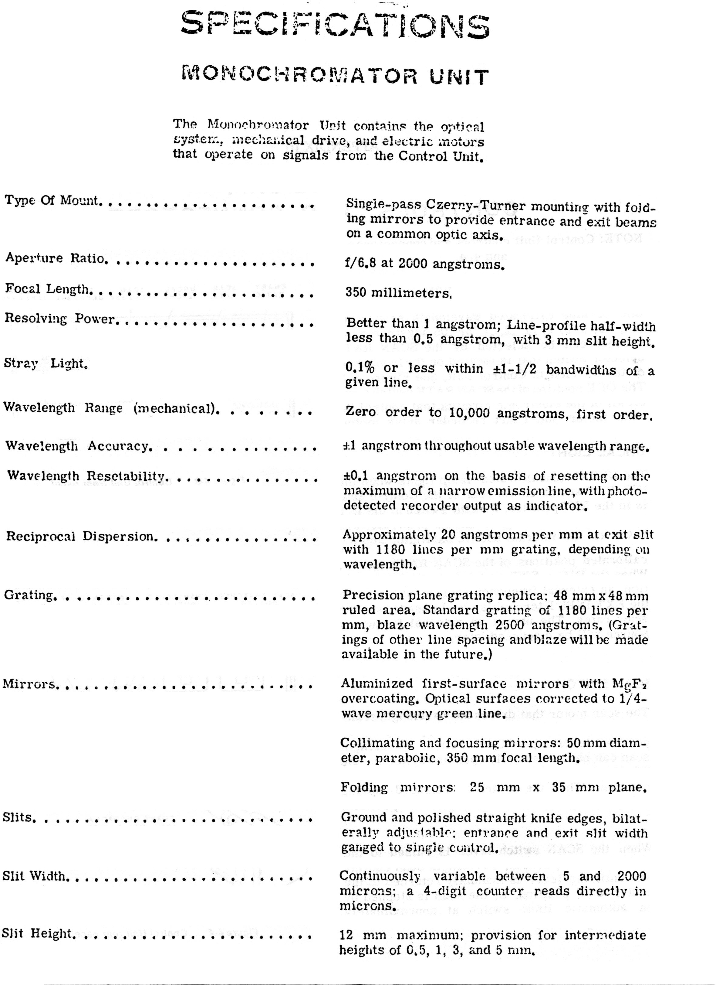
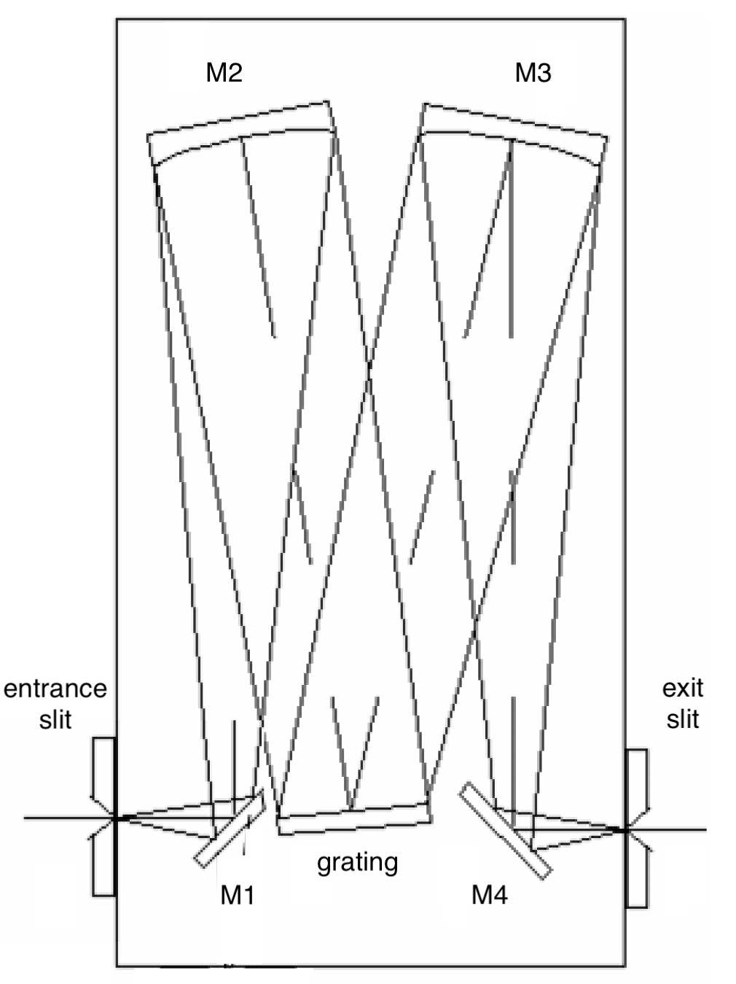
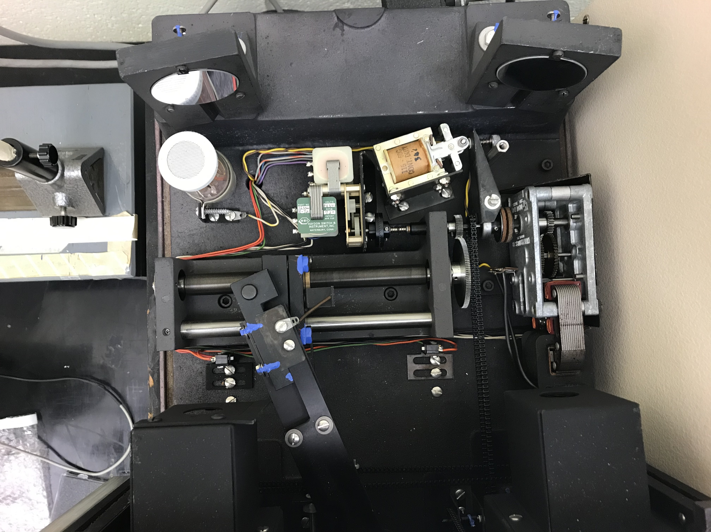
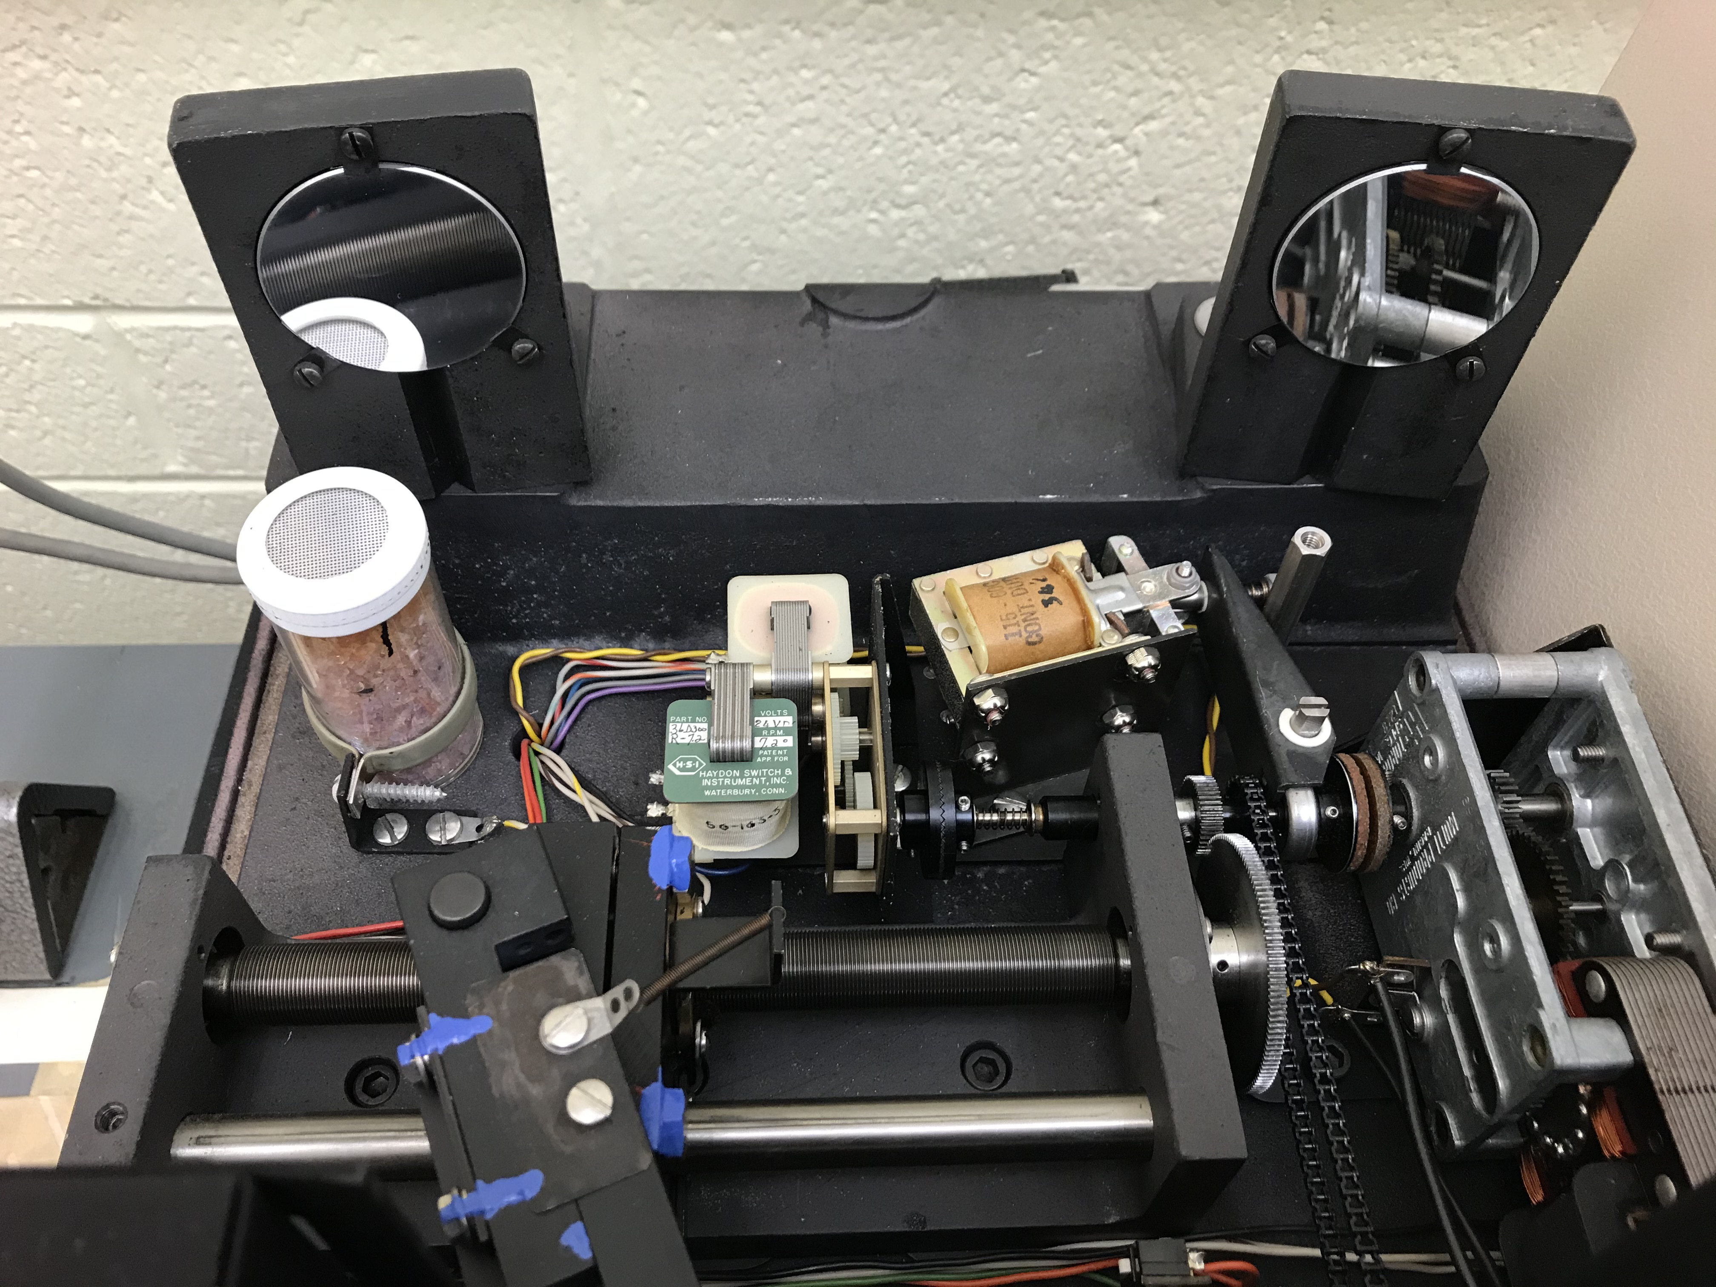

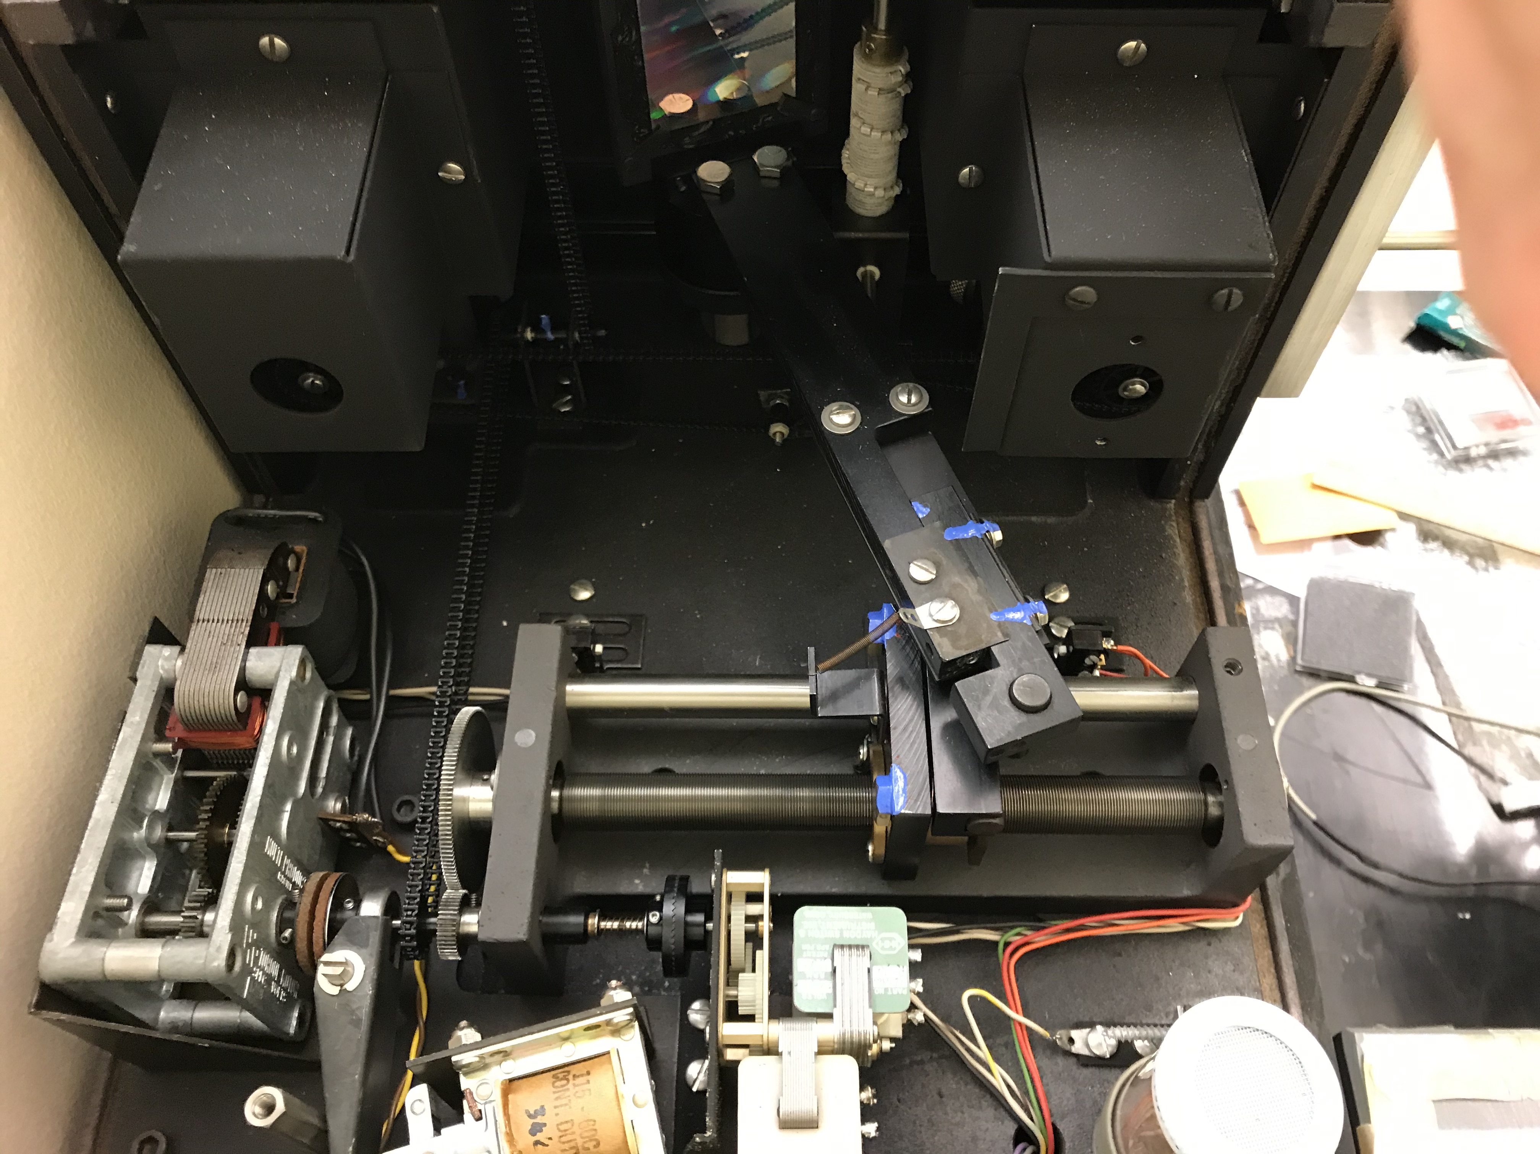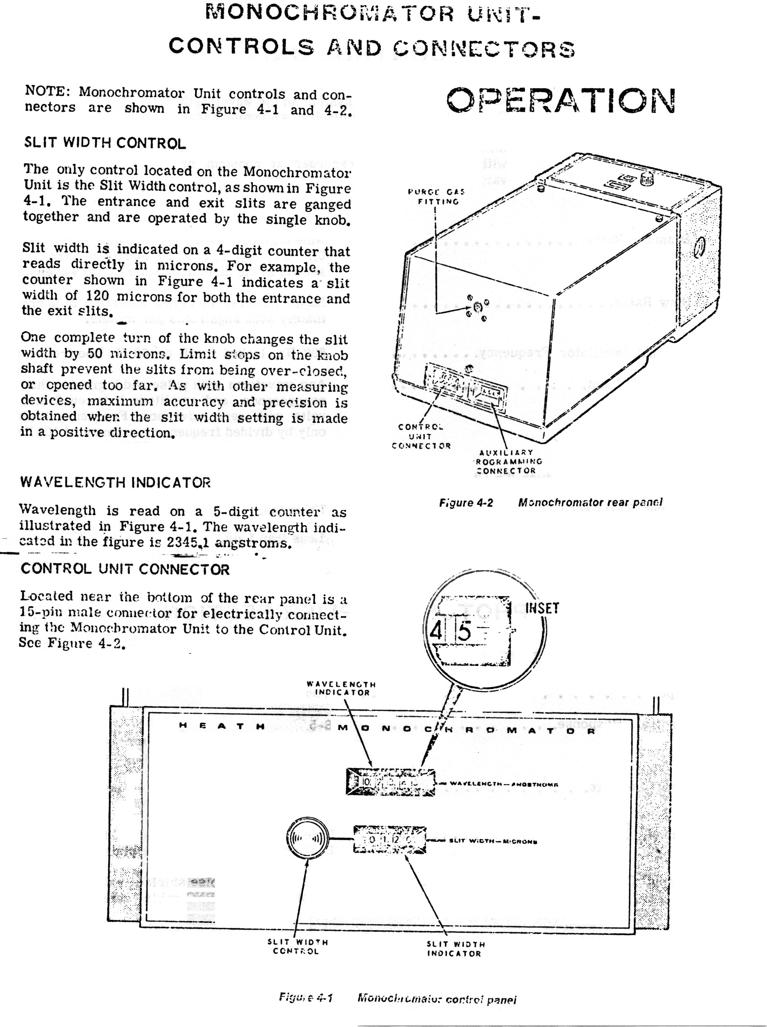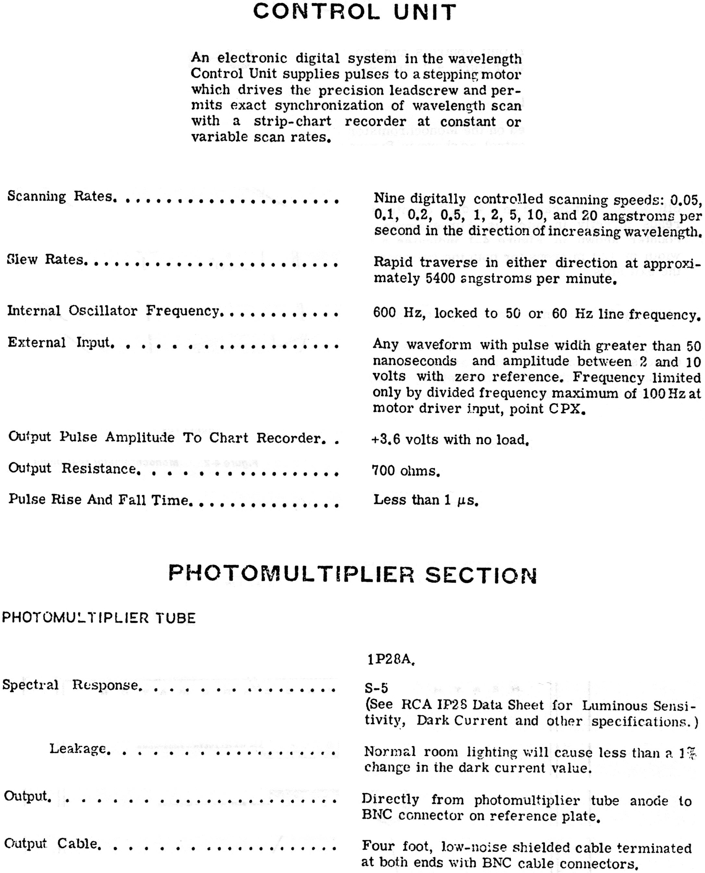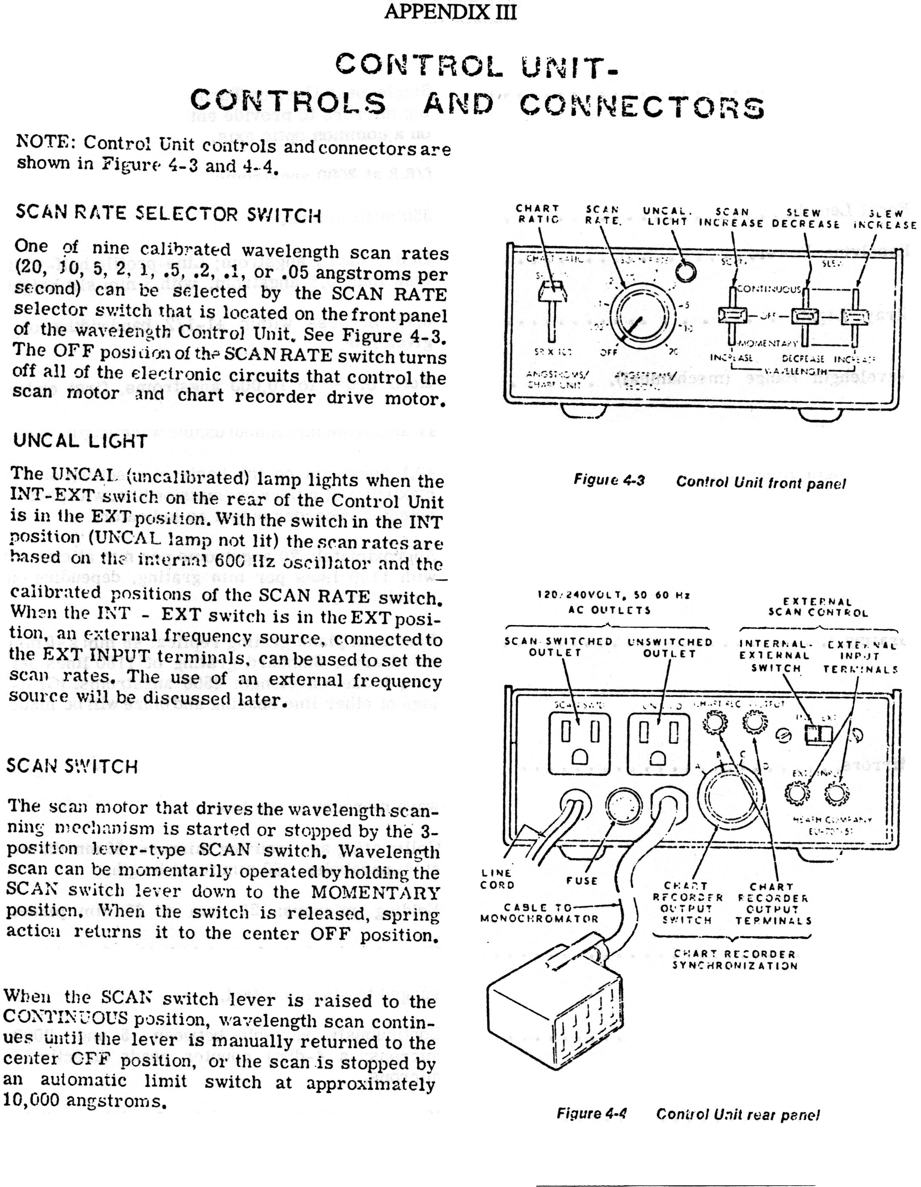
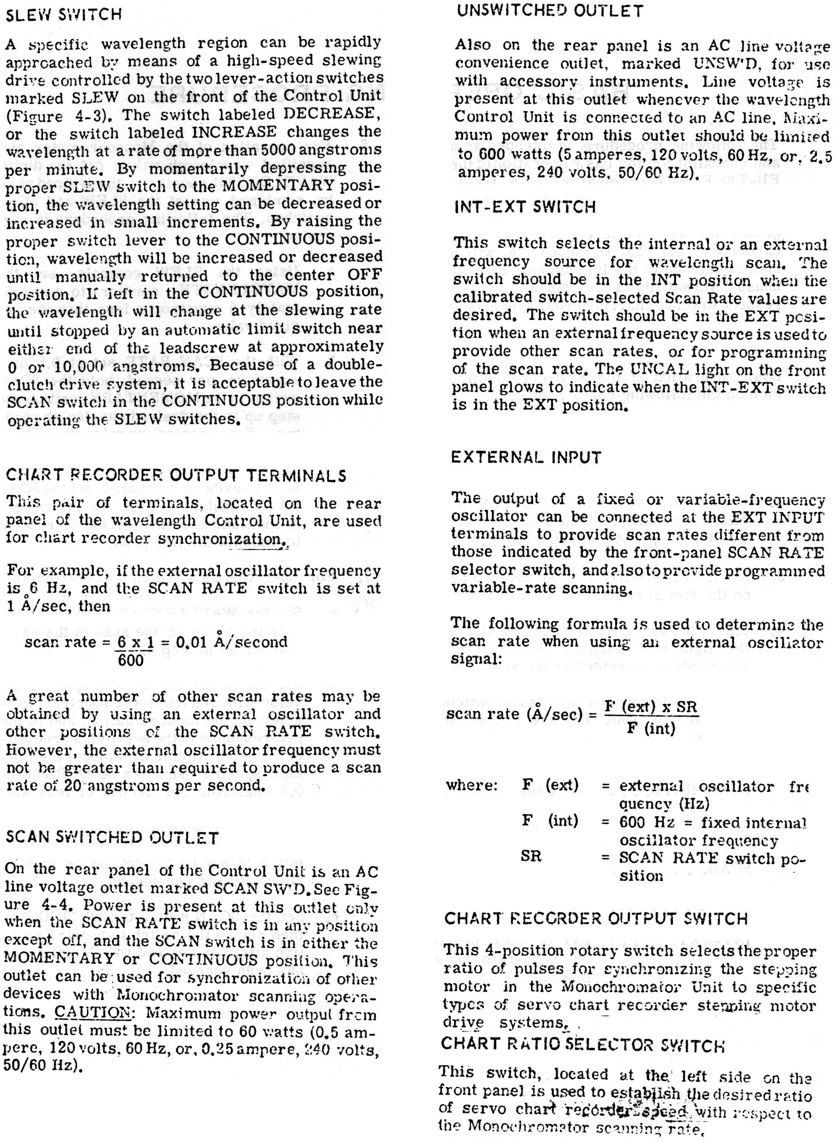
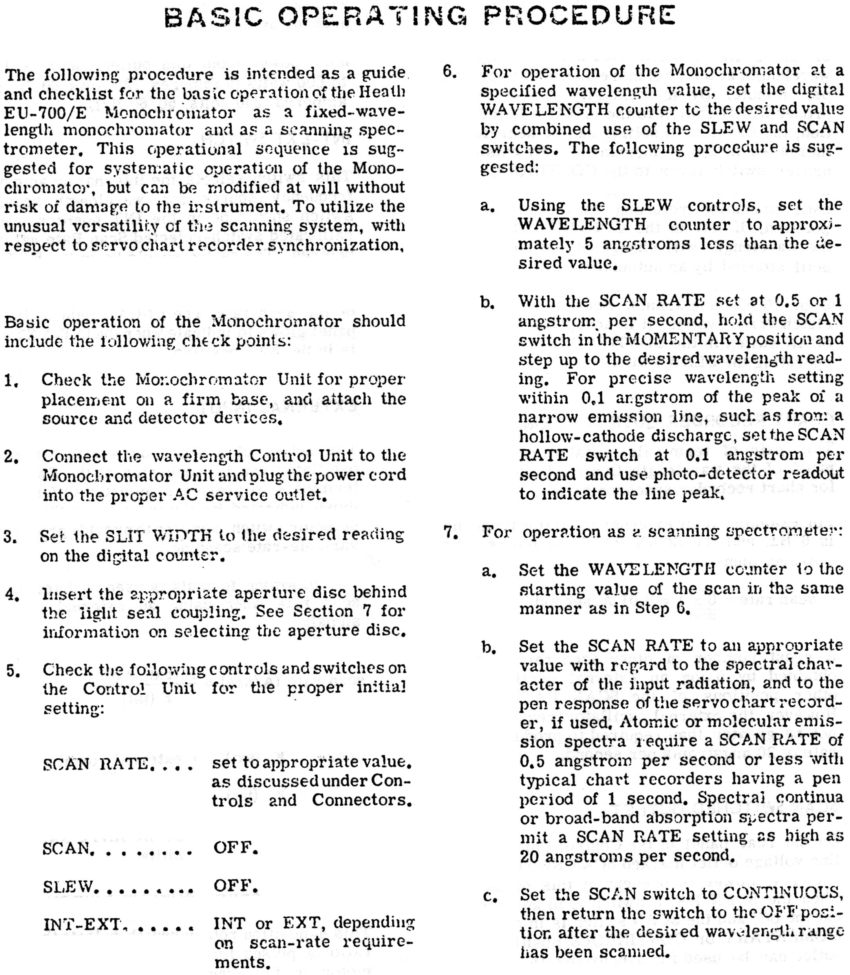

Contact the Supervising Professor or Lab Coordinator if these internet links are broken.

